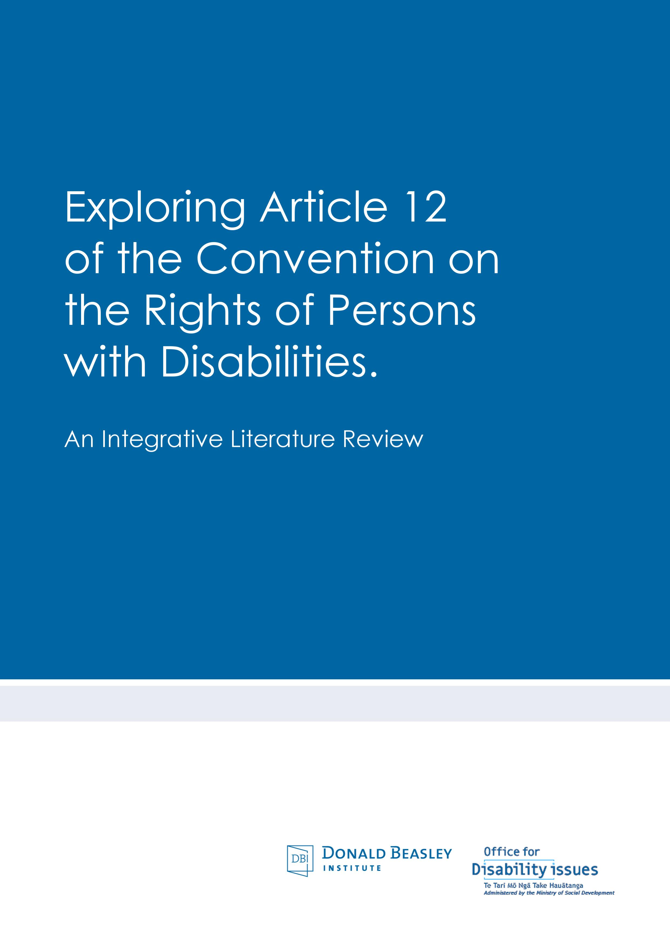
SUMMARY

Exploring Article 12 of the United Nations Convention on the Rights of Persons with Disabilities: An Integrative Literature Review

Suggested Citation: Mirfin-Veitch, B. (2016). Exploring Article 12 of the United Nations Convention on the Rights of Persons with Disabilities: An Integrative Literature Review. Donald Beasley Institute: Dunedin

Executive Summary
Disabled people continue to face barriers to exercising legal capacity, often as a consequence of being denied equal recognition before the law.
The purpose of this report is to provide information and direction based on recent research literature and evidence of actions taken by other states parties about the ways in which New Zealand may give effect Article 12, the right of disabled people to equal recognition before the law, of the United Nations Convention on the Rights of Persons with Disabilities. As a state party to the Convention, New Zealand has recognised that it has an obligation to give effect to the right in Article 12. The report was guided by questions provided by the Office for Disability Issues that have been utilised as an organising framework for this report.

Setting the scene
The report begins with an overview of states parties’ obligations set out in the Convention and Article 12, including obligations to adjust legislation, policy, and practice so to:
- Replace substituted decision-making with supported decision-making as both a process and a legal paradigm.
- Adjust and modify systemic factors and environments (both within states parties’ jurisdictions and private sectors) in order to improve opportunities for disabled people to exercise legal agency and capacity on an equal basis with others. This obligation is underpinned by an expectation that member states will approach disability from a social model rather than medical model perspective.
- Abolish capacity tests, such as the status, outcome, and functional approaches and replace them with disability-neutral practices and safeguards regarding disabled people’s exercise of legal capacity.
- Discard notions of legal incapacity, which involves the conceptual separation of mental and legal capacity. As a consequence, legal capacity is recognised as a non-derogable right while mental capacity, and subsequently the level of support a person requires, may fluctuate. This involves conceiving of capacity as a human right.
- Replace ‘best interests’ with ‘will and preference’ as part of a paradigm shift towards conceptualising legal capacity, whereby ‘will and preference’ becomes the determining and central factor in decision-making.
These principles signal an obligation for states parties to radically depart from current prevailing practice, norms, and models upon which disabled people are engaged with often on an involuntary basis. In traditional and current practice in various jurisdictions, disabled persons have been denied equal legal agency and capacity before the law on the basis of a minimum threshold of evidence of cognitive ability or solely on the basis of their status of having a disability (Bartlett, 2012; Keeling, 2016; and Kohn & Blumenthal, 2014), often for the purposes of risk-avoidant interventions (McDaid & Delaney, 2010). It is expected that this radical departure ought to occur as an immediate and wide-scale revision. The Convention has been the catalyst for a paradigm shift in conceptualising legal capacity as independent of mental capacity and as non-derogable. However, the obligations that have emerged as a result of this re-conceptualisation remain hotly contested.

Remaining tensions concerning Article 12
Although there is general consensus with the spirit of the Convention, issues of tension remain due to dramatically different interpretations being posited about the nature and extent of states parties’ obligations. While the General Comment No. 1 (2014) was intended to clarify the intent of Article 12 and to provide states parties with direction on how to give expression to it, interrogation of the literature enabled a number of key issues and debates related to the implementation of supported decision-making at a systemic and practice level to be highlighted. These included debates about: how to theorise supported decision-making for individuals with severe cognitive impairment; how to determine when a disabled person requires assistance with decision-making; how to identify and manage situations whereby a person’s will and preferences conflict; how to determine and how to respond when disabled people and their supporters have conflicting will and preferences; and the nature and extent of safeguards required for disabled people, and in some cases their supporters, in the Convention era.
Particularly, disagreement remains in the literature regarding the extent to which disabled persons can be engaged with on purely voluntary bases and whether substituted decision-making is a necessary last resort option or whether it can be replaced in its entirety by different froms of supported decision-making (such as facilitated decision-making). One side of the debate argues that there will always be cases where a person is too dangerous, lacks a sufficient understanding of the decision, or is completely unable to communicate their will and preference (see Dawson, 2015; Ciavano, 2014; Gooding, 2015). On the other side of the debate, it is argued that it is critical to optimise people’s true will and preferences as much as possible and violating the equal rights and dignity of people through proxy (substituted decision-making) is not permissible (see Byrnes et al., 2007; Kohn & Blumenthal, 2014). It is also argued from this body of literature, that people’s will and preferences can always be ascertained, even if it means proceeding on the basis of information known about them, which enables that person to exercise their agency through a third party (see Arstein-Kerslake & Flynn, 2015; Devi, 2013; Flynn & Arstein-Kerslake, 2014). It is also argued that disability-neutral options are available to states parties to protect disabled people and others from danger (see Richardson, 2012; WNUSP, 2008).

Who are we talking about?
The significance of the obligations in Article 12, and the subsequent radical departures from traditional understandings of legal and mental capacity they require, pertain to all disabled persons but pertain significantly to groups most who have frequently been obstructed from exercising their legal capacity. The groups most significantly affected, as identified through the literature, are people with: developmental and learning disabilities; dementia; acquired brain injuries; and mental distress.

Giving effect to Article 12 in law, policy, and practice
This report identifies and explores specific approaches and mechanisms for supported decision-making that have been signalled in the literature, or have been implemented by states parties committed to embedding Article 12 of the Convention in the daily lives of disabled people. While a dominant way of theorising the implementation of supported decision-making is still to emerge, there is quite a high degree of consensus relating to the elements of effective supported decision-making. The most extensive body of research relating to Article 12 of the Convention articulates the critical elements required to ensure that will and preference remains central in all situations involving disabled people who require assistance with decision-making.
Implementation strategies by states parties, non-governmental organisations, and disabled persons’ organisations have ranged from:
- Legislative change to discard notions of legal incapacity (as in the case of Sweden) or adjust notions of incapacity (Denmark).
- Legislative change or review to embed Article 12 in jurisdictionally-binding rights frameworks (Charter of Human Rights and Responsibilities, Australia).
- Legislative change to embed the reasonable accomodation of disabled people in jurisdictionally-binding rights frameworks (Charter of Human Rights and Responsibilities, Australia).
- Legislative change to make provisions for supported decision-making practices, including:
  - Legislative change to grant rights to access supported decision-making (as in the case of Scotland).
  - Legislative change to provide formal supported decision-making options, including microboards (British Columbia, Canada), co-decision-making arrangements (Saskatchewan, Canada), personal mentors or administrators (Sweden), or other recognised supporter roles (Delaware, USA; Texas, USA).
  - Legislative change to provide formal monitoring options for safeguarding supported decision-making arrangements (British Columbia, Canada).
  - Legislative change to make provisions for formal support agreements (for example Representation Agreements in British Columbia, Canada).
- Provisions for support in practice or pilot programs, including:
  - Enabling advance support decisions made in statements (pilot program, South Australia, Australia).
  - Making supporters in the form of advocates available for individual and/or decision-specific assistance (Scotland; Victoria, Australia).
  - Making supporters in the form of advocates available for taking initiatives towards addressing structural obstacles that impact on the exercise of legal capacity (Scotland; Victoria, Australia).
  - Providing information for supporters and supported people on making decisions, factors to consider, and organising formal supported decision-making arrangements (Nidus Personal Planning Resource Centre, Canada; Scotland; Victoria, Australia).
- Practice restrictions on the use and frequency of involuntary treatment and detention (Victoria, Australia).
However, it is important to note that no states parties have fully given effect to Article 12, in line with the interpretation proffered by the Committee on the Rights of Persons with Disabilities, as a result of their efforts to comply with the United Nations Convention on the Rights of Persons with Disabilities.

Challenges to giving effect to Article 12 in law, policy, and practice
A number of challenges have been identified in the literature as having the potential to derail states parties efforts to give effect to Article 12 and embed supported decision-making within their particular jurisdictions. These challenges include: outdated understandings and perceptions of disability and their subsequent impact on the treatment of disabled people; ensuring supporters are trained to provide effective support, given the limited resources available; the complex and subjective process of obtaining people’s will and preferences; system and service issues that frustrate the realisation of disabled persons’ will and preference; the tendency to favour risk-avoidance and paternalistic intervention; implementing robust and appropriate safeguards; and disabled people often having limited or absent close support networks who could provide support with decision-making.

Gaps in the literature
Discourse in the literature about the process of giving effect to Article 12 highlights a number of issues of contention. Debates remain about how to identify and manage situations whereby a person’s will and preferences conflict internally. There are differing opinions about how to determine and how to respond when disabled people and their supporters have conflicting will and preference. More significantly, there are gaps in empirical research to guide and inform legislative change and guide policy, and practice related to supported decision-making. There is also a critical need for well-considered and substantial safeguards that are designed to protect both disabled people and their supporters.
With regard to resources, and beyond the signalled need that could be used to provide better resources to best facilitate decision-making, the literature is unclear about the specific ways in which resources should be provided and distributed for supported decision-making.
The review also identified an acute lack of evidence to guide legislative change related to Article 12, to underpin and inform policy, and practice related to supported decision-making. Of particular note is an absence of the experiences and perceptions of disabled people within the body of information available. It is also apparent that there is a lack of robust evidence about the level of resourcing required to embed supported decision-making in the lives of all disabled people, including who should provide, and who should receive such resourcing.

Future challenges
Available literature has evidenced that states parties have often taken a conservative position on the implementation of Article 12; that is they perceive substituted decision-making (and thus involuntary treatment or detention) as sometimes being necessary in last resort and extreme cases, and consequently have developed supported decision-making initiatives alongside the traditional paradigm of substituted decision-making. In considering the literature in relation to the questions upon which this review is based it is apparent that considerable tension exists in relation to how to interpret the wider intent of Article 12 of the United Nations Convention on the Rights of Persons with Disabilities, and consequently, how states parties should proceed to implement it in legislation, policy, and practice. While there are robust and well-considered arguments emerging from both sides of the debate, to date, no states parties have implemented the required level of legislative, policy, and practice change for their efforts to be recognised as giving full expression to Article 12, according to the Committee on the Rights of Persons with Disabilities’s interpretation of Article 12. As the ultimate arbiter of the Convention, it is clear that to achieve this goal states parties would need to accept the Committee’s interpretation, be prepared to undertake significant change to legislation, policy, and practice, and expend time and effort to identify, develop and embed supported decision-making processes and the necessary safeguards for both disabled people and their supporters.

