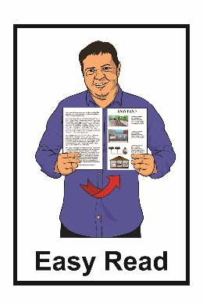
Report:
How the Government
is getting on with the Disability Action Plan

6-monthly report:
January 2021 to June 2021
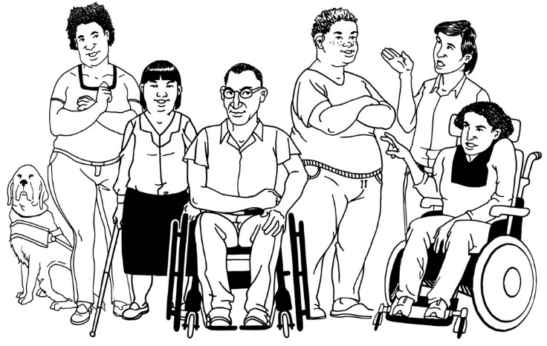

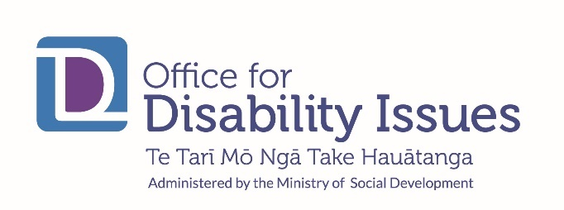
Before you start

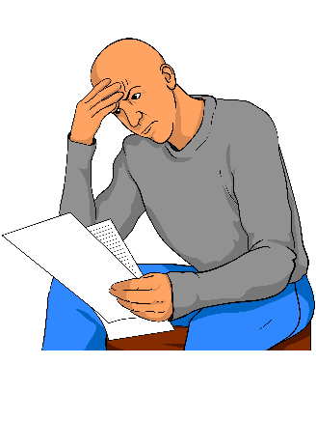
This is a long document.

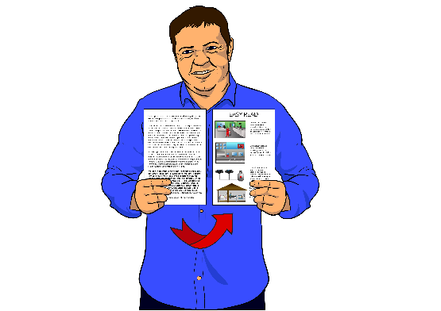
While it is written in Easy Read it can be hard for some people to read a document this long.

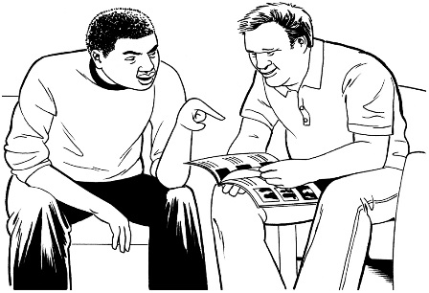
Some things you can do to make it easier are:

- read it a few pages at a time

- have someone help you to understand it.

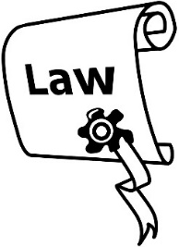
This document talks about a lot of laws that are:

- new

- being changed.

To find out more about how laws are made there is Easy Read information called:

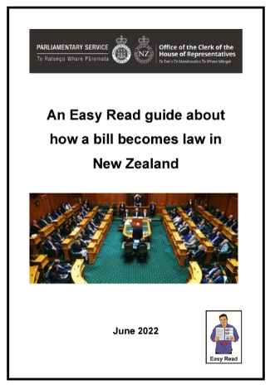
An Easy Read guide about how a bill becomes law in New Zealand

You can find the document online on the Parliamentary Services website:
www.parliament.nz/media/9257/parl-services-how-a-bill-becomes-law-easy-read-20-6-22.pdf

What you will find in this report

Page number:
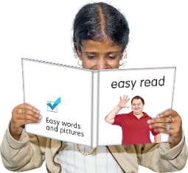

What is this report about? 6
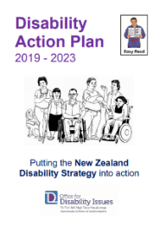

What is the Disability Action Plan? 8

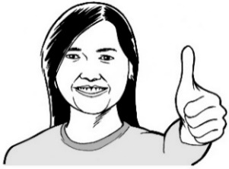
What has happened so far? 12

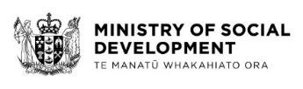
What the Ministry of Social Development
has done 15

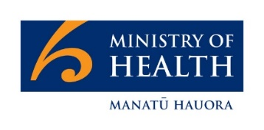
What the Ministry of Health has done 20

Page number:

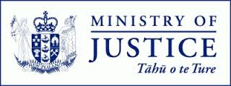
What the Ministry of Justice has done 23

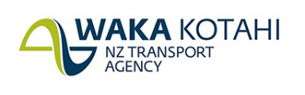
What Waka Kotahi has done 29

What Kāinga Ora has done 33

What other work has been done 36
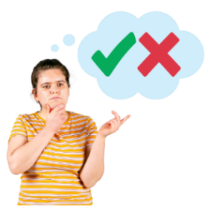

What has not been done 44

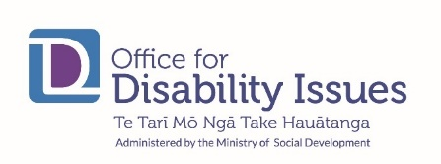
Where to find more information 48

What is this report about?

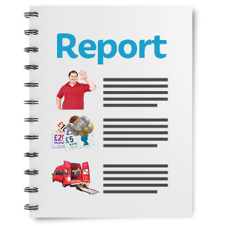
This Easy Read document is a report about how well the Disability Action Plan is working.

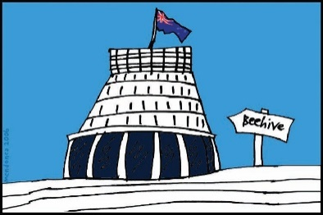
The Disability Action Plan is how the Government will make the New Zealand Disability Strategy happen.

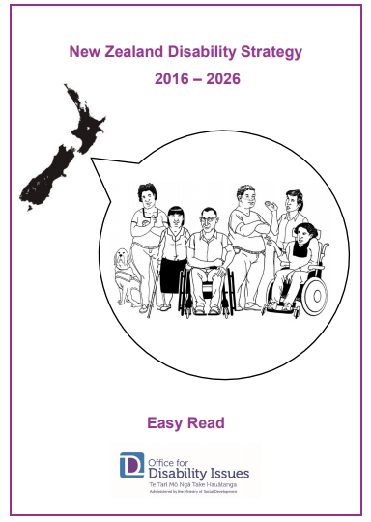
The New Zealand Disability Strategy works to make sure disabled people:

- are treated fairly

- get what they need to have a good life

- are part of the community

- can make their own decisions.
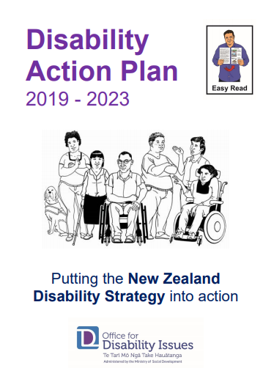
There are Easy Read translations about the:

- New Zealand Disability Strategy

- Disability Action Plan.

You can find these Easy Read translations on the Office for Disability Issues website:

https://www.odi.govt.nz

What is the Disability Action Plan?

The Disability Action Plan started in November 2019.

The Disability Action Plan works to improve the wellbeing of disabled people by working on 8 main outcomes.

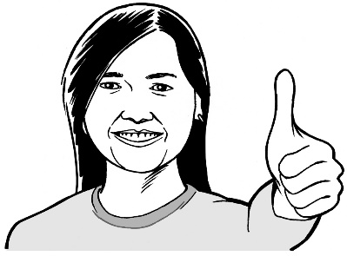
Wellbeing means how people feel about their lives.

Some of the things that are important to wellbeing are:
- health
- money
- housing.
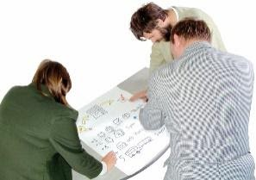
Outcomes are the things we want to happen from the Disability Action Plan.

These outcomes are:
- Education

- Jobs and money

- Health and wellbeing

- Protecting the rights of disabled people

- Accessibility

- Attitudes towards disability

- Disabled people having choices
and control over their own lives

- Disabled people as leaders
You can find more information about the things being worked on in each of these outcomes in the Disability Action Plan.

You can find this Easy Read translation on the Office for Disability Issues website:

https://www.odi.govt.nz

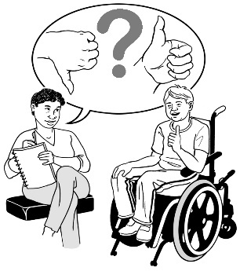
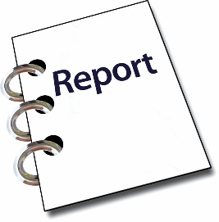
Every 6 months the Office for Disability Issues puts out a report about what the different parts of Government are doing from the Disability Action Plan.

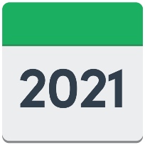
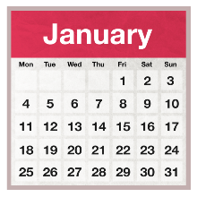
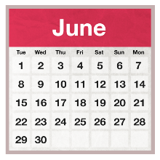
This report looks at what the different parts of Government did from:

January 2021

to

June 2021.
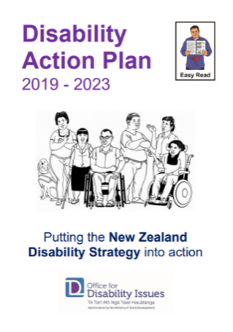

These reports are 1 of the ways to see how well the Disability Action Plan is working.

3
This report is the third report they have done.

What has happened so far?

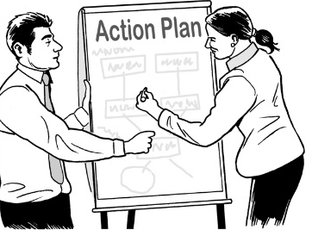
29
The Disability Action Plan has 29 work programmes.

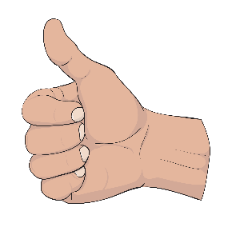
The people working on 2 of these programmes said their work is finished.
2

4
The people working on 4 of these programmes said their work is going well.
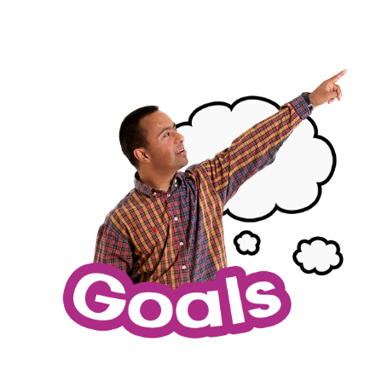

The people working on these 4 programmes said they are meeting the goals set out in the Plan.

Goals are the things the people planned to do by a certain time.

Some of those 4 people said they are further ahead than planned.

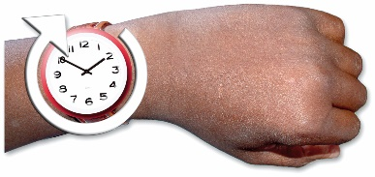
The people working on 18 of the programmes said they will finish on time.
18

The people working on 4 of the programmes said they have not done as much as the plan said.
4

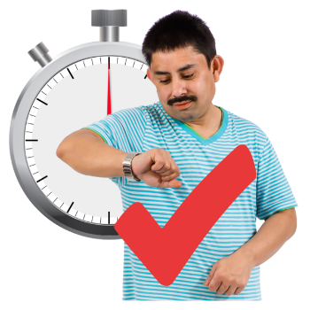
The people working on these 4 programmes said they think they will still finish their work on time.

1 of the work programmes has had problems with doing its work on time because of COVID-19.
1

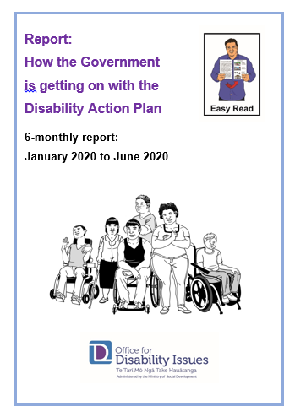
Some important things have been done by different government departments.

In this Easy Read report we look at what the government departments have been doing for each outcome:

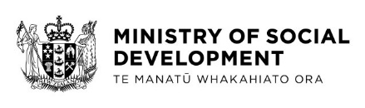
- the Ministry of Social Development

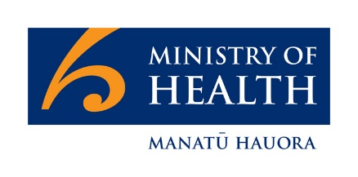
- the Ministry of Health

- the Ministry of Justice

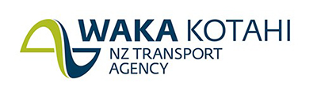
- Waka Kotahi – the New Zealand Transport Agency

- Kāinga Ora which looks after social housing.

What the Ministry of Social Development
has done

The Ministry of Social Development is a part of the New Zealand Government.

The Ministry of Social Development is also known
as MSD.
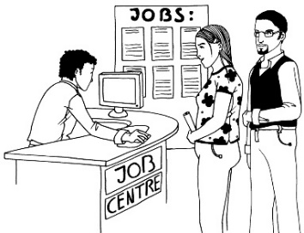

MSD supports people with things like:

- finding a job
- getting money if you do not work

- getting money if you are studying
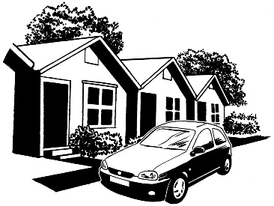
- finding a place to live.

MSD is working on Outcome 2 of the Disability Action Plan.

Outcome 2 is about:

- jobs
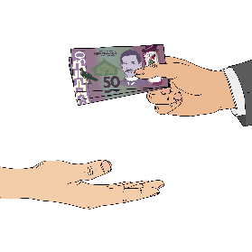
- making sure people have enough money to live a healthy life.

The report says MSD is working with the Access Alliance to look at laws for accessibility.
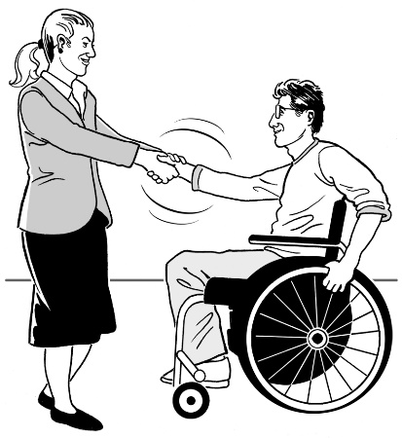

The Access Alliance is a group made up of organisations who speak up about disability.

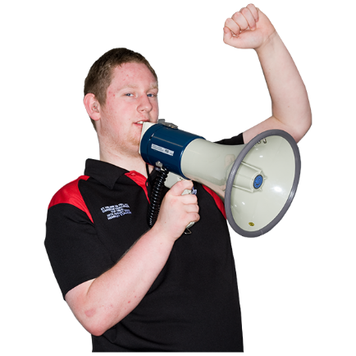
Some of the groups in the Access Alliance are:

- advocacy organisations who speak up about the rights of people with disability.

- service providers supporting disabled people

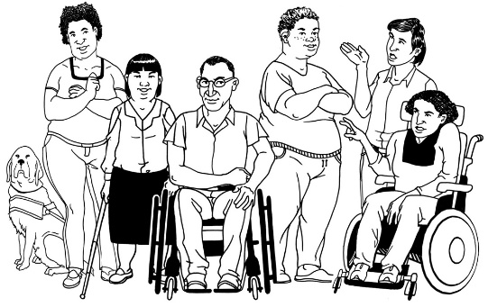
- Disabled People’s Organisations who:

- represent people with disability

- are run by disabled people.

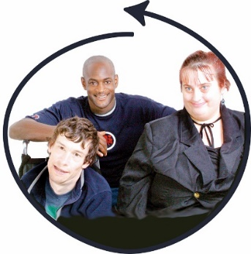
The Access Alliance group wants to make sure disabled people are fully included in New Zealand society.

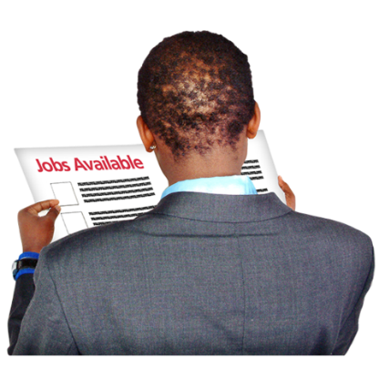
The report says MSD now has an internship coordinator.

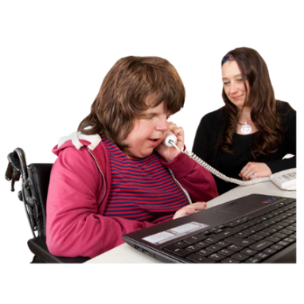
An internship is when someone gets work experience doing a job about their studies.

They can be:
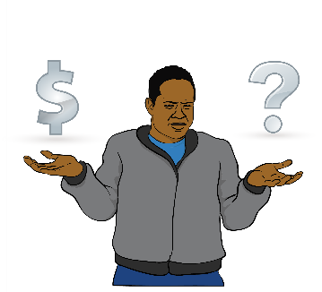
- paid

- unpaid.

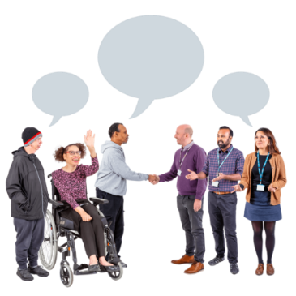
A coordinator is someone who brings together all the people and things to get a job done.

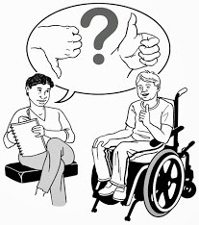
The report also says the coordinator will work with tertiary organisations to support disabled students to get internships with government.
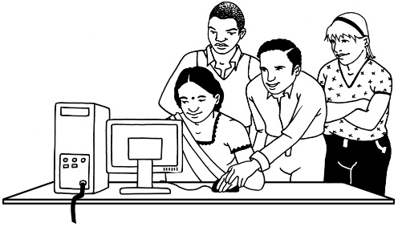
Tertiary organisations are places that people go to after high school / college to do more learning.

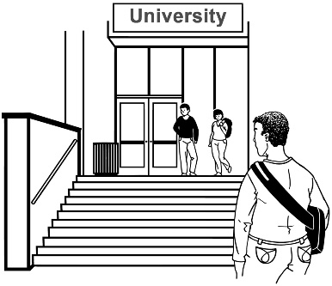
Some tertiary organisations are:

- universities

- polytechnics.

What the Ministry of Health has done

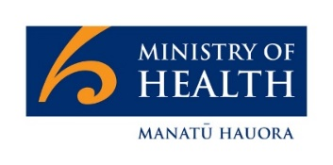
The Ministry of Health is a part of the New Zealand Government.
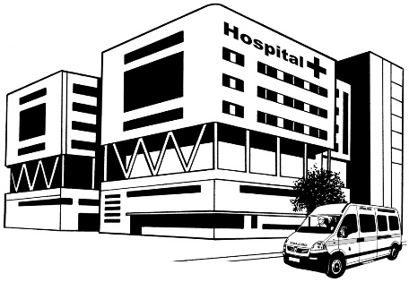

The Ministry of Health is in charge of health care in New Zealand.

The Ministry of Health is looking at Outcome 3 of the Disability Action Plan.

Outcome 3 is about:

- health

- wellbeing.

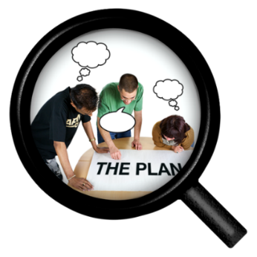
The Ministry of Health is leading a number of work programmes in the Disability Action Plan.

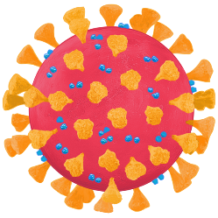
The report says most of the work the Ministry of Health is doing for the Disability Action Plan is delayed because of the COVID-19 pandemic.

The report says the government is going to replace a law called the Mental Health (Compulsory Assessment and Treatment) Act 1992.

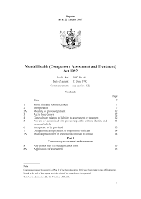
The Mental Health (Compulsory Assessment and Treatment) Act 1992 is about things like if people with mental illness can:

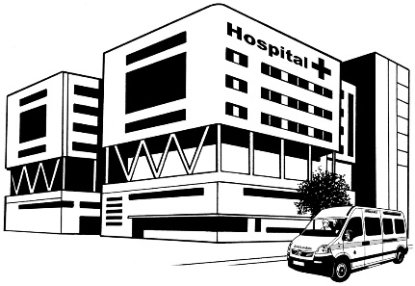
- be given treatment they do not want

- be made to stay in hospital if they do not want to.

Parliament needs to agree to the law.

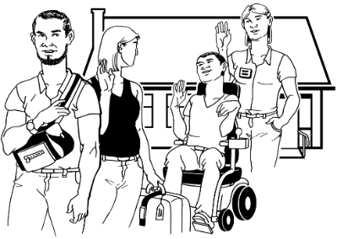
Many disabled people think the law needs to be changed so people get better care.

See page 3 for a link to Easy Read information about how a law is made.

What the Ministry of Justice has done

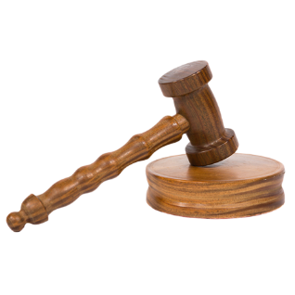
The Ministry of Justice is a part of the New Zealand Government.

It is in charge of things like:
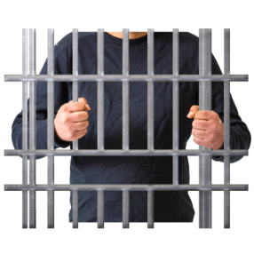
- courts

- prisons
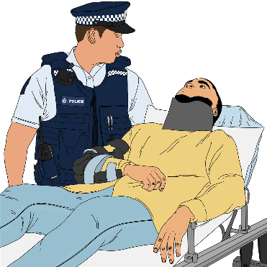
- police

- less people breaking the law

- supporting victims.

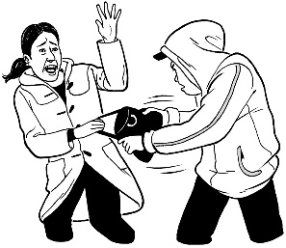
A victim is a person who is harmed or injured during a crime.

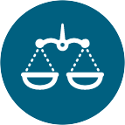
The Ministry of Justice is looking at Outcome 4 of the Disability Action Plan.

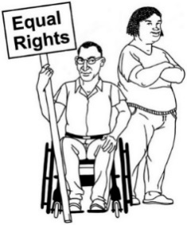
Outcome 4 is about protecting the rights of disabled people.

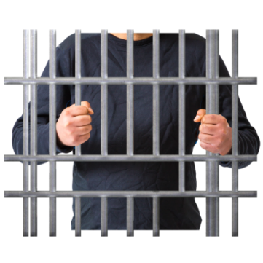
The report says there is a new form for prisoners so that the Ministry of Justice can collect data about disabled people.

Data means information about things.

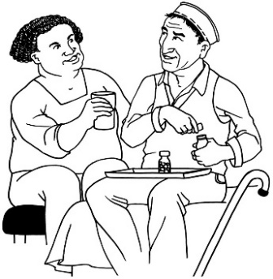
This data means more can be done to support prisoners with disabilities.

The report says the Sexual Violence Bill has had its first reading.

A bill is something that will become a law if parliament agrees to it.

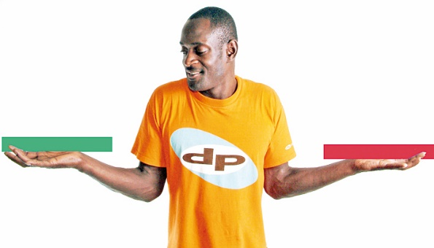
The first reading is when Members of Parliament talk about the bill.

The Members of Parliament vote on what to do with the bill.

If more than half vote yes the bill will go to the next stage.

See page 3 for a link to Easy Read information about how a law is made.

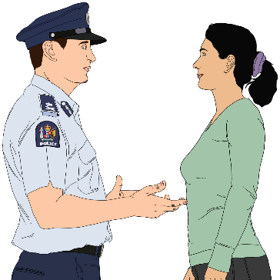
The Sexual Violence Bill was made to change some things in the law to protect victims of sexual violence.

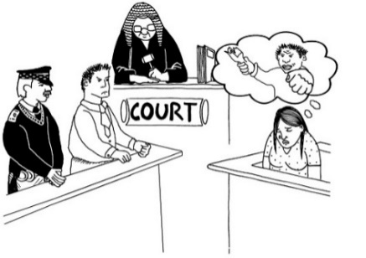
The bill wants to make it not so bad for victims when they have to give evidence in court about their experience.

It can be scary or painful to remember what happened.

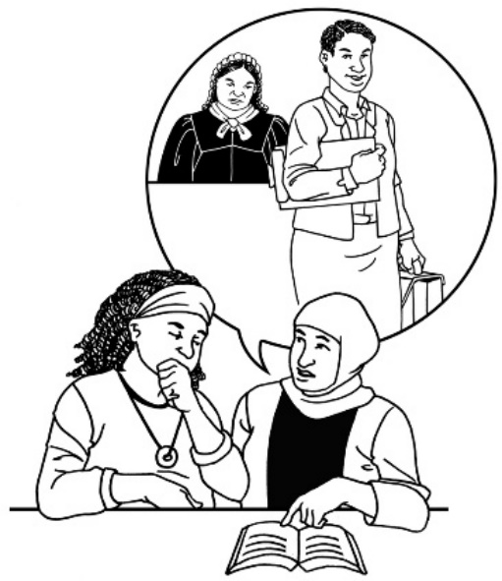
The report says the Ministry of Justice set up a communication assistance programme.

The programme finds out what assistance disabled people need when going through the court process.

The report also says the Ministry of Justice is asking people what they think about the adoption law reform.

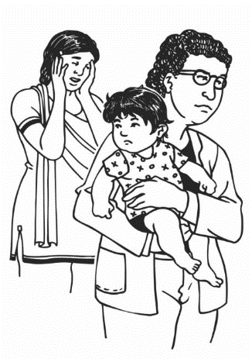
The adoption law reform is being changed so it is:

- a better fit for what things are like now

- about what is best for children.

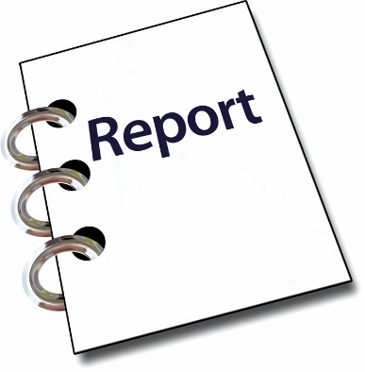
The report says a new law called Family Court (Supporting Children in Court) Act is at select committee.

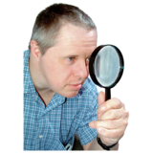
A select committee is when a smaller group of Members of Parliament take a closer look at the bill.

See page 3 for a link to Easy Read information about how a law is made.

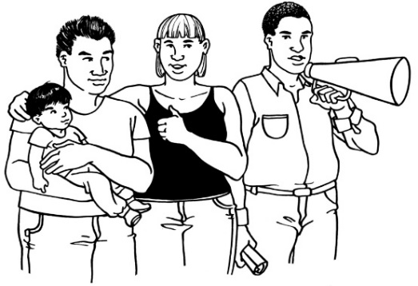
The Family Court (Supporting Children in Court) Act is a law that will make sure children can have their views heard in family court cases.

What Waka Kotahi has done

Waka Kotahi is the New Zealand Transport Agency.

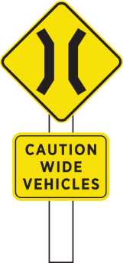
Waka Kotahi looks after things like:

- transport safety

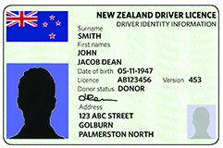
- road signs

- driving licences.
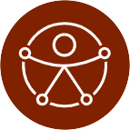

Waka Kotahi is looking at Outcome 5 of the Disability Action Plan.

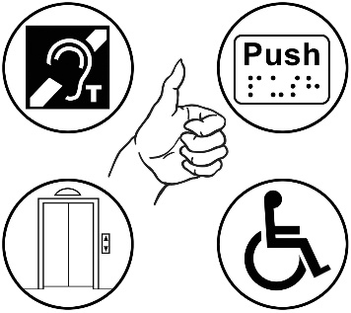
Outcome 5 is about making things accessible.

The report says Waka Kotahi wants to:

- better understand the transport experience of disabled people
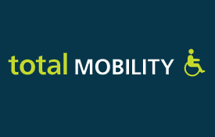
- look at the barriers that are there for people who want to use the Total Mobility scheme.

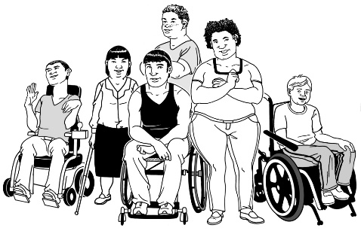
Total Mobility is a scheme for people with:

- disabilities

- long term impairments.

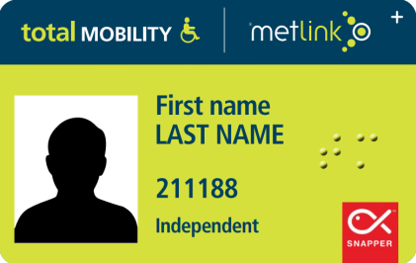
Total Mobility provides:

- electronic cards or vouchers that make transport cheaper
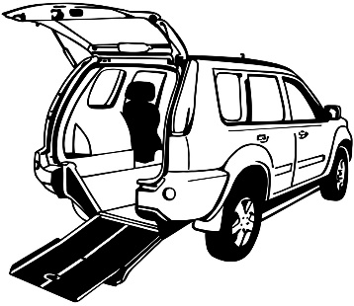
- funding so providers can get accessible vehicles for wheelchair users.

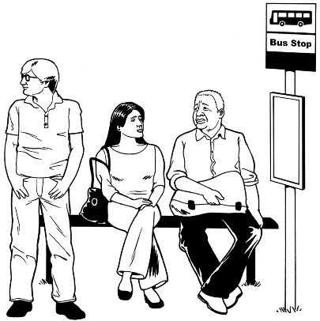
The report says Waka Kotahi is also finding out some things about noises made by electric buses because people with low vision cannot hear them coming.

Waka Kotahi will let the Government know what they need to do to make transport better for disabled people.

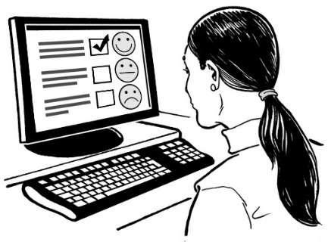
Waka Kotahi also wants its tools to be accessible for disabled people.

An example of a tool is Journey Planner which helps plan trips from start to end.

What Kāinga Ora has done

Kāinga Ora is an agency for:
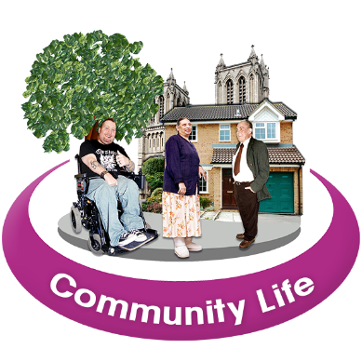
- homes

- community.

It brings together the people from:
- KiwiBuild

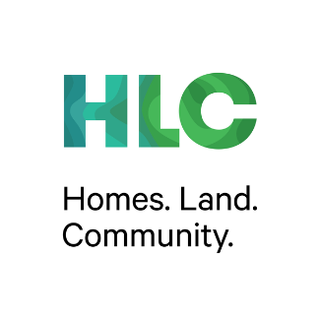
- Housing New Zealand

- Homes. Land. Community.

Kāinga Ora is also looking at Outcome 5 of the Disability Action Plan.

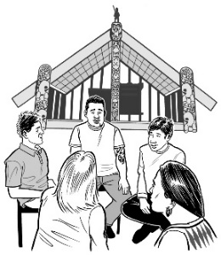
Kāinga Ora works on building projects with:

- developers

- the Māori community.
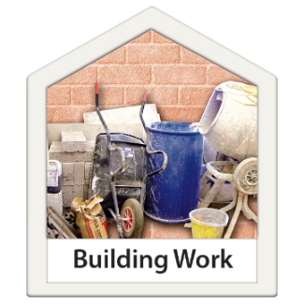

Developers are people who build lots of homes.

Kāinga Ora also works with:

- local government

- central government.

Local government is in charge of:

- regions

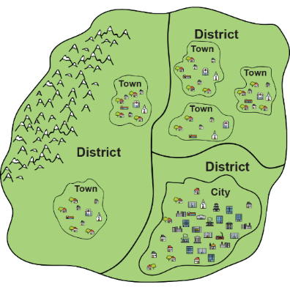
- towns

- cities.

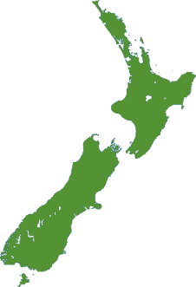
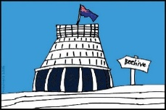
Central government is in charge of the whole country.

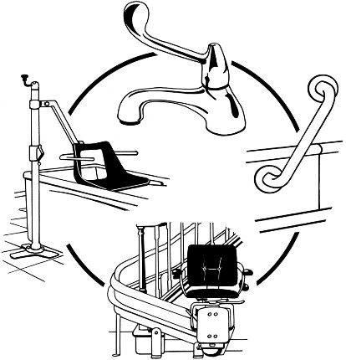
The report say Kainga Ora has adapted four thousand five hundred homes for people so they can be more independent.

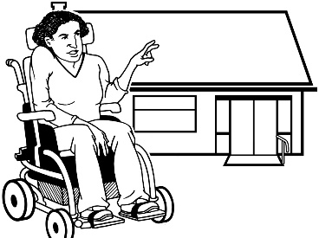
They worked with the people using these buildings to:

- find out the individual needs of the people using the buildings
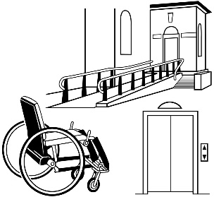
- put the right support systems in place.

Other work that has been done

Outcome 2: Jobs and money

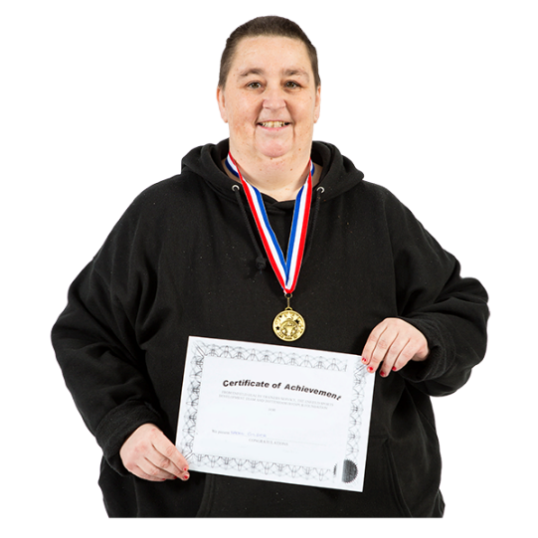
The report says a New Zealand Diploma in Health and Wellbeing will be launched soon.

A diploma is a certificate that shows a person has done some study.
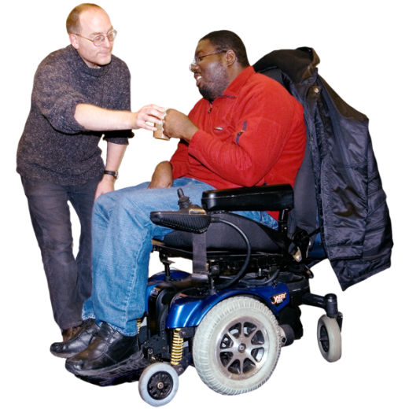

The diploma will train experienced support workers to support people with complex needs.

Outcome 3: Health and wellbeing

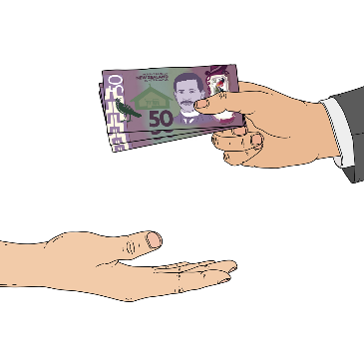
The report says the Office for Seniors has money from the government to do the things in the Better Later Life Action Plan.

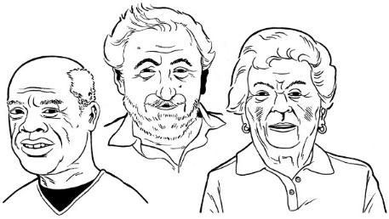
The Office for Seniors advises the Government on things that affect older people.

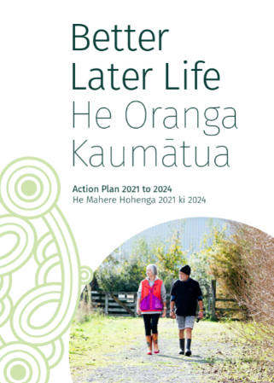
The Better Later Life Action Plan tells us what Government will do to make things better for older people over the next 3 years.

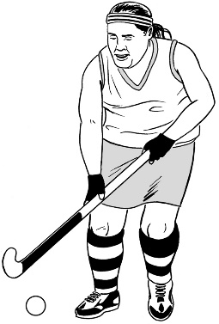
The report says Sport New Zealand has a Disability Plan that is going well.

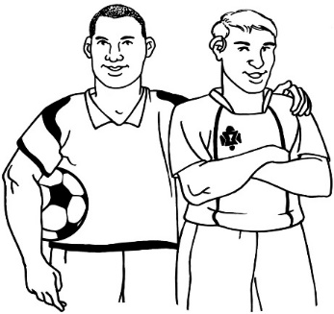
Sport New Zealand works to make sure people have a good time playing sport.

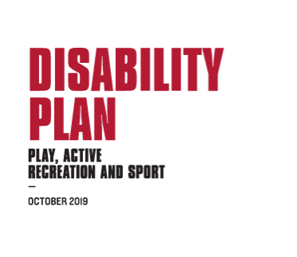
The Sport NZ Disability Plan is about making sure disabled people can have equal access to recreation and sport.

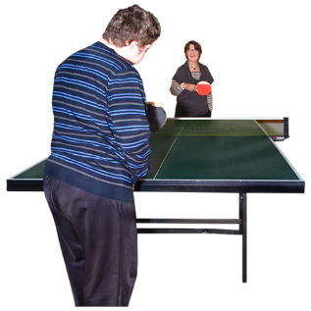
Recreation is when people do something for fun when they are not working.

Outcome 7: Choice and control

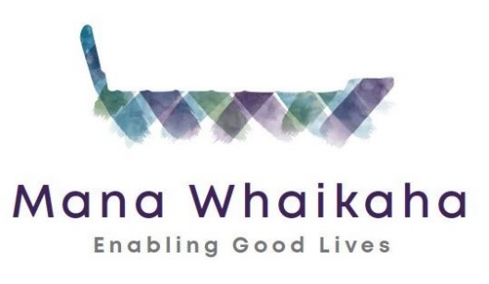
The report says disabled people in some regions continue to get support for:

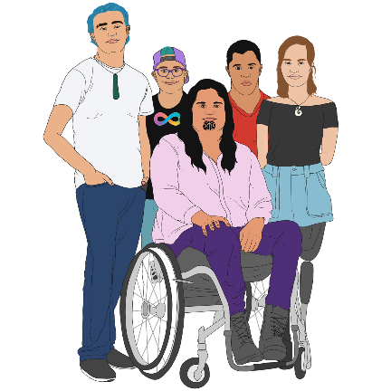
- Mana Whaikaha which is a disability support system offering more choice for:

- disabled people

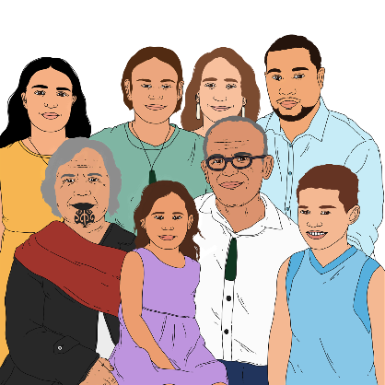
- tāngata whaikaha Māori / Māori disabled people

- their whānau / aiga / families.

- Enabling Good Lives which gives disabled people and their whānau / families more choice and control over their support.

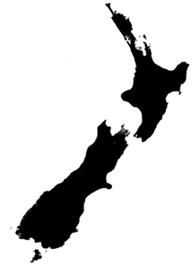
The report says a cabinet paper is being written about a national roll out of Enabling Good Lives.

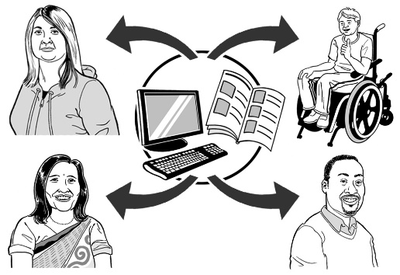
A cabinet paper is written by a Minister and shared with other Ministers to see what they think.

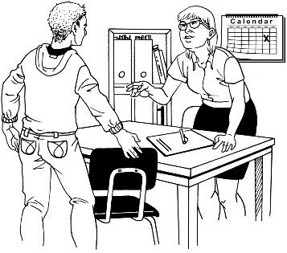
The report also says the Supported Decision Making document is being worked on.

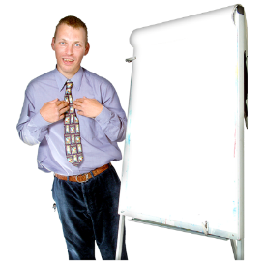
The report says there is more work being done to get more disabled people in leadership positions.

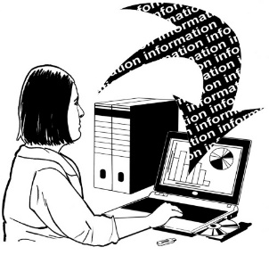
A lot of the work has been done
on keeping the list with all the positions up to date.

About the work on Disability Data

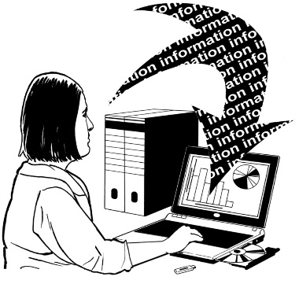
The report says the work on disability data:

- does not fit in one outcome

- belongs to all government agencies.
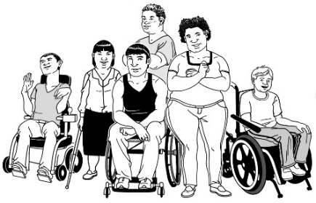

Disability data is the information collected about disabled people.

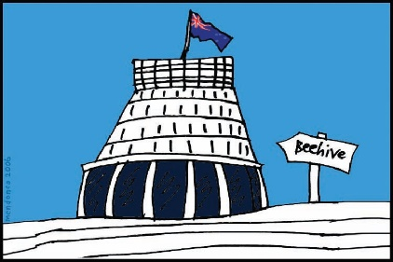
To make Government policy we need to know about disabled people in New Zealand.

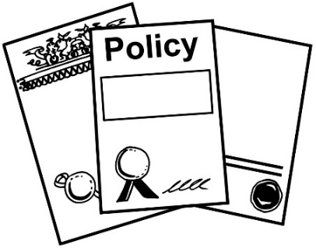
Government policy is what Government chooses to do to make things better for people.
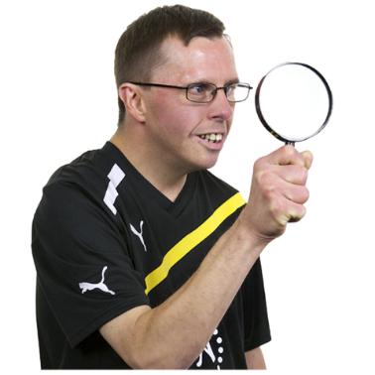
To find out about disabled people the Government looks at the information it collects.

Every 6 months the working group on disability data reports to the Minister of Disability Issues.

What has not been done

The report says information about the work on Outcome 1: Education is not in this report.

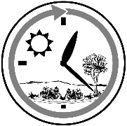
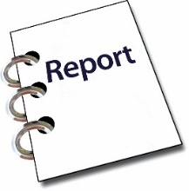
The reports for education were not in on time.

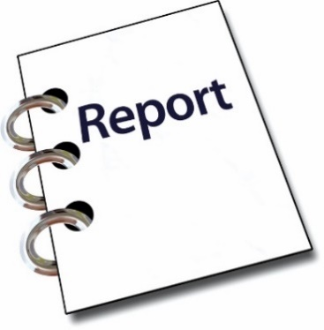
The late reports could not be approved in the way that was agreed with the Disabled People’s Organisations Coalition.

Approved means that the reports are checked to make sure they are okay.

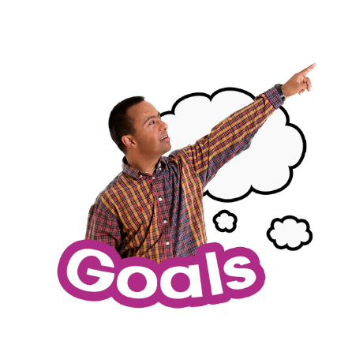
The Disabled People’s Organisations Coalition is a group of Disabled People’s Organisations working towards the same goals.

Outcome 6 in the Disability Action Plan is about attitudes towards disability.

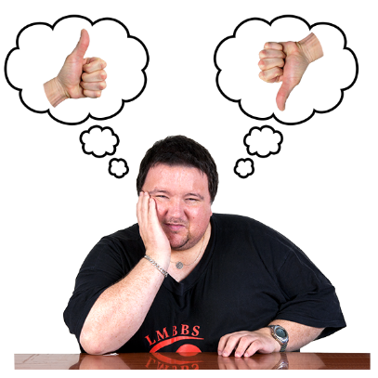
Attitudes towards disability means changing the ways people think about disability.

This means we want disabled people to be:
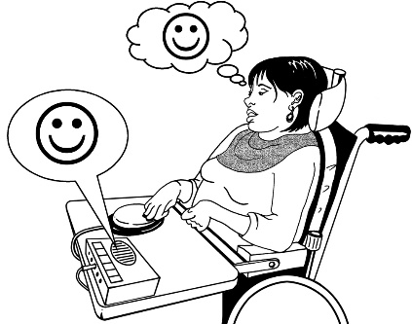
- understood

- accepted.

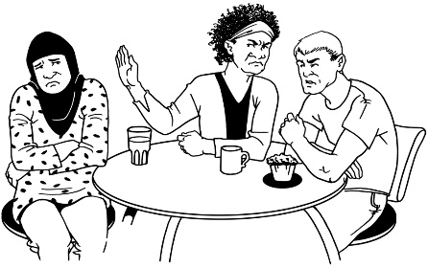
This outcome will change attitudes by ending the negative ideas that some people have about disability.

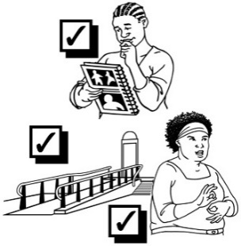
This will be done by:

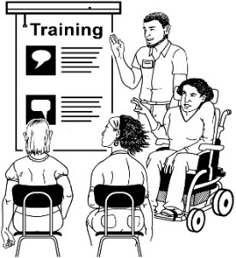
- making sure we know more about the needs of disabled people

- making sure disabled people are involved in more projects about changing attitudes towards disability

- listening to disabled people.

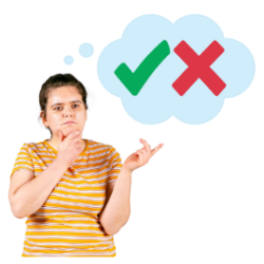
There are no programmes for Outcome 6 which is about the way people think and act towards disabled people.

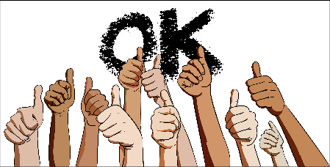
The report says that the way people think and act will improve by doing all the work talked about in this report well.

Where to find more information

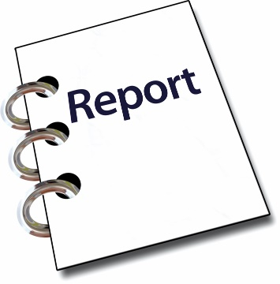
You can find more information about what other government agencies have done in the full report called:

Office for Disability Issues:
Bi-annual Progress Report –
January 2021 to June 2021

You can find this report on the Office for Disability Issues website:

https://www.odi.govt.nz

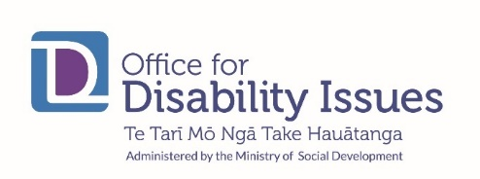
You can contact the Office for Disability Issues:
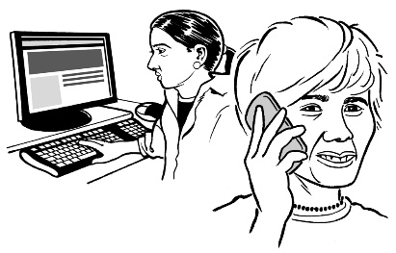
Phone: 04 916 3300

Email: odi@msd.govt.nz
This information has been written by The Office for Disability Issues.
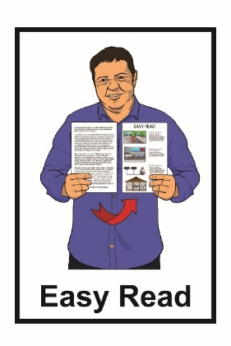
It has been translated into Easy Read by the Make it Easy service of People First New Zealand Inc. Ngā Tāngata Tuatahi.

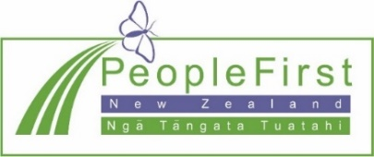
The ideas in this document are not the ideas of People First New Zealand Inc. Ngā Tāngata Tuatahi.
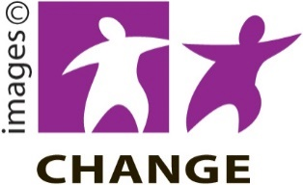
Make It Easy uses images from:

- Changepeople.org

- Photosymbols.com

- SGC Image Works

- Huriana Kopeke-Te Aho.

All images used in this Easy Read document are subject to copyright rules and cannot be used without permission.

