What the United Nations said about how things are for disabled people in New Zealand.

3 October 2014

What is in this report?

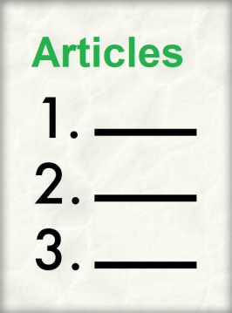
Page

Introduction 7

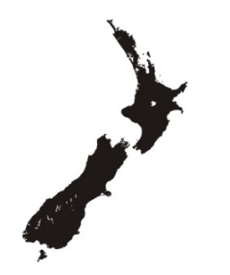
Good things that
are happening in NZ 10

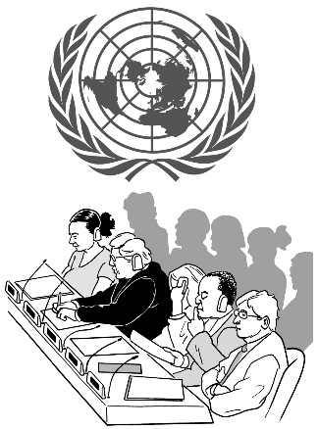
Things in NZ the UN
Committee is worried
about – articles 1-4 13-15

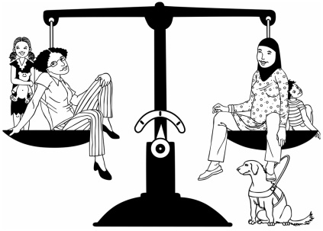
Article 5: Being equal 16

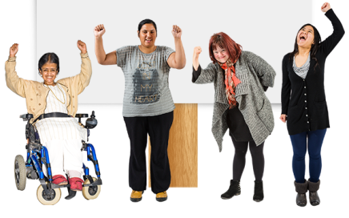
Article 6: Disabled women 19

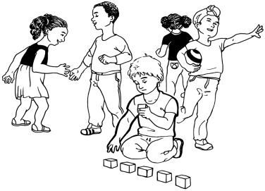
Article 7: Disabled children 20
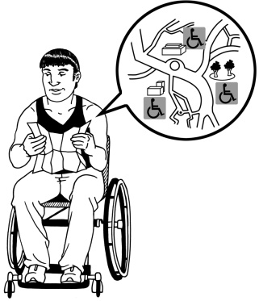

Article 9: Accessibility 21

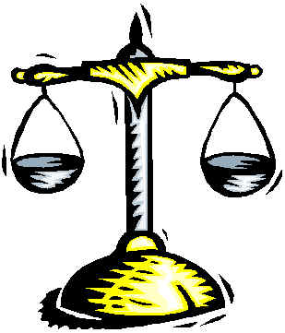
Article 12: Being treated
equally by the law 23

Article 13: Getting justice 25

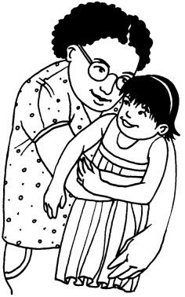
Article 14: Being free and
safe 29
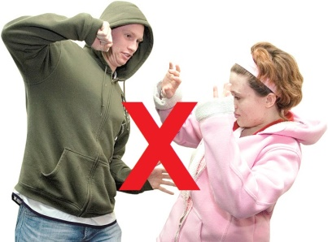
Article 16: Not being
used or abused 33

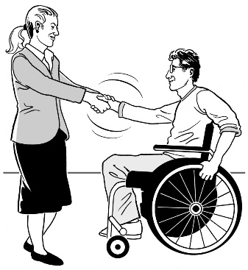
Article 17: Treating
disabled people as people
first 35

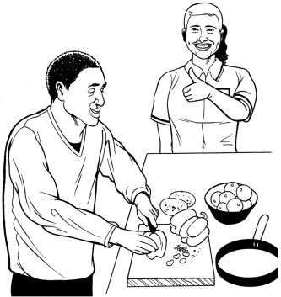
Article 19: Living
independently 38

Article 21: Saying what
you want and access to
information 40

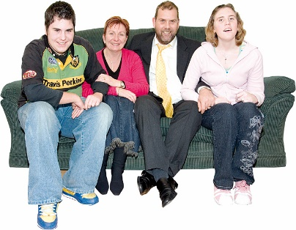
Article 23: Respect for
home and family 43
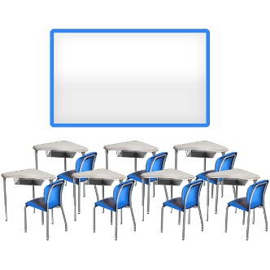

Article 24: Education 46
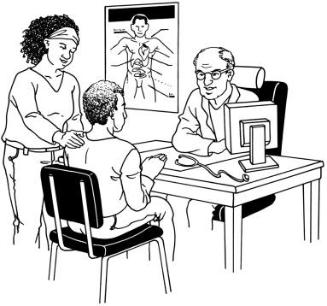

Article 25: Health 49

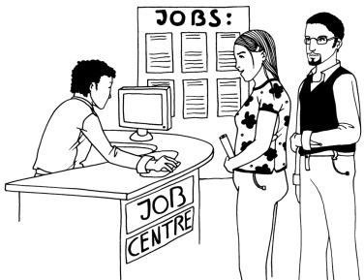
Article 27: Work 52

Article 28: Standards of
Living 54

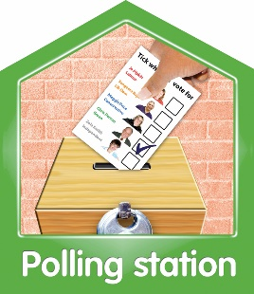
Article 29: Being involved
in politics 57

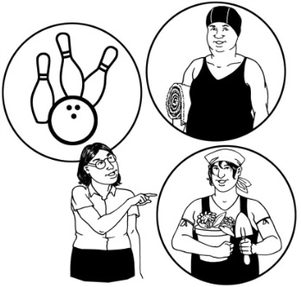
Article 30: Culture, sport
and leisure 58
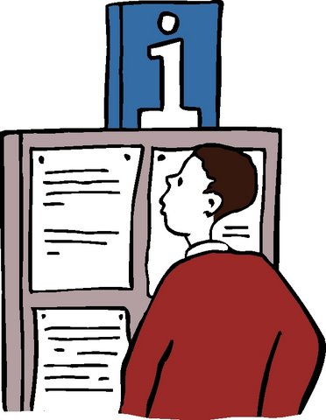

Article 31: Information 61

Article 32: Countries
working together 63

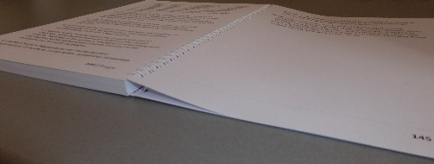
Final words 65

Introduction

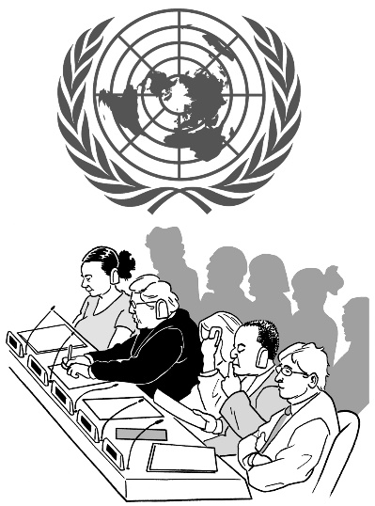
There is a United Nations (UN) Committee on the Rights of Persons with Disabilities.

The job of the Committee is to listen to reports from different countries about what things are like for disabled people in those countries.

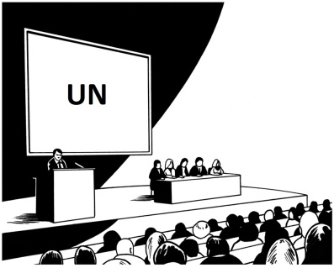
The UN Committee heard from the Government and Disabled Peoples Organisations of New Zealand on the 15th and 16th September 2014.

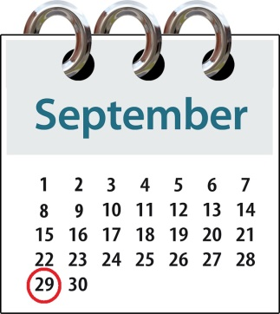
On the 29th September 2014 the Committee gave New Zealand this report.
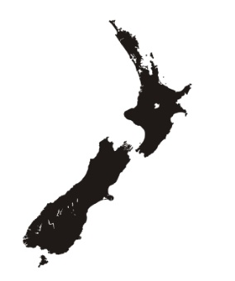
The Committee looked at New Zealand and checked what is being done here against the Convention on the Rights of Persons with Disabilities.

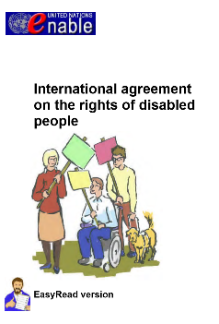
This convention is also known as the Disability Convention.

The Committee made comments about the work that is being done in New Zealand.

On some issues the Committee said New Zealand should be doing better.

On other issues they said that New Zealand is doing well.

The Disability Convention is made up of different parts – called articles.

Not all of the articles in the Disability Convention are talked about in this report.

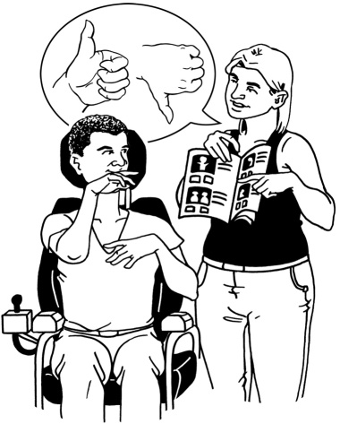
This report only talks about the parts of the Disability Convention that the Committee were:

- happy with

- worried about.

Good things that are happening
in New Zealand
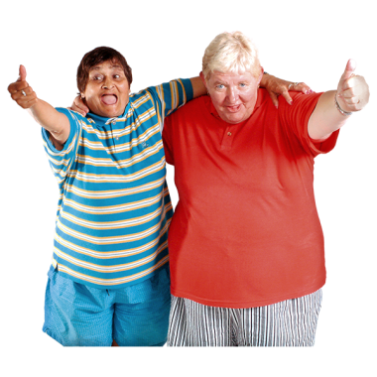

The Committee would like to say well done to New Zealand for these things:

- The Government gave a good report.

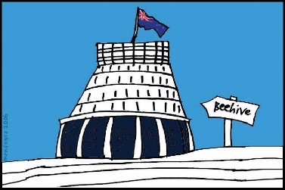
- The Government gave answers to all of the questions the Committee had for them.

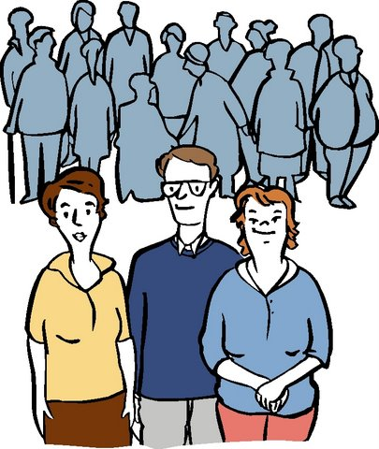
- The Government sent a good group of government workers to the United Nations to meet the Committee.

- It was very good that the New Zealand Disability Rights Commissioner came to the meeting too.

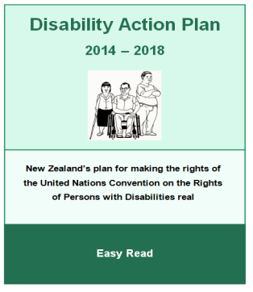
- For having the NZ Disability Strategy and the 2014-2018 Disability Action Plan.

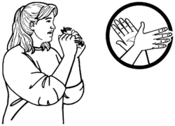
- There is now a New Zealand Sign Language Board.

- New Zealand Sign Language is an official language in New Zealand.
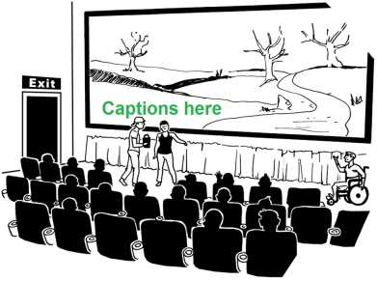

- TV and movie theatres now have more captions.

- Work has been done to make it easier for disabled people to do more study after finishing High School.
- Disabled people will be able to vote using phones in the 2014 national election.

- People with learning disability are able to vote in New Zealand elections.

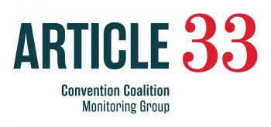
- The Government has set up independent groups to see if New Zealand is following the Disability Convention.

How to read the next part of this book

Only the articles the Committee talked about in their report are in this book.
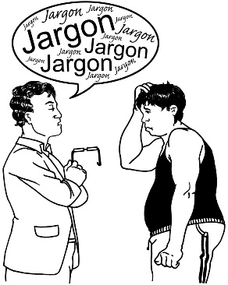

First, these articles will be explained.

Then this book will tell you:
- what the Committee thinks New Zealand should do about those articles

- what worries the Committee has about how we are going.
Things in New Zealand the UN Committee is worried about

Here is what the Committee thought about the first 4 articles in the Disability Convention:

Article 1: The reason why there is a Disability Convention.

Article 2: What the words in the Convention mean.

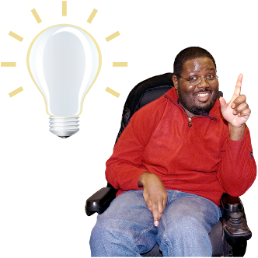
Article 3: The basic ideas that guide the Disability Convention.

Article 4: Things that countries who sign the Disability Convention agree to do.

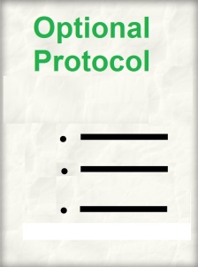
A worry:
- The New Zealand Government has not ratified the optional protocol of the Disability Convention.

Ratifying means to make something official by voting for or signing it.

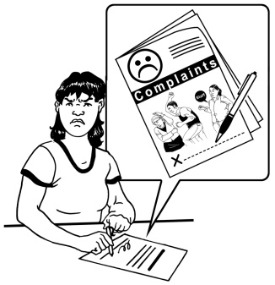
If New Zealand ratifies the optional protocol people will be able to complain to the Committee when they are not getting their rights.

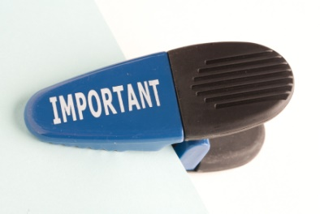
What the Committee thinks:
- The Government should ratify the optional protocol as soon as they can.

A worry:
- Bad words about disabled people come up when you use Google on the computer in New Zealand to look for information about Autism.

What the Committee thinks:
- The Government needs to talk to Google about making sure this does not happen.

Here is what the Committee thought about the rest of the articles in the Disability Convention:

Article 5: Being equal
Disabled people should be treated the same as people without disability.

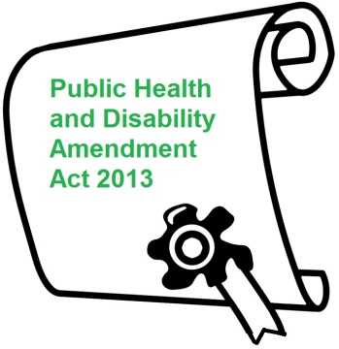
A worry:
- The Public Health and Disability Amendment Act 2013 means some family members who look after disabled people cannot get paid for their work.

What the Committee thinks:
- The Government should make sure all family members who are carers get paid for their work.

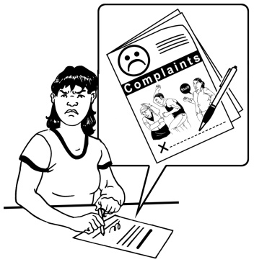
- Family members who are carers should be able to make a complaint if they are not paid for their work.

A worry:
- The New Zealand Human Rights Act 1993 does not say what reasonable accommodations are.

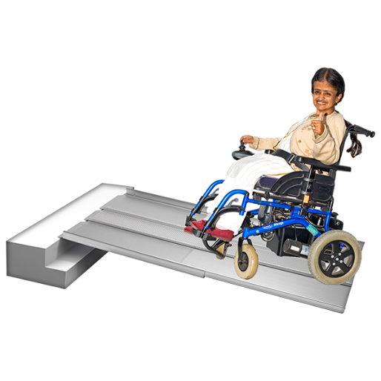
Reasonable accommodations means changing things so that disabled people are able to do the things they want to.

Like putting in a ramp at a workplace or paying for a support person.
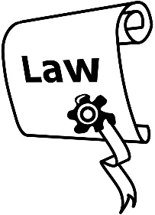
What the Committee thinks:
- The Government needs to change the NZ Human Rights Act 1993 so that it says what reasonable accommodations are.

A worry:
- Not many people understand what reasonable accommodations are in New Zealand.

What the Committee thinks:
- The Government needs to finish making information about reasonable accommodations.

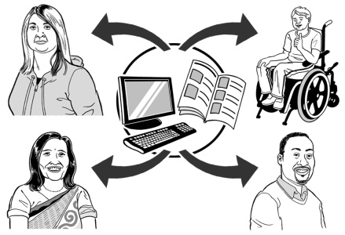
People need to be able to get this information.

Article 6: Women with disabilities

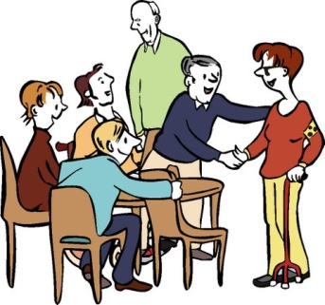
What the Committee thinks:
- The Committee thinks the Government must keep supporting work to help disabled women.

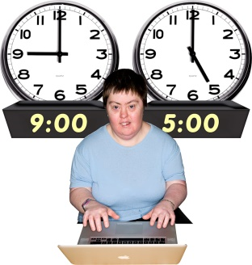
Work like this is important, especially projects about disabled women and:

- work

- education
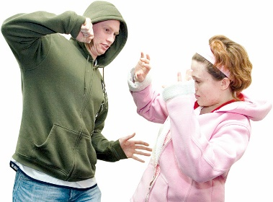
- abuse.

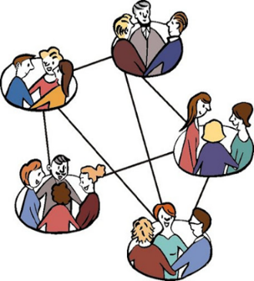
- Organisations that speak up for disabled women and children need to be part of these projects.
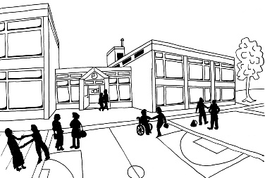
Article 7: Children with disabilities

Worries:
- It is hard for some disabled children to access government services like health or education.
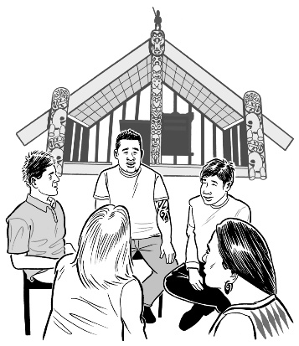

- It is very hard for some Māori children with disabilities to get services.

What the Committee thinks:
- There needs to be more work done through the new Disability Action Plan to make it easy for all disabled children to get the services they need.

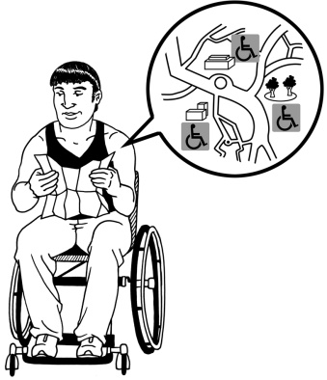
Article 9: Accessibility
Making things and places easy for disabled people to use.

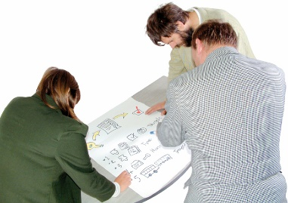
What the Committee thinks:
- The Committee knows that the Government has been looking at how easy buildings are for disabled people to use.

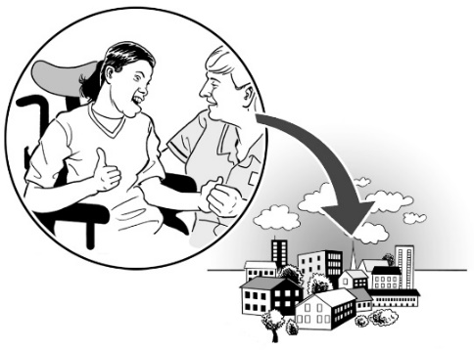
The Government needs to make sure that all:

- public buildings are easy to use

- new houses built are fully accessible

- webpages that provide services are easy to use.

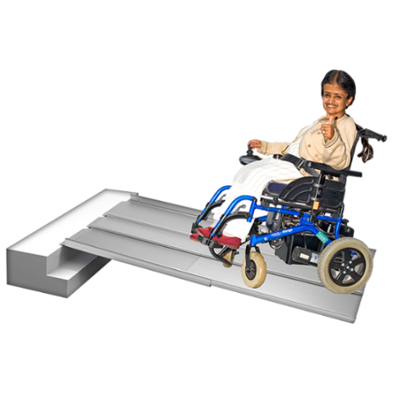
- There is a law in New Zealand that says that in workplaces where less than 10 people work the buildings do not have to be accessible.

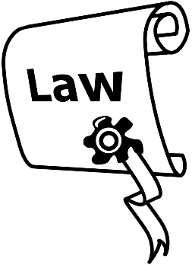
The Committee thinks the Government needs to change this.

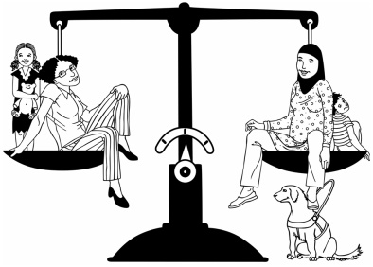
Article 12: Being treated equally by the law
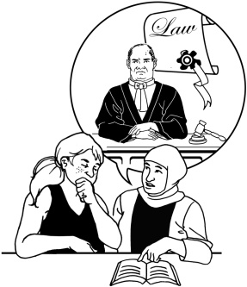
- Having the same legal rights as everyone else.

- Having support to use your legal rights.

What the Committee thinks:
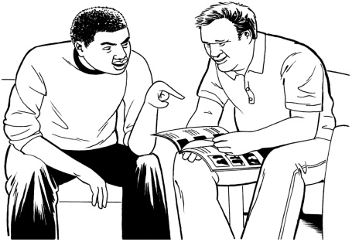
- The Committee knows that the Government has been looking at the different ways of using supported decision-making.

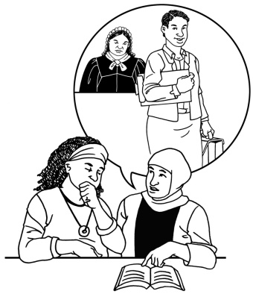
Supported decision-making is where people have support to make choices for themselves.

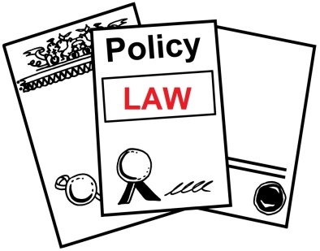
- The Committee thinks the Government should look at changing the laws in New Zealand straight away.

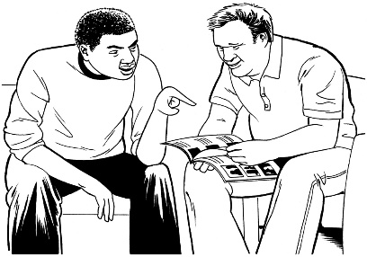
- The Committee thinks the Government needs to use supported decision-making instead of substituted decision-making.

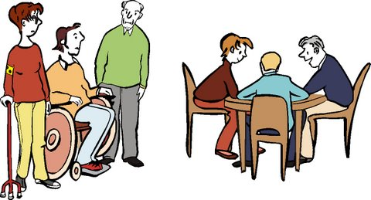
Substituted decision-making means someone else making choices for disabled people.

The legal system in New Zealand uses it a lot.

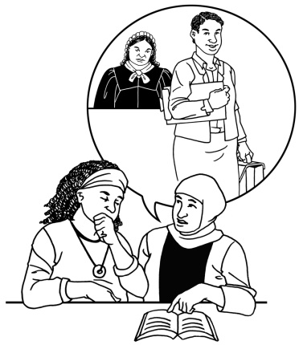
Article 13: Getting justice
Having access to the right support when going to court.

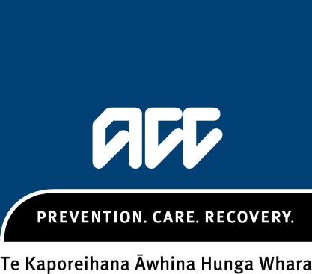
Worries:
- At the moment, people who get a disability after an accident are only able to get money from ACC – the Accident Compensation Corporation.
They cannot go to court to get more money if they got hurt at work for example.

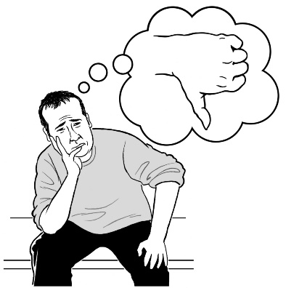
- People in New Zealand who get their disability after an accident do not think they are getting justice.

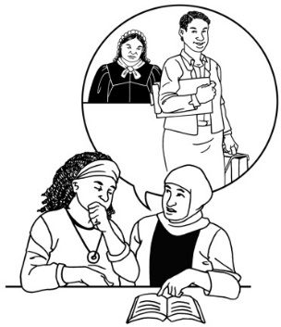
- There is not much legal aid to help people get justice.

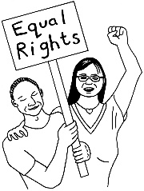
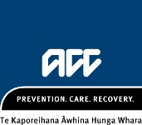
- ACC does not have a human rights focus.

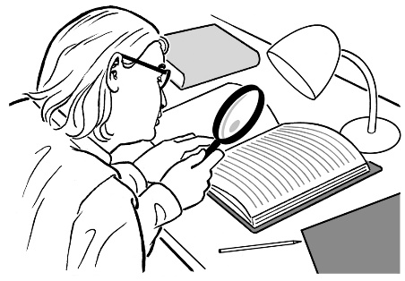
What the Committee thinks:
- The Government needs to look at ACC and make sure:

  - there is legal aid for people who need it

  - ACC is easy to access for all people

  - ACC has a human rights focus.

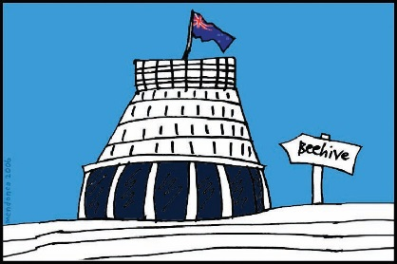
A worry:
- The Government is thinking about making changes so that ACC cases will not go through the District Court anymore.

Instead there will be a new Accident Compensation Tribunal – a court just for ACC cases.

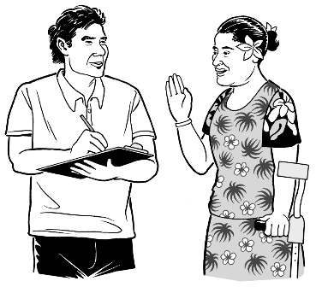
The Government has not done enough talking about this with disabled people who have got their disability by getting hurt and their organisations.

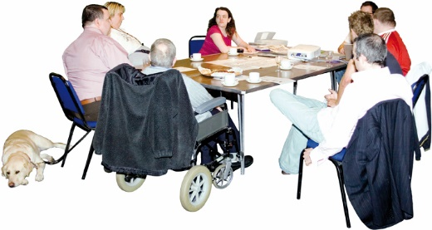
What the Committee thinks:
- The Government needs to talk to the organisations that work for people who are disabled by getting hurt about the new Tribunal.

A worry:
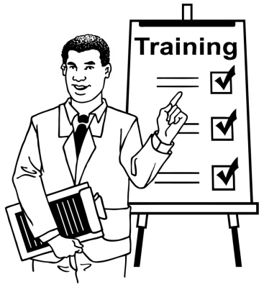
- There is no training for judges in New Zealand on:

  - the Disability Convention

  - making sure the justice system is accessible for all disabled people.

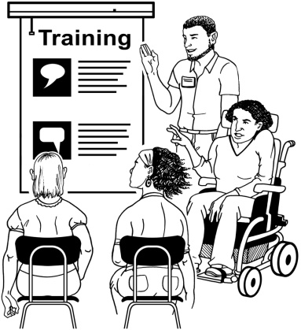
What the Committee thinks:
- The school where judges are trained must work together with Disabled Persons Organisations (DPOs) to train judges on these topics.

Article 14: Being free and safe
People with disabilities have the same rights to freedom and safety as others.

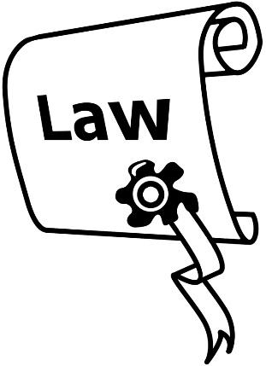
A worry:
- The Committee is worried that the ideas that guide the Mental Health Act 1992 are not based on human rights.

What the Committee thinks:
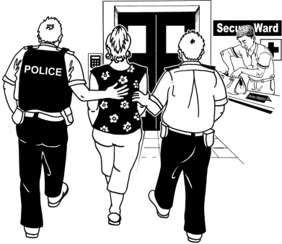
- The Government must make changes straight away to make sure disabled people are not locked up in hospitals because of their disability without their consent.
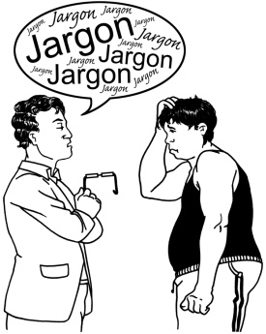

Consent means understanding and agreeing to something.
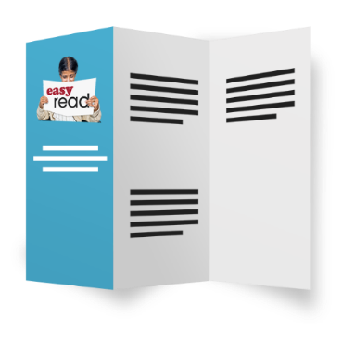
- The Government must make sure all mental health services:

  - give people good information
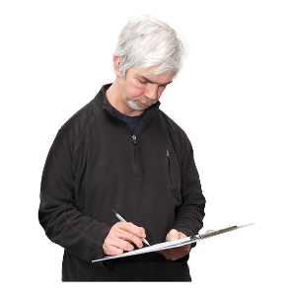
  - have the consent of the people they help

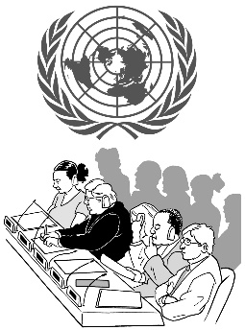
  - follow the Disability Convention.

- The Government must make sure the Mental Health Act 1992 follows the rights in the Disability Convention.

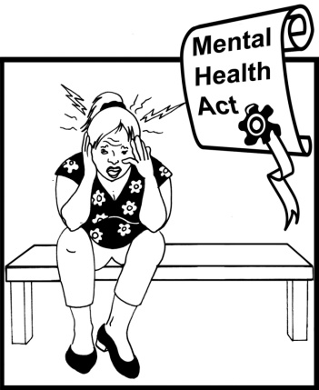
A worry:
- It is still legal in New Zealand mental health hospitals to:

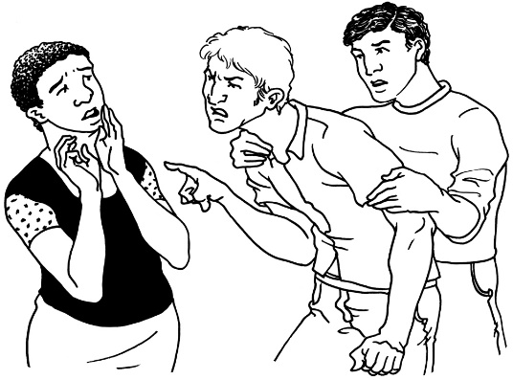
  - lock people in rooms by themselves

  - tie or hold people down.
What the Committee thinks:
- Doing this to people is not okay.

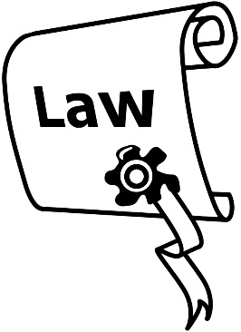
The Government must change the laws straight away so that these things do not happen anymore.

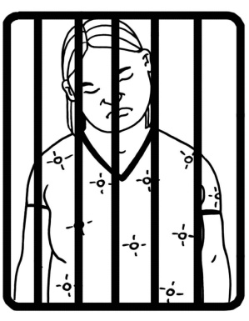
A worry:
- If a disabled person goes to court for doing something wrong the court can choose to lock them away, even if they have not been found guilty.

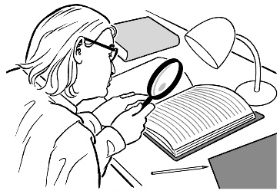
What the Committee thinks:
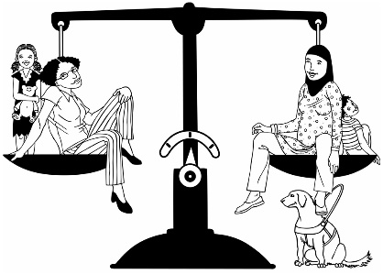
- The Government must look at the justice system and make sure that disabled people:

  - go through the same justice process as other people
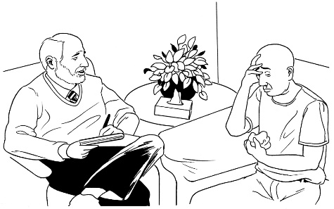
  - have the same chances to change their behaviour as other people who commit crimes

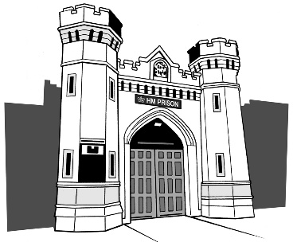
  - are only locked away if nothing else can be done to stop them breaking the law

  - that are in prison have somewhere safe to stay.

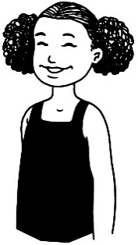
Article 16: Not being used or abused

A worry:
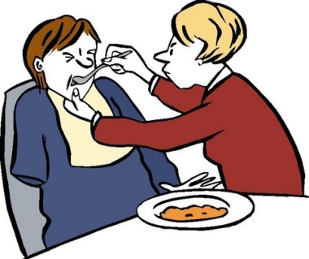
- The Committee is worried that the Domestic Violence Act 2013 might not:

  - keep disabled people in residential or supported living services safe
  - include abuse between disabled people and the people who live with them or support them.

What the Committee thinks:
- The Government must give more support to organisations and programs that work to keep disabled people safe from abuse.

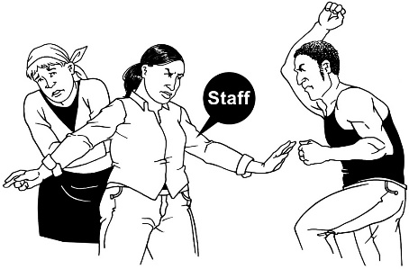
- There needs to be a good system to check for abuse and help people when it is happening.

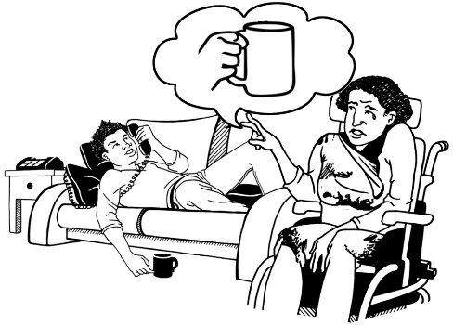
- The law need to be changed so that Domestic Abuse includes disabled people being abused by people they live with or people who support them.

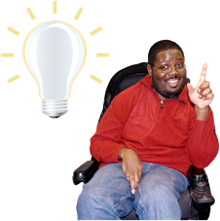
Article 17: Treating disabled people as people first
Disabled people’s minds and bodies:

- are their own
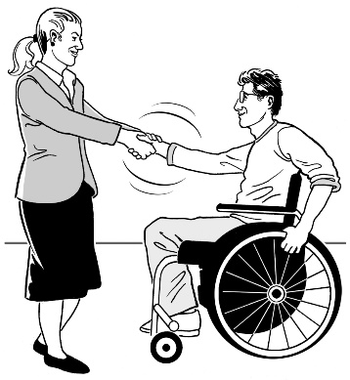
- must be respected the same as everyone else’s.

A worry:
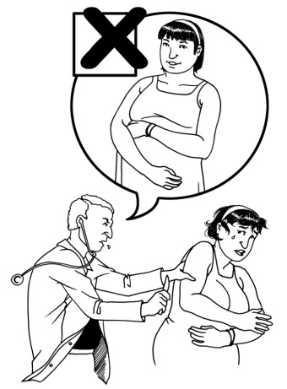
- In New Zealand parents of disabled people can make the choice to have them sterilised.

If a person is sterilised it means they have had an operation so that they cannot make a baby.

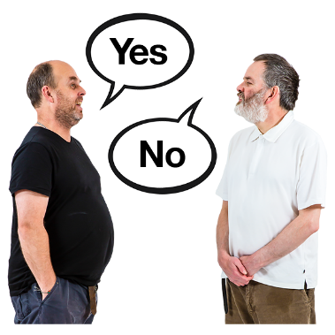
In New Zealand the disabled person does not always get to make this choice for themselves.

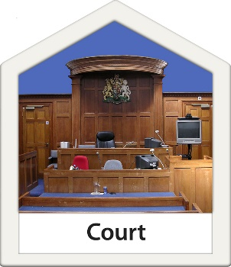
The courts can say a disabled person must have this surgery even if they do not want it.

What the Committee thinks:
- Doing this is not okay.

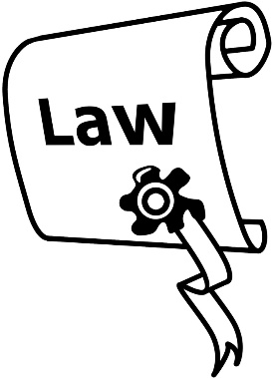
The Government needs to make a law to say no one with a disability can be sterilised without:

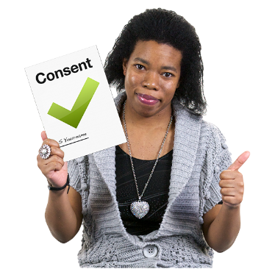
- being told what will happen and what it will mean for them in a way they can understand

- their freely-given consent.

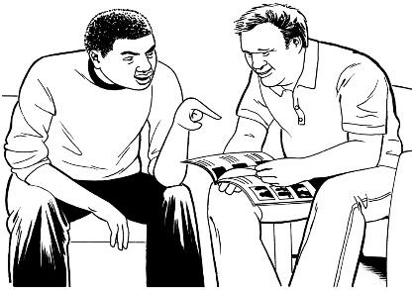
Freely-given consent means it is the disabled persons’ choice to be sterilised.

It should be against the law for people to put pressure on someone to have the surgery.

Article 19: Living independently and being part of the community

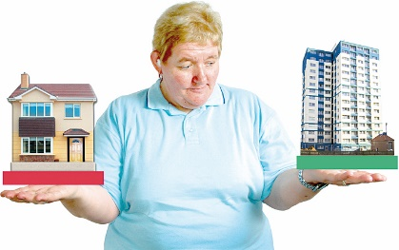
Worries:
- The Committee is worried that many disabled people do not get the choice or right support to live where they want to.

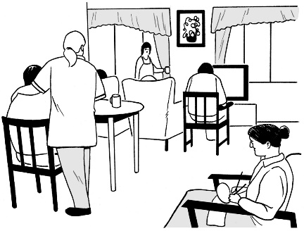
- Some young disabled people in New Zealand have to live in rest homes for old people.

What the Committee thinks:
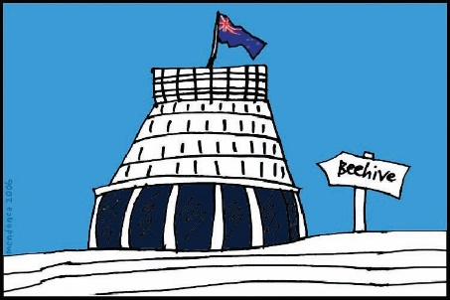
- The Committee knows the Government has been supporting the:

  - Independent Living model
  - Enabling Good Lives project.

These are both good ways to give disabled people more independence.

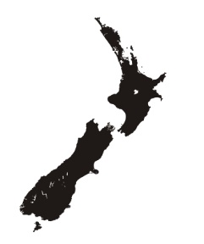
- More disabled people in New Zealand should be able to try:

  - Independent living
  - Enabling Good Lives.
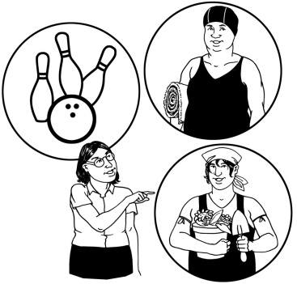

- Disabled people should have more choice and control over their own lives.

Article 21: Saying what you want and access to information
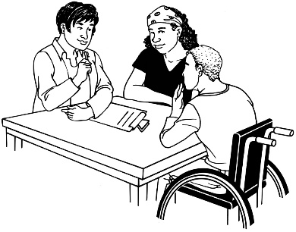
Disabled people have the right to:

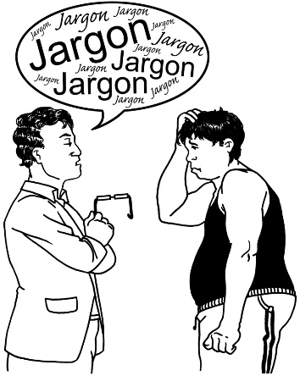
- say what they want and think

- get information they want in ways they can understand.

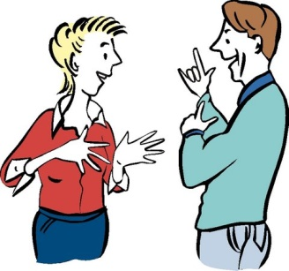
Worries:
- There are not enough Sign Language interpreters in New Zealand.
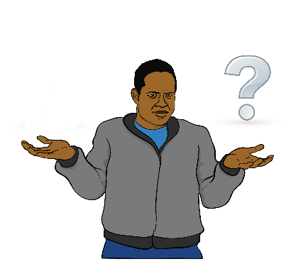

- Disabled Māori have a very hard time finding information in the Māori language.

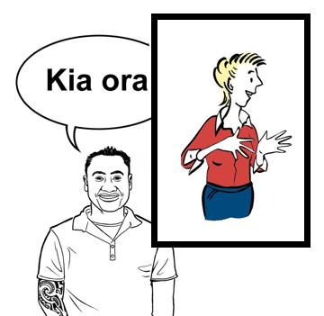
- There are hardly any Sign Language interpreters that understand Māori language and can translate it into Sign Language.

This makes it very hard for Deaf Māori to access any information that is available in the Maori language.

What the Committee thinks:
- The New Zealand Sign Language Board needs to make sure there is money to pay for training more Sign Language interpreters.
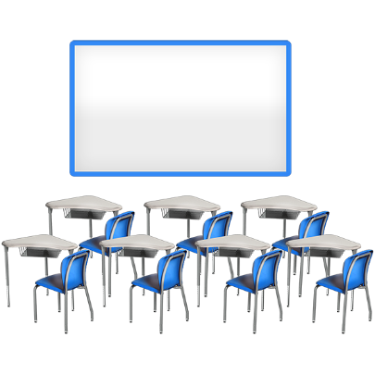

- New Zealand Sign Language needs to be used a lot more, especially in cultural and educational activities.

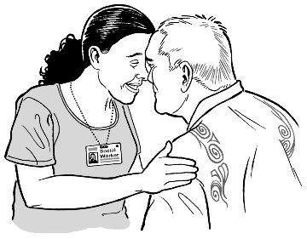
- Māori people who are Deaf or Deaf-blind must be able to access more information.

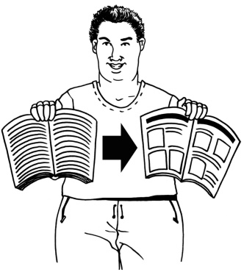
Information must be made in ways they can understand.

Article 23: Respect for home and family
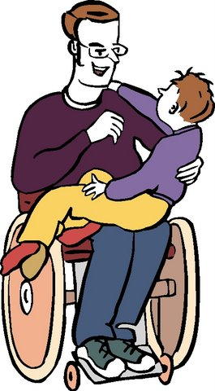
- Disabled people have the right to have personal relationships and have children.

- Countries must support disabled people who are parents.
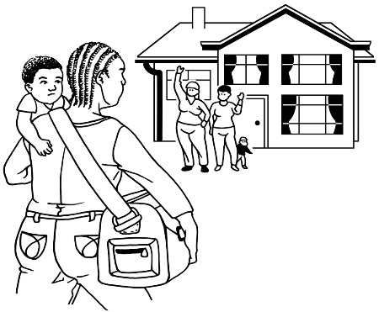
- Countries must look after disabled children if their families cannot do so.

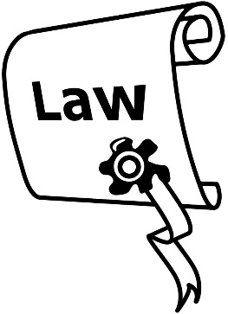
A worry:
- There are 3 sections of the Children, Young Persons and Their Families Act 1989 that the Committee is worried about.
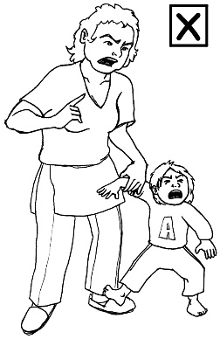
When disabled children cannot live with their families the Committee is worried that they are not kept safe the same way as other children.

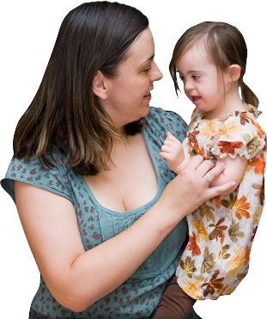
What the Committee thinks:
- When disabled children cannot live with their families they need to be safe.

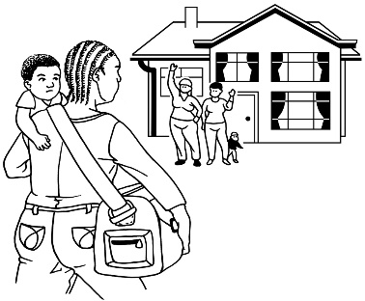
Disabled children away from home should be kept safe the same way other children are.

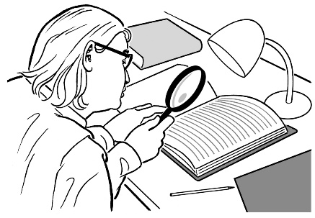
- Changes must be made to the:

  - Children, Young Persons and Their Families Act 1989

  - Vulnerable Children Act 2014.

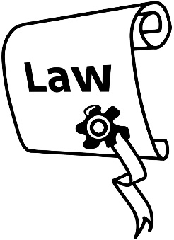
A worry:
- Section 8 of the Adoption Act 1955 means that disabled parents are treated differently because of their disability.
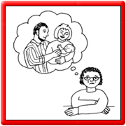

Courts can decide to take children away from disabled parents without the consent of the parents.

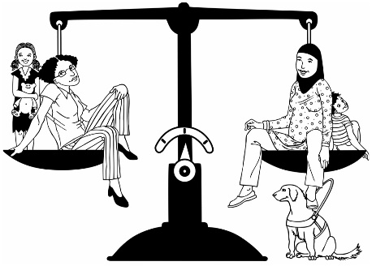
What the Committee thinks:
- Section 8 of the Adoption Act 1955 must be taken out or changed so that disabled parents are treated the same as other parents.

Article 24: Education

What the Committee thinks:
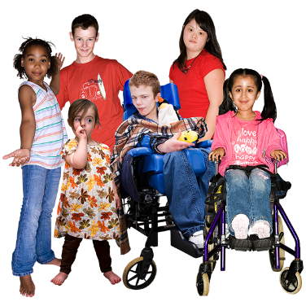
- The Committee knows that the Government has been trying to make sure primary schools and high schools are more inclusive for disabled students.

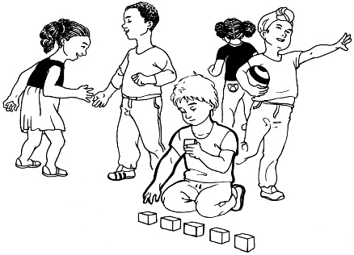
- It can be very hard to make all education inclusive.

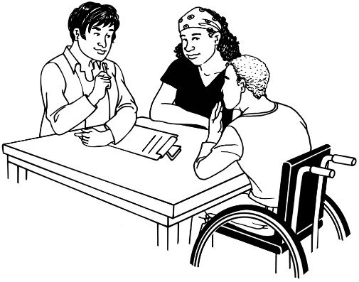
- More work needs to be done to make sure New Zealand primary schools and high schools:

  - know how to make changes to best support disabled students
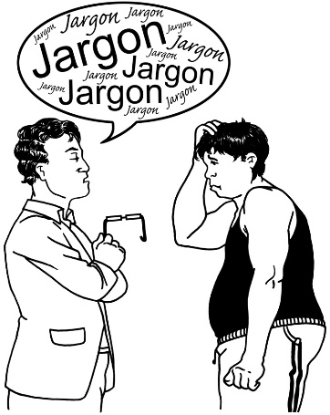
  - are willing to do some things differently for their disabled students.

- More work needs to be done so that more disabled people go on to study at:

  - Universities

  - Polytechnics.

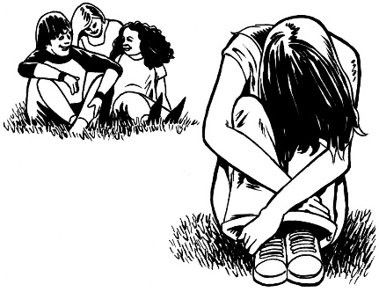
A worry:
- Disabled children are still being bullied at school.

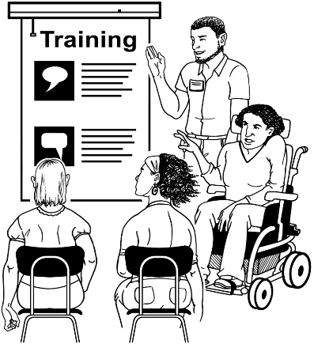
What the Committee thinks:
- The Government should run anti-bullying programmes in schools.

A worry:
- Schools in New Zealand cannot be forced to include disabled students.

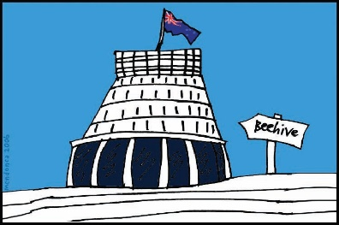
What the Committee thinks:
- The Government should be able to make schools include students with disabilities.

Article 25: Health

A worry:
- Disabled people, still have problems getting good advice and care about their:

  - health

  - sexual health.
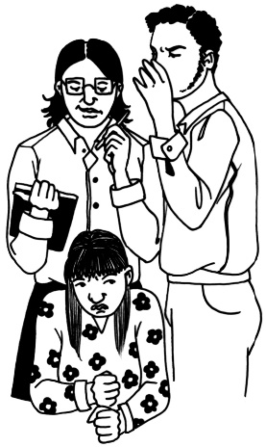

- People with learning disability have an even harder time getting this advice and care.

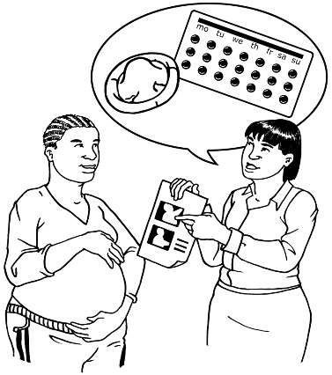
What the Committee thinks:
- More must be done to make sure all disabled people get good healthcare.

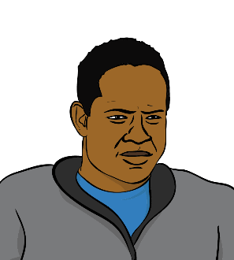
Worries:
- Disabled Māori have the worst health in New Zealand.

- More Māori people have disabilities than other groups in New Zealand.

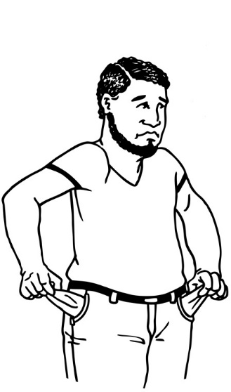
One of the reasons for this is because more Māori live in poverty.

Living in poverty means:

- not having enough money
- living with:

  - poor housing
  - poor food

  - few chances to make things better for yourself, like study or work.

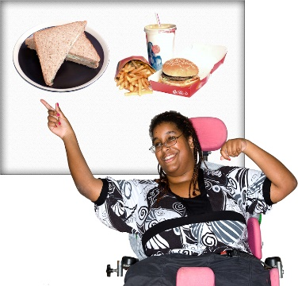
What the Committee thinks:
- More work must be done to make sure disabled Māori and Pasifika people in New Zealand have better health.

Article 27: Work

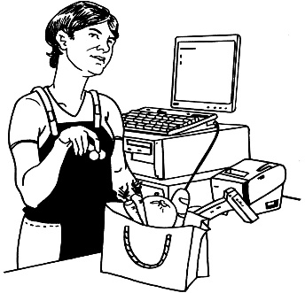
A worry:
- Many disabled people in New Zealand still do not have paid work.

This is even worse for Māori and Pasifika disabled people.

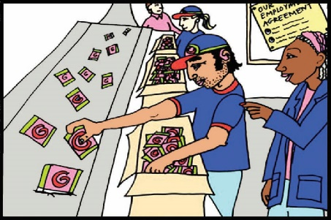
What the Committee thinks:
- More work needs to be done on getting disabled people into jobs.

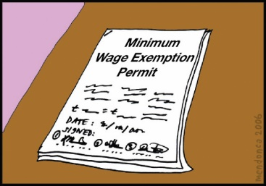
A worry:
- There are still around 1200 disabled workers in New Zealand on Minimum Wage Exemption Permits.

Minimum wage is the lowest amount you are allowed to pay someone for their work.

A Minimum Wage Exemption Permit makes it okay to pay someone less than minimum wage.

Disabled workers are the only people in New Zealand that can be paid less than the minimum wage.

What the Committee thinks:
- The Government should look at other ways to support disabled people having jobs, not the Minimum Wage Exemption Permit.

Article 28: Standards of living
Disabled people have the right to good enough:

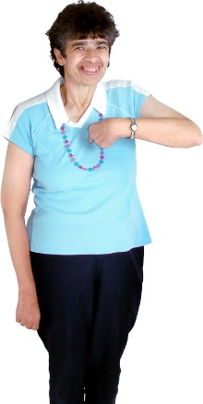
- housing

- food and water

- clothing.
Worries:
- Disabled adults and children are more likely to have a poor standard of living than other people in New Zealand.
This might mean:

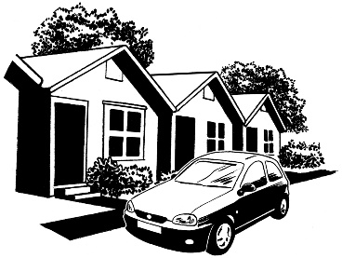
  - having less money
  - not having good housing
  - not having good food

  - not having good health.

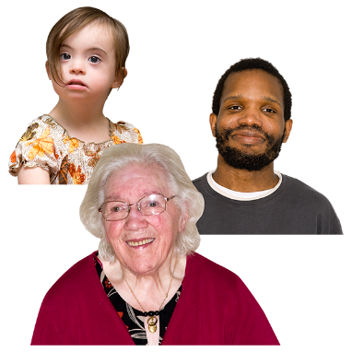
- The government benefit that a disabled person can get depends on how they got their disability.

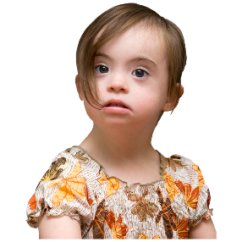
For example:
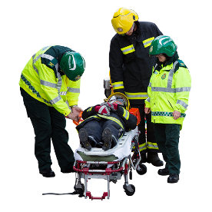
Someone that is born with a disability might get a different kind of benefit from someone who got a disability in an accident.
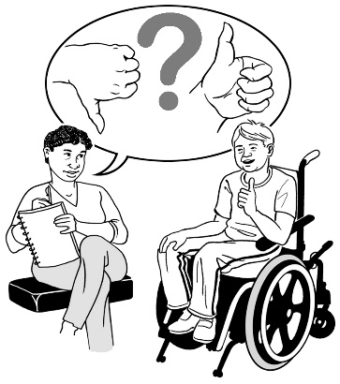

This means that how you got your disability can affect your standard of living.

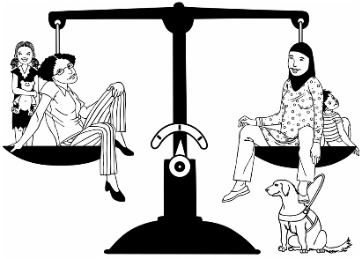
What the Committee thinks:
- The Committee thinks this is not fair.
- The Government should look at how it pays for what disabled people need for their disability.

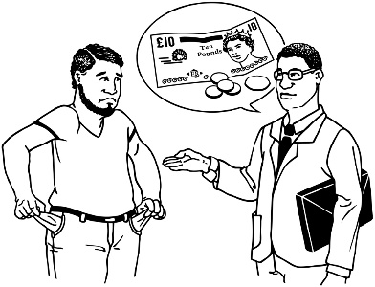
- Disabled adults and disabled children and their families should have:

  - enough money to live

  - a good enough standard of living.

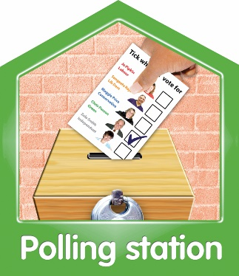
Article 29: Being involved in politics

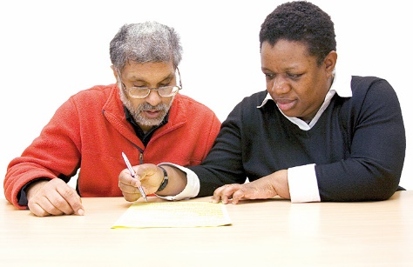
What the Committee thinks:
- The Committee knows that people who have a disability to do with their sight can have help from an official when they are voting in elections.

- The Government should make it possible for disabled people to vote in secret using computers that are easy for them to use.

Article 30: Culture, sport and leisure
Disabled people have as much right to take part in their culture or things they enjoy doing as anyone else.
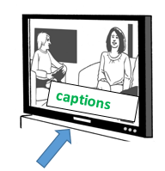
Worries:
- Very few TV programs in New Zealand have captioning – writing that you can see on the TV which tells Deaf and hard of hearing people what is being said.
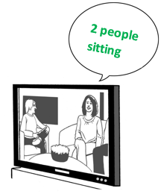

- Very little TV in New Zealand has audio describing –a voice on the TV that tells blind people what is being shown.

What the Committee thinks:
- The Government needs to make sure there is more:
- captioning

- audio describing.

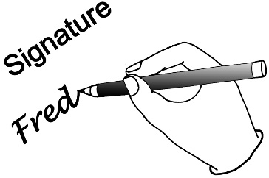
A worry:
- The Government has still not ratified the Marrakesh Treaty.

Ratify means to make something official by signing or voting for it.

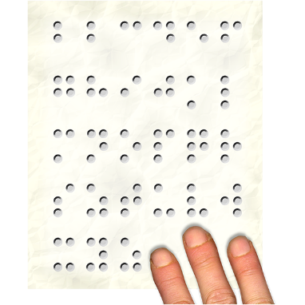
The Marrakesh Treaty is a set of rules that say that books can be copied so that they are made accessible for disabled people.

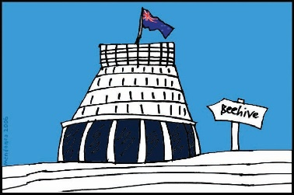
What the Committee thinks:
- The Government should get ready to ratify the Marrakesh Treaty.

Article 31: Information
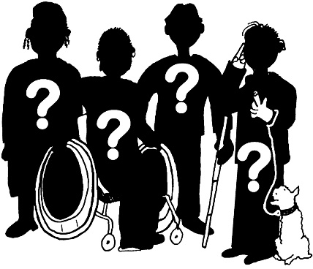
- Countries should collect the information they need to make the Disability Convention happen.

- Disabled people must be able to access information about them.

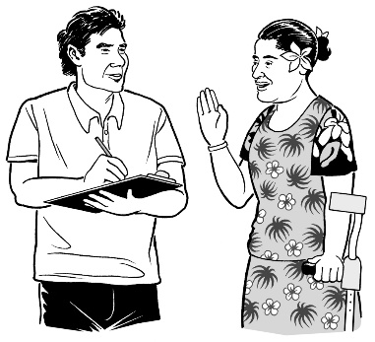
What the Committee thinks:
- It is good that the Government did a Disability Survey in 2013.

- Statistics New Zealand should make a report looking at the human rights of disabled people and the human rights of the rest of the country.
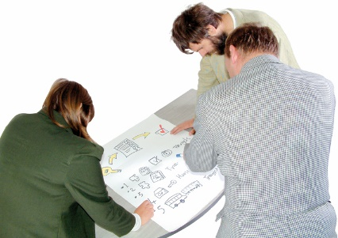
A worry:
- The Committee is worried that no government departments or councils are collecting information on disabled people.

What the Committee thinks:
- Government departments and councils should collect information about disabled people.

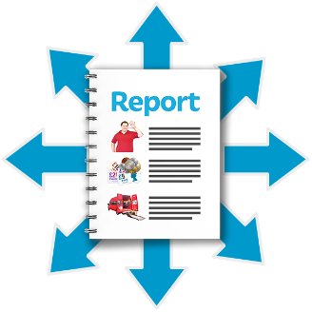
They should put this information in the reports they make every year.

Article 32: Countries must work together to make the Disability Convention happen.

A worry:
- The New Zealand Government is not giving any money to the Pacific Disability Forum now.

The Committee is worried that this will make things harder for disabled people in the Pacific.

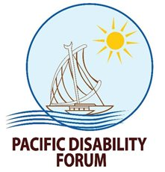
What the Committee thinks:
- The Government should start to give money to the Pacific Disability Forum again.

- When the New Zealand Government gives money to help people in other countries it is called Foreign Aid.

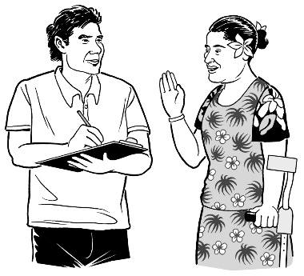
When the Government is choosing who they should give foreign aid to, they should look for projects that help disabled people too.

Final Words

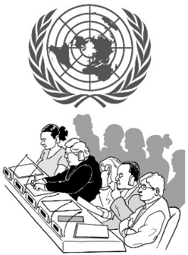
What the Committee thinks the Government should do now:

- Make the changes the Committee has put forward in this report.
- Share this report with the people in New Zealand on a Government website.

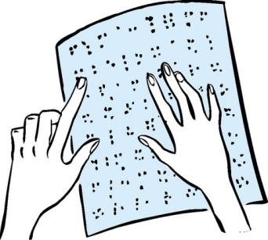
- Make sure this report is easy for all disabled people to read, using:

  - Braille
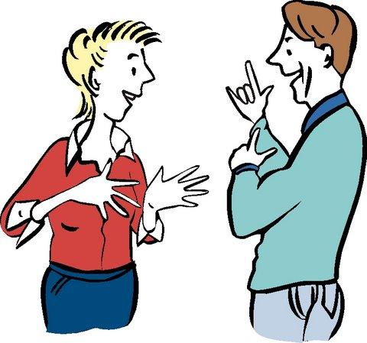
  - Sign language

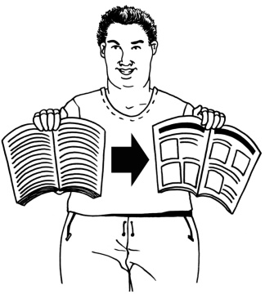
  - Easy Read.

- Talk to Disabled Persons Organisations, disabled people and their families when the Government is writing their next report.
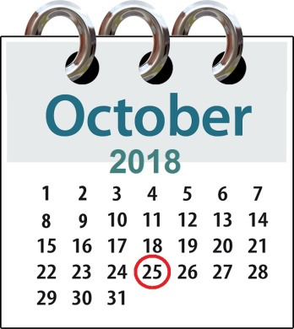
- The next 2 reports must be given to the UN no later than 25 October 2018.

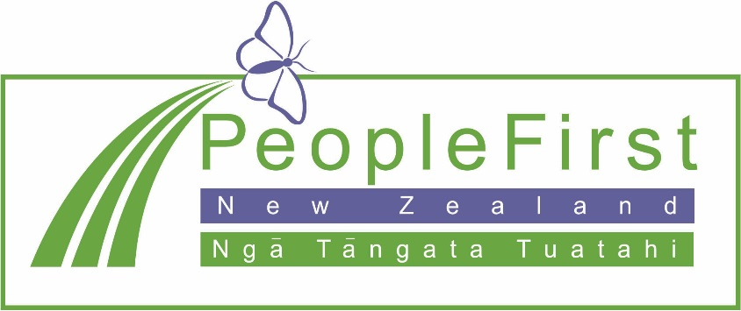

This information has been translated into Easy Read
by People First New Zealand Inc.

