New Zealand Sign Language Board |  | 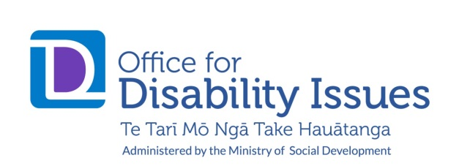

Nominations should be submitted using this form, the Cabinet Committee Curriculum Vitae CAB 50/01 form, and the NZSL Board declaration form in writing, sent to the Office for Disability Issues.
- Nominations should be received by 4pm Friday 23 April, 2021.
- The Office for Disability Issues will acknowledge receipt of nominations.
- Nominees will be informed about the Minister’s decisions.

Nomination form
Nominated by:
(name, and name of nominating organisation if applicable )
Nominee has been notifed of, and agrees to, nomination |  |  | Yes/No
Person being nominated
Name:
Email / phone:
Address:

Role the nomination is for:  (Put an x in the appropriate box) | Member |  |  | Chair
Deaf or hearing?
Fluent in New Zealand Sign Language?
Ethnicity identified with?

Contact details of two people who can act as a referee:
Contact One
Name:

Their relationship to nominee:

Contact details (telephone and email):

Contact Two
Name:

Their relationship to nominee:

Contact details (telephone and email):

Send the completed nomination forms:

- by post, or email as a Word document, to:
Kellye Bensley
Office for Disability Issues
Ministry of Social Development
Aurora Centre, P O Box 1556, Wellington
Email: nz_sign_language@msd.govt.nz

