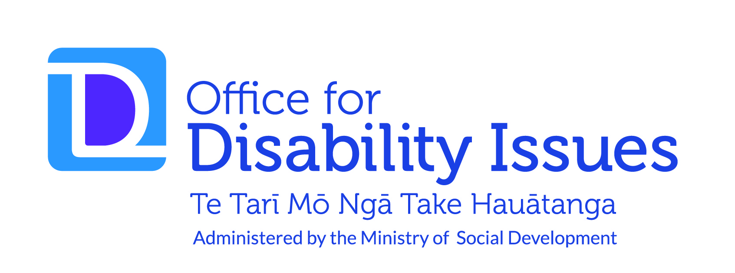
New Zealand Disability Strategy 2016–2026

Published November 2016
Ministry of Social Development
PO Box 1556 Wellington 6140 New Zealand
Telephone: +64 4 916 3300 Facsimile: +64 4 918 0099
Email: odi@msd.govt.nz Web: www.odi.govt.nz
Contents
New Zealand Disability Strategy 2016–2026 1
Foreword – Minister for Disability Issues 4
Executive Summary 6
Our journey – an introduction 9
Our vision – where to from here 11
Who we are – our community 12
Principles and approaches 16
Our outcomes – priorities for change 22
Outcome 1: education 24
Outcome 2: employment and economic security 26
Outcome 3: health and wellbeing 28
Outcome 4: rights protection and justice 30
Outcome 5: accessibility 32
Outcome 6: attitudes 34
Outcome 7: choice and control 36
Outcome 8: leadership 38
Making it work 40
Getting it going – who is involved 48
Glossary 49
Appendix 1 – The Reference Group 51

Foreword – Minister for Disability Issues
We have come a long way since the first New Zealand Disability Strategy was agreed in 2001. The aim of the strategy was to eliminate barriers to enable disabled people to reach their potential and participate fully in the community.
The progress that we have made in partnership with disabled people is something that we can all be proud of.
Our journey since 2001 has seen the development of initiatives that will oversee the transformation of the disability support system, an increased focus on supporting disabled people into employment, improvements in inclusive education opportunities for disabled children, and New Zealand Sign Language becoming one of our official languages.
There is much to celebrate.
Together, this work has helped New Zealand take a lead role in the negotiation on the United Nations Convention on the Rights of Persons with Disabilities.
Since ratifying the Convention in 2008, we have established a unique mechanism for independent monitoring, actively considered and responded to recommendations from the Committee on the Rights of Persons with Disabilities, and supported Robert Martin in his successful candidacy for the Committee.
We have reaffirmed our lead role internationally on the rights of disabled people.
The development of the New Zealand Disability Strategy 2016–2026 has given us an opportunity to reflect not just on our progress, but also what we are still learning as a country about disability and how we can keep improving the lives of disabled people.
We must continue to acknowledge and respect the diversity within the disability community and recognise the value it adds to the community.
People can experience disability in different ways depending upon age, gender, ethnicity, impairment and many other factors.
For example, during the consultation to develop this Strategy, disabled adults shared the importance of having a meaningful job and being able to support their families. Disabled children talked about wanting to fit in at school and get out and about with their friends.
Despite what we have learnt and the progress that has been made since 2001, many disabled children and adults still face some barriers that prevent them from reaching their full potential.
If these barriers are not dismantled and removed, then all of us miss out. We will not prosper if disabled people are not able to participate in and contribute to our communities on an equal basis with others.
The United Nations Convention on the Rights of Persons with Disabilities has reinforced that disabled people have the same rights as others. It is about making sure everyone is treated with dignity and respect at all times, and that no one is left behind.
Our government is committed to continuing to improve the lives of disabled people and the New Zealand Disability Strategy will guide the government to achieve this over the next 10 years.
The direction and priorities outlined in the Strategy are based on what disabled people have said is most important to them.
During the two-stage consultation process, more than 1130 people attended the workshops we held throughout the country. We also received around 770 submissions from individuals and organisations via our ‘Join the Conversation’ website.
It is this strong foundation that gives us confidence in this Strategy guiding the work of government agencies for the next 10 years. After all, disabled people are experts in their own lives.
The Strategy will be critical in ensuring we are all working together towards achieving the same vision. There is much to be done and it is vital that we have a consistent framework from which to make decisions on where to focus our efforts.
We would like to acknowledge and thank members of the New Zealand Disability Strategy Reference Group. Their expertise and advice proved invaluable in shaping this Strategy into something we are very proud of.
We want to thank the disabled people who participated in and supported the consultation to develop the New Zealand Disability Strategy.
You shared your hopes and dreams through this process with honesty and integrity. Your experience matters and your voices have been heard; it has become the foundation upon which this new Strategy has been built.
Finally, thank you to all the families, whānau and others who were involved in this process, particularly when disabled children or adults were not able to speak up for themselves.
We all have roles and responsibilities for achieving the vision of a non-disabling society. The Government will lead by example and we encourage others to join us too.
Hon Nicky Wagner
Minister for Disability Issues

Executive Summary

The New Zealand Disability Strategy (the Strategy) will guide the work of government agencies on disability issues from 2016 to 2026.

The vision of this Strategy is:
New Zealand is a non-disabling society – a place where disabled people have an equal opportunity to achieve their goals and aspirations, and all of New Zealand works together to make this happen.

Three sets of principles and two approaches will help implement the Strategy
The principles and approaches will help make sure the disabled community is visible, acknowledged and respected on an equal basis with others, and that disabled people can live a life with dignity and feel valued.
The three principles are: Te Tiriti o Waitangi, the Convention on the Rights of Persons with Disabilities, and ensuring disabled people are involved in decision-making that impacts them. The two approaches are: Investing in our whole lives – a long-term approach, and Specific and mainstream services – a twin-track approach.

The Strategy identifies eight outcome areas
The outcome areas that will contribute to achieving the vision of the Strategy are:
Outcome 1 – education
We get an excellent education and achieve our potential throughout our lives
Outcome 2 – employment and economic security
We have security in our economic situation and can achieve our full potential
Outcome 3 – health and wellbeing
We have the highest attainable standards of health and wellbeing
Outcome 4 – rights protection and justice
Our rights are protected, we feel safe, understood and are treated fairly and equitably by the justice system
Outcome 5 – accessibility
We access all places, services and information with ease and dignity
Outcome 6 – attitudes
We are treated with dignity and respect
Outcome 7 – choice and control
We have choice and control over our lives
Outcome 8 – leadership
We have great opportunities to demonstrate our leadership.

Targets will be developed, measures will be in place, and actions will be undertaken to implement the Strategy
An Outcomes Framework will be developed in 2017 which will set targets and measures for the Strategy. Annual reporting against the Outcomes Framework will be published on the Office for Disability Issues website. The Disability Action Plan will be the primary vehicle for implementing the Strategy. Figure 1 on the following page outlines the Strategy’s framework.

Figure 1 | Disability Strategy Framework
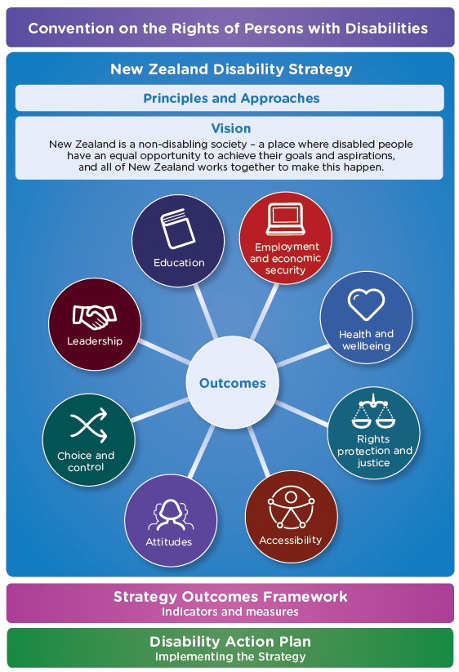n and justice

Our journey – an introduction
He aha te mea nui o te ao?
He tangata! He tangata! He tangata!
What is the most important thing in the world?
It is people! It is people! It is people!

The New Zealand Disability Strategy
– A map to guide our way
The New Zealand Disability Strategy (the Strategy) will guide the work of government agencies on disability issues from 2016 to 2026.
It can also be used by any individual or organisation who wants to learn more about, and make the best decisions on, things that are important to disabled people.
The Strategy realises the rights of disabled people and supports implementation of the United Nations Convention on the Rights of Persons with Disabilities (the Convention) in New Zealand.

The way we look at disability in New Zealand
has changed
Since the first New Zealand Disability Strategy was developed in 2001 there has been real progress in the lives of many disabled people and their families and whānau. A significant milestone was the development of the Convention, which New Zealand ratified in 2008.
Disabled children are growing up wanting the same things as non-disabled children and the expectations of disabled adults have changed and grown. There is also a growing recognition that disabled people are experts in their own lives, and ensuring their right to be involved in the decisions that impact on them will lead to better outcomes.

There is still more work to be done
Even though there has been progress since 2001, this revised Strategy is needed because disabled people remain worse off than non-disabled people across all social and economic outcomes. This persistent gap has a flow-on effect. When disabled people are not able to participate in society, the entire country misses out on their contribution.

Written from the perspective of disabled people
The development of this Strategy was supported by the New Zealand Disability Strategy Revision Reference Group, of whom the majority of members identify as disabled people. It is also based on what disabled people said was most important to them during public consultation in 2016.
In order to remain true to the vision and priorities of the people at the centre of this Strategy, the Who we are, Principles and Approaches and Outcomes sections have been written from the perspective of disabled people.
Some words and terms can be understood by different people in different ways. Wherever possible, an explanation of how a word or term has been used in this Strategy has been included. A Glossary is available on page 49.
NEW ZEALAND DISABILITY STRATEGY 2016–2026

Our vision – where to from here
New Zealand is a non-disabling society – a place where disabled people have an equal opportunity to achieve their goals and aspirations, and all of New Zealand works together to make this happen.
The Strategy’s Vision

A note on terms:
Non-disabling is about removing the barriers in society that disable people with impairments. We consider this to be stronger and more meaningful than ‘enabling’, which will only help disabled people get around barriers rather than remove them completely.

Who we are – our community
We are children, young people and adults, we are parents and grandparents. We are also friends, family and whānau. What we want is no different to anyone else in New Zealand; we want to belong, contribute to our families and whānau and participate in our communities.
We are 1.1 million New Zealanders and we represent almost a quarter (24 percent) of New Zealand’s population.

What disability means to us
Disability is something that happens when people with impairments face barriers in society; it is society that disables us, not our impairments, this is the thing all disabled people have in common. It is something that happens when the world we live in has been designed by people who assume that everyone is the same. That is why a non-disabling society is core to the vision of this Strategy.
Every human being is a unique individual. Even if we have the same impairment as someone else, we will experience different opportunities and barriers because of where we live and how we are treated by those around us. The time and context in our lives when we may acquire our impairment(s) also informs what barriers or opportunities we may experience.
This is the social model of disability and it is how we understood disability in the first Strategy in 2001. It still holds true today. It is also the same understanding of disability that is embodied in the Convention. The Convention says that disabled people include:
“…those who have long-term physical, mental, intellectual or sensory impairments which in interaction with various barriers may hinder their full and effective participation in society on an equal basis with others…” (Article 1).

The language about disability is really important
There are many words and terms that are used to identify disability. The way these are understood differs and this was apparent during consultation to support the development of this Strategy. For some of us, the term ‘disabled people’ is a source of pride, identity and recognition that disabling barriers exist within society and not with us as individuals.
For others, the term ‘people with disability’ has the same meaning and is important to those who want to be recognised as a person before their disability.
This Strategy uses the term ‘disabled people’. This is based on advice from the New Zealand Disability Strategy Revision Reference Group and in recognition of the history of the term in the 2001 Strategy. In future, it is possible that our community reaches a consensus on a different way to describe us. If this happens, the language in this Strategy can be changed to reflect this.
Not all members of our community identify with disability-focused language. For example, older people and their families and whānau sometimes think that disability is a normal part of the ageing process. People with invisible impairments such as mental health issues can sometimes identify as part of the mental health community, and not the disability community. Deaf people identify as part of the Deaf community with its own unique language and culture, and do not always identify as being disabled. Most Māori disabled people identify as Māori first. The importance of their cultural identity, which encompasses language, whānau, cultural principles, practices and linkages to the land through genealogy, is paramount to how they live their day to day lives in both Te Ao Māori and Te Ao Pakeha.
It is also important to recognise that Te Reo Māori and New Zealand Sign Language are both official languages of New Zealand. Their place in our society needs to be acknowledged, respected and supported in the implementation of this Strategy.
We know that non-disabled people are sometimes not sure which words or terms to use in order to be respectful. Our advice is to listen to how we refer to ourselves and use the same language. If you are still not sure, then just ask us what language we prefer.

We are part of diversity and we are diverse ourselves
Disabled people are part of the vast and diverse human experience. Just as we accept and respect differences like gender, ethnicity, language or belief, the difference and diversity of disabled people need to be understood, acknowledged and celebrated.
Just like other communities, the disability community has different groups of people who experience life in different ways. We think it is important to acknowledge the diversity of our community, both because we are proud of it and also because we want to make sure that no one is left behind. The Strategy is for all of us.
The points below describe some of the rich diversity within our community:
- Māori are the tangata whenua of New Zealand and as the indigenous people they have a special relationship with the Crown. This relationship is recorded in the founding document of Aotearoa New Zealand, Te Tiriti o Waitangi.
- Addressing the inequality that Māori disabled people face is important; 26 percent of Māori identified as disabled in 2013. When adjusted for age, the Māori disability rate is 32 percent. A Māori world view needs to be woven into the implementation of this Strategy. This includes the cultural importance of whānau and a whānau-centred approach which differs from Western concepts of family and disability.
- New Zealand Sign Language (NZSL) is an official language of New Zealand used by some 20,000 New Zealanders, approximately 4,000 of whom are Deaf people who use NZSL as their first or preferred language.
- The demography of our country is changing, and we are increasingly becoming a multicultural society. This is important to the disability community, as people from different ethnic and cultural backgrounds can sometimes understand and experience disability in different ways to others.
- Pacific peoples make up a growing proportion of our country and of the disability community (19 percent of Pacific people identified as disabled in 2013), as do people from Asian backgrounds (13 percent in 2013). Twenty-eight percent of people from Middle Eastern, Latin American and African backgrounds identified as disabled in 2013. Over the coming decades, we will see more cultural and ethnic diversity in the disability community.
- New Zealand has an ageing population which will result over time in an increasing proportion of people experiencing disability. In 2013, 59 percent of people over the age of 65 identified as disabled. Disabled people are also living longer, and there will be an increasing number of people with age-related impairments. This is a global trend and one that is drawing greater attention to disability. Meeting the needs and challenges of our ageing population is a significant issue now, and will continue to be over coming decades.
- Gender norming plays out in the disability community, just like it does in society more generally. Disabled women and girls face different barriers to disabled men and boys.
- Disability and sexuality is also important for our community. Some of our members do not identify as part of the gender binary (male or female) or have a predominant sexual orientation. There can also be an incorrect perception that disabled people do not have sexual needs or desires.
- The international catch-cry of disabled people is ‘nothing about us, without us’. For our disability community in New Zealand, this also includes those of us who find it hard to, or are not able to, speak for ourselves. We are amongst the most vulnerable and marginalised members of our disability community. While there may be different terms used for our group, such as people with ‘intensive support’, or ‘special’ needs, the thing we have in common is that we often rely on other people to support us to make decisions and to communicate.

Our community will change
This is just a snapshot of the rich diversity of the disability community. Because disability is about the way other people treat us, it is a dynamic concept that will continue to evolve as our society changes over time.
Future economic growth of the country has the potential to be constrained by skill and labour shortages. The low employment rates of disabled people represent a significant loss of potential contribution to New Zealand’s economy.

Disability impacts on many non-disabled people too
Our families, whānau, friends, carers and supporters are an important part of our community. In this way, disability is something that impacts on people without impairments. The disabling society we experience affects them too.

Principles and approaches

Figure 2 | Principles and approaches
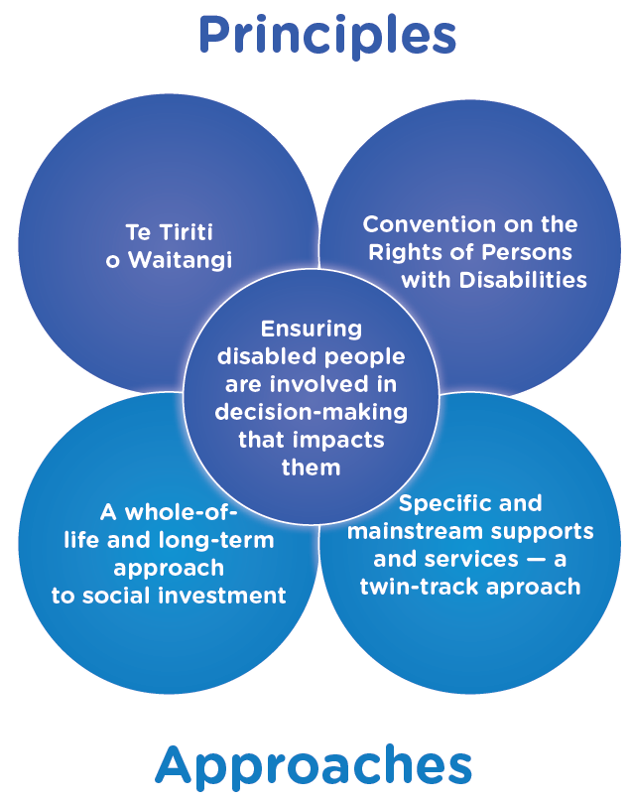

The principles and approaches that will be used to implement the Strategy are outlined in this section; they are the ‘how’ to complement the outcomes (which are the ‘what’).
The principles and approaches will help make sure all of our community is visible, acknowledged and respected on an equal basis with others, and that we can live a life with dignity and feel valued.
This section has three sets of principles:
- Principles of Te Tiriti o Waitangi
- Principles of the Convention on the Rights of Persons with Disabilities
- Ensuring disabled people are involved in decision-making that impacts them.
It also has two approaches:
- Investing in our whole lives – a long-term approach
- Specific and mainstream services – a twin-track approach.
Figure 2 on the previous page illustrates the connection between the principles and approaches.

Principles
The principles of both Te Tiriti o Waitangi and the Convention will be reflected in the way this Strategy is implemented; they are for everyone and apply to Māori and non-Māori, disabled people and non-disabled people. The principles are a framework for building a positive relationship between disabled people and the Government.

Principles of Te Tiriti o Waitangi
The Strategy will be guided by the principles of Te Tiriti o Waitangi as the founding document of our country.
The principles of the Treaty are:
- Partnership: Māori and the Crown have a relationship of good faith, mutual respect and understanding, and shared decision-making.
- Participation: the Crown and Māori will work together to ensure Māori (including whānau, hapū, iwi and communities) participate at all levels of decision-making. This includes the right to seek opportunities for self-determination and self-management.
- Protection: the Crown actively contributes to improving the wellbeing of Māori, including support for independent living and the protection of Māori property and identity, in accordance with Māori values. Māori have the same rights and privileges as other citizens.

Principles of the Convention on the Rights of Persons with Disabilities
The principles of the Convention are:
- Respect for inherent dignity, individual autonomy including the freedom to make one’s own choices, and independence of persons
- Non-discrimination
- Full and effective participation and inclusion in society
- Respect for difference and acceptance of disabled people as part of human diversity and humanity
- Equality of opportunity
- Accessibility
- Equality between men and women
- Respect for the evolving capacities of disabled children and respect for the right of disabled children to preserve their identities.

3. Ensuring disabled people are involved in decision-making that impacts them
We are experts in our own lives and making sure we are involved in decision-making on issues that impact us leads to better quality results. The Convention also has a specific obligation on this (Article 4.3):
“In the development and implementation of legislation and policies to implement the present Convention, and in other decision-making processes concerning issues relating to persons with disabilities, States Parties shall closely consult with and actively involve persons with disabilities, including children with disabilities, through their representative organisations”.

Approaches

1. A whole-of-life and long-term approach to social investment
It is important that both whole-of-life and long-term approaches are considered when social investment decisions are being made by the Government on things that impact on us. This will help ensure that we are more independent, are able to participate as much as we choose to, and that we are able to contribute to our communities and reach our potential.
Such an approach will help ensure that:
- the silos between different supports and services are removed to provide a coordinated approach to enable us to achieve our potential
- we receive the right supports and services throughout our lives. Early and proactive support, particularly after an impairment has been diagnosed or it changes, will help set us up for a better future
- the contribution we make to our families, whānau and communities is recognised across a broad range of areas including economic, community and social participation
- our families, whānau and carers are also able to access the right supports and services in order to help us reach our potential.
Making sure there is the right evidence at the right time to inform investment decisions is critical. All too often we have been invisible because disability has not been counted, recognised or understood, and therefore our needs have not been considered.
Evidence is both quantitative (data) and qualitative (lived experience, or stories, directly from us and those who care for us). We know that both are equally important and need to be valued alike to ensure there is a good understanding of the problem (before deciding on solutions); what interventions work best for us; and to be able to measure results against the outcomes we are seeking.

2. Specific and mainstream supports and services – a twin-track approach
A twin-track approach is about making sure mainstream services and supports are inclusive of, and accessible to, us and that services and supports that are specific to us as disabled people are also available. This approach is not about having to choose between the specific or mainstream option; rather it is about having the right access to the right high quality support or service, at the right time and in the right place.
Some of us do not need any specialised supports or services, whereas some of us do so that we can access mainstream opportunities. Our needs for either or both can change over time too.
Ensuring that mainstream services and supports are inclusive of us requires the provision of reasonable accommodation and incorporation of universal design.
- Reasonable accommodation is defined in the Convention as:
- “…necessary and appropriate modification and adjustments not imposing a disproportionate or undue burden, where needed in a particular case, to ensure to persons with disabilities the enjoyment or exercise on an equal basis with others of all human rights and fundamental freedoms” (Article 2).
- Reasonable accommodation can often cost very little or nothing at all. Because it is specific to a situation, what it looks like in practice can vary significantly.
- Universal design is good design that works for everyone.
- It is about making sure everything is accessible to, understood by and used to the greatest extent possible by everyone, without adaptation or requiring little adaptation. Incorporating universal design early on is cost-effective.
- Universal design is often referred to in relation to the built environment, but it applies to services, supports, the curriculum and technologies as well.
- Universal design is distinct from accessible design. Accessible design represents the minimum accessibility requirements in built design, whereas universal design seeks accessible design outcomes that work for everyone.

A note on terms:
Mainstream refers to services or supports that are not designed to be specific to or only for disabled people. It includes things that are open for everyone to use or participate in (such as public transport) and also things that may still be targeted towards a particular group (such as maternal health services).

Our outcomes – priorities for change

Figure 3 | Interconnections of outcomes
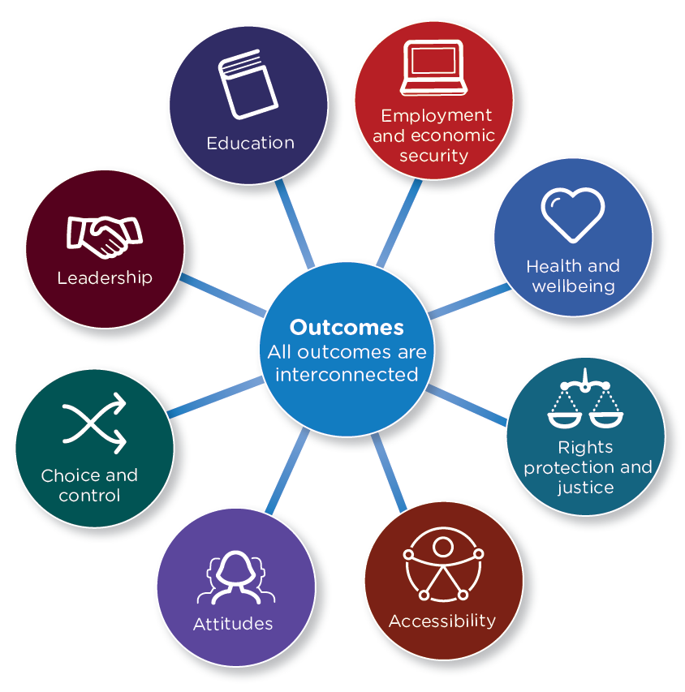

The eight outcomes that will contribute towards achieving the vision of the Strategy are outlined in this section.
Each outcome has two parts to it:
- A description of what our future looks like – this is an aspirational description of what things should look like for disabled people in the future. This will help make sure that everyone has the same understanding about what the future should look like and that all actions are consistent with this.
- What this means – this describes at a high level what needs to happen to achieve the aspirational description. It also gives direction to what needs to happen in implementation.
- For each outcome, the first bullet point states that disabled people are consulted on and actively involved in the development and implementation of legislation and policies concerning the outcome area.
- This language is taken directly from the Convention.
Specific actions to implement the outcomes will be determined through the Disability Action Plan. You can read more about this in the Making it work section from page 40.
All outcomes are interconnected and should not be read in isolation. For example, achieving the employment outcome is dependent upon the education outcome. The outcome on attitudes is also relevant to all other outcomes. Figure 3 on the previous page shows this interconnection.

Outcome 1: education
We get an excellent education and achieve our potential throughout our lives

What our future looks like
Our learning pathway supports us to develop friendships and social skills, as well as resilience, determination and confidence. It gives us a sense of belonging, builds our identity and language skills and prepares us for life beyond compulsory education.
All local schools and education services (including early childhood, primary secondary, tertiary, kohanga reo and kura kaupapa Māori) are welcoming and provide a great inclusive education for us. We have trained teachers and educators who support and believe in our progress and achievement, and value our contribution to the learning environment.
Education is provided in a way that supports our personal, academic and social development, both in and out of the formal schooling system. This includes making sure that those of us who use different languages (in particular New Zealand Sign Language), and other modes or means of communication, have ready access to them to achieve and progress. Information will be made available at the right time to those who support us, both when we are young or for those of us who need on-going support. This will help us succeed – whatever our individual education pathway may look like.
We are treated with respect and dignity by those around us in the education system, including our peers and those who teach and support us. The love and expertise of our families and whānau and their wish to see us succeed in education will be honoured without question.
As we move on to tertiary and life-long learning, the transition periods are smooth, with the right information and supports available at the right time – particularly when our needs or situations change.

What this means:
- Disabled people are consulted on and actively involved in the development and implementation of legislation and policies concerning education, including early childhood, primary, secondary and tertiary education.
- Access to mainstream education is inclusive (including policy, practice and pedagogy).
- Services that are specific to disabled people are high quality, available and accessible.
- Inclusive education is a core competency for all teachers and educators.
- Decision-making on issues regarding education of disabled people is informed by robust data and evidence.

Outcome 2: employment and economic security
We have security in our economic situation and can achieve our potential

What our future looks like
We take pride in the meaningful paid and voluntary work we do, knowing that we are contributing to our families and whānau, communities and the country as a whole.
We are proportionately represented at all levels of employment, we are self-employed, we own businesses, and we are employers, managers and employees. Career progression is an important part of our working life.
Employers are confident and willing to employ us in meaningful jobs that utilise our strengths and make the best use of what we have to offer. They also have access to on-going support, guidance and tools to help support them in their role as a fair and equitable employer. When we apply for jobs, we do not face any barriers in the application process.
We are treated with respect and dignity by our non-disabled peers and we feel that the work we do is meaningful, valued and real.
Those of us who need specialised supports and services have ready access to them to secure and sustain employment. Reasonable accommodation is understood and provided by our employers. We will have the same opportunities to progress our careers as our non-disabled peers. The additional costs of disability are met, so that we are able to enjoy the same standard of living as other workers.
We have an adequate standard of living that enables us to fully participate in society, where necessary through the provision of income support which takes into account the additional cost of disability. This applies to everyone, including those of us who are not able to work, are retired, are unable to work full-time, or work full-time yet are still unable to afford and maintain an adequate standard of living.

What this means:
- Disabled people are consulted on and actively involved in the development and implementation of legislation and policies concerning employment and income support.
- Access to mainstream employment and income support services is barrier-free and inclusive.
- Services that are specific to disabled people are high quality, available and accessible.
- All frontline workers, including case managers and employers, treat disabled people with dignity and respect.
- Decision-making on issues regarding employment and income support of disabled people is informed by robust data and evidence.

Outcome 3: health and wellbeing
We have the highest attainable standards of health and wellbeing

What our future looks like
Healthcare professionals treat us with dignity and respect. We are seen as individuals and receive appropriate and timely support for all of our health needs, not just those related to our impairment. We do not face barriers accessing mainstream health services because of our impairments, in particular sexual and reproductive health services for disabled women and girls. When we need to, we can access services specific to our impairment (including habilitation, rehabilitation and recovery) in a way that provides early diagnosis and ensures our needs as individuals are taken into consideration.
We have choice and control over all the supports and services we receive, and information about these services is available in formats that are accessible to us. We also have access to information about us. Those of us who need support to communicate or make decisions receive it in an appropriate way at the right time, and those decisions are recognised and respected. We are not secluded within services, and not segregated from or isolated within our communities.
Issues of bio-ethics and bodily integrity are treated with sensitivity, with due regard for our rights and informed consent. This includes making sure our families, whānau and those who support us have the right access to the right information when they are involved in supporting us to make decisions. In the rare circumstances when decisions need to be made on our behalf, these are based on the best interpretation of our will and preference, as opposed to just thinking about what is in our best interests.
Access to high quality peer support enables us to recover from periods of being unwell, and flourish with the confidence that we are not alone.
Our identity as members of other communities, such as Māori or Pacific, will be respected and we will have access to services that are culturally appropriate.
The importance of belonging to and participating in our community to reduce social isolation, and increase our overall wellbeing, is recognised and supported. We get involved in sport, recreation and arts activities, and are recognised and valued for this. Those of us who identify as members of other communities do not face barriers participating in and contributing to cultural activities because of our impairments. We are supported to be healthy and well, and can participate in community activities on an equal basis with others.

What this means:
- Disabled people are consulted on and actively involved in the development and implementation of legislation and policies concerning health and wellbeing, including sport, recreation, arts and culture.
- Access to mainstream health services is barrier-free and inclusive.
- Services that are specific to disabled people, including mental health and aged care services, are high quality, available and accessible.
- All health and well-being professionals treat disabled people with dignity and respect.
- Participation in community activities if we choose (for example, sport, recreation, arts and culture), or just being present and belonging to our community is supported and valued.
- Decision-making on issues regarding the health and well-being of disabled people is informed by robust data and evidence.

Outcome 4: rights protection and justice
Our rights are protected; we feel safe, understood and are treated fairly and equitably by the justice system

What our future looks like
We will continue to be treated with fairness and respect at all stages of our journey through the justice system, regardless of whether we are victims, perpetrators, witnesses, or fulfilling a civic duty such as jury service.
Those of us who need services or supports specific to our impairment will receive them, wherever possible, the first time we interact with the justice system. We will continue to receive these supports in a way that does not require us to keep telling our story or risk missing out on something we need, unless our needs change. The people we interact with have a good understanding of any impact our impairment may have on our journey, and take this into account as appropriate.
Those of us who need support to communicate or make decisions receive it in an appropriate way at the right time, and those decisions are recognised and respected. We will continue to be recognised as a person before the law. We feel secure exercising our rights as there are appropriate safeguards in place, even if we need support to make decisions and understand what’s happening.
For those of us who end up in the youth or adult justice system, the transition out of it is accompanied by rehabilitation services that recognise and understand our impairment, and help us to find a positive place in society.
If we feel unsafe, vulnerable to or affected by violence and abuse, we will continue to have access to support that recognises our needs and responds effectively and with sensitivity. We also feel confident in speaking up or complaining if we have been discriminated against or hurt, because we are listened to and our concerns are addressed.
Our needs and rights continue to be taken into account in any prevention and response initiatives. This includes making sure there continue to be safeguards in place for those of us who may be at risk of violence and abuse (for example, caring relationships, community awareness).

What this means:
- Disabled people are consulted on and actively involved in the development and implementation of legislation and policies concerning justice, violence and abuse prevention and human rights.
- The justice sector is barrier-free and inclusive of disabled people with supports and services specific to a person’s impairment provided readily when required.
- All justice sector professionals treat disabled people with dignity and respect.
- Supported decision-making will increasingly be recognised and disabled people can use it in practice.
- Decision-making on issues regarding justice, violence and abuse prevention and human rights is informed by robust data and evidence.

Outcome 5: accessibility
We access all places, services and information with ease and dignity

What our future looks like
We have access to warm, safe and affordable housing that meets our needs and enables us to make choices about where we go to school or work and to fully participate as members of our families, whānau and communities.
We can get from one place to another easily and safely, for example from home to school, work or to a friend’s house. We can also access all public buildings, spaces and facilities with dignity and on an equal basis with others.
We feel safe taking public transport to get around and are treated well when we do so. Our needs are also appropriately considered when planning for new transport services. Private transport services are responsive to and inclusive of us. For those of us who need it, there is access to specific transport options that are affordable, readily available and easy to use.
Information and communications are easy for us to access in formats and languages that are right for us, including in our country’s official languages of Te Reo Māori and New Zealand Sign Language. This helps us to be independent because we do not have to rely on other people. We use technology on the same basis as everyone else; those of us who need specific technology solutions will have access to these in a way that is innovative, progressive and helps to eliminate barriers. The evolving opportunities presented by new technology helps us to achieve our goals.
Our accessible communities are free of barriers (for example, access to shops, banks, entertainment, churches, parks, and so on), which enables us to participate and contribute on an equal basis with non-disabled people.

What this means:
- Disabled people are consulted on and actively involved in the development and implementation of legislation and policies concerning housing (home ownership, social housing and private rentals), transport (public and private), public buildings and spaces and information, communication and technology.
- Universal design is understood, recognised and widely used.
- All professionals involved in accessibility have a good understanding of the principles of universal design and the needs of disabled people and take these into account in their work.
- We enjoy and are fully included in artistic, cultural, sporting and recreation events whether as spectators or as performers.
- Decision-making on issues regarding housing, transport, public buildings and spaces and information, communication and technology are informed by robust data and evidence.

Outcome 6: attitudes
We are treated with dignity and respect

What our future looks like
Disability is understood and accepted as a part of the diversity of the human experience and we are treated with dignity and respect by those around us and society more broadly.
There is a willingness to explore attitudes towards disability, in particular those that negatively stereotype, stigmatise and discriminate. There is an appetite for seeking out ways to change attitudes and ensure that basic human rights are upheld for all people. These changes are made in a way that is safe and that upholds our views and diverse voices.
We are able to choose how we want to be identified and this is acknowledged and respected by society. This is particularly important for those of us who identify first within, for example, our ethnicity or culture and not with disability.
We will be encouraged to speak out in whatever language we use, and our views will be listened to. This includes those of us who may communicate differently, use technology to communicate, and/or have support to communicate or express our preferences. As a result, we are confident demonstrating the value we bring to our families, whānau, community and the country as a whole.
Our views, either as an individual or as part of a group, will be listened to without being diminished, and society will not seek to take this away, either by accident or design.

What this means:
- Disabled people are consulted on and actively involved in the development and implementation of legislation and policies concerning attitude change, stigma and discrimination, in particular where they are specific to disabled people.
- The rich diversity of the disability community will be included and represented in initiatives to change attitudes and behaviours, which will also ensure that disabled people are seen as part of other communities or groups.
- There is a particular focus on making sure all frontline service providers and professionals treat disabled people with dignity and respect.
- Decision-making on issues regarding attitude change, stigma and discrimination, is informed by robust data and evidence.

Outcome 7: choice and control
We have choice and control over our lives

What our future looks like
When we are young, our families, whānau and carers will be supported to help us grow up. Our views as children and those of our families, whānau and carers will be considered when choices are made about what supports and services we receive and what things work best for us. There will also be respect for the evolving capacities of disabled children, and ensuring their input into decisions that affect them.
As we get older we will make our own choices and decisions on things that affect how we live our lives, including where we live. Some of us may need support some of the time or all of the time. Plans or decisions that affect, or have implications for us, will not be developed without our involvement or consent. We have access to information in ways that help us understand what is happening so that we give consent in an informed way.
Those of us who need support to communicate or make decisions receive it in an appropriate way at the right time and those decisions are recognised and respected. The way this support is provided will be empowering and will help build our confidence. In the rare circumstances when decisions need to be made on our behalf, they are based on the best interpretation of our will and preferences, as opposed to just thinking about what is in our best interests. Needing support does not diminish our independence or our ability to have choice and control over our lives.
We will make informed choices based on what is available, rather than settling for a less desirable option because that is all that is offered to us. We are able to change our mind about our decisions.
Sometimes the decisions we take may expose us to risk. Taking risks is part of the human experience, and it is our right to take risks, learn from our mistakes and live our lives as we see fit. If we need support to understand risks and make decisions, this will be provided in a way that helps us understand all the options and consequences. The times when we are prevented from taking risks will be the exception rather than the rule.

What this means:
- Disabled people are consulted on and actively involved in the development and implementation of legislation and policies concerning supports and services that are both specific to them and for the mainstream.
- Those who support disabled people to make choices or decisions will have a good understanding of their role and access to information and support to help them do this in an informed way.
- Decision-making on issues regarding choice and control over supports and services, in particular those specific to disabled people, is informed by robust data and evidence.

Outcome 8: leadership
We have great opportunities to demonstrate our leadership

What our future looks like
We have opportunities and are supported to be leaders or role models in whatever field or level we may choose. Leadership for us includes doing great things on behalf of our country or at a national level, and also doing everyday ordinary things for ourselves, our families, whānau or communities. For example, we can be leaders in employment, through voluntary work or at a political level, both locally and nationally.
We are on a level playing field with others and are recognised for our skills, talents and leadership potential. We are supported to develop our leadership potential, and take responsibility for the pursuit and achievement of our goals. When we are young or have an emerging leadership role, we are supported and mentored.
When there are discussions and decisions on things that are important to disabled people, we have strong leaders who represent our views around the table. Our experience of disability is recognised as expertise, and we are acknowledged as experts in our own lives. This representation includes the diversity of the disability community, including the groups within our community who often have not had a voice.
When there are non-disabled people in leadership roles that are important to our community, in the public, private and not-for-profit sectors, they will act as our allies and work closely with us. In this way they can use their influence to help break down the barriers that we experience and that disable us.

What this means:
- Disabled people are consulted on and actively involved in the development and implementation of legislation and policies concerning leadership, in particular where this is specific to them.
- Disabled people are recognised as experts in their own lives.
- People in leadership roles in the public, private and not-for-profit sectors will be supported to see themselves as allies to the disability community. They will work in partnership with disabled people on things that are important to them.
- Decision-making on issues regarding leadership, in particular those specific to disabled people, is informed by robust data and evidence.

Making it work

Figure 4 Governance and Monitoring
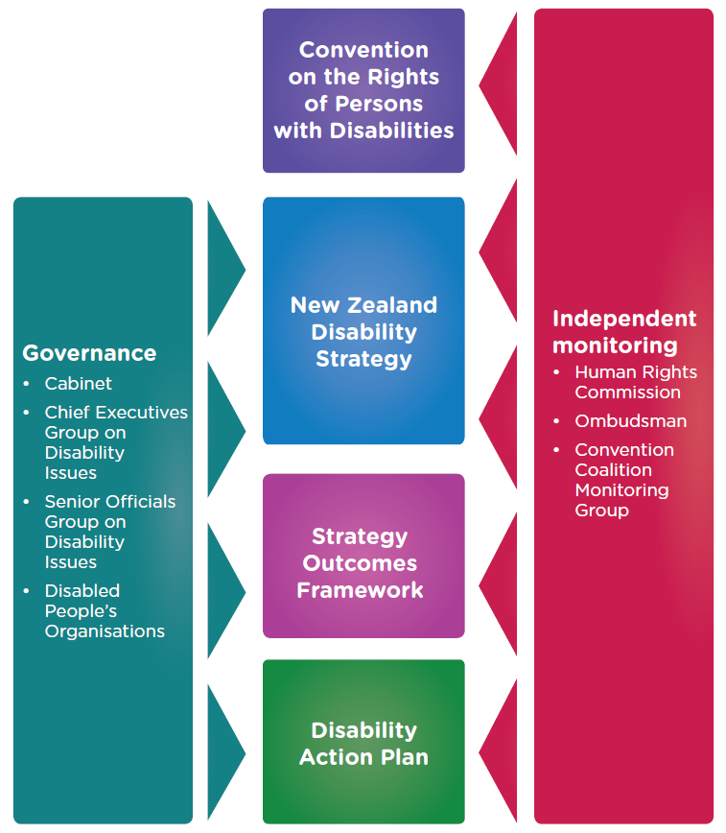

This section outlines how the Strategy will be implemented.
It has two parts:
- Keeping on track with progress
- Achieving practical action
- Disability Action Plan
- Governance
- Monitoring implementation
- Convention on the Rights of Persons with Disabilities – making rights a reality
- Making sure the priorities are right – how consultation will work.
An area of strength for the disability community and sector is that it is diverse, with a range of perspectives. This includes different experiences, areas of expertise and representation (either being representative of a particular group or more formally representing an organisation/group) and advocacy. This is sometimes referred to as wearing many different ‘hats’. We are also recognised as experts in our own lives and making sure we are involved in decision-making on issues that impact on us leads to better quality results.
All of these perspectives are important in different ways for the governance and independent monitoring mechanisms, as well as the consultation processes that will support the effective implementation of this Strategy. These mechanisms and processes should aim to reflect the diversity and the changing nature of the disability community.
Figure 4 on the previous page reflects the governance and monitoring of the Strategy.

Keeping on track with progress
It is a priority for the Government that progress toward implementing the Strategy remains on track. To monitor this, an Outcomes Framework will be developed with public consultation in 2017. The Outcomes Framework will outline how we will monitor progress against the Strategy. The framework will specify:
- the targets and indicators (including for each outcome and the principles and approaches where appropriate)
- where the information comes from
- how often it will be collected
- who is responsible for collecting it
- where proxies are needed and how information gaps will be addressed. (Note: ‘proxy’ or ‘proxies’ means ‘something similar’. Proxy indicators are used when the required data is not available, so a similar indicator is used instead.)
The Outcomes Framework will also help make sure there is continuous learning and improvement prior to a final evaluation of the Strategy in 2026.
Every year, the Minister for Disability Issues will report publicly to Parliament on the progress made to implement the Strategy against the Outcomes Framework. This will meet the requirement for the Minister to report under the New Zealand Public Health and Disability Act 2000. The reports will also be submitted to Cabinet to ensure they inform the development and update of Disability Action Plans.

Achieving practical action

Disability Action Plan
The Disability Action Plan (the Plan) will be the primary vehicle for implementation of this Strategy. Future plans will:
- focus on high priority and significant actions for one or more government agencies (this will help make sure the Plan is manageable and easy to understand)
- present a complete picture of the priorities in implementing the Strategy
- support effective learning across government agencies, particularly in the application of the principles and approaches that are applied throughout the Strategy.
Future Plans will continue to cover a four-year period and they will be updated at the mid-point to ensure priorities remain relevant (that is after two years). Issues like funding or legislation need to be considered in the context of actions in the Plans rather than in this Strategy.
There are other strategies and plans that are also relevant to the Disability Strategy. A description of some of these links can be found on the Office for Disability Issues website.

Governance
As a Government Strategy, decisions on implementation will be made by Cabinet.
These will be informed by the existing governance mechanisms for the Disability Action Plan: the Chief Executives’ Group on Disability Issues (and associated Senior Officials Group) and Disabled People’s Organisations.

Monitoring implementation
The Independent Monitoring Mechanism (IMM) will help provide an independent perspective on progress toward achieving the outcomes and goals of the Disability Strategy.
The IMM was established by the Government in 2011. It fulfils an obligation for the Government under the Convention to have an independent mechanism to promote, protect and monitor implementation under Article 33 of the Convention. It is made up of the Human Rights Commission, Office of the Ombudsman and the Convention Coalition Monitoring Group (a group of Disabled People’s Organisations).
The Strategy is the primary vehicle for progressive realisation of the Convention. Therefore it is appropriate for the IMM to provide an independent perspective on implementation of the Strategy. This will not however, be seen to limit in any way, the IMM’s mandate to monitor the Convention.

Convention on the Rights of Persons with Disabilities – making rights a reality
Every four years, the Government reports to and receives Concluding Observations from the United Nations Committee on the Rights of Persons with Disabilities. Concluding Observations recognise areas of good progress but also include recommendations on things that need to be improved.
The Concluding Observations will be included as part of the public consultation process to develop and update the Disability Action Plans. Recommendations from the IMM will also be considered as part of this consultation alongside those from the Committee.
Making the Concluding Observations and recommendations an integral part of implementation of the Disability Strategy will help make the rights of disabled people a reality.

Consultation
Every two years there will be public consultation to inform the development or update of the Disability Action Plans. There is a lot that needs to be done to make this Strategy work, and it is important that priorities for action are informed by what disabled people and the community says is most important to them.
The process for public consultation will reflect the diversity of the disability community as well as the principles of Te Tiriti o Waitangi and the Convention (including Articles 4.3).

Making it work – a schedule of implementation
Year | What happens
2016 | New Disability Strategy 2016–2026 agreed by Cabinet
2017 | Public consultation process to develop the Outcomes Framework for the Strategy  Outcomes Framework for the Strategy agreed by Cabinet  Update of the Disability Action Plan – to align with the new Strategy  Annual report from Minister for Disability Issues, including baseline information against the Outcomes Framework where possible
2018 | Government reports to and receives Concluding Observations from the United Nations Committee on the Rights of Persons with Disabilities  Government receives recommendations from the Independent Monitoring Mechanism  Annual report from Minister for Disability Issues against Outcomes Framework
2019 | Public consultation process to develop new Disability Action Plan (to include recommendations from the United Nations Committee/Independent Monitoring Mechanism)  New Disability Action Plan (2019–2022) agreed by Cabinet  Annual report from Minister for Disability Issues against Outcomes Framework
2020 | Annual report from Minister for Disability Issues against Outcomes Framework
2021 | Public consultation process for mid-point update of Disability Action Plan  Updated Disability Action Plan to be agreed by Cabinet  Annual report from Minister for Disability Issues against Outcomes Framework

2022 | Government reports to and receives recommendations from the United Nations Committee  Government receives report from the Independent Monitoring Mechanism  Annual report from Minister for Disability Issues against Outcomes Framework
2023 | Public consultation process to develop new Disability Action Plan (to include recommendations from the United Nations Committee/Independent Monitoring Mechanism)  New Disability Action Plan (2023–2026) agreed by Cabinet  Annual update report from Minister for Disability Issues against Outcomes Framework
2024 | Annual report from Minister for Disability Issues against Disability Outcomes Framework
2025 | Public consultation process for mid-point update of Disability Action Plan  Annual report from Minister for Disability Issues against Outcomes Framework
2026 | Government reports to and receives recommendations from the United Nations Committee  Government receives report from the Independent Monitoring Mechanism  Evaluation of the Strategy (and Disability Action Plans)  Annual report from Minister for Disability Issues against Outcomes Framework  End of current Disability Strategy 2016–2026. Next steps to be confirmed

Getting it going – who is involved
Achieving the vision and outcomes of the Strategy will take all New Zealanders working together. With rights there also come responsibilities, for everyone. There are also some key groups who have particular responsibilities under the Strategy. They are:
- Disabled people, families, whānau, allies and the disability community and sector – providing input through governance, independent perspectives and public consultation.
- Cabinet – responsible for considering regular reports and making decisions on implementation of the Strategy through the Disability Action Plan.
- Ministerial Committee on Disability Issues – supports co-ordination of implementation across government.
- Independent Monitoring Mechanism – responsible for providing an independent perspective on implementation of the Strategy.
- Chief Executives’ Group on Disability Issues (and Senior Officials Group) and Disabled People’s Organisations – responsible for governance and coordination of the Disability Action Plans.
- Government agencies – responsible for implementing the Strategy according to the priorities agreed in the Disability Action Plan.
- All New Zealanders – breaking down the barriers of a disabling society and supporting implementation of the Strategy.
- Local Territorial Authorities (City, District and Regional Councils) – consider their responsibility for disabled people in the space they oversee, in line with the Strategy and the Convention.
- Private sector, businesses and Non-Governmental Organisations – ensure their business as usual is inclusive and responsive to disabled people on an equal basis with others.

Glossary
Barrier is something that makes it difficult or impossible for people to do something
Demography is statistics about people, such as age and ethnicity
Disability is something that happens when people with impairments face barriers in society that limit their movements, senses or activities
Disabled people are people who have long-term physical, mental, intellectual or sensory impairments which in interaction with various barriers may hinder their full and effective participation in society on an equal basis with others. This is the understanding of disability in the Convention
Enabling is to provide with the ability or means to do something
Equality means that everyone gets the same opportunities
Equity is recognising that sometimes people need different things in order to be equal
Impairment is a problem with the functioning of, or the structure of someone’s body
Investing is about spending time, energy or money on something
Mainstream means things including activities, services, supports, attitudes or ideas, that are open to everyone to use or participate in (for more detail of the disability context, see page 21)
Non-disabling is about removing the barriers in society that disable people with impairments
Pedagogy is the theory of teaching
Proxy means something similar
Reasonable Accommodation is making necessary and appropriate modifications and adjustments not imposing a disproportionate or undue burden, where needed in a particular case, to ensure to persons with disabilities the enjoyment or exercise on an equal basis with others of all human rights and fundamental freedoms
Twin-track approach is making sure that mainstream activities and opportunities are inclusive of, and accessible to, all people and that specific activities and opportunities that are required by some people are also made available to those people (for more detail of the disability context, see page 21)
Universal design is good design that works for everyone (for more detail of the disability context, see page 21)

Appendix 1 – The Reference Group
Members of the New Zealand Disability Strategy Reference Group (for further details on each member of the group please refer to the Office for Disability Issues website): www.odi.govt.nz
Colleen Brown MNZM, from Auckland, brings a families perspective.
Robbie Francis, from Hamilton, brings the perspective of young people and lived experience of disability.
Lance Girling-Butcher QSM, from New Plymouth is a nominated Disabled People’s Organisations (DPOs) representative. Lance became blind as an adult.
Peggy Koopman-Boyden CNZM, from Hamilton brings an older person’s perspective from research and personal experience.
Clive Lansink, from Auckland, is a nominated DPOs representative. Clive is blind and is a strong advocate for disabled people speaking for themselves.
Victoria Manning (Co-Chair) MNZM, from Wellington is also the Chair of the NZSL Board. Victoria is Deaf and also brings 20 years’ experience in disability policy.
David Matthews, from Christchurch and Wellington, brings a service provider’s perspective.
Papaalii Seiuli Johnny Siaosi, from Auckland, brings a perspective from mental health and addictions consumers, their families and Pasefika communities.
Dr Martin Sullivan QSO, from Palmerston North, brings his perspective as a disabled person.
Hamish Taverner, from Palmerston North, speaks up for the rights of people with learning disabilities. He brings the perspective of lived experience of this disability.
Jonny Wilkinson, from Whangarei, brings the perspective of a person with lived experience of disability.
Gary Williams MNZM, from Christchurch, is a self-employed disability consultant bringing over 40 years of expertise in the disability sector. Gary also brings a perspective of a Māori disabled person.
Government agencies had two representatives on the group. During the development of the Strategy, these representatives were Brian Coffey (Ministry of Education), Kathy Brightwell (Ministry of Health) and Sacha O’Dea (Ministry of Social Development).
Paul Brown from the Office of the Ombudsman was an observer.
Megan McCoy, Director of the Office for Disability Issues, Co-Chaired the reference group meetings.

Statistics New Zealand (2014) Disability Survey: 2013
The New Zealand Disability Strategy Revision Reference Group members are listed in Appendix 1
Statistics New Zealand (2015). He Hauā Māori: Findings from the 2013 Disability Survey
Statistics New Zealand Disability Survey: 2013
From Deaf Aotearoa’s Deaf Way Report, page 5 http://deaf.org.nz/resources/deaf-way-report
Statistics New Zealand (2014) Disability Survey: 2013

