Including all New Zealanders

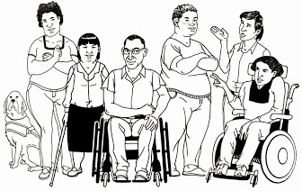

2013 report from the Minister for Disability Issues

December 2013

Easy Read

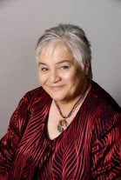

A message from Minister Tariana Turia

Kia ora,
We are starting to see good changes for disabled people in New Zealand.

3 things are coming together and making the good changes happen:
- new rules about how the Government can spend disability money

- new ways of supporting disabled people

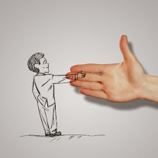
- people who want to try new ways of supporting disabled people.

I want to celebrate the goals we have reached this year.
We have reached the goals working together with:
- disabled people
- whanau/ families
- government
- others who work with and support disabled people.
We have worked out new and better ways of working together.
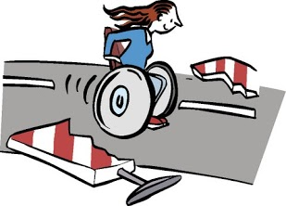
We are working hard to make sure disabled people get their rights in New Zealand.

It is important that disabled people are leading the way for disabled people in New Zealand and I am pleased to be able to say this happened in 2013.
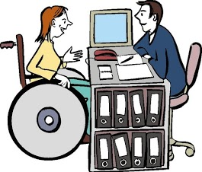
We have made sure that disabled people and families led the way with the Enabling Good Life project.
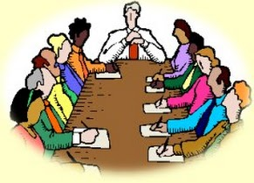
We have worked with Disabled People’s Organisations and written a Disability Action Plan.

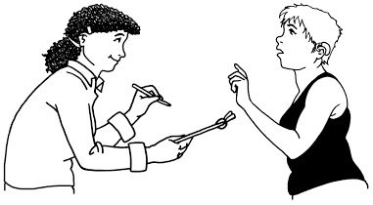
The Disability Action Plan:
- shows that the Government is working better with disabled people

- has disabled people leading the work.
The Enabling Good Lives project is an example of how the Government listened to disabled people.

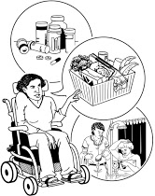
This project means disabled people will have more choice and control over:
- the support they get
- the lives they lead.

We know it is hard for disabled people to take part in local communities.

There are problems with:
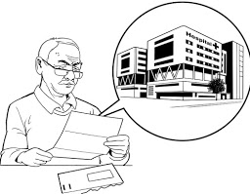
- getting into and around in buildings and communities

- getting information in ways you can understand.

We are going to look at how hard it is for disabled people to get around buildings and the community.

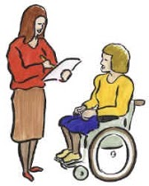
We want to make sure the rules about making new buildings and new things in communities include how to make it easy for disabled people to use and get around in.
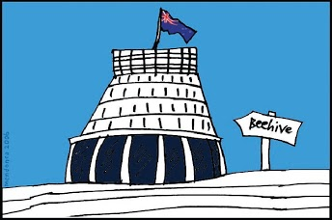
The Government wants to make New Zealand an easier place for disabled people to live.

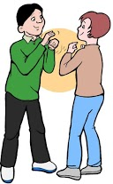
This year we have been working hard to make New Zealand Sign Language stronger.

New Zealand Sign Language is New Zealand’s 3rd official language.

We have set up a New Zealand Sign Language advisory group.

The role of the group is to give the government advice about how to make New Zealand Sign Language well known in New Zealand.

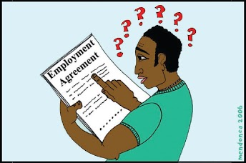
I am worried because I don’t think we are listening well to:
- disabled Māori

- disabled Pasifika.

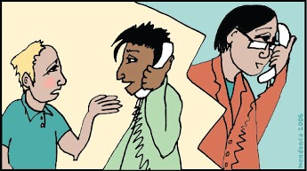
We still do not understand all the problems disabled Maori and Pasifika have.

I want to do more work in supporting these communities.

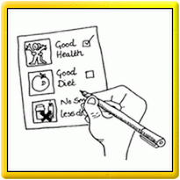
This year my report is being done in:

- Easy Read

- New Zealand Sign Language.

I hope more of us make our information easy for more people to understand in 2014.

Tariana Turia
Minister for Disability Issues

2013 report

This report tells you what the Government has been doing to meet the goals in the:

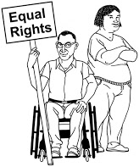
- The United Nations Disability Convention

- New Zealand Disability Strategy.

Enabling Good Lives

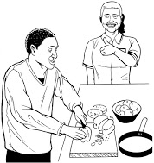
Enabling Good Lives:
- is a new way of supporting disabled people

- gives disabled people more choice and control over what happens in their lives.

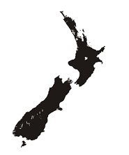
Enabling Good Lives is in:

- The Waikato

- Christchurch.

Disabled people and their family/ whanau will be able to say:
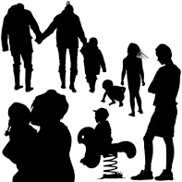
- I can choose the kind of support I need to help me be part of my community

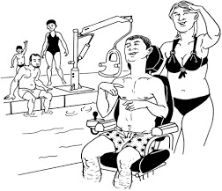
- I have a real choice about the kind of support I get, where I get it and how I want it

- I can make a plan based what I am good at and what I enjoy doing

- I am in control of planning my support

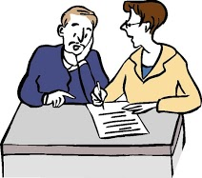
- I can get the help I need to help me make choices

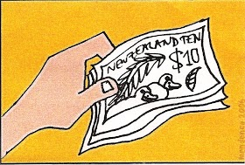
- I know how much money I get for my support and I can decide how to use it

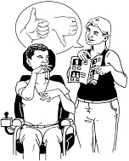

- my support works well for me

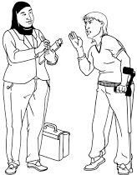
- I do not have to have assessments all the time or apply for funding

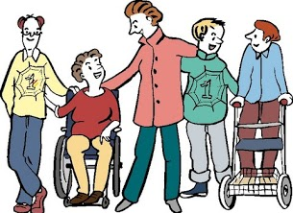

- my family/ whanau feel valued.
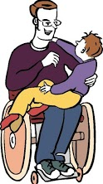

A Good Start in Life

A Good Start in Life is for parents, family/ whanau of disabled children from 0-6 years old.

A Good Start in Life will provide better support and make sure there is:
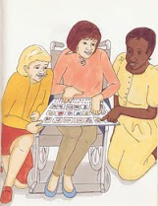
- information that is easier to understand

- the right support at the right time.

Employment

The Government has been working on getting more disabled people jobs by working alongside:

- disabled people

- employers/ bosses

- disability support services.

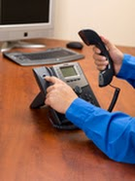
Together they have been working out new ways to get disabled people into:

- work experience

- paid work.

They are also working with employers/ bosses to help them learn about employing and supporting disabled people in the work place.

There is a website called WorkAble.

The WorkAble website has information to employers/bosses to help them employ disabled people.

The website is: http://www.dol.govt.nz/er/workable/index.asp

Rebuilding Christchurch

There are three new things in place to help disabled people in Christchurch:

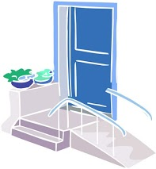
- a free advisory service on building homes that disabled people can easily live in

- a website about how to make homes easy for disabled people to live in.
Here is the website
http://www.branz.co.nz/cms_display.php?sn=215&st=1

- a guide about how to make sure disabled people are part of the planning for civil defence and emergencies.

Here is the website:
http:/www.civildefence.govt.nz/memwebsite.nsf/Files/Publications-Information-Series/$files/Disability-IS-16-July-2013.pdf

Changing how people see disabled people

The Thinking Differently programme aims to:

- change people’s attitudes about disabled people

- change the way people think about disabled people
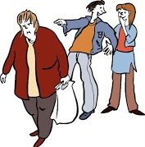
- change the way people treat disabled people.

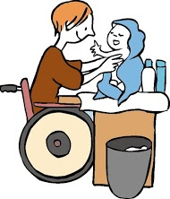
Thinking Differently is about looking at what disabled people can do, instead of what they cannot do.

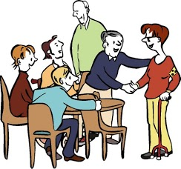
Thinking Differently funding is for projects run in the community that help change how people treat and think about disabled people.

The Thinking Differently programme funded 23 projects in local communities in 2013.

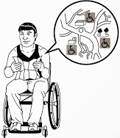
The projects were about changing local communities include disabled people and their families/ whanau more.

Making communities easier to get around in
The Government wants to make sure everyone can easily get into and use:

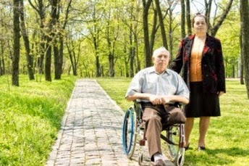
- buildings

- public places

- footpaths and roads

- parks and playgrounds

- houses

- shops

- transport.

The Government is working hard to make sure this happens with the rebuild of Christchurch.

The new design of the area around the Avon River was checked to make sure it was going to be easy for disabled people to get to and use.

Making sure disabled people are involved

Nothing about us, without us

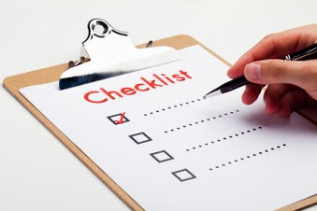
The Government has agreed to a new way of working with Disabled Person’s Organisations.

The Government is working with Disabled Person’s Organisations to make a plan.

The plan will be about the work that needs to be done to make New Zealand a better place for disabled people to live.

Education

Success for All - Every School, Every Child is the government’s plan for New Zealand children.

Success for All will make sure disabled children and young people get a good education like other New Zealand children.

The Government is also working to make sure that children who use New Zealand Sign Language can get education like hearing students.

The Government is working with:

- the Deaf Community

- families/ whanau

- Deaf Education Centres.

The Government has 800 staff working in schools and early childhood centres supporting disabled children and young people.

Better Government services for Deaf people

.
Video Remote Interpreting is a new service to make it easier for Deaf people to use government services.

It uses a sign language interpreter through the internet to help Deaf and hearing people talk to each other.

New Zealand is only one of 6 countries in the world has this service.

The Mobile Text Relay service helps Deaf people with their cell phones.
Cap Tel is a captioned telephone service for Deaf people.
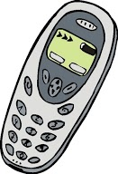
It is like an ordinary phone but it also shows the words that the other person is saying to you.

New Zealand was the 2nd country in the world to have this service.

Making the justice system work better

The New Zealand government now has video conferencing into court so that people do not need to actually be in the court room.
There are now New Zealand Sign Language interpreters available in court.

Making government websites easy to use

The government worked with disabled people to set new standards to make sure government websites are easy to use.

Support

Payment to family carers

In May 2013 New Zealand changed a law so that some family carers can be paid to look after their disabled family member.

New Zealand is only the 3rd country in the world to do this.

New ways of supporting disabled people

Disabled people want:

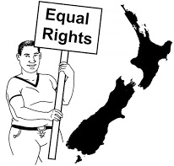
- a good life

- more choices

- more control over the supports they have.

The Government has 3 ways to make this happen.

The 3 new ways are:

Local Area Coordination

Local Area Coordination is a new service that:

- works beside the disabled person

- helps disabled people reach their goals

- helps disabled people be part of their community.

Enhanced Individualised funding

Enhanced Individualised Funding gives disabled people:
- more choice in how to pay for support

- more choice in how to use the funding

- about 100 disabled people now control their own budgets through Enhanced Individualised Funding.

Choice in Community Living

Choice in Community Living:
- is in Auckland and the Waikato

- is about living in the community, not in group homes

- 23 people are now using this funding to live in the community.

Supported Self- Assessment

Supported Self- Assessment
- is in the Bay of Plenty

- means disabled people and families/ whanau can do their own assessments in their own time.

Living in the community

There have been many projects this year to make sure disabled people are fully included in local communities.

Whangarei District Council’s Disability Advisory Group has been making sure they tell the Council what disabled people living in their district need.

In May 2013 Auckland Council held the first New Zealand Universal Design conference.

Thames District Council libraries provided resources in accessible formats:
- large print
- talking books
- delivered to people’s homes.

Tauranga City Council agreed to their first Disability Strategy in September 2013.

New Plymouth District Council rolled out the “Let’s Go” project to make the following areas easier for everyone to use:
- walkways
- bridges
- better kerbs.

Kapiti Coast District Council staff had disability awareness training to:
- make staff more aware of the needs of the disabled people living in Kapiti.

Wellington City Council put into action its Accessible Wellington Action Plan to make it easier for disabled people to use:
          - services
          - buildings
          - programmes.

Wellington City Council also has a new neighbour’s card that has information for emergencies about:
- neighbour’s contact details
- family/ whanau
- support people.

Christchurch City Council made new rules about new Council building so that people can live in their homes longer:
- all new buildings are built to Lifetime Design standards.

Dunedin City Council made their Mobility Parking Scheme better:
- more mobility parking spaces
- bigger mobility parks
- better inner city pick up and drop off points.

Disability Assist Dog ID tagging project

ID Dog tags have been made for Disability Assist Dogs so they can be found easily in an emergency.

Making buildings easy to get into and around in

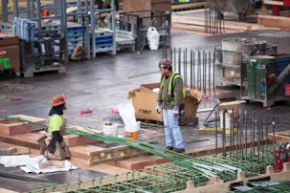
The Government and the Office for Disability Issues are looking at the:
- Building Act
- Building Code.

We want to make sure they have the right rules so that it helps make buildings and public places easy for disabled people to use.
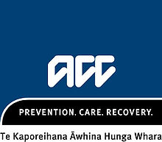

National Serious Injury Service
The National Serious Injury Service is part of ACC.

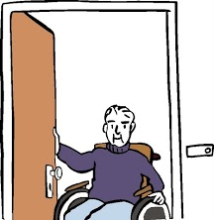
It is a new way of supporting people who have had a bad injury so they can live everyday lives in their community.
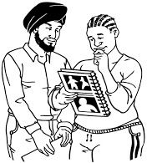
Part of the new service is a self-management programme.

This means the disabled person has control over the money that pays for the supports and services they need.

ACC has a new website for disabled people and their support:
www.acc.co.nz/disability

Changes to benefits

The government has new rules for people that are on a benefit who:
- have health problems
- are disabled.

The benefit name is now the Supported Living Payment.

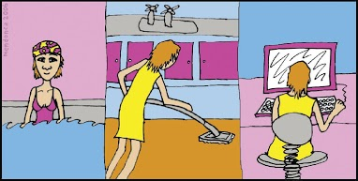
People getting this benefit are asked:
- what work they think they could do
- what support they need to do the work.
If a person does not have a job but can work they get a benefit called Jobseeker Support.

New employment services have been set up for 1,000 people on Jobseeker Support who have:
- experience of mental illness
- problems with stress
- depression.

Work and Income staff now have more time to work with people on the Jobseeker Support payment.

Doing the things you enjoy and your culture

There are new audio guides that you can download for your cell phone.

The audio guide will tell you information about the places you are visiting when travelling around New Zealand.

Here is the website to get more information and to download the app:
http://www.mch.govt.nz/roadside/

The audio guides are now being captioned so that Deaf people can read the information.
The information tells people about:
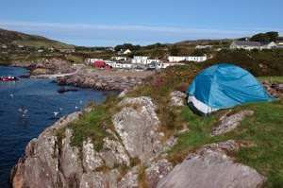
- nature
- people of the area
- culture
- history
- customs of the area.

Another important event was the Arts Access Aotearoa Big A Awards in 2013.

You can see this on the website:
http:/artsaccess.org.nz/big-a-awards/big-a-awards-2013

Collecting information about disabled New Zealanders

Statistics New Zealand did the New Zealand Disability Survey in 2013.

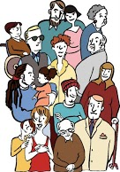
The information from the survey will tell the Government how many disabled people there are living in New Zealand.

The survey will help the Government make changes so New Zealand is a better country for disabled people to live in by:
- making new rules
- making new laws.

Māori

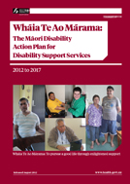
The Ministry of Health has been putting into action The Maori Disability Action Plan 2012-2017.

The Maori Disability Action Plan is called Whaia Te Ao Marama.

There are 4 main goals for disabled Māori:
- having good lives
- better support for family/ whanau
- good partnerships with Māori
- having the right services.

Supporting Pacific disability support services and communities
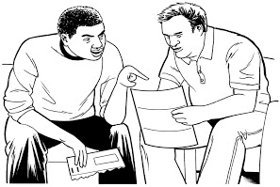
The Government wants to make sure that disabled Pacific people can live in their homes and take part in communities.
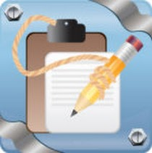
There is a national Pasifika Disability Action Plan called Faiva Ora.

Some of the good things that happened in 2013 are:
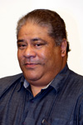
- support service guides in are now in 6 Pacific language
- having better Pacific leadership
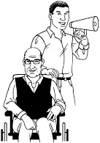
- the Faiva Ora National Leadership Group has given the Ministry of Health good advice
- creating more awareness about disability in Pacific communities.

Keeping disabled people safe

All disabled people have the right to be safe and have good services.

The Government has looked at better ways for disabled women and disabled people who live in residential services to have better:

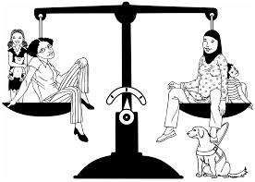
- choices
- services
- control over their lives
- and be safer.

Valuing disability support workers
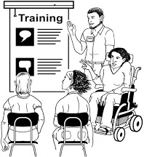
2,732 disability support workers did training in 2013.

Looking ahead to 2014

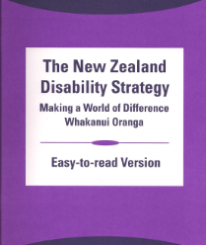
The New Zealand Disability Strategy was written in 2001.
Over the last 12 years the Government has made big changes to give more control to disabled people.

A big job in 2014 will be looking at the New Zealand Disability Strategy to make sure it works with the Disability Convention.

This work will be done by the Office for Disability Issues together with Disabled Person’s Organisations.

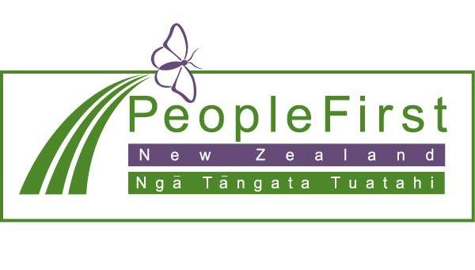

This information has been translated into Easy Read
by People First New Zealand Inc.- Ngā Tāngata Tuatahi

