A Good Start in Life

WHAT IS IT?
A Good Start in Life seeks to improve the way the system as a whole works for parents, family and whānau with disabled children from 0-8 years old. When we talk about ‘the system’ we mean everyone who can and should be supporting parents, family and whānau to give their disabled children the best possible start in life.

WHO’S INVOLVED?
To achieve the kind of change we are looking for we need to work closely together. The project is led by the Ministry of Education. The Ministries of Health, Social Development and ACC are the main government agencies partnering in this work. Disabled Person’s Organisations and allied organisations such as Parent to Parent, CCSDisabilityAction, and IHC are closely involved too.

We are also working directly with parents, family and whānau to ensure that their voices shape what we do, and how we do it, in the future.

We have set up a sector Reference Group to support the project. It is made up of people with diverse knowledge, expertise and experience in supporting parents, family and whānau and disabled children. Several members are parents of one or more disabled children, and have current or recent first-hand experience of the system.

There will be many opportunities to contribute to A Good Start in Life as the work progresses.

THREE KEY INITIATIVES UNDERWAY
There are currently three key initiatives underway. New initiatives may emerge over time. We will be providing regular progress updates over the course of the work and will share the findings widely.
1. Child Development Service Improvement Project
Scope: The Ministry of Health was planning to do some work to improve Child Development Services. This work is now happening under the umbrella of A Good Start in Life so that we can work towards enhancing access, coordination and collaboration across all early supports and services.

Phased approach: The Child Development Service Improvement Project is initially beginning with improvements that can be implemented in the shorter term. Over time we will look at opportunities for greater service integration with Ministry of Education and NGO services.

Current activity: New service outcomes are currently being drafted. The Ministry of Health will seek feedback on these before incorporating them in the service specifications for the next contracting round.

Contact: For further information on the CDS Improvement Project you can contact Gordon Sinclair, Development Manager, Disability Support Services, Ministry of Health Gordon_sinclair@moh.govt.nz

2. Parent, Family and Whānau Centred Design Process
Design process: We have contracted Elizabeth Goodwin and Sarah Scott from Connect+Co to undertake a Parent, Family and Whānau Centred Design Process for us, as outlined in the diagram below.
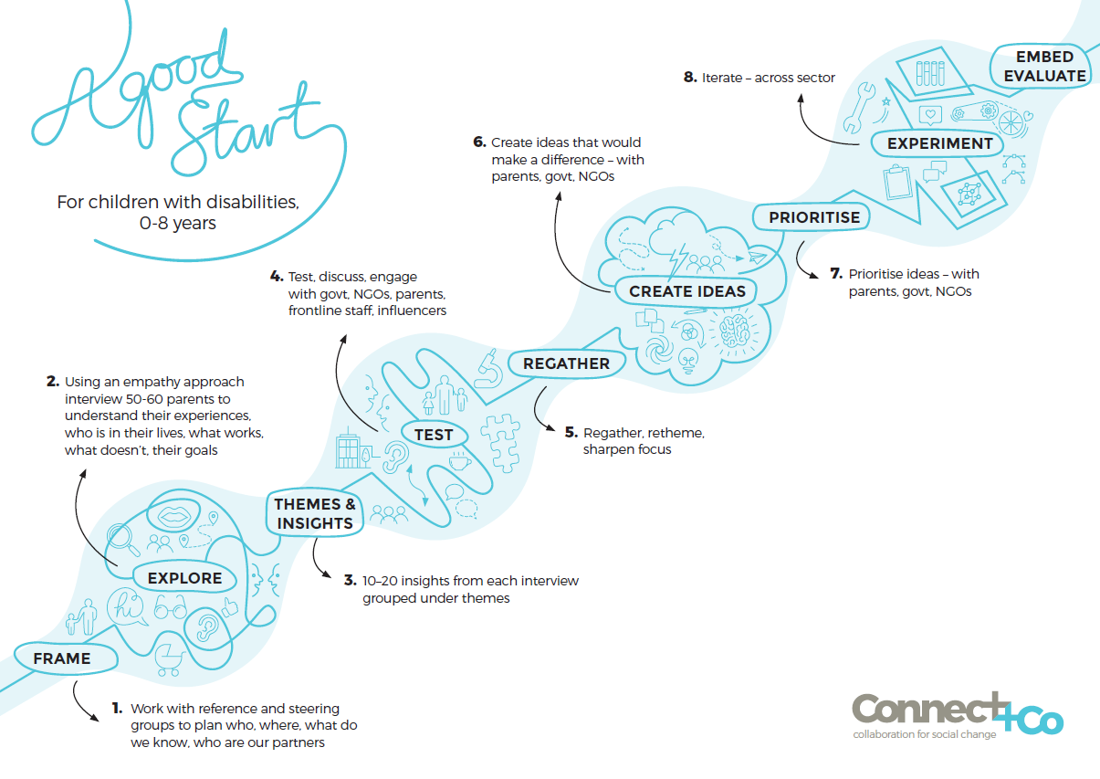

Design processes have been used in the private sector to design user-friendly and effective products and services, and are increasingly used to come up with innovative responses to complex social challenges. If you want to know more about the nitty gritty of design process and look at some examples you may want to check out http://www.nesta.org.uk/sites/default/files/nesta_ideo_guide_021216.pdf

In-depth interviews: Most design processes start with the voice of the customer. Sarah and Elizabeth have carried out more than 60 in-depth interviews with parents, family and whānau. They worked hard to make sure they met with a diverse range of families, including those we don’t traditionally hear from. They went to four locations from the Far North to Central Otago. The response has been amazing.

“The interviews are showing us the rich diversity of parents caring for children with disabilities. Each parent or carer is unique depending on their experience, environment, connections and supports, challenges and how they operate in their world. We haven’t started analysing the interviews yet (some are over 20 pages of transcript) but we have been struck by the resilience of parents who have developed knowledge and expertise about their children that is deep and giving. Families are dealing with very complex situations, drawing on support from within their family, culture, technology and social media, local supports and community.

We’re looking forward to the next stage and hope that we can engage as many people as possible in exploring the themes and findings. Thank you to everyone who has supported this project – it’s a busy time and we really appreciate the help finding the families we’ve met. And a big thank you to the families who’ve generously shared their time and stories.”
Elizabeth and Sarah, Connect+Co

Next steps: Early next year we will be analysing the interviews to identify insights and themes. The results will be used to develop potential responses to the identified needs. These will then be tested and refined through a ‘walk-through process’ with individuals and groups, from parents, family and whānau through to government Ministers. The walk-through involves coming into a space where the journey is up on the wall, so people can get a really good sense of what it is like to stand in the shoes of parents, family and whānau. Participants will have the opportunity to see what we’ve done and contribute their ideas. We plan to do this in several locations, and are exploring options for putting the material online so that everyone has a chance to participate in the process.

The findings from the design process will help people who are already trying to improve information, supports and services, and will inform our advice to government.

Contact: For further information on the design process please contact Adele Carpinter, Project Lead for A Good Start in Life, Ministry of Education adele.carpinter@education.govt.nz

3. Action research on partnership with families
Action research: We all know how important partnerships are but good partnership practice can be challenging. We have contracted Megan Ellis and colleagues from What it Takes Aotearoa/NZ to develop and lead an innovative action research project to explore what helps or hinders people from working in partnership with parents, family and whānau, and each other. They’ve designed the My Working World Learn & Sustain Programme for this purpose.

Three separate groups will participate in the research, which involves a series of five one-day interactive workshops followed by six 2.5 hour practice integration sessions. The purpose of the practice integration sessions is to explore participants’ experience of implementing good partnership practice, and ways of addressing challenges experienced.

Current Activity: What it Takes have already started working with the first group in West Auckland, which involves teams from the Waitemata DHB Child Development Service and Ministry of Education Early Intervention Services.

“We all like to believe that we are working in a family centred way, but being involved in the My Working World programme has challenged that. We just feel really privileged to have the opportunity to be part of it – there is so much learning for us. It has been a wonderful process and everyone is so focussed on how the learning will influence their partnering - personally, as part of a team and as part of the wider networking for/with families and disabled children.”
Susan Peters, Child Women and Family Service, Waitemata DHB

“What an engaged and generous group of practitioners! The diversity in professional and cultural background makes for a rich and diverse group. We have been developing a shared picture of what helps partnering and what makes it more difficult. Practitioners have been open and curious about their own practice, celebrating and deepening their understanding about the gems, where partnering has created great moments with parents on their journey. They have leaned into reflective tasks and shown curiosity and humility about aspects of their personal practice, practices in the teams and processes and relationships across the network that may be less helpful to partnering. We have been delighted and humbled in equal parts by the practitioner’s commitment to the children and their families/ whanau.”
Megan Ellis, What it Takes

Next Steps: We are still in the planning phase for the next two groups. We will be sharing information as the work progresses. The action research will be completed by the end of October 2017.

The results will help people to identify and implement the changes they can make to support partnership practice, and will inform our advice to government.

Contact: For further information on the action research please contact Josi Wilson, Senior Advisor – Social Action Team Child, Family & Community, Community Investment, Ministry of Social Development josi.wilson045@msd.govt.nz

Keeping in touch
If you have any questions or want to be added to, or taken off, the mailing list for information about the Good Start in Life project, please email a brief message with your name and email address to goodstartinlife@education.govt.nz

Feel free to share this newsletter with your networks.

