A brief history of disability in Aotearoa New Zealand
Contents
Introduction 1
Disability unwelcome in colonial New Zealand 2
The influence of eugenics 4
Rehabilitation 9
Institutionalisation and parental advocacy 11
Disability policy: ACC, Social Welfare to Ministry of Health 14
Education and employment 15
Disability activism 18
Medical versus social model 18
Conclusion 19
Disability timeline: Aotearoa New Zealand 20
Bibliography 23

Compiled by Hilary Stace and Martin Sullivan, October 2020

Introduction
There have been significant changes in the experience of, and attitudes to, disability in the two centuries since the early days of European settlement in Aotearoa New Zealand. But policies and services today still reflect a legacy of tensions between the European Pākehā colonisers and indigenous Māori. Very generally, Pākehā tended to see disability as an individual flaw requiring containment or intervention, while for Māori it was part of human and whānau diversity.
In New Zealand we had a long and toxic mix of colonisation, racism and eugenics in which many poor, Māori or disabled people had no chance of equal citizenship. We now have a Royal Commission on historic abuse in state care to examine some of the long-term effects, and remaining inequities in many areas.
There is no definitive version of Pākehā disability history, and it is often invisible in the historical narrative. But there is evidence that disability was often viewed negatively by the majority. It has been a long journey from colonial settlement to disability rights.

Disability unwelcome in colonial New Zealand
Missionaries and traders began to settle in Aotearoa New Zealand from the early decades of the nineteenth century. In 1840, Te Tiriti o Waitangi (the Treaty of Waitangi) was signed between the British Crown and the indigenous Māori population. Despite the Treaty’s principles, much later summarised as promising partnership, participation and protection, colonialism was largely negative for Māori, who are still disproportionately affected by disability.
Colonial New Zealand was settled by immigrants mainly from Britain and Europe who were prepared to endure a risky and lengthy sea trip for a chance of a better life in a new country. Although infectious illness and accidents were common, disability was unwelcome as it challenged the idea of a new society and could be a burden on others in a time when hard physical work was a daily necessity. So support was left to the benevolence of families or those providing charitable aid.
The Immigration Acts that discriminated against Chinese people in the late nineteenth century also sought to deter disabled people. The 1882 Imbecile Passengers Act restricted “cripples, idiots, lunatics, infirm, blind, deaf and dumb”, and the 1899 Immigration Restriction Act banned the “idiotic”, the “insane” and the contagious.
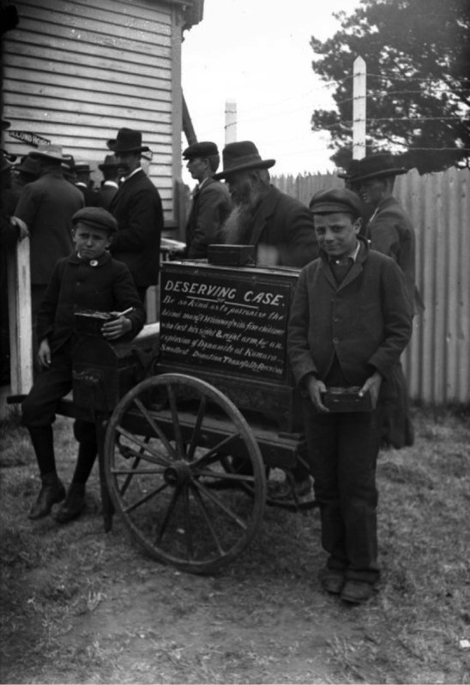
Jack (right) and Rudolph Lousich collecting donations for their father Louis Lousich. The sign reads: Deserving Case. Be so kind as to patronise the blind man a widower with five children who lost his sight and right arm by an explosion of dynamite at Kumara. Smallest donation thankfully received. Photograph taken ca 1897 in Kumara by Steffano Francis Webb. Alexander Turnbull Library Ref: 1/2-049635-G

Mental illness was generally feared and misunderstood. The 1846 Lunatics Ordinance provided incarceration of the mentally ill, initially in jails. The first public ‘lunatic’ asylum was opened in Karori in 1854, followed by Porirua in 1887. The Porirua asylum mixed several categories of ‘undesirables’: those with mental health issues, intellectual impairment, disabled children, alcoholics, as well as elderly and homeless people. Physically disabled people were often housed in the ‘chronics wards’ in ordinary hospitals established in the early twentieth century. For decades, all these ‘inmates’ also provided large captive communities for doctors and specialists to practice theories and treatments.

As New Zealand society developed, children came to be regarded as more than little adults or economic units. The 1877 Education Act provided free, secular, primary school education. The Act’s aim was an educated workforce while enabling state surveillance of children. Rules and inspections were rigid.
As the nineteenth century progressed, so did medical and social policy, and some groups such as those with vision and hearing impairments, were seen as ‘habitable’, meaning they had potential as worker citizens. Hence, the establishment of residential schools such as the Sumner Institute for the Deaf and Dumb (later Van Asch) in 1880, and the Jubilee institute for the Blind in Auckland in 1890. Although deaf children were forced to learn oral language and lip reading and were punished for signing for most of the next century, indigenous New Zealand sign language quietly developed. These sites provided the opportunity for deaf and blind people to develop cultures in opposition to oral and sighted cultures, and thus for activism to emerge among these impairment groups.

The influence of eugenics
The rise of the pseudo-science of eugenics and what became known as Social Darwinism became very influential during the latter part of the nineteenth century. In 1859, Charles Darwin published his bestseller, On the origin of the species by natural selection or the preservation of favoured races in the struggle for life. The ideas of evolution, genetics, heredity and the potential of selective breeding in humans were taken up by his cousin, Francis Galton, who named the new science eugenics. In New Zealand ‘Social Darwinism’ was embraced by liberals and conservatives concerned about the declining white middle class birth rate and consequent fears of losing their racial and moral supremacy. Improving racial ‘fitness’ was vital.

Two influential Social Darwinists in colonial New Zealand were Dr Duncan MacGregor and Robert Stout. MacGregor from Scotland was Professor of Mental and Moral Science at Otago University, and advocated in the 1870s for the extension of the definition of insanity to include “hopeless drunkards, hopeless criminals, and hopeless paupers”, so that these dangerous classes might be: “made to work for their support, and deprived of liberty until they die, in order to prevent their injuring society either by their crimes or by having children to inherit their curse.” (MacGregor, 1876:320). In the 1880s, Premier Robert Stout, a former student of MacGregor, who believed moral failings caused poverty, warned of an emerging class of permanent paupers which would pollute the new society. His wife, Anna, was a prominent suffragist. Many feminist writings of the era also reflected eugenic beliefs, particularly as a means to rid society of undesirables such as alcoholics and to reduce the ‘caring’ demands placed on women.

By the turn of the twentieth century, many of New Zealand's leading politicians, doctors and academics believed in the false scientific validity of eugenics. In New Zealand disabled or mentally unwell people and Chinese people were the main targets (In 2002, Prime Minister Helen Clark formally apologised to Chinese New Zealanders).

In 1903, W.A. Chapple, a politician and doctor, published his influential booklet, The Fertility of the Unfit. The problem he saw was the decline in the fertility of the ‘fit’ and the increasing birth rate of the ‘unfit’. His solution lay in encouraging the ‘fit’ to have more children and by sterilising the ‘unfit’ (those with mental, moral and physical impairments).

The Eugenics Education society was founded in Dunedin in 1910 with an influential membership, one of whom was Truby King, at that time the Medical Superintendent of Otago’s Seacliff Asylum. Theories and language linked intellectual impairment and some physical impairments like epilepsy to inferiority and moral degeneracy.

Negative eugenists sought to limit fertility while positive eugenists supported interventionist policies to increase population ‘fitness’. Truby King founded Plunket in 1907: he was a positive eugenist who believed that teaching mothers the strict rules of ‘scientific’ mothering would increase the fitness of the race.

But surveillance of those deemed dangerous and deviant required legislation to segregate, classify and contain them. For the ‘unfit’ various institutions were developed to keep the sexes apart and prevent reproduction. The 1911 Mental Defectives Act classified groups of ‘other’ into six categories: “persons of unsound mind”, “mentally infirm”, “idiots”, “imbeciles”, “feeble-minded” and “epileptics”. Each label had a specific meaning. The 1914 Education Act required parents, teachers and police to report ‘mentally defective’ children to the Department of Education. The School Medical Service was founded to identify ‘defective’ children so they could be subject to surveillance. Health Camps developed to temporarily remove children from their families to instil ideals of health and fitness. The new science of IQ testing provided a valuable classification tool.

But certain types of intellectual impairment continued to be linked with immorality. So girls’ and boys’ homes and farm schools were founded mainly to keep the sexes apart and prevent criminality, deviant behaviour or reproduction. In 1908, Otekaike (Campbell Park School) near Oamaru was opened as a residential school for ‘feeble-minded’ boys and a few years later a similar residential school for ‘feeble-minded’ girls, Salisbury, was opened in Richmond, near Nelson.
These special schools were run by the Education Department, while Templeton near Christchurch and Levin Farm, later the Kimberley psychopaedic hospital, came under the Mental Hospitals Department. Differing classifications of ‘defect’, as listed the 1911 Act, determined which government department was responsible for each individual. The Census of 1916 was the last time until 1996 that specific questions about disability were asked, possibly due to the repercussions for identification.

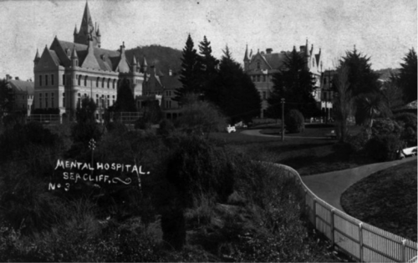
Seacliff Hospital, Dunedin, showing the grounds, taken 1912 by an unidentified photographer. Alexander Turnbull Library Ref: PAColl-8769-02

French-born nun, Suzanne Aubert, had personal experience of disability and was one of the few to speak out against eugenics. She founded her Home for Incurables in Whanganui in 1899 and, in 1907, opened her first Home of Compassion for all ‘needy’ or disabled adults or children in Wellington.
A 1922 committee on venereal disease was led by William Triggs, a Member of the Legislative Council. His concluding remarks expressed concerns with the role of ‘feeble-minded’ women infecting men, causing debauchery and corruption. By now moral panic was high so Mr Triggs was appointed to chair a Committee of Inquiry into Mental Defectives and Sexual Offenders which reinforced the links between intellectual impairment, moral degeneracy and sexual offending in the public mind.
Theodore Gray was a Scottish clinician influential in New Zealand psychiatric hospital administration. He advocated villas instead of old multi-storey hospitals. In 1927, he succeeded Truby King as head of the Department of Mental Hospitals. To protect white racial fitness he wanted segregated farm colonies for those with intellectual disability or mental illness, registration, screening and sterilisation. These were proposed in the 1928 Mental Defectives Amendment Bill. Under the Bill at-risk children could be taken off families and the short-lived Eugenics Board kept lists of ‘defectives’. A rare voice of protest was expressed by a mother about the proposed travelling clinics which would examine intellectually impaired children.
“Oh Mother, save me from Dr. Gray
‘Cause teacher says he’s coming to-day
And if I’m stupid he’ll take me away.
Oh, Mummie, save me from Dr.Gray!”
“I cannot save you, my little child.”
His Mummie said and her eyes were wild.
“You belong to the State, you’re no more my child!
But Oh, my darling, don’t stupid be
Or he’ll say we’ve tainted heredity.
And must be eradicated – you and me!”
(quoted in Robertson, S. Production not reproduction: the problem of mental defect in New Zealand, 1900-1939. Unpublished BA Hons, University of Otago, 1989).
After much political debate on the 1928 Bill, sterilisation was rejected under the leadership of Opposition Labour MP, Peter Fraser, who would become Prime Minister a few years later. His was a rare voice against eugenics possibly because of his own family experiences of mental illness. Even though eugenic sterilisation was never legalised in New Zealand many were likely disguised as operations such as appendectomies.
The 1928 Mental Defectives Amendment Act led to the establishment of our first psychopaedic institution, Templeton Farm Mental Deficiency Colony, near Christchurch, in 1929 under the authority of Dr Gray and his Mental Hospitals Department. The first residents were boys but soon girls were sent there too, although sexes were segregated inside the institution. Dr Gray personally signed some of the admission forms. When Templeton closed in the late 1990s some residents had been there for decades unsure why they had ever been placed there.
Over time more psychopaedic hospitals were established, including Braemar (Nelson), Kimberley (Levin) and Mangere (Auckland). Residential units were also established in some hospitals, or in psychiatric hospitals, such as Porirua which set up an autism unit in the 1970s when that diagnosis started increasing. Many disabled children spent time in mainstream psychiatric hospitals. Pukeora, an institution for children and young adults with physical impairments, was founded near Dannevirke in the late 1950s.
Support for eugenic policies was widespread globally and it was in this context in 1939 that a German father asked the state authorities to kill his disabled child. That was the start of the euthanasia policies of the Nazis. It is estimated that over 200,000 disabled people were killed in what is known as the ‘silent holocaust’. Support for eugenic policies dimmed internationally, including in New Zealand, but did not die with the Nazis.

Rehabilitation
The arrival home of disabled soldiers following the First World War challenged the dominant eugenic narrative around disability. These soldiers exemplified the eugenic ideal of fighting for the empire and their impairment couldn’t therefore be linked with immorality or blamed on faulty genes.
The large numbers of disabled war veterans led to the creation of the new concept of ‘rehabilitation’, meaning to make fit again. This was different to the earlier concept of ‘’habilitation’ for genetically deaf and blind people who could potentially be trained to be fit and useful citizens. Following the Second World War, rehabilitation became strongly linked with employment potential, as in the development of the organisation, the Rehabilitation League, and which still exists today as the employment service Workbridge.
The general population became increasingly aware of mental illness and physical impairments as experienced by soldiers returning home after the world wars. The rehabilitation of mentally and physically impaired into society was emphasised. There was a need for better services, including psychiatric treatment, physiotherapy and plastic surgery. War injuries also helped in the development of improved medical skills such as treatment for burns, plastic surgery and orthopaedics.

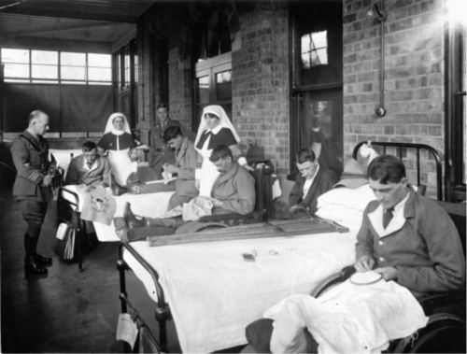
Hinge, Leslie, 1868-1942. World War I returned servicemen embroidering [Christchurch Public Hospital].
Ref: PAColl-5932-27. Alexander Turnbull Library, Wellington

Some of the injured came from privileged families, for example, Clutha Mackenzie, whose father was briefly Prime Minister, and who lost his sight at Gallipoli. In the 1922 general election he stood unsuccessfully for the Reform Party against the Labour Party’s John A Lee, who had lost an arm in battle. McKenzie helped develop the New Zealand Foundation for the Blind and the development of a universal Braille system. In 1924, legislation was passed allowing a pension for blind people.
In 1935, surgeons founded the Crippled Children’s Society to deal with physical impairments such as those caused by polio. It was expensive for families to get this help before the first Labour Government (elected in 1935) established free hospital care. The 1938 Social Security Act founded the welfare state with some disability support and pensions.
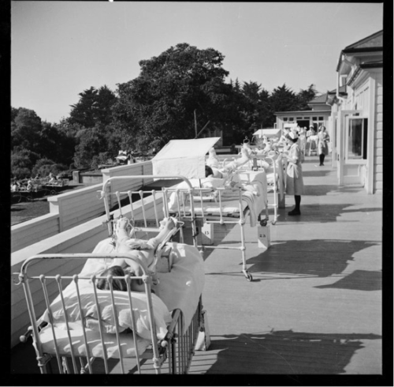
The Wilson Home for crippled children in Takapuna, Auckland. Photograph taken in 1943 by John Pascoe. Turnbull Library Ref: 1/4-000643-F

Institutionalisation and parental advocacy
In 1949, parents of children with impairments, including intellectual disability, founded the forerunner to the IHC, called the Intellectually Disabled Children’s Parents’ Association. They wanted schools and community facilities for their children so they could keep them at home and out of institutions, as recommended by the World Health Organisation. At that time there were few disability support organisations. One was the Wellington After Care Association – but its support was limited.
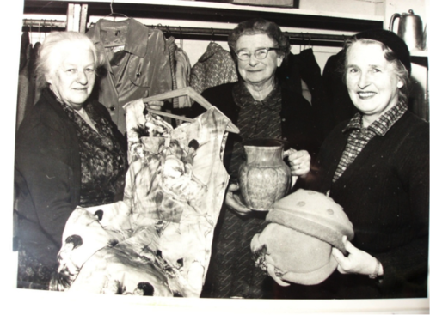
IHC women fundraising 1960s Turnbull Library PA Coll 9653
The parental advocates faced much discrimination. In Wellington, Oriental Bay residents petitioned against their planned school. The local MP, Peter Fraser, instead found them temporary space in the stand at the Basin Reserve and they eventually built their own preschool and centre in Newtown. Over the decades IHC nurtured the establishment of numerous disability organisations such as Autism NZ, Parent to Parent and the Down Syndrome Association.
Although parents lobbied the new government for direct support, the Government instead set up a Consultative Committee under Dr Aitken of the Otago Medical School, who was also the father of a disabled daughter. The Committee recommended expansion of the current psychopaedic institutions – including Templeton, Kimberley, Braemar and Mangere — into large ‘mental deficiency colonies’ with parents encouraged to send their children there by five years old. This resulted in a huge expansion in institutionalisation over the next two decades, despite another report in 1959 by Dr Burns of the British Medical Association supporting the parents’ calls for community facilities and services.
As a result of the Aitken report the institutions were extended and numbers of residents rapidly increased. A 1964 documentary estimated that one in a thousand children had an impairment which required their institutionalisation. Smaller units were attached to some local public hospitals, while other children ended up in adult psychiatric hospitals. To deal with these growing numbers the new profession of specialist psychopaedic nurse was developed in New Zealand with in-house training. The first cohort graduated in 1964.
Concerns about institutionalisation had been growing since the 1940s. In 1973, a Royal Commission on psychopaedic hospitals recommended transference from large institutions to community care, and led to three decades of deinstitutionalisation, during which the Government had to pay for both community care and upkeep for the large institutions. At its height, an estimated 2% of the population was institutionalised with more than 800 people at Kimberley. By 1978, the occupancy rate was 0.24%, the lowest since 1881.
In 2007, the Confidential Forum for Former In-Patients of Psychiatric Hospitals heard stories about the ‘back wards’ of the institutions as places of horror and threat, of adults and children living together in distressing conditions.
Sir Robert Martin’s biography, Becoming a person, provides valuable insights into institutionalisation. Soon after his birth in 1957, he was labelled ‘retarded’ and placed in Kimberley Hospital and Training Centre near Levin. He also experienced Otekaike/Campbell Park residential school in North Otago, violent and abusive foster care, and the notorious Lake Alice Hospital in rural Rangitikei. Numerous reports of abuse at Lake Alice eventually emerged. Like many other institutions it was isolated in a rural area, far from nurturing community. The doctor in charge created a climate of sadism and fear that the young people, mainly boys, could not escape. As disability advocate, Sir Robert Martin, often says, “How can humans treat other humans like that?”

Although the deinstitutionalisation movement started in the 1970s it took until 2006 and a march on Parliament for the last one, Kimberley, to close.

Sir Robert warns:
Though it’s great that New Zealand closed its last institution, being institutionalised is not just about the buildings − the bricks and mortar − it’s also about values, beliefs, actions and activities. It’s about the way things are done, the decisions that are made, who makes them and who has the control. In New Zealand we still need to work hard to ensure that people with disabilities do not continue to be institutionalised even though they live in community settings. (People First, 2010:9)

Disability policy: ACC, Social Welfare to Ministry of Health
Advocacy was also behind the development of ACC. Members of Parliament and others who knew about the impact of war injuries and disability on earning potential were behind the establishment of the Woodhouse Commission in 1967 which recommended the no-fault compensation scheme. By 1974, the ACC was up and running for those workers whose disability was caused by accident.
The 1975 Disabled Persons Community Welfare Act aimed to provide community support for those whose impairment was not caused by accident. The Act also legislated compliance for the recently developed New Zealand Standard Building Accessibility Code 4121. This Standard marked the first-time society had had to change for disabled people, not the other way around. Organisations such as IHC and CCS received government grants to provide services.
Woodhouse intended that there eventually be one system for disability and income support. However, 50 years later that has not yet eventuated with considerable disparities between disability support through ACC and the Ministry of Health, depending on the cause of the impairment.
Disability policy has always been problematic. Despite the 1988 Royal Commission on Social Policy advocating more support for disabled people, the Government’s 1991 ‘Mother of all budgets’ chopped welfare and cut ACC provisions. The Minister of Social Welfare and the Minister of Health promised new disability policy within financial constraints. Support for Independence for People with Disabilities – A New Deal was incorporated in the 1993 Health and Disability Services Act 1993. From 1994, most disability support services were transferred from Social Welfare to the Regional Health Authorities and funded by a capped and ring-fenced budget from within Vote: Health. The 1975 Disabled Persons’ Community Welfare Act was repealed with its main provisions being retained in the new Act.

During the 1990s, the market was brought into service provision. A service provider tendered for the service via a contestable, competitive contracting process. Previously free services were now purchased by ‘clients’ from the state through Regional Health Authorities and service providers. Support was no longer a statutory right but dependent on available budgets, and disability became an individualised health problem. Access was through a new Needs Assessment and Service Coordination process, with strict eligibility criteria comprising only physical, intellectual or sensory (vision, hearing) impairment. The growing numbers diagnosed with Asperger’s Syndrome (autism without intellectual disability) were one group to miss out (and this was not rectified until 2014).

Education and employment
Despite the 1877 Education Act, access to education for many disabled children remained out of reach for many. In 1939, the Director General of Education, Dr Beeby, and Minister of Education, Peter Fraser, made their visionary statement about the rights to education for every child including the words “to the best of their abilities and the fullest extent of their powers.” Eight decades on, this goal remains elusive for many disabled children.
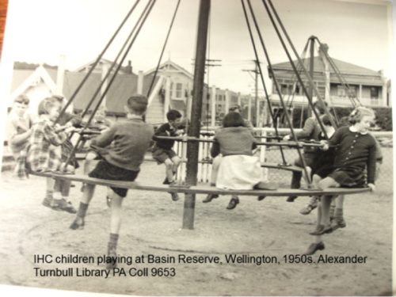
IHC Children playing at the Basin Reserve in Wellington during the 1950s. Alexander Turnbull Library PA Coll 9635
Education for children was one of the main aims for parents establishing the IHC in 1949, but segregation of disabled children from their non-disabled peers remained.
The 1989 Education Act was a victory of advocacy as Section 8 legislated for the right for all disabled children to attend their local state school on the same terms as other children.
The 1989 Education Act meant the state supported two systems: increasing numbers of disabled children at regular schools, as well as in numerous segregated environments. Considerable regional variation also developed. The Government’s response was the controversial 1995 policy of Special Education 2000. Its aim was to promote mainstreaming of children with ‘special educational needs’ in regular schools and to close units and special schools. Unfortunately, resourcing to support mainstreaming was inadequate. Legend has it that a Treasury official decided that only 1% of children would require targeted assistance, which was implemented through an Ongoing Reviewable Resourcing Scheme (ORRS/ORS) via a complex application and faceless verification system. There was widespread opposition to this policy from parents, including a group who took the Government to court. There have been numerous reviews of ‘special education’ and the ORS system in the last two decades, but the principle of rationed support remains.
A Learning Support Action Plan developed by the Ministry of Education in 2019 sets out a plan to increase access to education and support for disabled children over time.
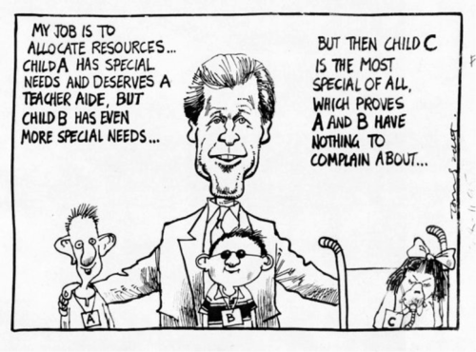
1995 Tom Scott Cartoon featuring Minister of Education Lockwood Smith and three children with special needs. Ref: H-242-020 Turnbull Library

Advocacy for employment opportunities for disabled people led to the 1960 Disabled Persons Employment Promotion Act and the establishment of ‘sheltered workshops’. Operators of sheltered workshops were exempted from applying the same employment conditions and wages required elsewhere. Contemporary thinking was that giving people something to do, and thus keeping them out of institutions, was more important than them having the same working conditions as non-disabled people. Of course, disabled people had no say in the formulation of this policy. Over time this policy came to be seen as discriminatory and ongoing advocacy by disabled people and allies saw the repeal of the Act in 2007, but Minimum Wage Exemptions remain widespread.

Disability activism
The global reforming zeal of the 1960s and 70s also encouraged disability activists. The big changes of the following decades were a result of political activism by disabled people and allies. It is not surprising that the global disability rights movement developed out of the 1960s ferment which also encouraged women, youth, ethnic minorities, gay people and other marginalised groups to fight discrimination and reclaim civil and political rights. But for disabled people it was not always easy to organise into a strong advocacy force.

Medical versus social model
A 1976 manifesto published by the London Union of the Physically Impaired Against Segregation called for a change of attitude to disability and disability policy. They challenged the ‘medical model of disability’ whereby disability was considered to be an individual’s problem, something wrong or broken that could be cured or contained. The individual’s consequently lowered status often led to institutionalisation or exclusion from participation in education, employment and other aspects of citizenship.

Instead, the growing international disability rights movement developed what became known as the ‘social model of disability’, whereby people have impairments, but it is society’s attitudes that disable. For example, when a person who uses a wheelchair requires access to a public building the problem lies not with the person’s paralysis – the impairment – but poor building design that excludes the entry of some citizens.

Disability was thus the negative economic, social and political responses to impairment by a society built by and for non-impaired people. A disabled person is someone with an impairment who is disabled by society. To identify as a disabled person is therefore to adopt a highly politicised position which requires change to society’s values and structures.

The disability rights movement also demanded a say in disability policies and governance. “Nothing about us without us” became the international slogan in the fight for nondisabling services and structures. It remains the impetus for disability activism today.

New Zealand experienced a burst of disability activism and empowerment in the first decade of the twenty-first century. There was the first Minister for Disability Issues, a dedicated office in the Ministry of Social Welfare, a social model based New Zealand Disability Strategy and numerous pieces of rights-based legislation, including the promotion of NZ Sign Language as an official language. New Zealand and New Zealanders had significant input in the development of the United Nations Convention on the Rights of Persons with Disabilities (CRPD) which was finalised in 2006, and ratified by New Zealand in 2008. The articles of the CRPD set out what rights look like, and what signatory countries must implement. Several groups have established their own disability-led Disabled People’s Organisations (DPOs), which partner with Government in monitoring the CRPD, while there are also numerous impairment specific and provider groups. Robert Martin was elected to the UN Committee to monitor the CRPD in 2016, and in 2020 became the first New Zealander with learning disability to receive a Knighthood.

Conclusion
The disability community in Aotearoa NZ has grown immensely in size, capacity and influence in the last 200 years. But considerable inequities remain. Although the institutions have closed, and a Royal Commission is currently inquiring into historic abuse, there is evidence that disabled people are still suffering discrimination and abuse as revealed by a 2008 Select Committee Inquiry, a 2013 Ministry of Health report and media investigations. Despite some good providers, poor and neglectful care seems widespread. A 2011 Ministry of Health report revealed life expectancy of about 20 years less for people with intellectual disability than for those without, and other disparities.

In the past many people died at an early age. Improvements in medical knowledge and technology now enable many people with ill health or physical impairments to live longer, including babies born very prematurely. This is one reason why there are more disabled people today than there were in early New Zealand. But for many, access to rights and participation in citizenship remains elusive.

The 2013 Census revealed that 24% of respondents identified as disabled. With the addition of family members and carers, that makes a large disability constituency. But there is much work to do. Our official disability policy is underpinned by the social model but operational policy is based on targeting and rationing. We also have two different systems depending on whether the impairment is a result of accident or caused by other means. More recently ‘Enabling Good Lives’ principles have been co-developed between disabled people and government to underpin new policy initiatives. But intersectionality means that some groups such as Māori and other marginalised groups face multiple disparities. These tensions ensure ongoing inequities and the need for continued activism.

Disability timeline: Aotearoa New Zealand

1846 Destitute Persons Ordinance
1850 Lunatic Asylum Dept – system of lunatic asylums
1854 Karori lunatic asylum; 1887 Porirua – mixed categories of undesirables – mental health issues, ID, alcoholics, elderly homeless people
1880 ‘School for Deaf Mutes’ at Sumner, Christchurch
1882 Imbecile Passengers Act – for undesirables – cripples, idiots, lunatics, infirm
1890 Jubilee Institute for the Blind, Auckland – charity based initially
1899 Immigration Restriction Act – went further banning the idiot, the insane, the contagious
1899 St Joseph’s Home for Incurables – Wanganui Mother Aubert-Sisters of Compassion
1907 Home of Compassion – chronically & terminally ill adults & children, Wellington
1908 Separate ‘chronics’ or ‘incurables’ wards in old people’s homes
1910 Hospital & Charitable Aid Boards amalgamated and ‘chronics’ wards become official care centres
1911 Mental Defectives Act - classifies other into idiot, imbecile & feeble-minded
1914 Education Act made it obligatory for parents, teachers and police to report ‘mentally defective’ children.
1925 Committee of Inquiry into Mental Defectives and Sexual Offenders links intellectual impairment with moral degeneracy and potential sexual offending
1935 New Zealand Crippled Children Society (CCS) founded by surgeons
1945 Dominion Association of Blind, first major disability consumer group. Later became Association of Blind Citizens
1945 Levin Farm mental deficiency colony, first North Island psychopaedic institution, established on site which was previously corrective farm for young male offenders
1949 Intellectually Handicapped Children’s Parents Association formed
1953 Aitken Report - Govt establishes residential ‘mental deficiency colonies’ ie institutions. Recommends 400 – 500 ‘mental defectives’ in each and parents encouraged to place children from 5yrs
1959 Pukeora home for physically disabled young adults
1959 Burns Report – rejects Aitken Report, recommends community services and community care and small neighbourhood hostels
1960 Disabled Persons Employment Promotion Act establishes sheltered workshops

1971 United Nations Declaration on the Rights of Mentally Retarded Persons signalled a new era of international disability rights including in NZ
1972 Accident Compensation Act provides no-fault compensation and rehabilitation for injury caused by accident in New Zealand

1973 Report of the Royal Commission into Psychopaedic Hospitals recommended closure of the big institutions and shift to community care; became government policy.

1975 The Disabled Persons Community Welfare Act gave disabled people, who were not eligible for ACC, access to services to help them stay in the community. It also provided the first disability allowance, respite and carer support, and building access code 4121.

1981 The United Nations declared 1981 the International Year of Disabled Persons. In New Zealand, funds raised by a Telethon went towards the establishment of Teletext, Total Mobility services and other services benefitting disabled people.

1983 The formation of the pan disability organisation the Disabled Persons Assembly controlled by and for disabled people. The same year parents with disabled children established their advocacy group Parent to Parent.
1987 People First formed under the umbrella of the IHC (later, 2003, became independent).
1988 The Royal Commission on Social Policy had a chapter on disability.
1989 Section 8 of the 1989 Education Act legislated for the right for all disabled children to attend their local school on the same terms as other children.
1992 Mental Health Act provided new processes including a complaints pathway,
1993 Human Rights Act made it illegal to discriminate on the basis of disability. DPA worked in coalition with gay rights groups to win this human rights struggle for both groups.
1994 Health and Disability Commissioner established with a code of patient rights
1996 First disability survey following NZ Census
1999 First Minister for Disability Issues (Hon Ruth Dyson).
2001 New Zealand Disability Strategy published. The Strategy was based on the social model of disability, which makes a distinction between impairments (which people have) and disability (which lies in their experience of barriers to participation in society).

2002 The Office for Disability Issues established. Its purpose was to provide a focus on disability across government and to lead the implementation and monitoring of the New Zealand Disability Strategy.
2003 To Have an Ordinary Life Report and associated reports by the Donald BeasIey Institute outlined many issues concerning health and wellbeing of those with intellectual/learning disability in the post-institution era
2006 Closure of last psychopaedic institution Kimberley
2006 United Nations Convention on the Rights of Persons with Disabilities (CRPD) completed. New Zealand and New Zealanders took a leading role in the development of the CRPD. New Zealand signed it at the United Nations on 30 March 2007, and ratified it in September 2008.
2006 NZSL becomes third official language of NZ
2007 Repeal of Disabled Persons Employment Promotion Act signalled the closure of sheltered workshops
2007 NZ won International FD Roosevelt Award for disability leadership.
2008 Select committee report into quality of disability care and service provision
2011 Enabling Good lives principles developed, leading to New Model and Mana Whaikaha (2017) demonstration projects
2013 Disability Survey reveals 24% of population disabled
2016 NZ signs Optional Protocol of CRPD meaning individuals can take cases to UN

2016 Robert Martin elected to UN Committee

2016 New Zealand Disability Strategy revised to enable New Zealand to better support disabled people to achieve their potential, and improve the lives of disabled New Zealanders and their families.

2018 Royal Commission on Abuse in Care established

2020 Sir Robert Martin becomes the first New Zealander with a learning disability to receive Knighthood

Bibliography

Aitken, R. et al (1953). Report of the Consultative Committee set up by the Hon. The Minister of Education in August 1951. Wellington: NZ Parliament.

Beatson, P. (2004). The disability revolution in New Zealand: a social model (2d ed). Palmerston North: Massey University.

Burns, C. (1959). The mental deficiency services: an analysis of existing policy and the community’s requirements: a report. Wellington: British Medical Association. New Zealand Branch. Mental Deficiency Sub-committee.

Chapple, W.A. (1903). The fertility of the unfit. Melbourne, Christchurch: Whitcombe and Tombs.

Darwin, C. (1859). On the origin of species by means of natural selection, or the preservation of favoured races in the struggle for life. London: John Murray.

Department of Internal Affairs (2007) Te Aiotanga: Report of the Confidential Forum for former in-patients of psychiatric hospitals. Wellington: Department of Internal Affairs.

Fleming, P.J. (1981). Eugenics in New Zealand 1900-1940. Unpublished MA thesis Massey University.

Frank Film (2019) Eugenics in New Zealand. Christchurch. https://frankfilm.co.nz/changing-south-2019/eugenics-in-nz/

Hamilton, C. (2012). Sterilisation and intellectually disabled people in New Zealand—still on the agenda?, Kotuitui: New Zealand Journal of Social Sciences Online, 7:2, 61-71.

Hickey, H. (2020) A Personal Reflection on Indigeneity, Colonisation and the CRPD
In Recognising Human Rights in Different Cultural Contexts, The United Nations Convention on the Rights of Persons with Disabilities (CRPD) (pp.79-93)

Hutchison, C.P et al. (1973). Services for the mentally handicapped : third report of the Royal Commission of Inquiry into Hospital and Related Services. Wellington.

IHC New Zealand Deposited Papers, 1949-2003 MS Papers 2003-211. Alexander Turnbull Library.

McClure, T. (2017) The dark, unknown story of eugenics in New Zealand: how a powerful group of New Zealanders attempted to wipe out 'mental defectives' and improve the white race. Vice, 6 December 2017. https://www.vice.com/en_nz/article/7xw9gb/the-dark-unknown-story-of-eugenics-in-new-zealand

McKee, R.L. (2001). People of the eye: stories from the Deaf world. Wellington: BWB.

McRae, J. (2014). Becoming a person: the biography of Robert Martin. Nelson: Craig Potton.

MacGregor, D. (1876). The problem of poverty in New Zealand Part lll. New Zealand Magazine, Vol.1, No.3 (July 1876), p.320.

Millen, J. (1999). Breaking barriers: IHC’s first 50 years. Wellington: IHC NZ.

Milner, P. (2008). An examination of the outcome of the resettlement of residents from the Kimberley Centre. Dunedin: Donald Beasley Institute.

Ministry of Health (2001). The New Zealand Disability Strategy: making a world of difference/whakanui orange. Wellington: Ministry of Health

Ministry of Health (2011). Health Indicators for New Zealanders with intellectual disability. Wellington: Ministry of Health.

Mirfin-Veitch, B. and J. Conder (2017). “Institutions are places of abuse”: the experiences of disabled children and adults in state care. Dunedin: Donald Beasley Institute.

National Advisory Committee on Health and Disability (2003). To have an ‘ordinary’ life: kia whai orange ‘noa’. Wellington.

National Film Unit (1964). One in a thousand. [documentary]

People First New Zealand (2010). A place of our own: living with the legacy of institutionalisation. People First NZ: Wellington.

‘Robert Martin: the people’s advocate’ (2014). AttitudeLive. https://attitudelive.com/watch/Robert-Martin-The-People-s-Advocate

Robertson, S. (1989) Production not reproduction: the problem of mental defect in New Zealand, 1900-1939. Unpublished BA Hons thesis, University of Otago.

Smyth, G. (1996). Out of sight [documentary]. Christchurch.

Smyth, G. (2004). Out of sight, out of mind [documentary]. Christchurch.

Social Services Select Committee (2008). Inquiry into the Quality of Care and Service Provision for People with Disabilities. Wellington: House of Representatives

Spectrum Care Trust Board (2010). Extraordinary journeys: twelve extraordinary people retrace their journeys from institutional care to supported community living. Auckland: Spectrum Care Trust Board.

Stace, H. (2011). Moving beyond love and luck: building right relationships and respecting lived experience in New Zealand autism policy. Unpublished PhD thesis, School of Government, Victoria University of Wellington

Stace, H. & Sullivan, M. (2011). ‘A society that highly values our lives and continually enhances our full participation’ Policy Quarterly , vol 7, no 3 (August): 50-55

Standards Plus (2007). Seeking community/he ngakau aata kitea: living with a learning disability. Standards Plus/Whitireia Publishing: Auckland.

Sullivan, M. (2016) Disability Policy: towards emancipation in Aotearoa New Zealand. In Maidment, J. & Beddoe, L. (Ed.s) Social Policy for Social Work and Human Services in Aotearoa New Zealand: Diverse perspectives. Christchurch University Press.

Sullivan, M. (1996). Paraplegic bodies: self and society. Unpublished PhD thesis, University of Auckland.

Triggs, W. et al (1925). Mental defectives and sexual offenders: report of the Committee of Inquiry appointed by the Hon Maui Pomare, Minster of Health. Wellington: NZ Parliament.

Triggs, W. et al (1922). Venereal diseases in New Zealand: Report of the committee of the Board of Health Appointed by the Hon. Minister of Health. Wellington: NZ Parliament.

United Nations (2006). Convention on the Rights of Persons with Disabilities. New York: United Nations

Van Eden, K. (2013). Putting People First A Review of Disability Support Services Performance and Quality Management Processes for Purchased Provider Services. Wellington, Ministry of Health, 2013.

