New Zealand Sign Language
Community Survey 2022

Final report

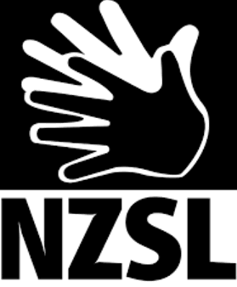
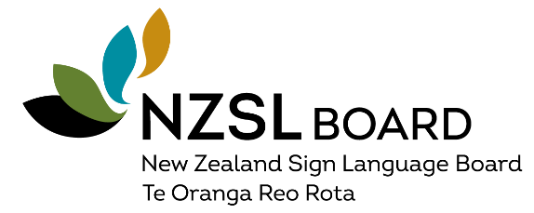 | 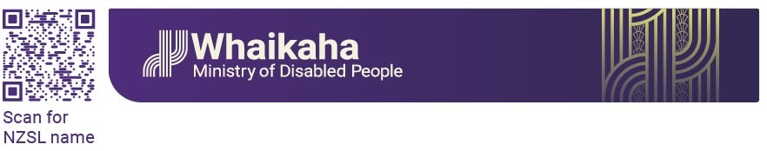

Contents
New Zealand Sign Language Community Survey 2022 1
Acknowledgements 4
Executive Summary 5
Introduction and Background 12
Purpose of the survey 12
Methodology 13
Designing the survey and ensuring accessibility 13
Participant criteria and target sample 16
Views of NZSL translations online 16
Participants – Who completed this survey? 18
Summary of sample characteristics and its limitations 18
Gender 19
Ethnicity 20
Age 21
Regional representation 22
Self-identification 23
Impairment (functional) 24
Mental Health 25
Self-rated proficiency in NZSL 26
Results for NZSL Priority 1 - Acquisition 27
Where is NZSL learned? 27
Satisfaction with Availability, Location, Content & Cost 30
Interest in learning more NZSL 32
Results for NZSL Priority 2 – Use and Access 33
Participation in Deaf spaces 33
Communication context 35
Difficulty experienced in use of NZSL 38
Satisfaction with translation into NZSL 39
Availability of interpreter in government services 41
Results for NZSL Priority 3 – Attitudes 43
Attitudes towards NZSL 43
Results for NZSL Priority 4 – Documentation 47
Documentation of NZSL 47
Finding information about signs 50
Results for NZSL Priority 5 – Status 51
What the government can do to support the NZSL community 51
Tāngata Turi – Māori Deaf participants 56
Concluding observations 58
Appendix 1 – NZSL Survey 60
Appendix 2 – Tables for graphs 69
Appendix 3 - Tables of responses from Māori participants 83

Acknowledgements
The NZSL Office at Whaikaha – Ministry of Disabled People would like to thank the NZSL Board, Ministry of Social Development and Deaf Studies Research Unit at Victoria University of Wellington for their advice on survey development.
We also acknowledge the individuals who assisted in testing the survey, and the Deaf clubs, Deaf Societies and Deaf Communities who attended community engagement hui across the country:

- Northland Deaf Club
- Auckland Deaf Society
- Waikato Deaf Club
- Bay of Plenty Deaf Club
- Hawkes Bay Deaf Club
- Taranaki Deaf Club
- Manawatu Deaf Society
- Wellington Deaf Society
- Nelson Deaf Community
- Deaf Society of Canterbury
- Otago Deaf Society
- Invercargill Deaf Community

Handwaves to all the respondents – thank you for your time!

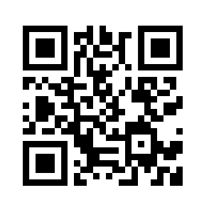
Executive Summary

Use the QR code to access the executive summary in NZSL.
The NZSL Board commissioned a national survey to gather data about the NZSL community’s satisfaction with the maintenance and promotion of NZSL, following the five priorities of the NZSL Strategy. This will help the Board to be responsive to the views of the community. The Board will consider the survey findings in its recommendations for the review of the NZSL Act 2006 that will be presented to Cabinet in 2023. The survey information will also be used as a baseline to help the NZSL Board monitor, evaluate, and make informed decisions on actions to maintain and promote NZSL.
The survey was developed in the first half of 2022 and tested with a small group of Deaf people. It was translated into NZSL, and community engagement hui were held across the country.
Sample characteristics
The sample size used for analysis was 584 individuals who knew or use NZSL. The sample was predominantly female, aged between 30-60 years, New Zealand European, and living in Auckland, Wellington, and Canterbury. 230 people identified as Deaf, 58 as hard of hearing (HH). The prevalence of a mental health condition was higher among Deaf and hard of hearing than hearing respondents. 75% of Deaf and hard of hearing respondents were proficient in NZSL compared to 46% of hearing.
While the sample is by no means representative, it has captured a wide range of issues that are currently relevant to many NZSL users and will help to grow NZSL and promote the inclusion of the Deaf community.

Priority 1 – Acquisition
Informal learning and community programmes were the most popular modes of acquisition of NZSL, followed by learning NZSL in the home as a natural language. 32% of Deaf and hard of hearing identified NZSL as their natural language and Deaf and hard of hearing were more likely to learn NZSL at school (23%) compared to hearing respondents (5%).
Figure 11 of the report (copied below) shows the difference between Deaf & HH and hearing respondents with regards to acquisition of NZSL.

Respondents reported greater satisfaction with the content covered in NZSL classes and the cost of classes, and greater dissatisfaction with the location and the availability of NZSL classes.
There is a call to prioritise the acquisition of NZSL for Deaf children, and for the Deaf community to take more of a leadership role in Deaf education in New Zealand.
Priority 2 - Use and access
Deaf/NZSL events were the most popular Deaf spaces among respondents, followed by Deaf clubs. A greater proportion of Deaf and hard of hearing respondents attended Deaf clubs, Deaf organisations, and online Deaf spaces than hearing respondents. The most frequent communication contexts among respondents were with Deaf friends, followed by home, Deaf club, and the workplace.
Figure 18 in the report (copied below) shows the differences between Deaf & HH and hearing respondents with regards to their participation in Deaf spaces.

91 Deaf and hard of hearing respondents had trouble using NZSL (about 32% of Deaf and HH respondents), which arose in a variety of spaces and for different reasons. Difficulties occurred in all public spaces and service places, all places where masks are used, in the family home, with friends, and at work or school. The reasons identified by respondents included lack of knowledge of NZSL/lack of effort made to learn NZSL, being unaware of Deaf culture, prohibitive cost, unavailability of interpreters, and large gatherings where there were multiple speakers and lots of noise.
Respondents were most satisfied with translations into NZSL provided by Deaf organisations. They reported lower satisfaction with translations by the media, and lowest satisfaction for translations provided by government agencies, and the education sector.
The good news is that access to services is being reported by some - close to two-fifths of Deaf and hard of hearing respondents are extremely and very satisfied with the provision of an interpreter when accessing a government service.
Priority 3 – Attitudes
Most respondents agreed that NZSL is a valid language and equal to other languages. This is shown in Figure 28 of the report (copied below).

Respondents were less likely to agree that NZSL is valued, recognised, and accepted by New Zealanders in general. This is shown in Figure 30 of the report (copied below).

Priority 4 – Documentation
The most popular source of documentation was the NZSL dictionary, followed by Learn NZSL. Hearing respondents were more likely to be familiar with the NZSL dictionary and Learn NZSL than Deaf and hard of hearing respondents. In contrast, a greater proportion Deaf and hard of hearing respondents were familiar with other sources, e.g., Deaf short films, Sign DNA and NZSL Share. This pattern is shown in Figure 33 of the report (copied below).

Most respondents agreed it was very or usually easy to find information about NZSL signs. 7% found it hard to find information.
Since the NZSL online dictionary is getting good mileage, there is potential for this tool to be expanded as a vehicle for knowledge of Deaf culture in general.
Priority 5 – Status
Free text entries from respondents regarding what the government could do to support the NZSL community, and any further comments about NZSL, were analysed according to themes that corresponded to the priorities of the NZSL Strategy. A selection of quotes from the report are presented for each theme.

Prioritising the acquisition of NZSL will contribute to enhancing its status
Prioritise NZSL acquisition for Deaf children:
“Focus funding and resources into early acquisition of NZSL for Deaf babies, children, childcare centres and their families”
Enable the completion of education in NZSL:
“Make an education pathway in NZSL real; create a first language learner curriculum for education”
Review Deaf education in New Zealand:
“Deaf Education in NZ should be run and controlled by Deaf”
Supporting the use of and access to NZSL will contribute to enhancing its status
Increase the accessibility of NZSL to ensure equal access to education, employment, health services, public services and cultural events:
“Have a database of all NZSL signers - so the govt agencies etc knowing in advance that the person is Deaf and required interpreters and/or extra assistance”
“Have iPads available at all government facilities in order for Deaf to access NZ relay instead of using up their own data to make video calls”
Consider access difficulties for Māori and for those in rural areas:
“Train more Māori Deaf to teach NZSL to the Māori Community”
“Better access to interpreters in smaller cities/towns especially in hospitals as often funding is given as an excuse not to provide interpreter”
Capitalise on the skills of Deaf people:
“Provide Deaf interpreting training for those who are Deaf. Their NZSL is their first and natural language that NZSL & Deaf community would understand easier and clear”

Changing attitudes towards Deaf culture and NZSL will contribute to enhancing its status
Time for a Public apology and reparation to the Deaf community:
“Public apology to the Deaf community for historical abuse, language deprivation, and subsequent inequities. Renumeration to the community for impact on potential earnings and damages”
“Acknowledge that years of discrimination have resulted in many Deaf people having … educational gaps create adult education programmes that are free, accessible, and safe culturally”
Communication in NZSL is a two-way street and can benefit everyone:
“Why is the onus on the Deaf community to use their [Workbridge] funding all the time? This has to be a collaboration. A hearing person/business needs the interpreter as much as the Deaf person”
Prioritise public education about Deaf history and culture:
“Include Deaf history as part of the new NZ history curriculum. Make NZSL learning a compulsory component of all teacher training”
Overall, respondents acknowledged the role of legislation, in particular the NZSL Act 2006, and protective bodies, such as a commission equivalent to the Māori Language Commission, in elevating NZSL. There was a call to establish roles to increase the presence of Deaf cultural advisors within government agencies, and ensure front line government and public service staff are educated on Deaf culture and the rights of a Deaf person.
Conclusion
Respondents in this survey have expressed that a positive environment for NZSL can be achieved by focusing on the needs of the Deaf community, and enhancing general public awareness of Deaf culture and knowledge of NZSL. Communication is an act of collaboration, and the promotion and protection of NZSL through the NZSL Strategy will benefit hearing people as much as Deaf people.

Introduction and Background
The New Zealand Sign Language Strategy (NZSL Strategy) 2018-2023 aims to enable Deaf and other NZSL users to learn and use NZSL naturally within a community of users, contributing significantly to its survival, sustainability, and vitality. The Strategy guides the NZSL work in government agencies and Crown entities to maintain and promote the use of NZSL by Deaf people and other NZSL users.
The 2018 Census identified about 23,000 people who use NZSL (including parents of Deaf children), of whom 4,599 are Deaf.
Of these:
- 1,410 people use NZSL as their only language
- 81 people indicated Māori (Te Reo) and NZSL only
- 12,930 indicated English and NZSL only
- 384 indicated another language and NZSL only
- 3,855 indicated Māori (Te Reo), English, and NZSL (the three official languages)
- 36 people indicated Māori (Te Reo), English, NZSL and other (four languages).

Purpose of the survey
The NZSL Board commissioned a national survey to gather data about the NZSL community’s satisfaction with the maintenance and promotion of NZSL, following the five priorities of the NZSL Strategy. This will help the Board to be responsive to the views of the community.
The priorities are:
- NZSL acquisition by adults and children
- Use/Access NZSL in all domains of society and within whānau
- Attitudes about NZSL
- Documentation of NZSL for research and reference
- Status of NZSL.
This survey is the second NZSL survey conducted nationally among NZSL users in recent history, following a 2014 study by the Deaf Studies Research Unit at Victoria University on the Vitality of NZSL.
The 2014 study analysed 255 responses to an online survey designed to understand Deaf people as the primary language community, where they use it, as well as perceptions about the vitality of NZSL and accessibility barriers faced. 75% of the participants were Deaf.
The current survey was designed with similar questions in mind, although it is broader in reach and seeks views from NZSL users in general to meet the needs of the NZSL Board. Information gathered will be used as a baseline to help them monitor, evaluate, and make informed decisions on actions to maintain and promote NZSL. The Ministry of Social Development and the NZSL Office at Whaikaha consulted with the Deaf community on the review of the NZSL Act 2006. The NZSL Board will consider this report in its recommendations that will be presented to Cabinet in 2023.

Methodology
This section outlines the approach taken to design the survey and make it accessible to users of NZSL, how the data was collected online, the target sample and narrowing of submissions to a final sample, and the type of analyses undertaken.
Ethics Approval
Ethics approval was obtained from the Ministry of Social Development Research Ethics Panel in April 2022.

Designing the survey and ensuring accessibility
The target audience was NZSL users, 18 years and older. However, younger NZSL users were also encouraged to complete the survey.
The survey questions were developed in the first half of 2022.
The NZSL Office received advice on the development of the questions from the NZSL Board, Ministry of Social Development and Deaf Studies Research Unit at Victoria University of Wellington.
Questions were designed to cover the five priorities of the NZSL Strategy. Options were provided for each question. In some cases, respondents could select more than one option (e.g., where do you learn NZSL?), in others, only one response was allowed (e.g., how satisfied are you with the availability of NZSL classes – very satisfied, somewhat satisfied, not at all satisfied, and not applicable).

Testing the survey
Testing was carried out with six Deaf and NZSL people between 15-70 years of age, including two Pākehā, two Māori, and two Pacific people.
Participants of this small pilot were asked three questions:
- What was the easy part(s) doing the survey?
- Which was the challenging part doing the survey?
- Was there anything you like to see to improve the survey?
All found the questions easy at first. As they became more difficult, participants found accessing the NZSL translations helpful.
The final 21 questions can be found in Appendix A.
Survey set up and activation
The questions were entered into Survey Monkey.
The survey and cover letter were spread across 12 electronic pages. Compulsory questions were designated with an asterisk (participants could not proceed until they had submitted a response, e.g., “How do you describe yourself – Deaf, hard of hearing, hearing, a parent, a professional, and other”).
Links to videos in NZSL were provided to describe the purpose of each question, outline the question, and the possible response options. A screen shot of the beginning of the survey is shown on the next page.
Responses were submitted between May 15 and June 26, 2022. The average time spent completing the survey was 10 minutes.

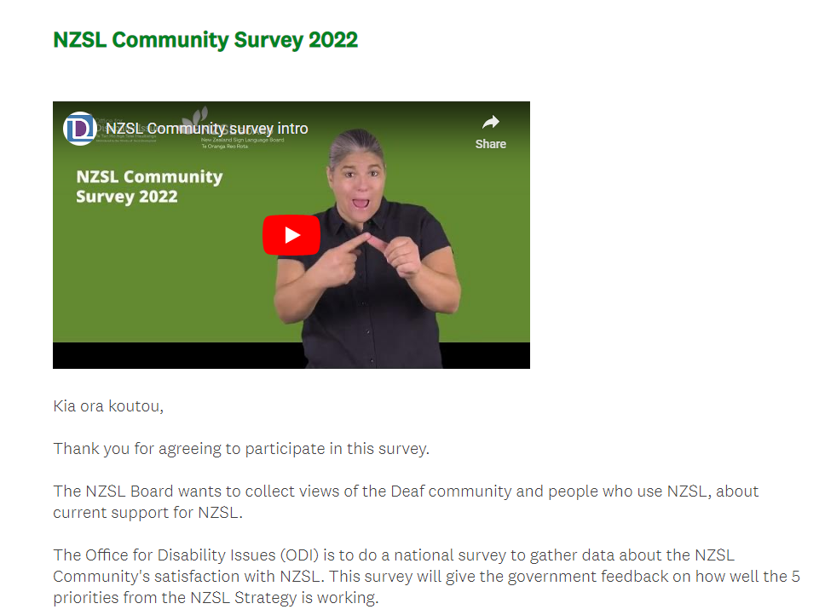
Promotion of the survey
The NZSL Office promoted the survey in person as well as in digital form.
Shona Jones and Darryl Alexander used the NZSL Community Engagement meetings to promote the NZSL Community Survey, and to educate and refresh the NZSL community’s understanding of the functions of the NZSL Board and NZSL Office, and how the NZSL Strategy works. The Community Engagement was also an opportunity for the NZSL community to bring up any questions and seek clarification about their feelings on the current issues of NZSL in Aotearoa, New Zealand.
12 Deaf clubs were identified as a meeting place for the NZSL Community because NZSL is used as their preferred language for communication. Holding the meetings at their local Deaf clubs was ideal.
Zoom sessions were offered for those who could not attend in person.
The survey was promoted with flyers and the NZSL Community survey cards, via emails to all our NZSL stakeholders, and on the NZSL Board and Office for Disability Issues Facebook pages. We encouraged NZSL stakeholders to share with their networks, not limited to their members, clients, colleagues, community, and learners.
A wide range of people attended the hui, including youth, older people, hearing, disabled people, families and parents of Deaf children, professionals, e.g., Teachers of the Deaf and Advisors of Deaf Children, NZSL learners, interpreters, and members from rural places such as the West Coast.
A summary of the four weeks of engagement with the Deaf community is presented in the NZSL Board Report from June 2022.
A total of 20 community engagement meetings were delivered across the country, including three on Zoom. 203 people participated in the meetings.

Participant criteria and target sample
The NZSL Office fixed a target of 500 completed surveys by 30 June 2022. This was surpassed with a total of 788 survey responses submitted over the seven weeks the survey was open.
After excluding participants who did not answer yes to the first question (“Do you know or use NZSL?”), the sample was reduced to 737 responses. When incomplete responses were excluded (those who did not answer all required questions and/or did not click Done on the last page of the survey), the sample was further reduced to 584 participants.

Views of NZSL translations online
The greatest use of the translations into NZSL was for the initial questions in the survey with 60 views for the first and 57 views for the second question (sparking interest and curiosity among participants). Question 3 on where people live and Question 7 on impairment both had 42 views.
Views of translations, then, tapered down, many questions having clicks from 25-26 participants, all the way down to 9 views for Question 9.
Overall, providing NZSL translations in the NZSL survey helped a core group of about 25-26 people to respond to the survey. No responses were submitted in NZSL.

Analysis
Data files were downloaded from Survey Monkey in excel format. For each question, the total number of respondents was calculated by deducting those who indicated N/A as a response.
Results are presented for each of the NZSL Strategy priorities with the relevant questions. First, responses from the entire sample are shown with the total number of respondents in a text box in each figure. Next, differences between Deaf and hearing respondents are presented. These were calculated by using responses to Question 9, “How do you describe yourself?”. Deaf and hard of hearing respondents were combined to form one category – Deaf – which was compared with respondents who indicated they were hearing.
Significance testing was used to determine whether the difference between two results is statistically significant or not, i.e., to determine the probability that an observed difference occurred because of chance or is a true difference that can be observed in the wider population. In these analyses, a statistically significant result was obtained if that probability was less than 5%.
Chi Square tests were conducted in Excel to determine whether there was a significant difference between the actual values observed and the expected values (if Deaf and hearing respondents were to demonstrate the same pattern of responding). If a significant difference was observed for a particular comparison, it means that being Deaf or hearing has an impact on the way a particular question is answered.
If a significant difference is not observed, it could mean that the way people respond to a particular question is not related to being Deaf or hearing. Or it can mean that there is a difference between groups, but the sample size is too small to reach significance.

Participants – Who completed this survey?

Summary of sample characteristics and its limitations
- The sample of 584 individuals was predominantly female, aged between 30-60 years, of New Zealand European heritage, and living in Auckland, Wellington, and Canterbury.
- 230 people identified as Deaf and 58 as hard of hearing, making up 49% of the sample. 207 people identified as hearing, making up 35% of the sample. This means that 15% of the final sample did not identify whether they were Deaf/HH or hearing. Only those who did identify with one of these groups were included in the cross-group analyses to determine any patterns in responses in relation to whether an individual is Deaf/HH or hearing.
- The prevalence of a mental health condition was higher among Deaf and hard of hearing than hearing respondents.
- 75% of Deaf and hard of hearing respondents were proficient in NZSL compared to 46% of hearing.
While the sample is by no means representative of the 23,000 people who use NZSL (including parents of Deaf children), of whom 4,599 are Deaf themselves, it has captured a wide range of issues that are currently relevant to many NZSL users, and will help to grow NZSL and promote the inclusion of the Deaf community.

Gender
This section is based on Question 4.
Figure 1 shows that of the 580 people who answered, 77% identified as female (447 people), 22% as male (125 people). 8 people identified as gender diverse/nonbinary/other.
The gender imbalance of this sample means that care needs to be taken in terms of generalising the results to all NZSL users.

Figure 1: Gender of respondents
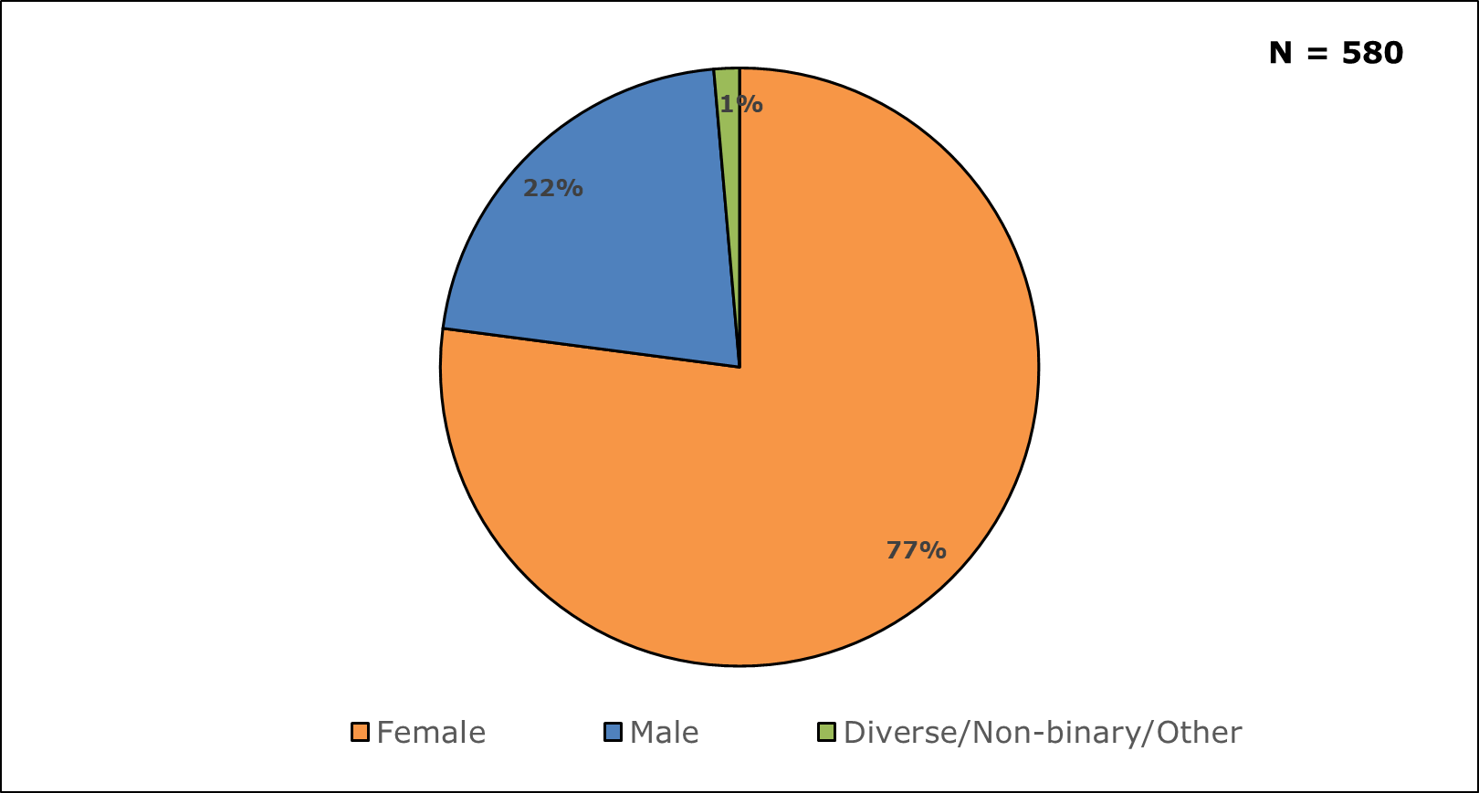

Ethnicity
This section is based on Question 6.
Individuals indicated whether they belonged to the following ethnic groups and could indicate more than one option: New Zealand European, Māori, Samoan, Cook Islands Māori, Tongan, Niuean, Chinese, Indian, and Other.
For these analyses, Māori and Cook Islands Māori were grouped together; Samoan, Tongan and Niuean were grouped as Pacific; and Chinese and Indian were grouped as Asian.
When Other was selected as an option, it was recoded where possible either in the former categories or as European.
Figure 2 shows that of the 578 individuals who answered, most respondents identified as New Zealand European (71% or 457 people), followed by Māori (14% or 91 people).

Figure 2: Ethnicity of respondents
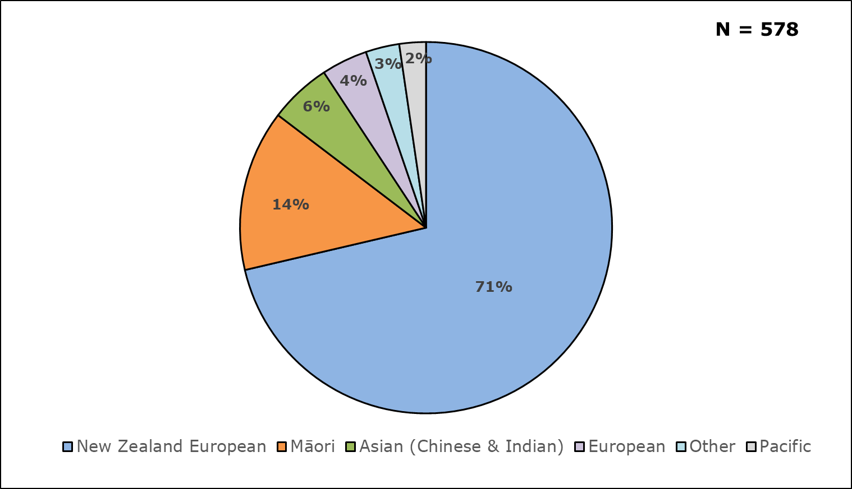

Age
This section is based on Question 5.
Figure 3 shows that most of the 555 participants who answered this question were aged between 30-60 years.
The age distribution of this sample may not reflect that in the population of the NZSL community. This means that care needs to be taken in terms of generalising the results to all NZSL users.

Figure 3: Age distribution of respondents

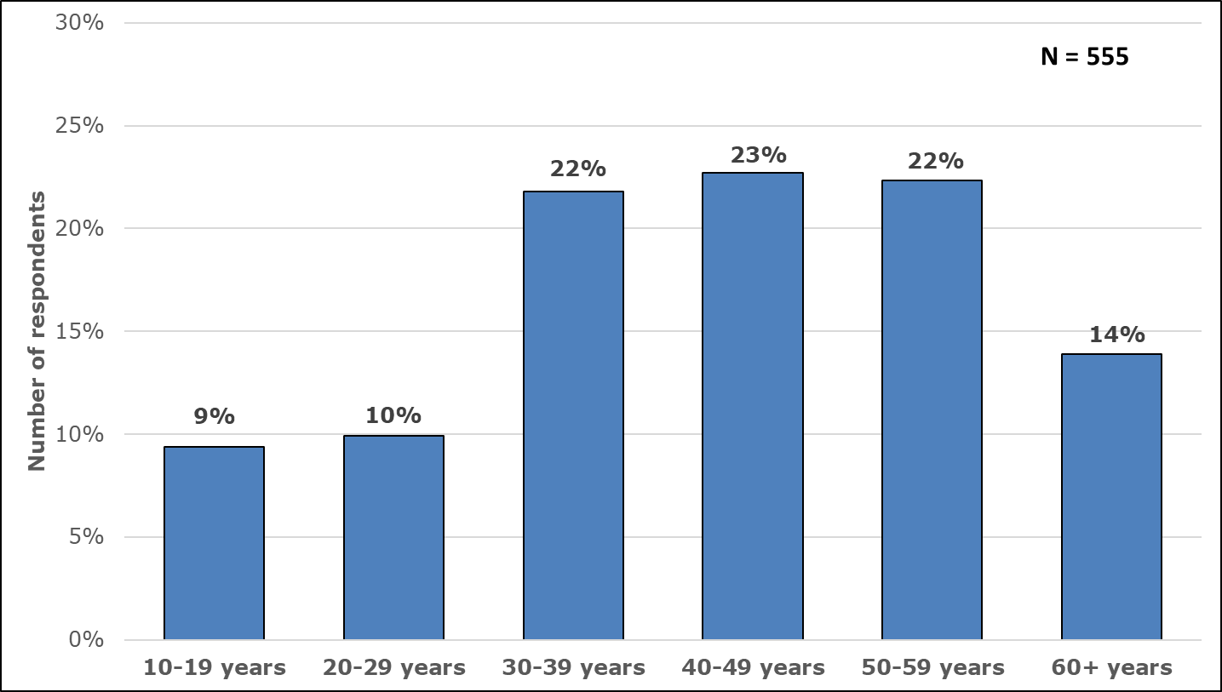

Regional representation
This section is based on Question 3.
Figure 4 shows that most of the 583 respondents who answered this question live in Auckland (26%), followed by Wellington (18.5%) and Canterbury (16%).
The regional distribution of this sample reflects the sampling methodology.
This means that care needs to be taken in terms of generalising the results to NZSL users in smaller regions.

Figure 4: Percentage of respondents by region

Self-identification
This section is based on Question 9. A total of 495 people indicated whether they were Deaf, hard of hearing, or hearing.
Figure 5 shows that most people identified as Deaf (230 individuals). A smaller number identified as hard of hearing (58 individuals). 207 individuals were hearing. For the purpose of analysis, Deaf and hard of hearing individuals were grouped together to compare their responses with hearing individuals.

Figure 5: Self-identification of NZSL users (based on hearing status)

Respondents to Question 9 were also asked to indicate if they were a parent/family/whānau of a Deaf or hard of hearing person, a NZSL professional, a community advocate, or other. Figure 6 shows that 122 people use NZSL because they are family members of a Deaf or hard of hearing person (21% of the total sample), and 114 individuals use it in a professional capacity or at work (20% of the total sample).

Figure 6: Relationship of NZSL users with Deaf and hard of hearing people

Impairment (functional)
This section is based on Question 7. Analyses do not include those who responded, “Don’t know” and “Not Applicable”.
562 respondents indicated whether they had difficulties doing certain activities because of a health condition, disability, or impairment. These questions are known internationally as the Washington Group Short Set, and they cover six functional domains: hearing, seeing, walking, self-care, communication and remembering or concentrating.
Disability status is usually derived from a threshold where individuals have at least “a lot of difficulty”, with at least one of the domains to be counted as disabled. However, we are not deriving this variable because the analyses in this report are presented by self-identification as Deaf and hard of hearing, and hearing.
Figure 7 below shows that most respondents had no difficulty across all six domains. It also shows that people who use NZSL have a range of impairments – not just hearing impairments. Among respondents the most common impairments were hearing (38%), and visual (30%).

Figure 7: Difficulty experienced across functional domains (Washington Group)
N = 562

Mental Health
This section is based on Question 8.
Of the 547 individuals who answered this question, 29 did not know if they experienced any mental health conditions such as depression or anxiety that have lasted for six months or more. 175 respondents reported that they did experience mental health conditions, 343 said they did not.
Mental health conditions, in general, are more common among disabled people – a pattern which was found in this sample. 239 Deaf and hard of hearing and 193 hearing individuals answered this question. Figure 8 shows a significantly higher percentage of people with mental health conditions were found among Deaf and hard of hearing respondents compared to hearing respondents.

Figure 8: Percentage of Deaf, hard of hearing, and hearing people who experience mental health conditions
N = 239

Self-rated proficiency in NZSL
Question 17, item 6, addressed self-rated proficiency in NZSL.
Of the 562 people who answered this question, 55% agreed that they are proficient, 25% disagreed (they do not think of themselves as proficient), and 17% were not sure whether they are proficient in NZSL.
Variation in proficiency, depending on whether someone is Deaf or hearing, was next examined. Based on the 229 Deaf and hard of hearing and 194 hearing individuals who answered this question, Figure 9 shows a greater proficiency in NZSL among Deaf and hard of hearing people than hearing people.

Figure 9: Self-rated proficiency in NZSL

Just under one-fifth of respondents are not sure whether they are proficient. This may be due to the absence of examples to illustrate what constitutes proficiency. Future surveys may include questions about specific situations, e.g., ability to purchase something using NZSL, to order from a menu, to communicate to their child’s teacher.

Results for NZSL Priority 1 - Acquisition | 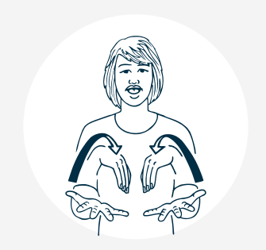

Where is NZSL learned?
This section is based on Question 10.
561 participants indicated where they learned NZSL, selecting as many responses as applicable. Figure 10 shows the most popular mode was through informal/social learning, followed by community education programmes.
“I absorbed NZSL as a deaf young adult mixing in the Deaf community.
It is now my everyday language”
A total of 276 respondents learned NZSL in their home environment – either as a natural language, or as a language spoken in the family.
“Grew up as a CODA* and went to Deaf preschool (KDEC)”
*Child of Deaf Adult(s)

Figure 10: Acquisition of NZSL
N = 561

There is a statistically significant difference between the way Deaf and hard of hearing people and hearing people reported how they learned NZSL, as shown in Figure 11.

Deaf and hard of hearing are more likely to report NZSL is their natural language and to have learned NZSL at school. In contrast, hearing people are more likely to report that they learned NZSL through a community programme, at work and through online classes.

Figure 11: Differences in acquisition of NZSL between Deaf and hard of hearing and hearing respondents

Respondents were able to select “other” and invited to specify where else they learned NZSL. There were 82 entries. Of these, First Signs and friends were mentioned 14 times each, night classes were mentioned 6 times, followed by Deaf Club and University (5 and 4 respectively).
Figure 12 shows a range of different places where NZSL is learned.

Figure 12: Word cloud showing the range of different sources of acquisition cited by all respondents

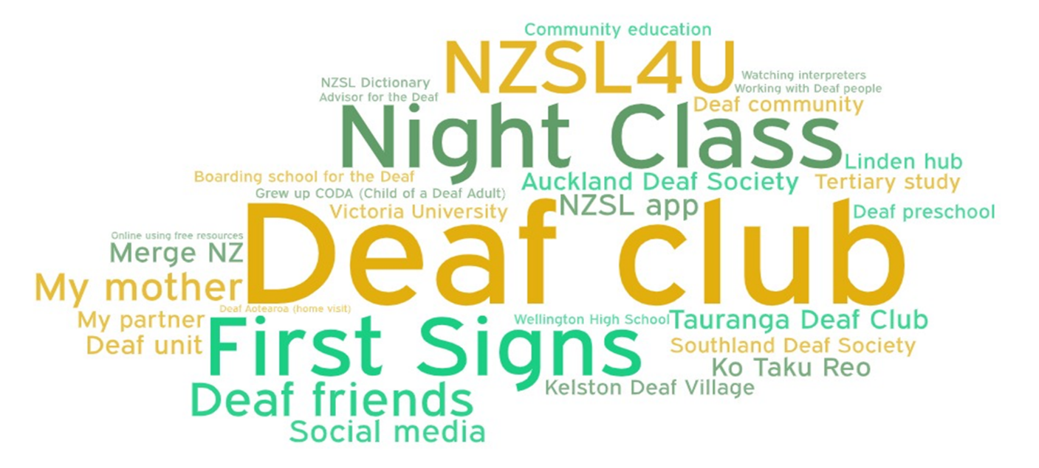

Satisfaction with Availability, Location, Content & Cost
This section is based on Question 11. 558 people indicated their level of satisfaction with at least one of the four learning opportunities presented in this question.
Figure 13 shows that most people are either very satisfied or somewhat satisfied with the availability, location, content, and cost of NZSL learning opportunities.
The greatest satisfaction was found for the content covered in NZSL classes (217 people were very satisfied with the content covered).
In contrast, more people were not at all satisfied about the location and availability of NZSL classes (93 people for both were not at all satisfied).

Figure 13: Satisfaction with availability, location, content, and cost of NZSL learning opportunities
N = 413

When comparing satisfaction between Deaf and hard of hearing and hearing respondents, sample sizes were small within the groups who responded. They were either very satisfied (Figure 14), or not very satisfied (Figure 15).
This means that observed differences are not statistically significant.

Figure 14: Differences in the proportion of Deaf and hard of hearing and hearing respondents who reported being very satisfied with availability, location, cost, and content of NZSL classes
N Deaf & HH = 85
N Hearing = 139
N Deaf & HH = 80
N Hearing = 134
N Deaf & HH = 112
N Hearing = 152
N Deaf & HH = 94
N Hearing = 144
Overall, a pattern emerged where more hearing respondents were very satisfied with the location, cost, and content of NZSL classes. In contrast, a greater number of Deaf and hard of hearing respondents were not very satisfied with location, cost, and content of NZSL classes.

Figure 15: Differences in the proportion of Deaf and hard of hearing and hearing respondents who reported being not very satisfied with availability, location, cost, and content of NZSL classes
N Deaf & HH = 85
N Hearing = 139
N Deaf & HH = 94
N Hearing = 144
N Deaf & HH = 94
N Hearing = 144
N Deaf & HH = 112
N Hearing = 152

Interest in learning more NZSL
This section is based on Question 17, item 7. 246 Deaf and hard of hearing and 198 hearing individuals answered this question.
As shown in Figure 16, most respondents overwhelmingly agreed that they have a strong interest in learning more about NZSL. A few respondents were either not sure or disagreed.

Figure 16: Interest in learning more about NZSL

Results for NZSL Priority 2 – Use and Access | 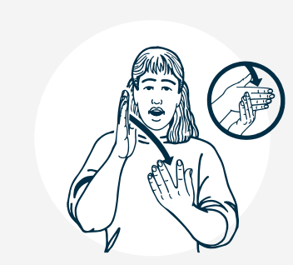

Participation in Deaf spaces
This section is based on Question 12. Respondents were asked about the Deaf spaces in which they participate. Four main spaces were presented as options. Of the 450 people who answered this question, 101 selected the option “other” and in the comments were able to specify their own Deaf domain/space. Some were able to be recoded into one of the four presented options.
Figure 17 shows that the most popular Deaf spaces presented in the main options are more formal Deaf/NZSL events (87% of respondents attended these), followed by Deaf clubs (70%). Deaf organisations and online Deaf spaces are also well-attended.
Some respondents noted that self-initiated or friend-initiated get-togethers in social groups constitute spaces for them. Others noted their church or marae, where members like to chat with them, or there is a specific religious Deaf group, e.g., Catholic Church group. Some noted their NZSL class as a space.
For some, access to Deaf space is limited. One respondent noted in their comments that there are no Deaf events in Gisborne, another noted that there is no Deaf club in Nelson, although they have regular community get-togethers.

Figure 17: Participation in Deaf spaces

Looking at the responses of the 147 Deaf and hard of hearing people and 92 hearing people who answered this question, there was a statistically significant difference, as shown in Figure 18. A greater proportion of Deaf and hard of hearing respondents attend Deaf clubs, online Deaf spaces, and Deaf organisations than hearing respondents.

Figure 18: Differences in participation in Deaf spaces between Deaf and hard of hearing and hearing respondents

Respondents were able to select “other” and invited to specify any other Deaf spaces in which they participate. A total of 105 entries were made.
20 people considered social get-togethers, coffee, and friends as Deaf spaces. Work was mentioned by 11 people. Deaf Wellbeing Society was mentioned 9 times. NZSL classes were considered a Deaf space by 6 people. Church was also designated by 4 people.
Figure 19 shows a range of different Deaf spaces noted by respondents.

Figure 19: Word cloud showing the range of different Deaf spaces cited by all respondents
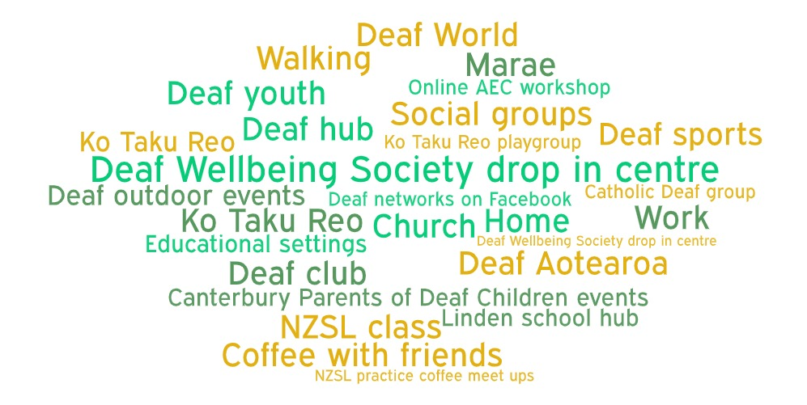

Communication context
This section is based on Question 13.
575 people indicated where they tended to communicate in NZSL from among 15 different contexts provided, ranging from sports to school to home. Marae was the most popular of the 88 “other” responses which participants could complete in free text.
Figure 20 shows that the most popular context for communicating in NZSL is with Deaf friends, followed by at home, and at the Deaf club.
Overall, communicating with friends represented almost one quarter of the context where respondents communicate in NZSL. The next most popular context of communication in NZSL was in the intimate sphere of one’s home and with family.
Work is also a frequent context where participants communicate in NZSL.

Figure 20: Contexts in which NZSL is used to communicate

The different patterns in communication contexts between the 159 Deaf and hard of hearing and 138 hearing people who answered this question, shown in Figure 21, are statistically significant.

The only context for using NZSL which is more frequent among hearing respondents is the workplace. Elsewhere, Deaf, and hard of hearing respondents more frequently use NZSL.

Figure 21: Differences in communication context between Deaf and hard of hearing and hearing respondents

Difficulty experienced in use of NZSL
This section is based on Question 14. 216 people answered this question.
Of these, 91 Deaf and hard of hearing people noted difficulty using NZSL (32% of Deaf and HH respondents).
Analysis of responses revealed two main themes – where difficulties are experienced, and why are they experienced.

Where are difficulties experienced?
- All public spaces and service places, e.g., shops, supermarket, cafes, doctors, dentist, hospital, library, sport, recreation, trades, real estate, bank, social services, e.g., WINZ
- Family home and family gatherings
- Friends and social gatherings
- Where masks are used
- In public transport
- At work with colleagues
- At school, whether in person or online, as a student or parent
- Community and cultural and educational events, in person or online
- At the marae.

Why are difficulties experienced?
- Others don’t know NZSL, or don’t make an effort to learn, e.g., family
- Others unaware of Deaf culture
- Mask wearing prohibits lip reading and facial expressions
- Prohibitive cost of interpreters and limited funding (not for community events or family events, not for 65+)
- Unavailability of interpreters (capacity in general & rural locations)
- Short notice to book an interpreter
- Large gatherings, noise - even with interpreter - hard to keep up
- Intersectionality, Deaf and another disability limits their ability to sign
- Limited sign language as learned later in life
- Screen set up on zoom is tricky to be able to see speaker and signer.

Satisfaction with translation into NZSL
This section is based on Question 15.
557 people indicated their level of satisfaction with at least one of the four translation sources presented in this question.
Figure 22 shows respondents were most satisfied with translations available by Deaf organisations, with 65% of responses falling into the extremely satisfied and very satisfied ratings.
In terms of media, 65% of respondents were either somewhat satisfied or not so satisfied. This means that while some needs are being met, there is much room for improvement.
The least level of satisfaction was evident among the education sector and other government agencies. Over one-fifth of respondents were not at all satisfied with the translation into NZSL in education and other agencies.

Figure 22: Satisfaction with translation into NZSL

Satisfaction can be compared between Deaf and hard of hearing and hearing respondents. For this analysis, respondents who indicated that they were somewhat satisfied were excluded. Observed differences in satisfaction with translations into NZSL between Deaf and HH, presented in Figures 23 and 24, are not statistically significant.

Figure 23: Differences in the proportion of Deaf and hard of hearing and hearing respondents who reported being extremely and very satisfied with the translation into NZSL

Figure 24: Differences in the proportion of Deaf and hard of hearing and hearing respondents who reported being not so and not at all satisfied with the translation into NZSL

Respondents were asked to list some examples of NZSL translations they have seen. Of the 230 entries, Covid-19 press conferences were noted in 39% of examples. The second-most popular example was on television during NZSL week (18% of examples). Translations by Deaf Aotearoa were mentioned 32 times, Deaf Clubs 21 times, and at school 9 times.

Figure 25 shows the range of translations mentioned by respondents.

Figure 25: Word cloud showing the range of examples of translations into NZSL cited by all respondents 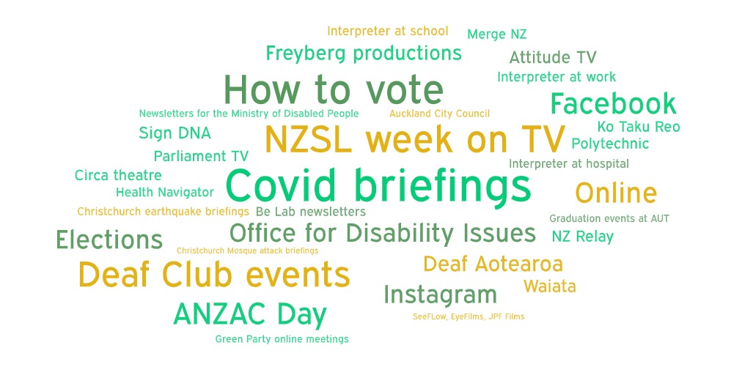

Availability of interpreter in government services
This section is based on Question 16.
301 respondents who use NZSL interpreters rated how satisfied they are that a qualified NZSL interpreter will be provided to them when accessing a government service.
Figure 26 shows that most respondents were somewhat satisfied that they would be provided with an interpreter, followed by not so satisfied.
One third of respondents were either extremely or very satisfied with the provision of a NZSL interpreter when accessing government services.

Figure 26: Satisfaction with availability of interpreter

202 Deaf and hard of hearing and 55 hearing people answered this question.
For this analysis, respondents who indicated they were somewhat satisfied were excluded. The difference in satisfaction with the provision of an interpreter between Deaf and hard of hearing and hearing respondents, shown in Figure 27, is statistically significant.

Figure 27: Differences in satisfaction with the availability of an NZSL interpreter between Deaf and hard of hearing and hearing respondents

A greater proportion of Deaf and hard of hearing respondents were extremely and very satisfied with the provision of interpreters. This pattern is likely to reflect lived experience among Deaf and hard of hearing respondents, and expectations and missed opportunities perceived by hearing respondents.
Results for NZSL Priority 3 – Attitudes | 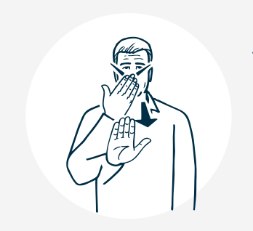

Attitudes towards NZSL
This section is based on the first 5 items of Question 17.
Respondents were asked whether they agreed with the statement that NZSL is:
- A valid language
- Equal to other languages
- Recognised by all New Zealanders
- Valued by all New Zealanders
- Accepted by all New Zealanders.
As shown in Figure 28 below, most respondents agreed with the statement that NZSL is a valid language, having a right to exist (97% of 565 respondents), and about two thirds indicated that NZSL is equal to other languages, being valued to the same extent as spoken languages (68% of 563 respondents).

Figure 28: Attitudes towards NZSL as an equal and valid language

Attitudes can be compared between Deaf and hard of hearing and hearing respondents. In the analysis below, respondents who indicated they were not sure were excluded. Observed differences between Deaf and HH respondents, shown in Figure 29, are not statistically significant.

Figure 29: Differences in attitudes towards NZSL being equal and valid between Deaf and hard of hearing and hearing respondents

Figure 30 shows that respondents thought New Zealanders in general held more negative attitudes towards NZSL than they did. Between 35-42% of respondents disagreed that NZSL was valued, recognised, and accepted by all New Zealanders.

Figure 30: Inferred attitudes towards NZSL among New Zealanders in general

Inferred attitudes were compared between Deaf and hard of hearing and hearing participants. In the analysis below, respondents who indicated they were “not sure” were excluded. Observed differences in Figure 31 are not statistically significant.

Figure 31: Differences in inferred attitudes between Deaf and hard of hearing and hearing respondents

The pattern in responses is for a higher number of Deaf and hard of hearing respondents to agree that NZSL is accepted, recognised and valued by New Zealanders in general than hearing respondents.
Results for NZSL Priority 4 – Documentation | 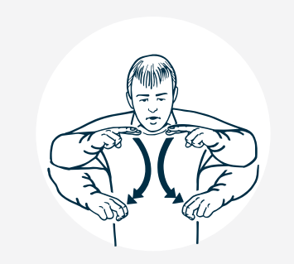

Documentation of NZSL
This section is based on Question 18.
565 respondents selected at least one of seven different resources or documentation modes of NZSL as ones they had previously seen or used.
Figure 32 shows that almost all respondents had come across the NZSL Online Dictionary (92%), followed by Learn NZSL (65%).
In contrast, less than 200 respondents were familiar with Sign DNA, NZSL Share, NZSL Reference Grammar and Research Publications on NZSL.

Figure 32: Familiarity with sources of documentation of NZSL

Differences in familiarity with modes of documentation of NZSL between Deaf and hard of hearing and hearing respondents, shown in Figure 33, are statistically significant.

Figure 33: Differences in familiarity with sources of documentation of NZSL between Deaf and hard of hearing and hearing respondents

More hearing respondents are familiar with the NZSL online dictionary and Learn NZSL. In contrast, Deaf and hard of hearing respondents are more familiar with other modes of documentation such as Deaf short films, Sign DNA and NZSL Share.
Respondents were invited to list examples of other NZSL documentation records that they have seen or used. Of the 136 entries, Turi TV was mentioned 21 times, Thumbs Up [https://nzsl.tki.org.nz] and Deaf Wellbeing Society 15 times each. Resources such as TeachSign, First Signs, NZSL4U and the NZSL Dictionary Online were mentioned between 9 and 14 times. YouTube was specified as a documentation source 11 times. Ko Taku Reo received 7 mentions.
Figure 34 presents the range of records noted.

Figure 34: Word cloud showing the range of examples of documentation of NZSL cited by all respondents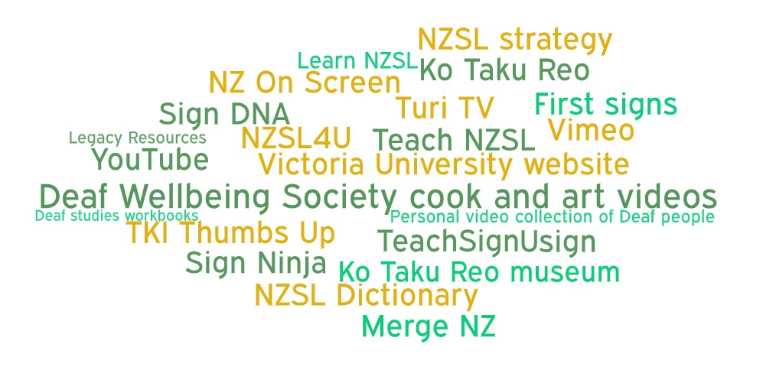

Finding information about signs
This section is based on Question 19.
The survey asked how easy it was for respondents to find information about NZSL signs. Figure 35 shows the majority of the 577 respondents found it either very easy or usually easy to find information about signs (86%).
41 individuals found it hard to find information about NZSL signs (7%).
No significant difference was found between Deaf and hard of hearing and hearing respondents in terms of ease of finding information about signs.

Figure 35: Ease of finding information about NZSL signs

Results for NZSL Priority 5 – Status | 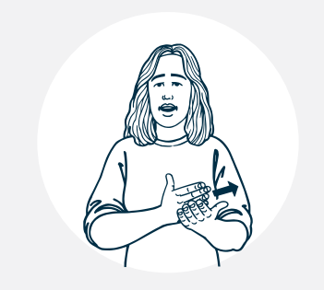

What the government can do to support the NZSL community
This section is based on the free text answers to Questions 20 and 21 about what the government can do to support the NZSL community and any further comments about NZSL use.
555 entries were received for Question 20 and a further 256 entries for Question 21. Some key themes came through the free text responses, presented first by frequency, and then by themes. Overall:
- school was mentioned 273 times (compulsory received 61 mentions)
- learn/learning was mentioned 217 times
- 164 entries were about funding
- community was mentioned 135 times
- children were mentioned 96 times, and Deaf children made up 57 of these entries
- work was specified 93 times
- Māori (language) was present in 84 entries as a comparison for NZSL
- family was mentioned 76 times
- Government was present in 60 entries
- Deaf culture was mentioned 49 times.
The entries were coded into themes that span the five priorities of the NZSL Strategy. Sub themes within each priority are presented below, along with an example quote.

Prioritising the acquisition of NZSL will contribute to enhancing its status
Offer NZSL as a subject at school:
“Make it a language that is learnt at school. It is one of our official languages so they should be making it accessible to all and encouraging all to learn”
“She should have access at school to her own language”
Make NZSL compulsory for one year at school:
“Make NZSL mandatory in every high school for first year, taught by Deaf tutors (not Teachers of the Deaf - there aren't enough available).
Need a MOU with the school”
Prioritise NZSL acquisition for Deaf children:
“Support more families to bring their children to NZSL bilingual classes”
“It [learning NZSL] was the best thing we have done for her and our family as it has given her the ability to be in the Deaf world and hearing world and for us to participate to an extent in the Deaf world”
“Focus funding and resources into early acquisition of NZSL for Deaf babies, children, childcare centres and their families”
Give consideration to Māori sign language:
“I think Māori sign language and NZSL be equal I did not want see Māori Deaf people are lost in future will happening”
Enable the completion of education in NZSL:
“Make an education pathway in NZSL real; create a first language learner curriculum for education”
Increase funding for free NZSL classes:
“More free NZSL classes available to families as well to those who wanted to learn NZSL to communicate with their Deaf/hard hearing friends or family members or with Deaf community”
Extend available classes for more in-depth learning:
“First Signs isn’t a good enough service - 45 mins a fortnight … doesn’t give you enough language to enhance cognition in kids”

Review Deaf education in New Zealand:
“Deaf children do not always have regular access to deaf language models and socialisation in the Deaf community when they should start learning NZSL (from birth). There are very few Deaf teachers of the Deaf in NZ deaf education, meaning even when a child goes to a Deaf school, they do not have fluent language role models and they do not learn about deaf culture, community, and identity development”
“Deaf Education in NZ should be run and controlled by Deaf”
“Urgent review of Deaf education especially after the merge of the two Deaf Education Centres”

Supporting the use and access to NZSL will contribute to enhancing its status
Increase the accessibility of NZSL to ensure equal access to education, employment, health services, public services and cultural events:
“Give NZSL community opportunity to get jobs or study with easy access example someone applied many jobs but mostly dropped … study is mostly hard for deaf with low English language”
“Have a database of all NZSL signers - so the govt agencies etc knowing in advance that the person is Deaf and required interpreters and/or extra assistance”
“Have iPads available at all government facilities in order for deaf to access NZ relay instead of using up their own data to make video calls”
“Make sure mental health & wellbeing services are available directly in NZSL. This is a very very real issue”
“Have more interpreters for the hearing impaired on TV”
“There are no provision for NZSL interpreters and/or translations for us [at festivals], the Deaf ratepayers. Maybe the government will look into forming a new levy system for funding NZSL accessibility i.e., media, transport, health, etc?”
Build NZSL into services from the start:
“Ensure that NZSL is built in at the beginning of services not an after-thought at the end - oh you need an NZSL translation, we will get back to you”

Consider access difficulties for Māori and for those in rural areas:
“Train more Māori Deaf to teach NZSL to the Māori Community”
“Better access to interpreters in smaller cities/towns especially in hospitals as often funding is given as an excuse not to provide interpreter”
Capitalise on the skills of Deaf people:
“Provide Deaf interpreting training for those who are Deaf. Their NZSL is their first and natural language that NZSL & Deaf community would understand easier and clear”
“Provide funding for more Deaf professionals to be employed by Deaf Aotearoa to enhance services that fill in the gaps… often Deaf people need Social Workers or support staff that can bridge the gaps”
Enable choice in the selection of interpreters:
“Unify some of the interpreter funding and allow choice of service for users”

Changing attitudes towards Deaf culture and NZSL will contribute to enhancing its status
Time for a Public apology and reparation to the Deaf community:
“Public apology to the Deaf community for historical abuse, language deprivation, and subsequent inequities. Renumeration to the community for impact on potential earnings and damages”
“Acknowledge that years of discrimination have resulted in many Deaf people having … educational gaps create adult education programmes that are free, accessible, and safe culturally”
Communication in NZSL is a two-way street and can benefit everyone:
“Why is the onus on the Deaf community to use their [Workbridge] funding all the time? This has to be a collaboration. A hearing person/business needs the interpreter as much as the Deaf person”
“People should be made more aware that it is useful not just for communicating with Deaf – e.g., can communicate to people far away or in noisy environments or there may be lots of us who lose our hearing as we get older who it would help to feel less isolated”

Time for discriminatory policies to be removed e.g., immigration:
“Remove constraints on immigration rules so that Deaf expertise can move to New Zealand to grow our workforce”
Role of Deaf community in changing attitudes:
“I don't think it is govt solely that need to support NZSL community better. Deaf Community has a role to play and learn to work in partnership to spread NZSL in a positive way”

Supporting the documentation of NZSL will contribute to enhancing its status
Keep the NZSL dictionary up to date:
“NZSL dictionary updated with more signs. So many not there”
“Remove old signs that are not used anymore”
Actively research for new signs:
“Keep researching for new signs and publish new signs due to technology there are new words being developed”
Encourage research in Deaf education:
“Would like to see more research in Deaf education in other countries that are successful and why? The NZSL itself is dying and need action to protect the language and the culture for future Deaf generation to come”

How the government can enhance the status of NZSL
Legislation can elevate the language and develop protective mechanisms / bodies / roles:
“Amend and strength the NZSL Act 2006. The Deaf community have some very valid arguments about why the NZSL Act is so weak and not producing the outcomes the Deaf community have hoped for. Until the Act is strengthened, it is unlikely that NZSL will progress in the country’”
“Recognise fully the value of NZSL – there is a Māori Language Commission, where is the equivalent for NZSL?”
“Establish roles for Deaf cultural advisors within government agencies”
Develop standards and qualifications in NZSL:
“Have a national standard of certification for people learning NZSL.
A qualification that we can then show to employers”

Prioritise public education about Deaf history and culture:
“Include Deaf history as part of the new NZ history curriculum. Make NZSL learning a compulsory component of all teacher training”
“Ensure front line government and public service staff are educated on how to access NZSL, on Deaf culture, and on the rights of a Deaf person”
“Get the legal system sorted so all lawyers learn to be Deaf aware. That police do not communicate or interview without an interpreter”

Tāngata Turi – Māori Deaf participants
Responses were received from 91 participants who identified as Māori (this includes Māori and another cultural heritage), comprising 14% of the total sample. Of these, 89 were included in analyses. Significance testing comparing the responses of Māori participants with the overall sample has not been carried out in this section of the report. Tables with data are included in Appendix 3.
44 Māori identified themselves as Deaf or hard of hearing (49%), and 26 identified as hearing (29%). 19 people did not identify themselves as either Deaf, HH or hearing. 43 Māori were proficient in NZSL, and 20 were not proficient.
Māori participants were most likely to learn NZSL at school (37%). 29% learned NZSL at home and similarly 29% through informal learning. NZSL is the natural language for 22% of Māori respondents.
35% of Māori respondents were very satisfied with the content of NZSL classes, and another 31% were very satisfied with the cost of classes. In contrast, 23% and 20% of Māori respondents were not very satisfied with the location and availability, respectively, of NZSL classes.
Māori respondents seemed to access fewer Deaf spaces than the overall sample, with an average of 2 spaces per person compared with 3 spaces for the overall sample. Of the spaces presented in the survey, Deaf or NZSL events were most popular (34% of responses), followed by Deaf clubs (28% of responses).
The most frequent NZSL communication contexts for Māori respondents were with Deaf friends and at home (58% and 54% of respondents respectively), followed by chats with hearing friends and the workplace (46% and 45% respectively). The marae was mentioned by 23% of Māori respondents.
18% of Māori respondents noted they had experienced difficulty in using NZSL. Most found it usually and very easy to find NZSL signs.
When it comes to satisfaction with translations into NZSL, 56% were extremely and very satisfied with the work done by Deaf organisations. In contrast, 50% were not so and not at all satisfied with the work done by government agencies. 32% were not so and not at all satisfied with translations by the media.
88% of Māori respondents agreed that NZSL is a valid language, and 57% agreed that it is equal to other spoken languages. When answering questions about attitudes of New Zealanders in general, 50% were not sure whether NZSL was accepted, 38% disagreed that it was recognised, and 30% disagreed that it was valued.
Almost all Māori respondents were familiar with the NZSL online dictionary (97%), and 63% were familiar with Learn NZSL.
Limited language impedes access to cultural heritage, as noted by a respondent who brought to light the unfair and limited access to te reo for Māori Deaf:
“My Deaf best friend (NZSL user) wanted to join my Te Reo Māori class which is a free course from a tertiary provider. Yet there are ABSOLUTELY no funding pools to cover for her to have access to an interpreter. We have contacted workbridge, MOE and MSD. Why is there a free course for the general public to attend yet Tangata-Turi have to pay to access and learn their own language and culture?”
Comments in the last two questions of the survey also reflected the need for interpreters who are trilingual (Māori, English and NZSL):
“…invest in making interpreting more sustainable as a profession in order to allow more to be accessible, as well as training more Deaf interpreters to be proficient in translation theory and practise so that more content can be produced in L1 NZSL, promote NZSL interpreting at kura kaupapa Māori and support access in te ao Māori”
One respondent suggested using a NZSL digital platform, such as BSL Zone (British Sign Language TV) for online access to video resources in NZSL that would bring Te Ao Māori to Tāngata Turi.

Concluding observations
This community survey of NZSL users has brought together clear messages about the importance of the five priorities of the NZSL Strategy, and how they are interrelated. Acquisition, increasing use and access, changing attitudes, promoting documentation and protection through legislative mechanisms are all key steps in elevating the status of NZSL as an official language of New Zealand. Often, the same key Deaf organisations are serving multiple purposes – teaching NZSL, a place where NZSL is used, and a source of documentation of NZSL.
While the sample was by no means representative, it captured a wide range of issues currently relevant to many NZSL users and will help to grow NZSL and promote the inclusion of the Deaf community.
Some issues and opinions are experienced and shared among Deaf and hard of hearing and hearing people, while others are particular to either Deaf and hard of hearing, or to hearing people. For instance, acquisition pathways differ between these two groups. The home and school are key places of learning NZSL for Deaf and hard of hearing (32% of Deaf and HH participants learned NZSL at home), while community programmes are important for hearing people (26% of hearing participants learned NZSL in such programmes).
Clear directions for growth have emerged from this survey. NZSL users have expressed dissatisfaction with the location and availability of NZSL classes (23% and 21% respectively said they were not at all satisfied). Almost everyone is keen to learn more about NZSL.
This survey has shown that NZSL is used in a wide variety of contexts, not just in traditional Deaf spaces such as clubs, and mostly with Deaf friends during social get-togethers, at home, in the workplace, and the marae.
Some Deaf and hard of hearing experience difficulty using NZSL in public and private spaces, given a lack of Deaf culture and NZSL knowledge, the use of masks during Covid which prevented the use of facial cues and lip reading, and the prohibitive cost and unavailability of interpreters. Challenges to the inclusion of Deaf people arise in crowded and noisy spaces with multiple speakers.
There is room for government agencies, especially the education sector, to improve their provision of translations into NZSL, with low levels of satisfaction among NZSL users. The good news is that inclusion is being felt by some - close to two-fifths of Deaf and hard of hearing respondents are extremely and very satisfied with the provision of an interpreter when accessing a government service. Growing the number of trilingual interpreters in Aotearoa New Zealand is important for Turi Māori.
NZSL users in this sample hold positive attitudes about NZSL, believing it is a valid language and equal to other languages. However, when it comes to inferred attitudes towards NZSL, users perceive that New Zealanders in general are less likley to agree that the language is valued, recognised and accepted.
Deaf and hard of hearing people are aware of a wider range of NZSL documentation sources than hearing people. The NZSL Online Dictionary is getting good mileage with 92% of respondents using this source. There is potential for this tool to be expanded as a vehicle for knowledge of Deaf culture in general.
Legislation and policies are key mechanisms in the wider society to protect NZSL, such as the NZSL Act 2006 and the potential to esablish a NZSL Commission. Respondents proposed that agencies have Deaf advisors in the organisation and have high expectations of public services to be able to engage with them in NZSL. Respondents noted that a register of communication requirements could be a useful tool for enhancing inclusion of the Deaf community.
The Deaf community is also a resource itself, with potential for Deaf professionals to be flagged for individuals seeking a service, as well as facilitating more Deaf people to become interpreters themselves.
There is a call to prioritise the acquisition of NZSL for Deaf children, and for the Deaf community to take more of a leadership role in Deaf education in New Zealand.
A call was made for discriminatory policies to end, such as immigration constraints, and for a formal apology to the Deaf community for historical abuse, language deprivation, and subsequent inequities.
In conclusion, respondents in this survey have expressed that a positive environment for NZSL can be brought about by focusing on the needs of the Deaf community and of Turi Māori, and enhancing general public awareness of Deaf culture and knowledge of NZSL. Communication is an act of collaboration, and the promotion and protection of NZSL through the NZSL Strategy will benefit hearing people as much as Deaf people.

Appendix 1 – NZSL Survey
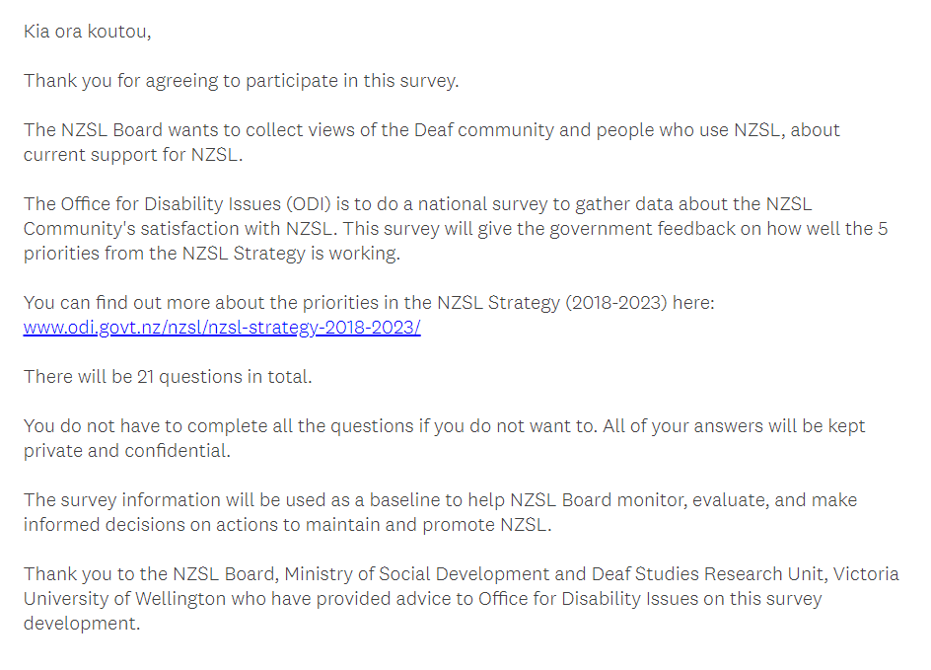
1.
2.
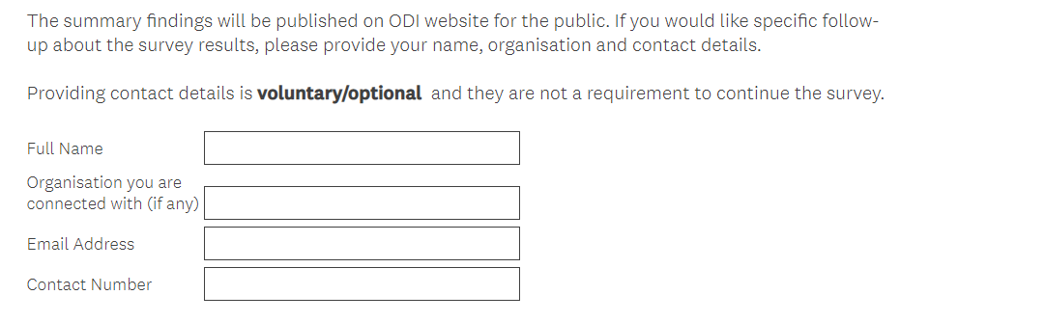
4.
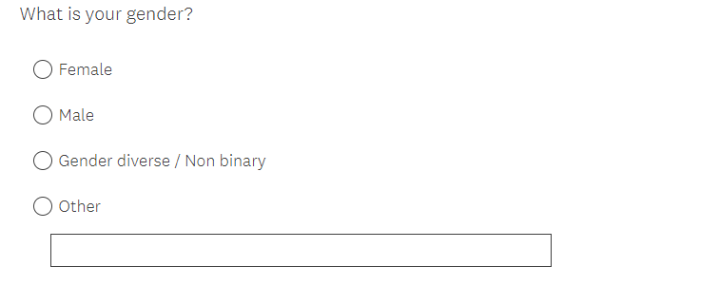
5.

6.
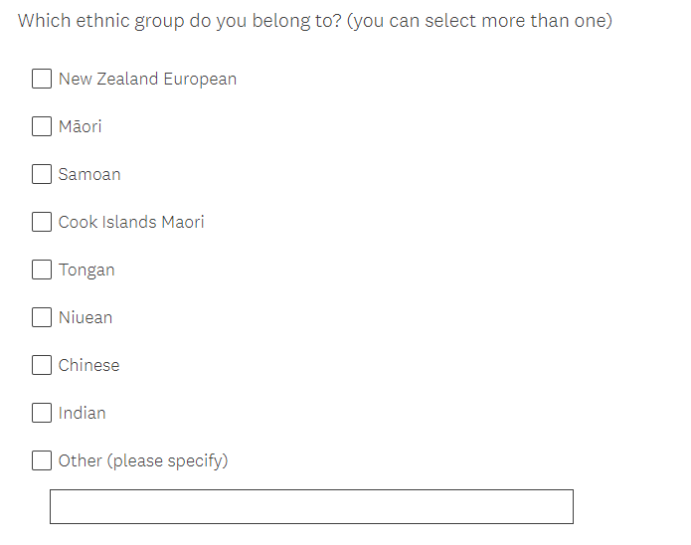

7.
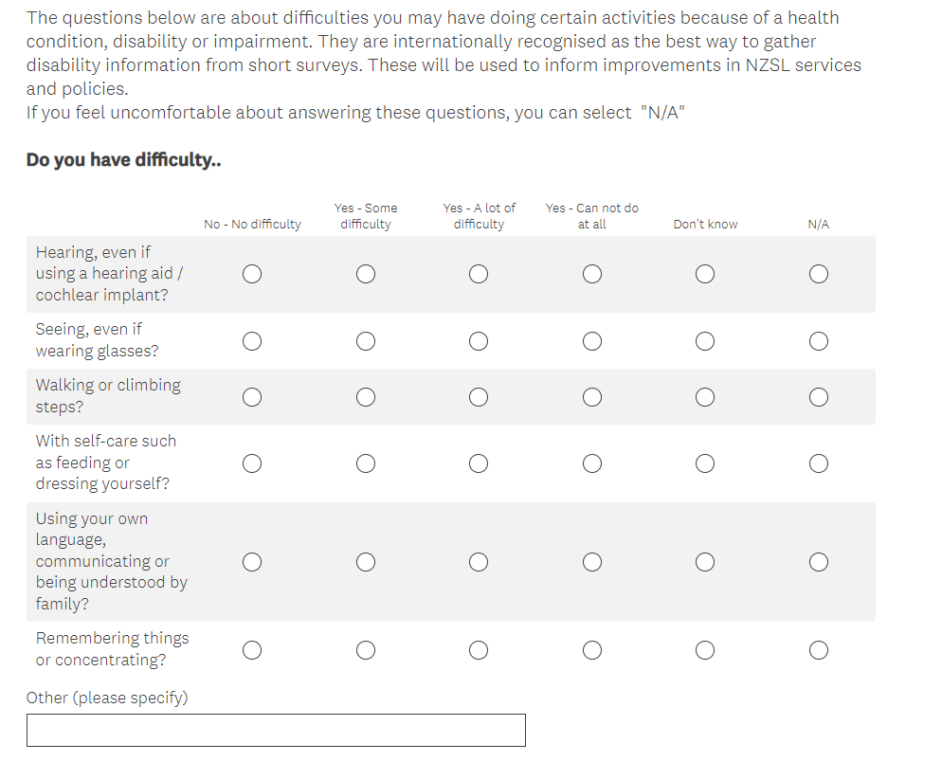

8.
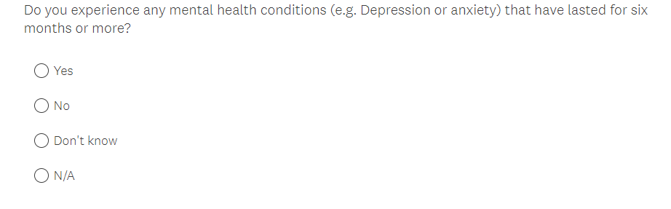

9.
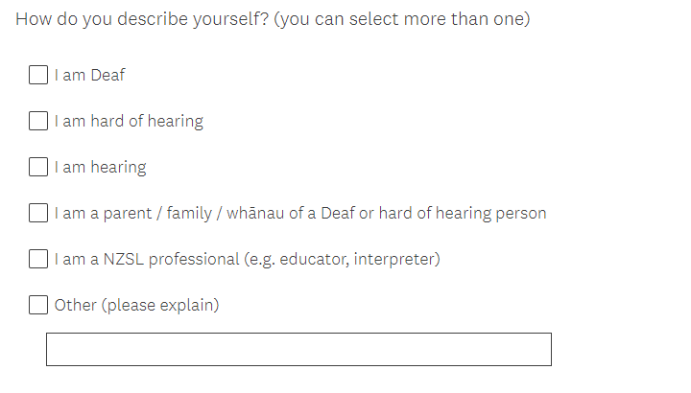

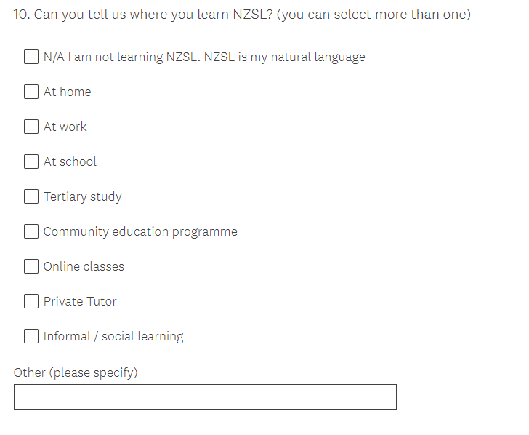

11.
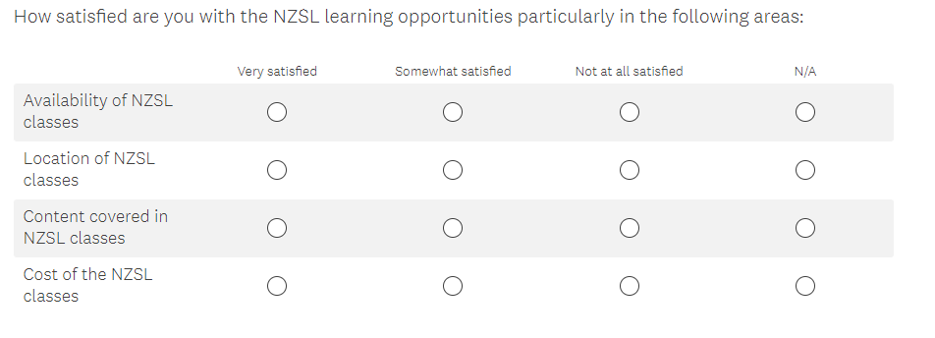

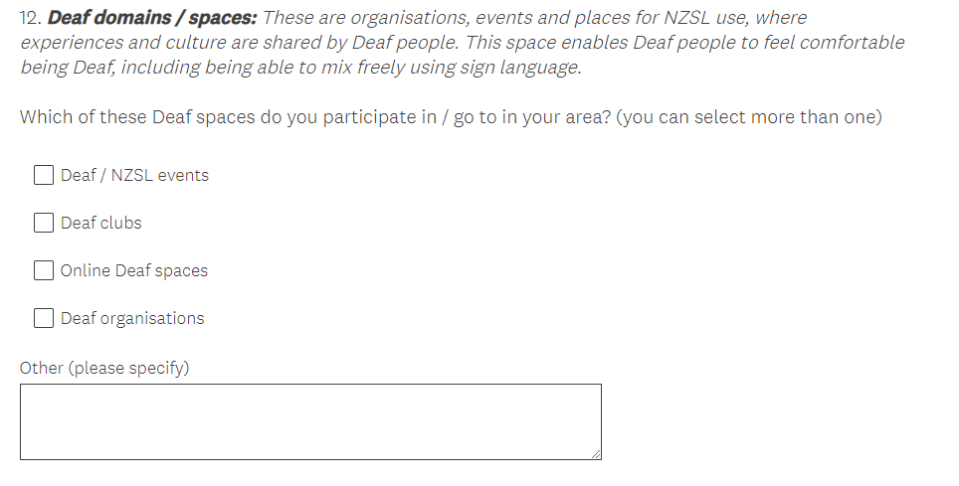

13.
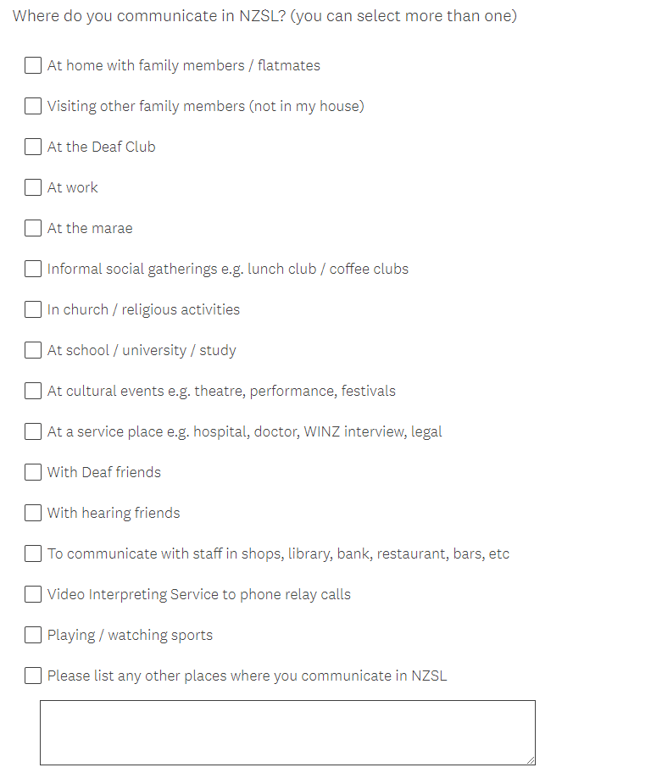

14.
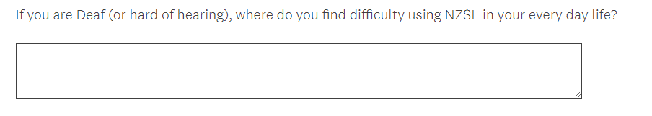

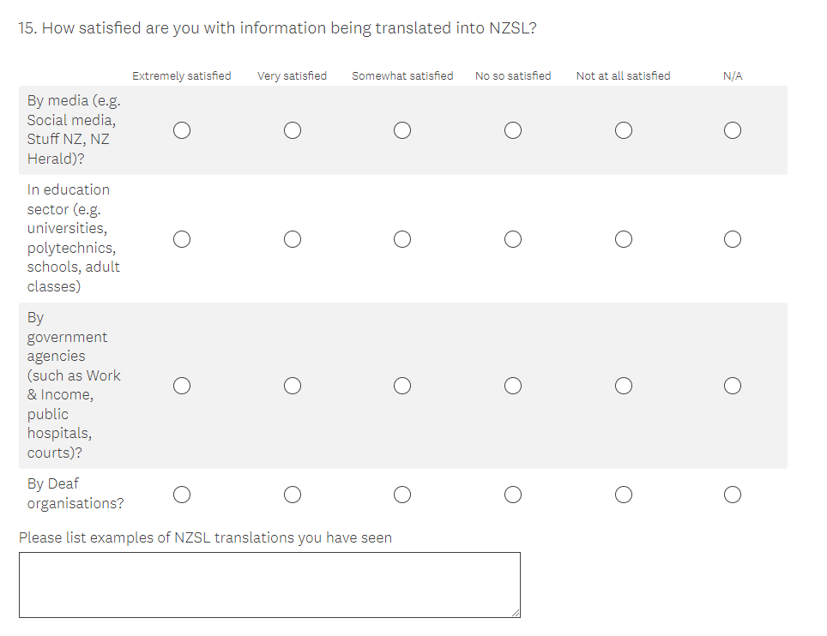

16.
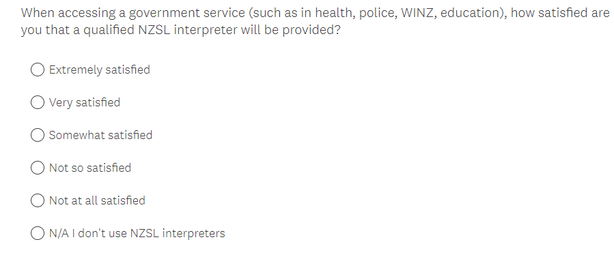

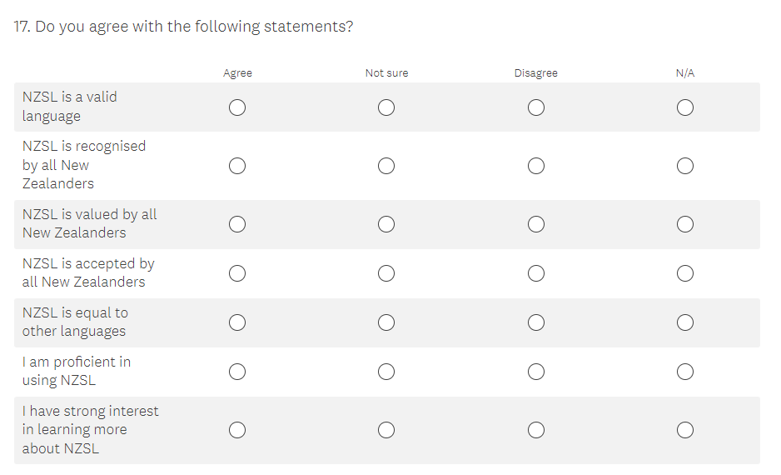

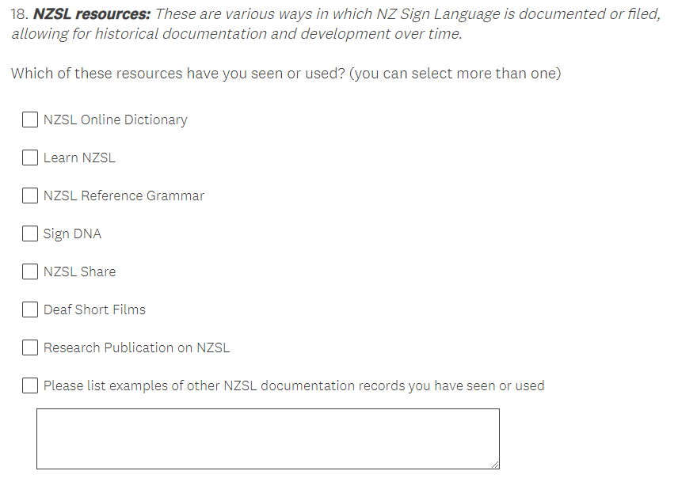

19.
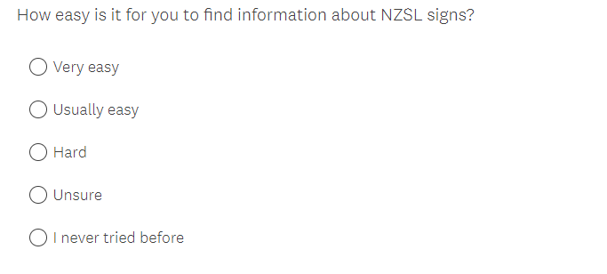

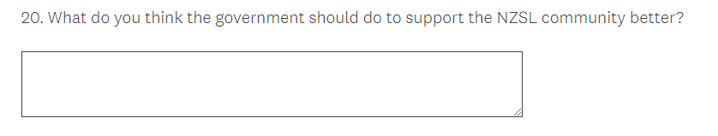

21.
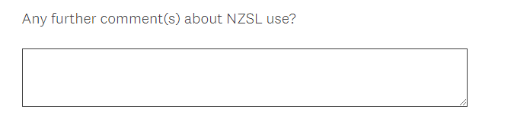

THANK YOU FOR DOING THE SURVEY. HANDWAVES!!!!

Appendix 2 – Tables for graphs

Table 1: Gender of respondents (580 people answered this question)
 | Number of respondents
Female | 447
Male | 125
Diverse/Non-binary/Other | 8

Table 2: Ethnicity of respondents (578 people answered this question)
 | Number of respondents
New Zealand European | 463
Māori | 91
Asian (Chinese & Indian) | 35
European | 26
Other | 19
Pacific | 15

Table 3: Age distribution of respondents (565 people answered this question)
 | Number of respondents
10-19 years | 52
20-29 years | 55
30-39 years | 121
40-49 years | 126
50-59 years | 124
60+ years | 77

Table 4: Number of respondents by region
(583 people answered this question)
 | Number of respondents
Auckland | 152
Wellington | 108
Canterbury | 92
Manawatu-Wanganui | 53
Waikato | 42
Otago | 28
Bay of Plenty | 24
Hawke's Bay | 23
Nelson | 18
Northland | 15
Southland | 13
Taranaki | 9
Tasman | 3
Gisborne | 2
West Coast | 1
Marlborough | 0

Table 5: Self-identification of NZSL users (based on difficulty hearing)
584 people answered this, of which 61 selected “other”
 | Number of respondents
I am Deaf | 230
I am hard of hearing | 58
I am hearing | 207

Table 6: Self-identification of NZSL users (based on relationship)
584 people answered this, of which 61 selected “other”
 | Number of respondents
I am a NZSL professional  (e.g., educator, interpreter) | 114
I am a parent / family / whānau of a Deaf or hard of hearing person | 122

Table 7: Difficulty experienced across functional domains (Washington Group) 502 people answered this question
 | Number of respondents
 | No difficulty | Some difficulty | A lot of difficulty | Cannot do at all
Seeing | 343 | 155 | 12 | 4
Walking | 446 | 62 | 22 | 5
Self-care | 498 | 16 | 7 | 5
Communicating | 396 | 112 | 31 | 7
Remembering or concentrating | 389 | 113 | 22 | 7
Hearing | 289 | 110 | 62 | 41

Table 8: Proportion of Deaf, hard of hearing, and hearing people who experience mental health conditions (547 people answered this question)
 | Number of respondents
 | Mental health condition | No condition
Deaf & HH | 93 | 146
Hearing | 51 | 142

Table 9: Self-rated proficiency in NZSL
 | Number of respondents
 | Proficient | Not proficient | Not sure
Deaf & HH | 171 | 18 | 40
Hearing | 89 | 71 | 34

Table 10: Acquisition of NZSL (561 people answered this question)
 | Number of respondents
Informal learning | 181
Community programme | 166
NZSL is my natural language | 152
At home | 124
At school | 118
Online classes | 99
At work | 98
Private tutor | 72
Tertiary study | 66

Table 11: Differences in acquisition of NZSL between Deaf and hard of hearing and hearing respondents
 | Number of respondents
 | Deaf & HH | Hearing
Natural language | 80 | 10
School | 56 | 13
Informal learning | 33 | 47
Home | 20 | 28
Community programme | 15 | 69
Work | 14 | 38
Private tutor | 14 | 14
Online classes | 10 | 28
Tertiary study | 6 | 22

Table 13: Satisfaction with availability, location, content, and cost of NZSL classes
 | Number of respondents
 | Very satisfied | Somewhat satisfied | Not at all satisfied
Content  (393 responses) | 217 | 144 | 32
Cost  (368 responses) | 161 | 144 | 63
Availability  (437 responses) | 126 | 218 | 93
Location  (413 responses) | 136 | 184 | 93

Table 14: Differences in the proportion of Deaf and hard of hearing and hearing respondents who reported being very satisfied with availability, location, cost, and content of NZSL classes
 | Number of respondents
 | Availability | Location | Content | Cost
Deaf & HH | 30 | 21 | 32 | 18
Hearing | 39 | 48 | 73 | 60

Table 15: Differences in the proportion of Deaf and hard of hearing and hearing respondents who reported being not very satisfied with availability, location, cost, and content of NZSL classes
 | Number of respondents
 | Availability | Location | Content | Cost
Deaf & HH | 19 | 20 | 13 | 16
Hearing | 25 | 22 | 4 | 17

Table 16: Interest in learning more about NZSL
 | Number of respondents
 | Interested | Not interested
Deaf & HH | 159 | 10
Hearing | 190 | 0

Table 17: Participation in deaf spaces (450 people answered this question)
 | Number of respondents
Deaf / NZSL events | 390
Deaf clubs | 316
Deaf organisations | 244
Online Deaf spaces | 165

Table 18: Differences in participation in Deaf spaces between Deaf and hard of hearing and hearing respondents
 | Number of respondents
 | Deaf or  NZSL events | Deaf  clubs | Online Deaf spaces | Deaf organisations
Deaf & HH | 123 | 120 | 91 | 67
Hearing | 75 | 57 | 33 | 23

There is no Table 19 to avoid confusion for the reader, so that table numbers correspond to figure numbers in the text.

Table 20: Contexts in which NZSL is used to communicate
(575 people answered this question)
 | Number of respondents
Deaf friends | 406
Home | 325
Deaf Club | 306
Workplace | 285
Informal gatherings | 241
Hearing friends | 222
Studies | 188
Visiting family | 164
Service place | 126
Video Interpreting Service | 118
At cultural events | 100
Staff in shops | 94
Church or religious activities | 67
Playing or watching sports | 55
Marae | 35

Table 21: Differences in communication context between Deaf and hard of hearing and hearing respondents
 | Number of respondents
 | Deaf & HH | Hearing
Deaf friends | 136 | 81
Deaf Club | 112 | 57
At home | 101 | 56
Informal gatherings | 86 | 46
Hearing friends | 72 | 49
Workplace | 70 | 76
Visiting family | 62 | 21
Video interpreting service | 61 | 5
Service place | 54 | 12
Studies | 47 | 36
Staff in shops | 47 | 7
Cultural events | 40 | 13
Sports | 27 | 3
Church or religious activities | 19 | 15
Marae | 16 | 6

Table 22: Satisfaction with translation into NZSL
 | Number of respondents
 | Extremely satisfied | Very satisfied | Somewhat satisfied | Not so satisfied | Not at all satisfied
Deaf organisations  (417 responses) | 102 | 169 | 120 | 19 | 7
Media  (448 responses) | 27 | 71 | 188 | 101 | 61
Education sector  (384 responses) | 22 | 44 | 119 | 115 | 84
Government agencies  (387 responses) | 21 | 44 | 125 | 108 | 89

Table 23: Differences in the proportion of Deaf and hard of hearing and hearing respondents who reported being extremely and very satisfied with the translation into NZSL
 | Number of respondents
 | Deaf associations | Media | Government agencies | Education sector
Deaf & HH | 75 | 31 | 22 | 19
Hearing | 68 | 18 | 11 | 15

Table 24: Differences in the proportion of Deaf and hard of hearing and hearing respondents who reported being not so and not at all satisfied with the translation into NZSL
 | Number of respondents
 | Deaf associations | Media | Government agencies | Education sector
Deaf & HH | 12 | 48 | 57 | 50
Hearing | 5 | 41 | 43 | 47

There is no Table 25 to avoid confusion for the reader, so that table numbers correspond to figure numbers in the text.

Table 26: Satisfaction with availability of interpreter
 | Level of satisfaction
 | Extremely satisfied | Very satisfied | Somewhat satisfied | Not so satisfied | Not at all satisfied
Number of respondents | 43 | 55 | 110 | 64 | 29

Table 27: Differences in satisfaction with the availability of an NZSL interpreter between Deaf and hard of hearing and hearing respondents
 | Number of respondents
 | Extremely & very satisfied | Not so & not at all satisfied
Deaf & HH | 75 | 48
Hearing | 12 | 26

Table 28: Attitudes towards NZSL
 | Number of respondents
 | Agree | Not sure | Disagree
Valid (565 responses) | 547 | 15 | 3
Equal (563 responses) | 382 | 64 | 117

Table 29: Differences in attitudes towards NZSL between Deaf and hard of hearing and hearing respondents
 | Number of respondents
 | Valid |  | Equal
 | Agree | Disagree | Agree | Disagree
Deaf & HH | 142 | 3 | 98 | 27
Hearing | 145 | 0 | 95 | 38

Table 30: Inferred attitudes towards NZSL among New Zealanders in general
 | Number of respondents
 | Agree | Not sure | Disagree
Accepted  (562 responses) | 146 | 217 | 199
Recognised  (563 responses) | 167 | 177 | 219
Valued  (563 responses) | 123 | 205 | 235

Table 31: Differences between Deaf and hard of hearing and hearing respondents in inferred attitudes towards NZSL among New Zealanders in general
 | Number of respondents
 | Accepted |  | Recognised |  | Valued
 | Agree | Disagree | Agree | Disagree | Agree | Disagree
Deaf & HH | 61 | 34 | 75 | 38 | 63 | 39
Hearing | 20 | 59 | 31 | 60 | 15 | 72

Table 32: Familiarity with sources of documentation of NZSL
(565 people answered this question)
 | Number of respondents
NZSL Online Dictionary | 522
Learn NZSL | 367
Deaf Short Films | 247
Sign DNA | 194
NZSL Share | 179
NZSL Reference Grammar | 130
Research Publication on NZSL | 121

Table 33: Differences between Deaf and hard of hearing and hearing respondents in familiarity with sources of documentation of NZSL
 | Number of respondents
 | Deaf & HH | Hearing
NZSL Online Dictionary | 128 | 142
Learn NZSL | 83 | 105
Deaf Short Films | 78 | 55
Sign DNA | 65 | 37
NZSL Share | 63 | 40
NZSL Reference Grammar | 38 | 29
Research Publications | 39 | 25

There is no Table 34 to avoid confusion for the reader, so that table numbers correspond to figure numbers in the text.

Table 35: Ease of finding information about NZSL signs
 | Number of respondents
 | Very easy | Usually easy | Hard | Unsure | I never tried before
Ease of finding signs | 161 | 334 | 41 | 29 | 12

Appendix 3 - Tables of responses from Māori participants

Table 1: Identification as Deaf, hard of hearing and hearing among Māori participants
 | Number of respondents
Deaf and hard of hearing | 44
Hearing | 26

Table 2: Self-rated proficiency in NZSL among Māori participants
 | Number of respondents
 | Proficient | Not proficient | Not sure
Māori | 43 | 20 | 18

Table 3: Acquisition of NZSL among Māori participants (63 answered this question)
 | Number of respondents
Informal learning | 18
Community programme | 12
NZSL is my natural language | 14
At home | 18
At school | 23
Online classes | 10
At work | 9
Private tutor | 3
Tertiary study | 7

Table 4: Satisfaction with availability, location, content, and cost of NZSL classes among Māori participants
 | Number of respondents
 | Very satisfied | Somewhat satisfied | Not at all satisfied
Content | 18 | 31 | 3
Cost | 13 | 21 | 8
Availability | 11 | 36 | 12
Location | 10 | 33 | 13

Table 5: Participation in deaf spaces among Māori respondents
(46 answered this question)
 | Number of respondents
Deaf / NZSL events | 34
Deaf clubs | 28
Deaf organisations | 18
Online Deaf spaces | 20

Table 6: Contexts in which NZSL is used to communicate among Māori participants
(65 answered this question)
 | Number of respondents
Deaf friends | 38
Home | 35
Deaf Club | 25
Workplace | 29
Informal gatherings | 19
Hearing friends | 30
Studies | 21
Visiting family | 22
Service place | 13
Video Interpreting Service | 9
At cultural events | 9
Staff in shops | 8
Church or religious activities | 7
Playing or watching sports | 5
Marae | 15

Table 7: Satisfaction with translation into NZSL among Māori participants
 | Number of respondents
 | Extremely and very satisfied | Somewhat satisfied | Not so and not at all satisfied
Deaf organisations | 29 | 13 | 10
Media | 12 | 31 | 20
Education sector | 10 | 22 | 22
Government agencies | 6 | 26 | 26

Table 8: Attitudes towards NZSL among Māori participants
 | Number of respondents
 | Agree | Not sure | Disagree
Valid | 60 | 7 | 1
Equal | 39 | 15 | 15

Table 9: Inferred attitudes towards NZSL among New Zealanders in general among Māori participants
 | Number of respondents
 | Agree | Not sure | Disagree
Accepted | 17 | 35 | 20
Recognised | 17 | 28 | 27
Valued | 14 | 29 | 30

Table 10: Familiarity with sources of documentation of NZSL among Māori participants (62 answered this question)
 | Number of respondents
NZSL Online Dictionary | 60
Learn NZSL | 39
Deaf Short Films | 22
Sign DNA | 15
NZSL Share | 14
NZSL Reference Grammar | 14
Research Publication on NZSL | 13

For more information, please contact the NZSL Office at Whaikaha NZSL@whaikaha.govt.nz

https://www.odi.govt.nz/assets/Uploads/NZSLStrategy-DocumentDigitalF.pdf
McKee, R., & Vale, M. (2014). Report on a Survey of the Deaf/NZSL community. Deaf Studies Research Unit, Victoria University of Wellington https://www.wgtn.ac.nz/lals/centres-and-institutes/dsru/research/previous-projects/deaf-children-in-mainstream-classrooms/NZSL-Vitality-Deaf-Community-Survey-Report-Sept-2014-.pdf
https://www.odi.govt.nz/nzsl/nzsl-act-consultation-2022/

