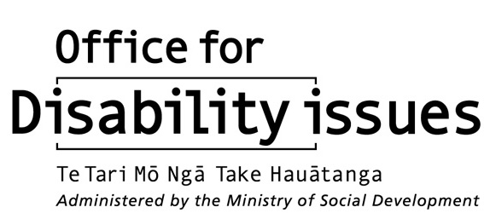
19 August 2015
Context for better information on disabled people in New Zealand
The paper provides an overview of current key issues relating to data and evidence on disabled people in New Zealand.
The Disability Data and Evidence Working Group (DDEWG) will have a major focus on the kind of data and evidence required to support the development of sound policy and appropriate services to meet the needs of disabled people in New Zealand.
The key issues covered in the paper include:
- absence of a common understanding of disability in New Zealand
- primary sources of data/evidence on disabled people in New Zealand
- drivers for needing to identify current high priority areas for data/evidence on disabled people in New Zealand.
Absence of a common understanding of disability in New Zealand
Disability is a multidimensional and complex concept. It is experienced by different people in different ways. For example, two people who are deaf will experience their impairment differently depending on various factors such as: what assistive technologies and support they have access to, societal attitudes and whether they see themselves as part of a Deaf culture (not disabled) or having a disability.
A recent discussion at the 2 July meeting of the Ministerial Committee on Disability Issues highlighted the importance of a common understanding of disability.
Such a common understanding of disability is important to:
- compare data/information across agencies
- compare survey data to administrative data
- collect data/information on both the needs and unmet needs of disabled people.
Although it is important to have a consistent understanding of disability, this understanding is likely to be operationalised differently depending on the criteria used by various agencies to determine eligibility for access to their services. It will also be useful to clarify whether it is shared understanding or definition that is required.
Global understandings of disability
One of the most well-known global understandings of disability is the Convention on the Rights of Persons with Disabilities (CRPD) which states that:

Persons with disabilities include those who have long-term physical, mental, intellectual or sensory impairments which in interaction with various barriers may hinder their full and effective participation in society on an equal basis with others.
The CRPD rendition of disability highlights the fact that people with impairments can be disempowered by a society that does not enable them to exercise their rights.
Prior to ratification of the CRPD in New Zealand in 2008, an assessment of the various understandings of disability was undertaken and minor amendments were made in legislation. At the time, it was considered that the various understandings of disability were consistent with the understanding of disability in the CRPD.
The World Health Organisation’s International Classification of Functioning, Disability and Health (ICF) is another rendition of disability which is widely accepted internationally. The ICF illustrates the interrelationship between the health condition that leads to an impairment (problems in body functions), the impact this has on someone’s ability to carry out everyday activities (participation) and the impact of other barriers such as those in the environment around the person. The ICF is broadly consistent with the CRPD.
Understandings of disability in government agencies
Disability is understood in different ways in government agencies depending upon the purpose and type of data collection:
- Statistics New Zealand uses a functional concept of disability. The 2013 Disability Survey defines disability as:
an impairment which has a long-term limiting effect on a person’s ability to carry out day-to-day activities. Long-term means six months or longer and limiting effect means a restriction or lack of ability to perform.
- The Ministry of Education uses the term, “special needs”, which includes a much larger population of students than those who are usually regarded as “disabled” (i.e., those with physical, sensory, psychological/psychiatric and intellectual impairments). “Students with special needs” also include those with behavioural problems, chronic health conditions, learning difficulties and so on
- The Ministry of Health’s Disability Support Services (DSS) use medical diagnostic criteria. Disability is understood as a result of a physical condition intrinsic to the individual’s body.
- Similarly, ACC uses a medical diagnosis for a disability arising from an injury to decide upon eligibility for services.
- The Ministry of Justice’s recently approved Service Delivery Needs Data Standard for implementation across justice sector agencies has a focus not only on the delivery of services to meet the needs of people with physical, sensory, psychological/psychiatric and intellectual impairments. Those experiencing chronic illness, neurological problems and those from diverse cultural and linguistic backgrounds are also taken into account.

Primary sources of data/evidence on disabled people in New Zealand
Information on disabled people in New Zealand can currently be accessed in a range of sources. It is difficult to compare the information in these sources because there is no shared understanding of the meaning of disability. In addition, the data is collected and used for different purposes.
Official statistics are the most comprehensive source of data/evidence on disabled New Zealanders. These statistics are derived by government departments from:
- statistical surveys
- administrative records.
Statistical surveys
Statistics New Zealand is the leader of the Official Statistical System (OSS) and the primary producer of official statistics in New Zealand. A post-census national disability survey has been undertaken every five years since 1996 by Statistics New Zealand. The most recent survey was carried out in 2013.
Administrative data
Unlike surveys, administrative data is collected by government departments and specified crown entities (e.g., district health boards, disability services in universities) without regard to its statistical or research use. This type of data is collected for the purpose of registration and record keeping, usually during the delivery of a service. Most administrative datasets tend to collect personal information such as name, address, phone number and age. Datatsets tend to collect additional information that is crucial for the administration of a programme such as the Ministry of Health’s DSS’ Socrates database and the Ministry of Education’s Ongoing Resourcing Scheme (ORS).
Academic institutions
A range of disability related research is carried out by academic institutions, although funding for disability research is not easy to access. It is difficult to build up a full profile of the disability research undertaken by academic institutions. Moreover, it is a challenge to work through how the connection between government agencies, the disability sector and academic institutions can be improved.
The following provides a few examples of disability research currently undertaken by academic institutions:
- The Donald Beasley Institute conducts disability research, with a specific focus on learning disability.
- Professor Kate Diesfeld at Auckland University of Technology has had a longstanding interest in mental health and disability law.
- Information is available within The Growing Up in New Zealand longitudinal study, directed by Dr Susan Morton (University of Auckland), on the disability status (acute and chronic) of both the parents and the approximately 7,000 children cohort from birth to two years.
- Massey University, Palmerston North has also had a long-term focus on disability research (e.g., Professor Robyn Munford and Dr Martin Sullivan).
Non-government organisations
Non-government organisations sometimes undertake research. For example, the Blind Foundation is currently conducting a Blindness and Low Prevalence Study.
New Zealand Convention Coalition Monitoring Group (Convention Coalition)
The Convention Coalition (a collaboration of Disabled People’s Organisations) is currently overseeing qualitative research on disabled individuals’ lived experience of their rights under the CRPD. Two reports on this research have recently been published: Disability rights in Aotearoa New Zealand: Acceptance in Society and Disability rights in Aotearoa New Zealand: Participation and poverty.
Current drivers for needing to improve range of data/evidence on disabled people in New Zealand
Bearing in mind the current lack of a shared understanding of both the meaning of “disability” and the data and evidence needs pertaining to disabled people in New Zealand, the following suggests some drivers for needing to improve the range of data/evidence available.
- The regular undertaking of a national survey to find out:
  - prevalence of disability across population subgroups
  - disability rates for specific impairment types
  - key social and economic outcomes for disabled people.
- The Government in its responses in June 2015 to both the United Nations Committee on the Rights of Persons with Disabilities’ Concluding Observations (October 2014) and the Independent Monitoring Mechanism (IMM) reports 2012 and 2014 - stated that it would address the recommendations relating to improving statistics and data collection in the newly established DDEWG. These include:
  - recommendations 68 and 70 in the Concluding Observations
  - key recommendation 2 and recommendations 3, 31, 39, 40 and 41 in IMM 2012 report
  - key recommendation B and recommendations 3, 5 and 36 in IMM 2014 report.
- A monitoring framework will be developed against which the implementation of the CRPD, a revised New Zealand Disability Strategy and an updated Disability Action Plan 2014-2018 can be evaluated. Sound data and evidence is required to support better quality and more efficient monitoring and reporting.

Appendix 1
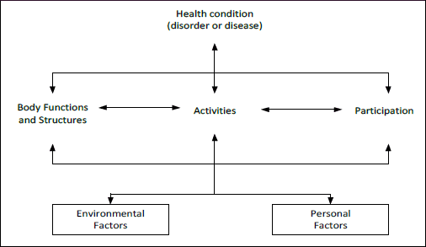
Within the ICF framework, disability is the umbrella term that covers difficulties encountered in any or all three areas of functioning. Unlike the CRPD, the ICF understands disability as a continuum of more or less, rather than categorising disabled people as a separate group.
Figure 1: Key components of ICF
In the ICF, problems with human functioning are categorised in three interconnected areas:
- Impairments relate to problems in body functions or alterations in body structure (e.g., blindness).
- Activity limitations pertain to difficulties in carrying out daily activities (e.g., walking).
- Participation restrictions are problems encountered in any area of daily life (e.g., facing discrimination in employment).

Ref: A8304666

For further information on ICF, see the diagram in Appendix 1.
The disability survey is addressed in Paper 1 prepared by Statistics New Zealand, Measuring disability in New Zealand: Current status and issues.

