New Zealand Disability Strategy
2016 – 2026

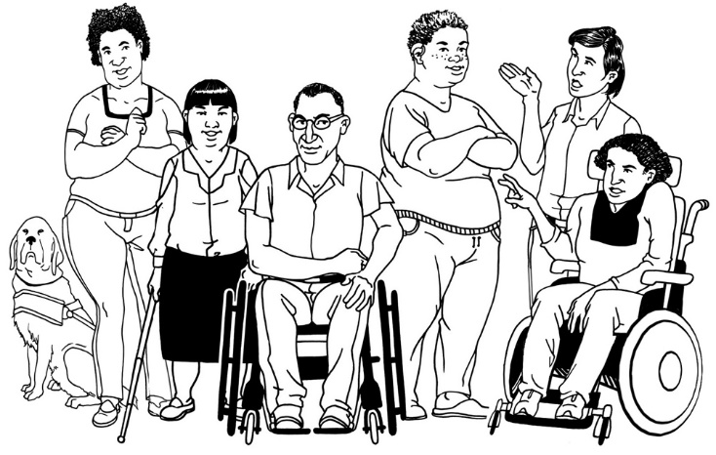

Easy Read
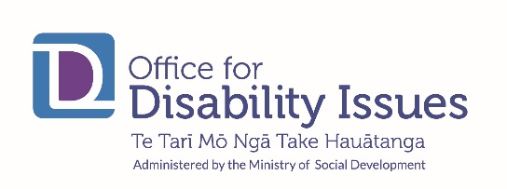

What is in this book
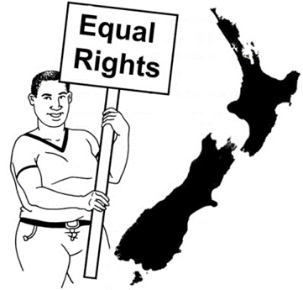
Message from Minister for Disability Issues 4
About the New Zealand Disability Strategy 9

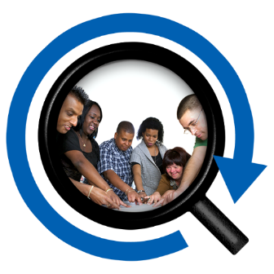
About the New Zealand Disability Strategy Reference Group 13
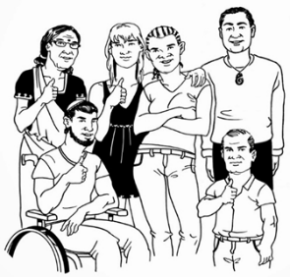
The vision of the New Zealand Disability Strategy 15
Who is part of the disability community? 18

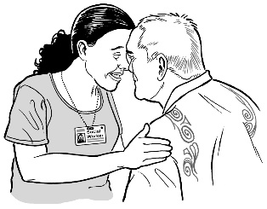
About the 3 Principles of the Strategy 21
Principle 1: Te Tiriti o Waitangi 23
Principle 2: Disability Convention 24

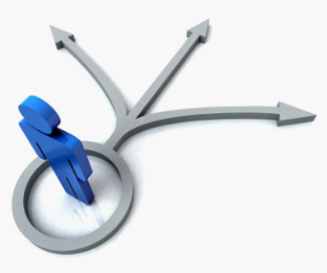
Principle 3: Decision making 25
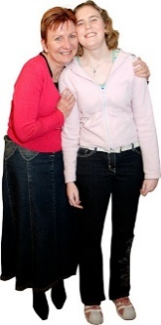
About the 2 Approaches of the Strategy 26

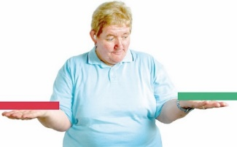
Approach 1: Whole of life and long term 27
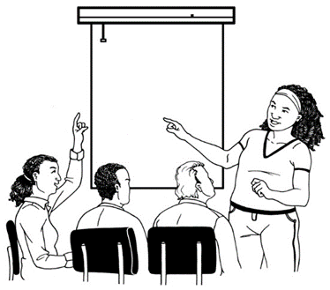
Approach 2: Twin track 29
About the 8 Outcomes of the Strategy 32
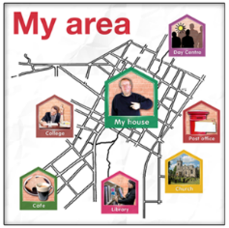
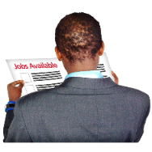
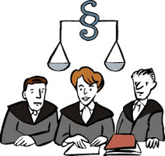
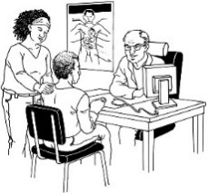
Outcome 1: Education – learning new things 35
Outcome 2: Employment – having a job 37
Outcome 3: Health – being healthy and well 40
Outcome 4: Rights and justice – getting my
legal rights 43
Outcome 5: Access – getting in and around
my community 45
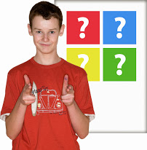
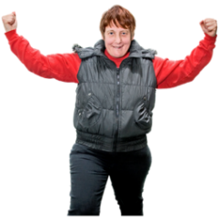
Outcome 6: Attitude – how disabled people
are treated by others 48
Outcome 7: Choice and control – making my
own choices and being in control of my own
life 50
Outcome 8: Leadership – being a leader 52
Making the Strategy work 54
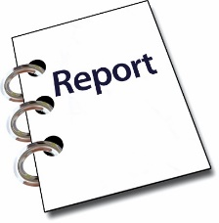
Keeping track of what has been done 59
Who makes sure the strategy gets done? 61
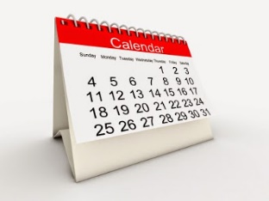
What is going to happen over the next 10 65
years?
Who is involved? 70

Message from Minister for Disability Issues

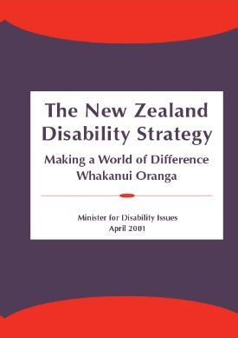
We have come a long way since the 1st Disability Strategy was made in 2001.

The New Zealand Government made the 1st Disability Strategy so that disabled people could reach their goals.
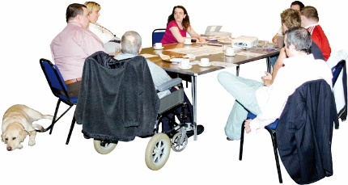
The New Zealand Government has been working together with disabled people.

A lot of good work has been done on:
- thinking about a new system of disability support
- getting disabled people into jobs
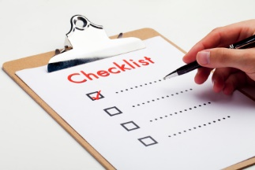
- inclusive education for children with disability
- making New Zealand Sign Language an official language of New Zealand.

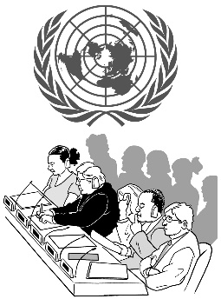
New Zealand played a lead part when the United Nations Convention on the Rights of Persons with Disabilities was being written.

This is also called the Disability Convention.
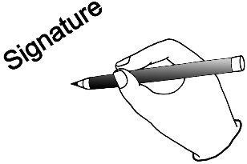
New Zealand agreed to the Disability Convention in 2008.

We have:
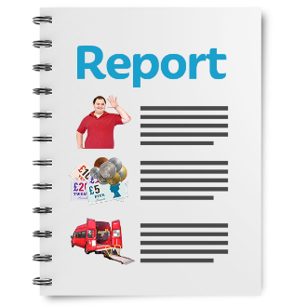
- made a system to check if we are putting the rights in the Convention into place
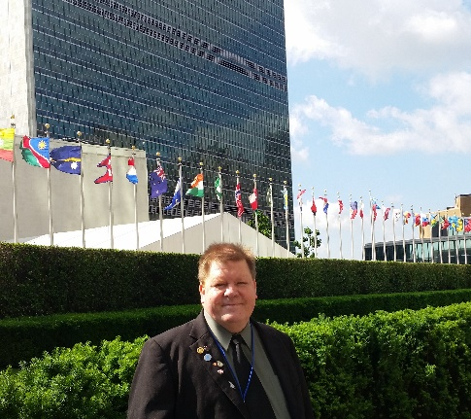
- heard what the United Nations Committee has said we need to work on
- supported Robert Martin MNZM to get on the next United Nations Committee.

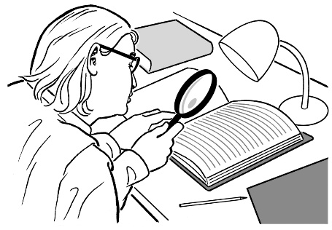
Making this Disability Strategy was a good way to look at:
- what we have done
- what we are doing
- what we still need to do.

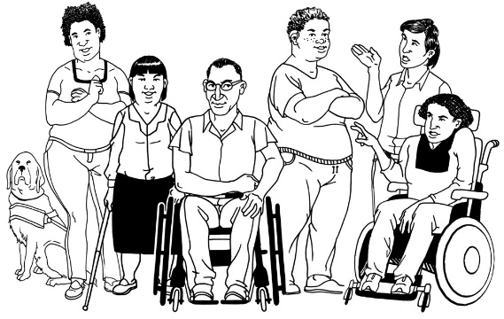
We always need to remember that people in the disability community are not all the same.

What it is like to have a disability is different for everyone.

We need to listen to all of the voices of the disability community.

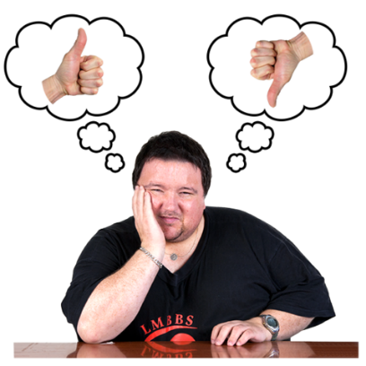
Many disabled people still do not have good lives.

This needs to change.

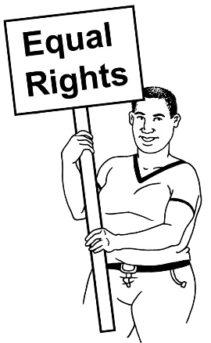
Disabled people have the same rights as non-disabled people.

Disabled people must be part of our work to make New Zealand a better place to live.
Many disabled people and others took part in making this Strategy.

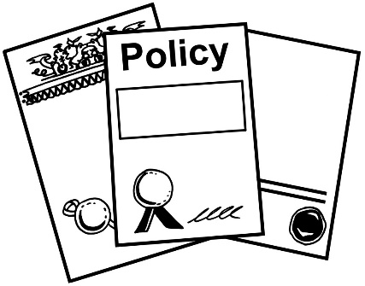
The Disability Strategy says what disabled people have said is important to them.

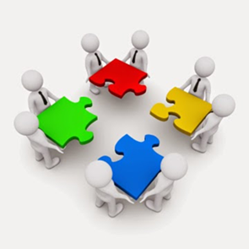
The Disability Strategy will tell the Government how to make good decisions about disabled people over the next 10 years.

It will help us to all work together towards the same things.
I want to thank:
- the people on the New Zealand Disability Strategy Reference Group
- the disabled people who took part
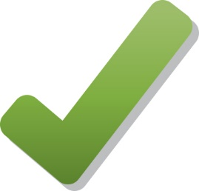
- the families / whanau and other people who took part.

Let us all work together to make New Zealand a good place for all people.

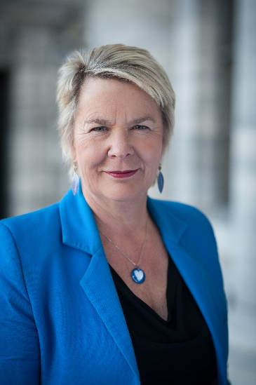
Nicky Wagner
Minister for Disability Issues

About the New Zealand Disability Strategy

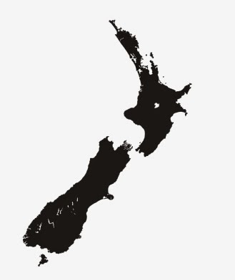
The first New Zealand Disability Strategy was made in 2001.
In 2016 the New Zealand Government made a new Disability Strategy.
The 2016 New Zealand Disability Strategy has things in it that disabled people say are important to:
- know about disabled people
- make good decisions.
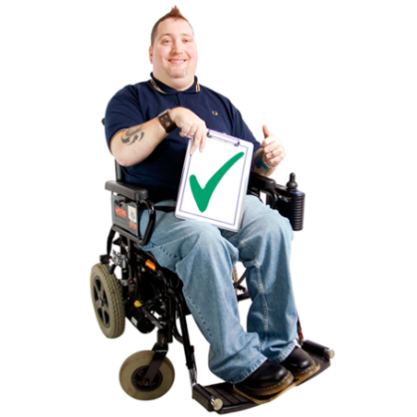
The New Zealand Disability Strategy can be used to:
- know more about disabled people
- make good decisions
- help the New Zealand Government know how to make things better for disabled people in New Zealand.
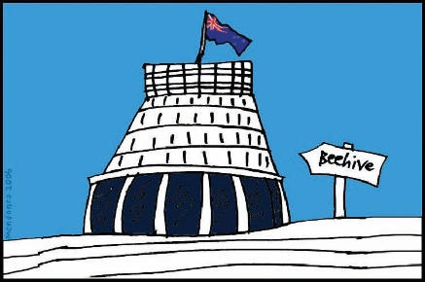
The Government has made the New Zealand Disability Strategy to make sure disabled people:
- are treated fairly
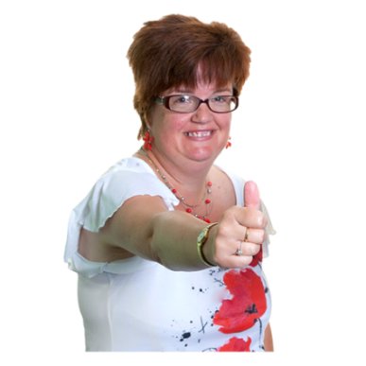
- get what they need to have a good life
- are part of the community
- can make their own decisions
- have good decisions made about them by the Government.

Disabled people want to have:
- a good life
- the same chance as everyone else to have a good life.

Lots of disabled people in New Zealand still do not have good lives.

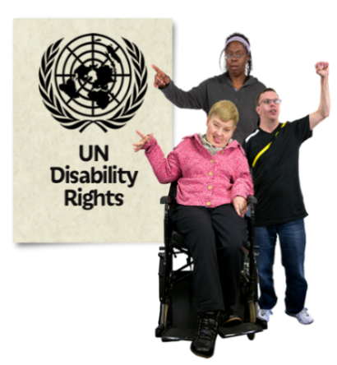
In 2008 the New Zealand Government agreed to the rights in the United Nations Convention on the Rights of Persons with Disabilities.
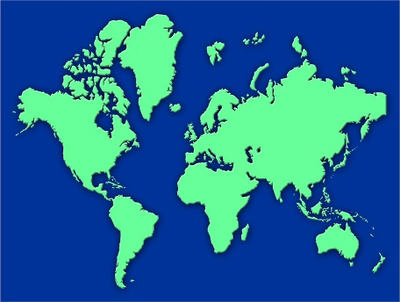
The Disability Convention says what countries need to do to make sure disabled people have a good life.
The New Zealand Disability Strategy can make sure that New Zealand is putting in place the rights in the Disability Convention.

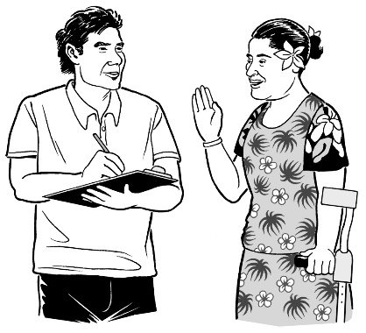
The New Zealand Disability Strategy has things in it that disabled people in New Zealand and their families think are important.

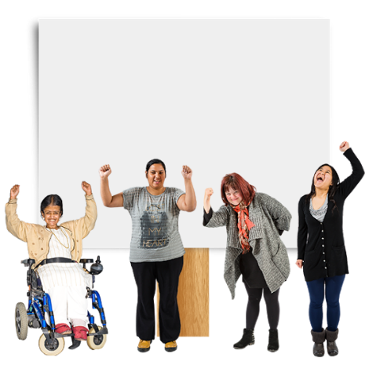
The New Zealand Disability Strategy is an important way to try to make sure that disabled people:
- have good lives
- get the same things as other people.

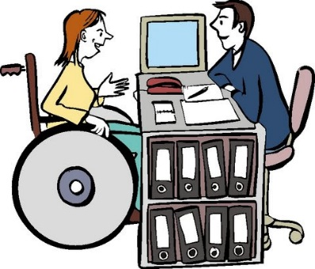
Disabled people want to:
- have the same things as other people
- have the same rights as other people
- be treated in a good way
- feel important
- feel valued
- make their own decisions.

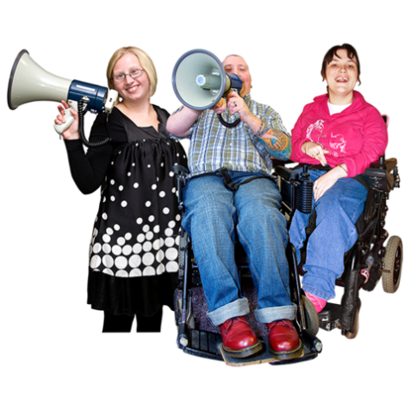
It is important that:
- all people are treated in a good way
- all people are treated with respect.

New Zealand Disability Strategy Reference Group
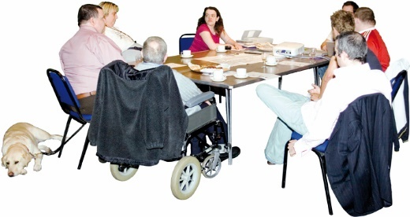
The Government set up a group of people to help make the 2016 New Zealand Disability Strategy.
This group is called the New Zealand Disability Strategy Revision Reference Group.

It is also known as the Reference Group.
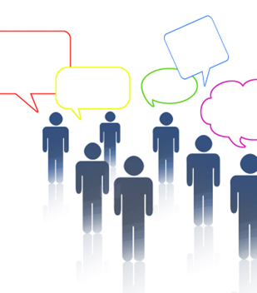
Here are the people on the Reference Group:
- Colleen Brown from Auckland
- Robbie Francis from Hamilton
- Lance Girling-Butcher from New Plymouth
- Peggy Koopman-Boyden from Hamilton
- Clive Lansink from Auckland
- Victoria Manning from Wellington
- David Matthews from Christchurch and Wellington
- Papaalii Seiuli Johnny Siaosi from Auckland
- Dr Martin Sullivan from Palmerston North
- Hamish Taverner from Palmerston North
- Johnny Wilkinson from Whangarei
- Gary Williams from Christchurch
- Brian Coffey from Ministry of Education
- Kathy Brightwell from Ministry of Health
- Sacha O’Dea from Ministry of Social Development
- Paul Brown from Office of the Ombudsman
- Megan McCoy from Office for Disability Issues.

More information about the Reference Group is on this website:
http://www.odi.govt.nz/

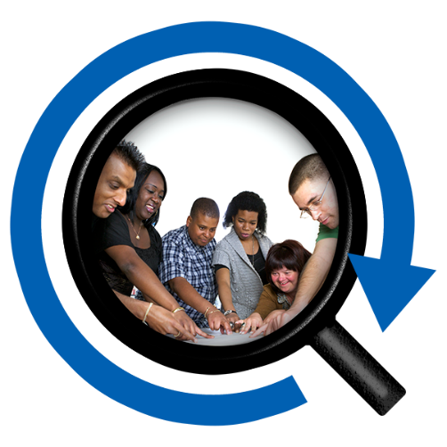
The vision of the New Zealand Disability Strategy
A vision statement says what we are working towards.

The vision of the New Zealand Disability Strategy says New Zealand needs to make sure disabled people can get the same chances as non-disabled people to reach goals.

Everyone in New Zealand needs to work together to make sure:
- New Zealand is a good place for disabled people to live

- disabled people in New Zealand have good lives.

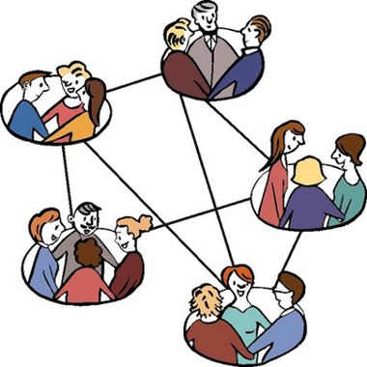
To have good lives disabled people in New Zealand must be able to join in with:
- friends
- family
- communities.

Some disabled people say there are barriers to having a good life.

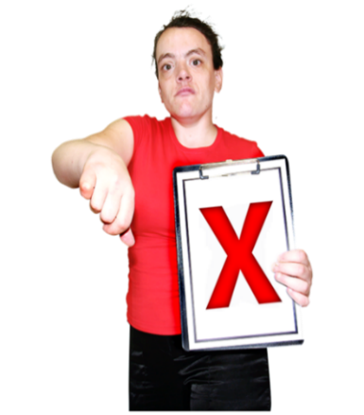
Barriers are things that make it hard for disabled people to join in with:
- friends
- family
- communities.
There is a way of thinking about disability called the social model of disability.

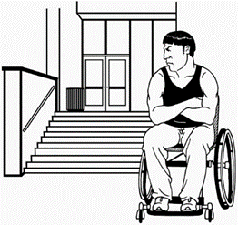
The social model says it is the world we live in that puts barriers up that make it hard for disabled people to live the lives they choose.

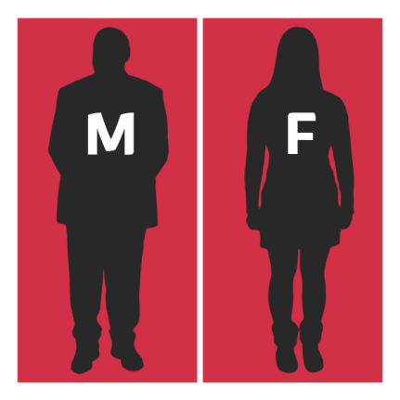
Not all disabled people face the same barriers.
For example, disabled women and girls can face different barriers than disabled men and boys.
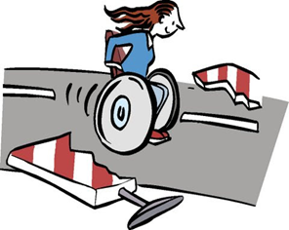
The New Zealand Disability Strategy wants to take away barriers that stop disabled people having good lives.

Who is part of the disability community?
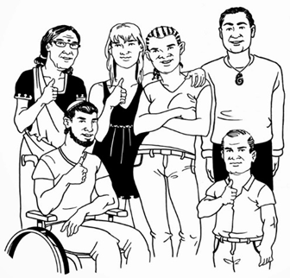
There are lots of different people in the disability community in New Zealand.
People that say they have a disability are part of the disability community.

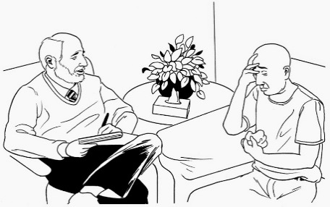
Some people do not want to say they have a disability, for example some:
- Deaf people
- older people
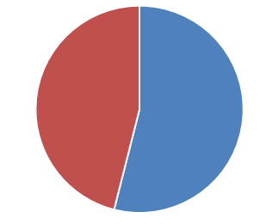
- people in the mental health community.
More than half of older people in New Zealand have a disability.
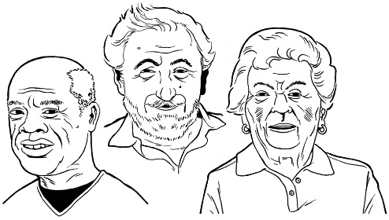
The number of disabled people in New Zealand is growing because people are living longer.

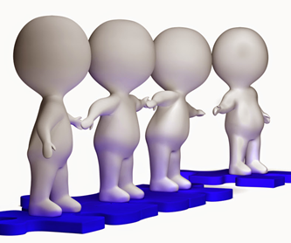
1 out of 4 people in New Zealand say they have a disability.
1 out of 4 Māori people in New Zealand say they have a disability.
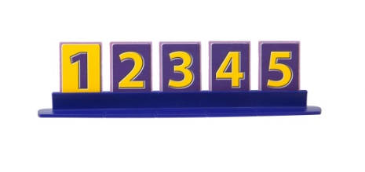
1 out of 5 Pacific Island people in New Zealand say they have a disability.
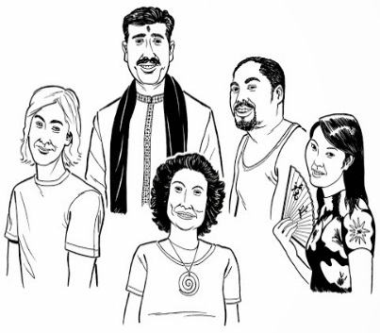
There are also people from lots of other cultures in New Zealand that have a disability.

Many people in the disability community get support from other people to say things and be heard.
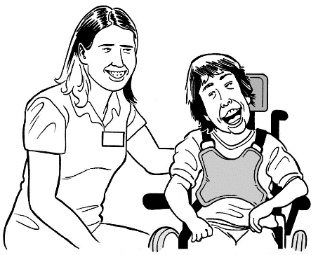
Friends, families and people who support and care for disabled people are also part of the disability community.

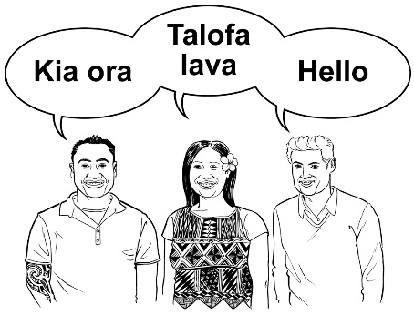
Language is important in the disability community.
The official languages of New Zealand are:
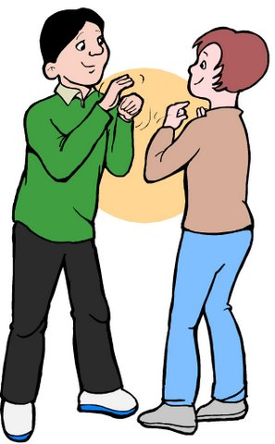
- Te Reo Māori
- New Zealand Sign Language
- English.
It is important that all 3 languages are respected and supported.

About the 3 Principles of the Strategy
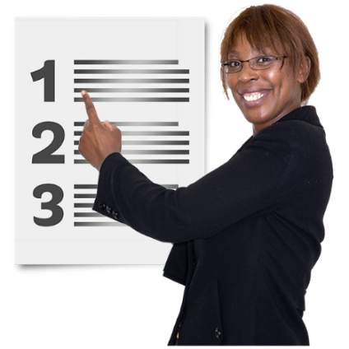
There are 3 Principles in the 2016 New Zealand Disability Strategy.
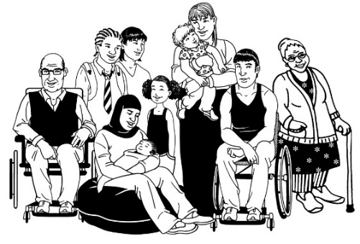
The Principles are things that can help to build a good relationship between the New Zealand Government and disabled people.
The Principles are for all people in New Zealand.

They are for:
- Māori people
- Non-Māori people
- Disabled people
- Non-disabled people.
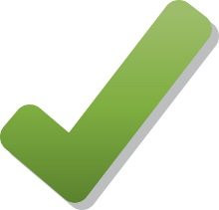
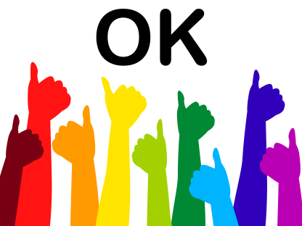
The Principles let the New Zealand Government know what to do to make sure the 2016 New Zealand Disability Strategy is done in the right way.
The Principles can make sure disabled people feel valuable and are:
- listened to
- treated in a good way
- respected by everyone.

Principle 1: Te Tiriti o Waitangi

In New Zealand there is a Treaty called Te Tiriti o Waitangi.

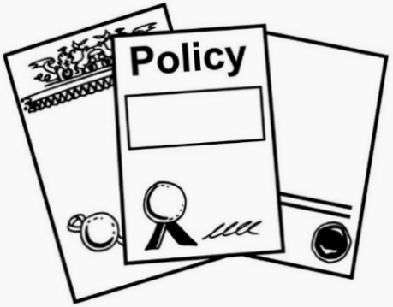
It is also called the Treaty of Waitangi.
The Treaty of Waitangi is the legal document that was signed in 1840 and made New Zealand one country.
The Treaty is important to New Zealand.

It is about:
Māori + Government =
partners
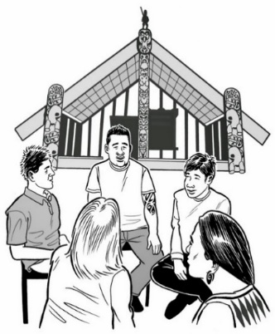
- the partnership between Māori and the New Zealand Government
- making decisions together
- protecting things that are important to Māori.
Principle 2: Disability Convention
The Disability Convention is important to New Zealand and can support disabled people to:
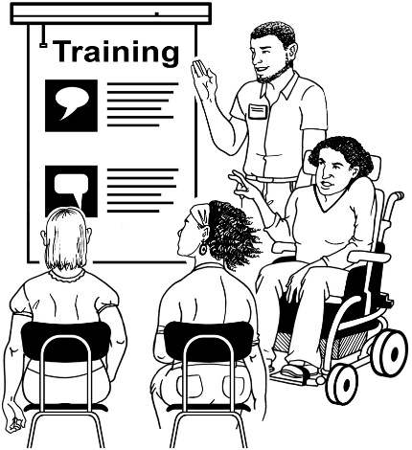
- get treated fairly
- be respected by everyone
- make their own choices
- be in control of their own lives
- join in with communities
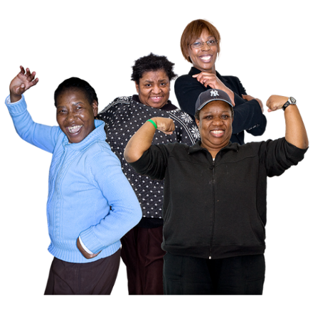
- be valued in communities
- be able to get everything they need to have good lives
- have the same chances as everyone else to reach goals.

Principle 3: Decision Making

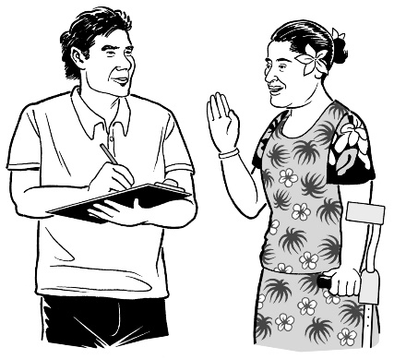
Disabled people know:
- what they need to have good lives
- a lot about disability.

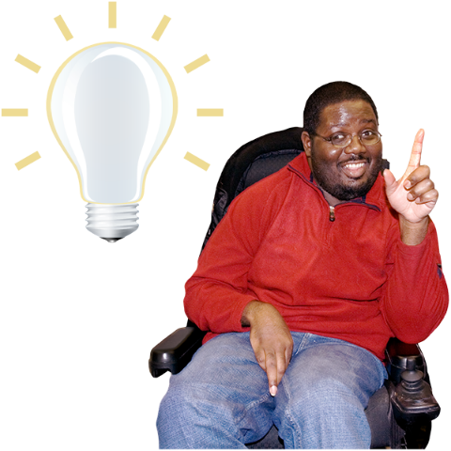
Disabled people need to be involved in decisions that:
- are about disabled people
- affect disabled people.

About the 2 Approaches of the Strategy
2
There are 2 Approaches in the 2016 New Zealand Disability Strategy.
The Approaches tell the New Zealand Government what to do to make sure the 2016 New Zealand Disability Strategy is done in the right way.

The Approaches can make sure disabled people are:
- listened to
- treated in a good way
- respected by everyone
- valued.

Approach 1: Whole of Life and Long Term
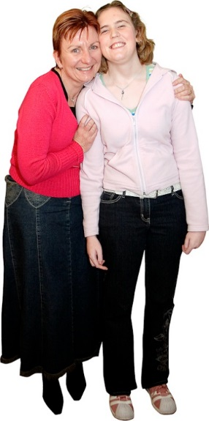
The Whole of Life and Long Term Approach means thinking about the whole life of a disabled person when decisions are made.

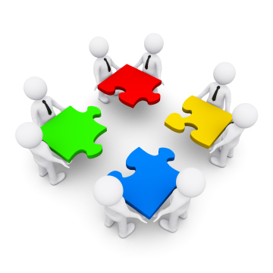
This means:
- places that give support or services are able to work together better
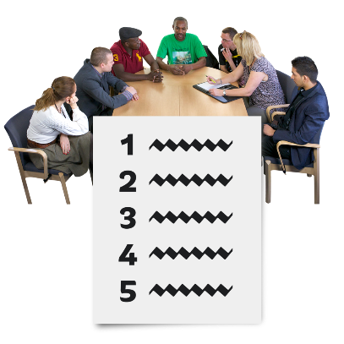
- looking at things disabled people can do
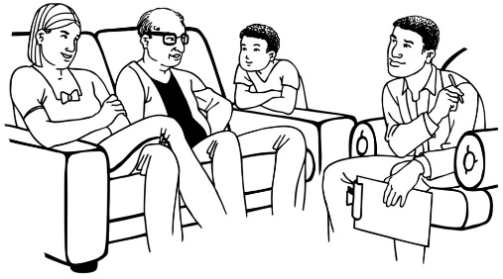
- disabled people should get the right support and services for their whole life
- families and carers of disabled people should get the right support and services.
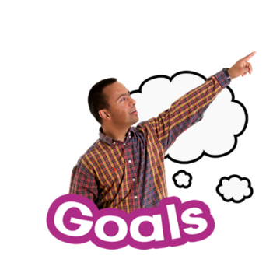
The Whole of Life and Long Term Approach will mean disabled people can:
  - do more things for themselves
  - give to their communities
  - be part of their communities
  - have the lives they want.

Approach 2: Twin Track
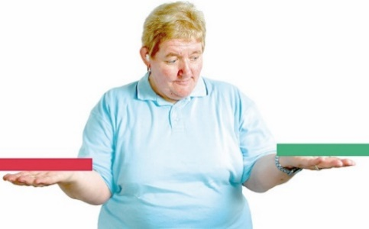
The Twin Track Approach means having both:
- support services that are set up for disabled people to use
- supports that everyone in the community can use, including disabled people.

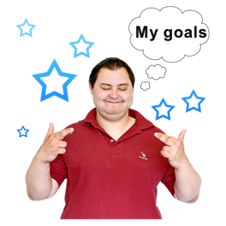
Working this way means that disabled people:
- have the same chances as everyone else to reach goals
- get the right community services and support at the right time
- get the right disability support services at the right time.
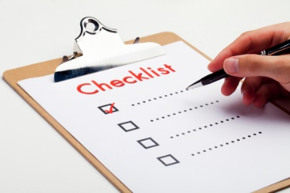
The Twin Track Approach can make sure services and supports are:
- working well
- easy to get and use.
2
2 things will make sure all services and supports are good for disabled people.

They are:
- Reasonable Accommodation
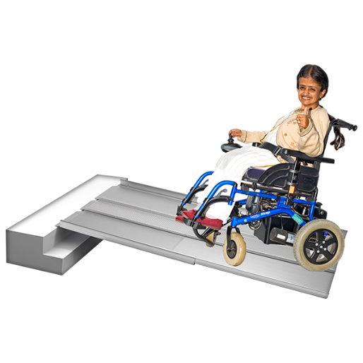
- Universal Design.
Reasonable Accommodation means changing something so it can be used by a disabled person.

A reasonable change is 1 that is not too hard to make and does not cost too much to do.

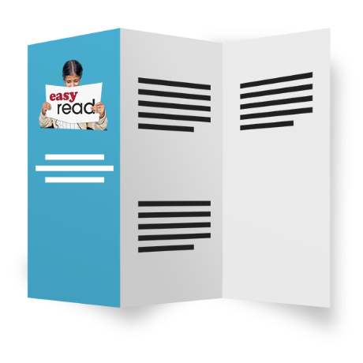
Universal Design is about making sure everything is easy to:
- get by everyone
- understand by everyone
- use by everyone.
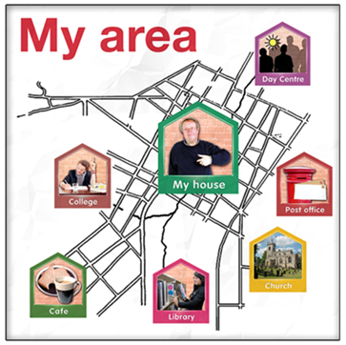
Universal Design is for:
- buildings
- services
- supports
- technology.
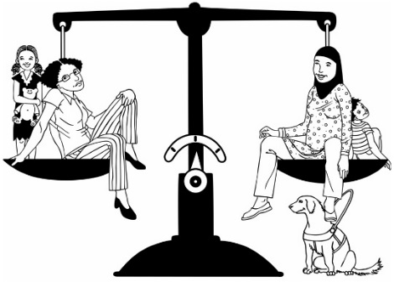
All support and services will be easy for everyone to get if they are made using these ideas:
- Twin Track Approach
- Reasonable Accommodation
- Universal Design.

About the 8 Outcomes of the Strategy
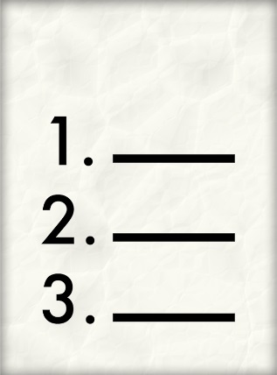
There are 8 Outcomes in the New Zealand Disability Strategy.
An outcome is how we want something to turn out.

The 8 Outcomes can help make sure disabled people in New Zealand:
- have a good life

- are treated fairly

- have the life they want.

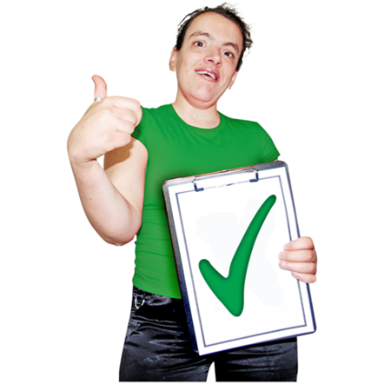
The 8 Outcomes can help make:
- New Zealand a good place for disabled people to live
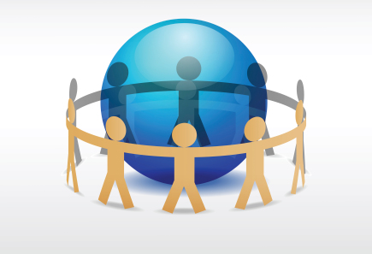
- everyone in New Zealand work together to make sure disabled people have good lives.
All 8 Outcomes link with each other so it is a good idea to read them together.

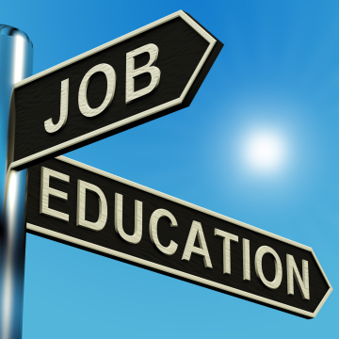
For example: getting a good job links with getting a good education.
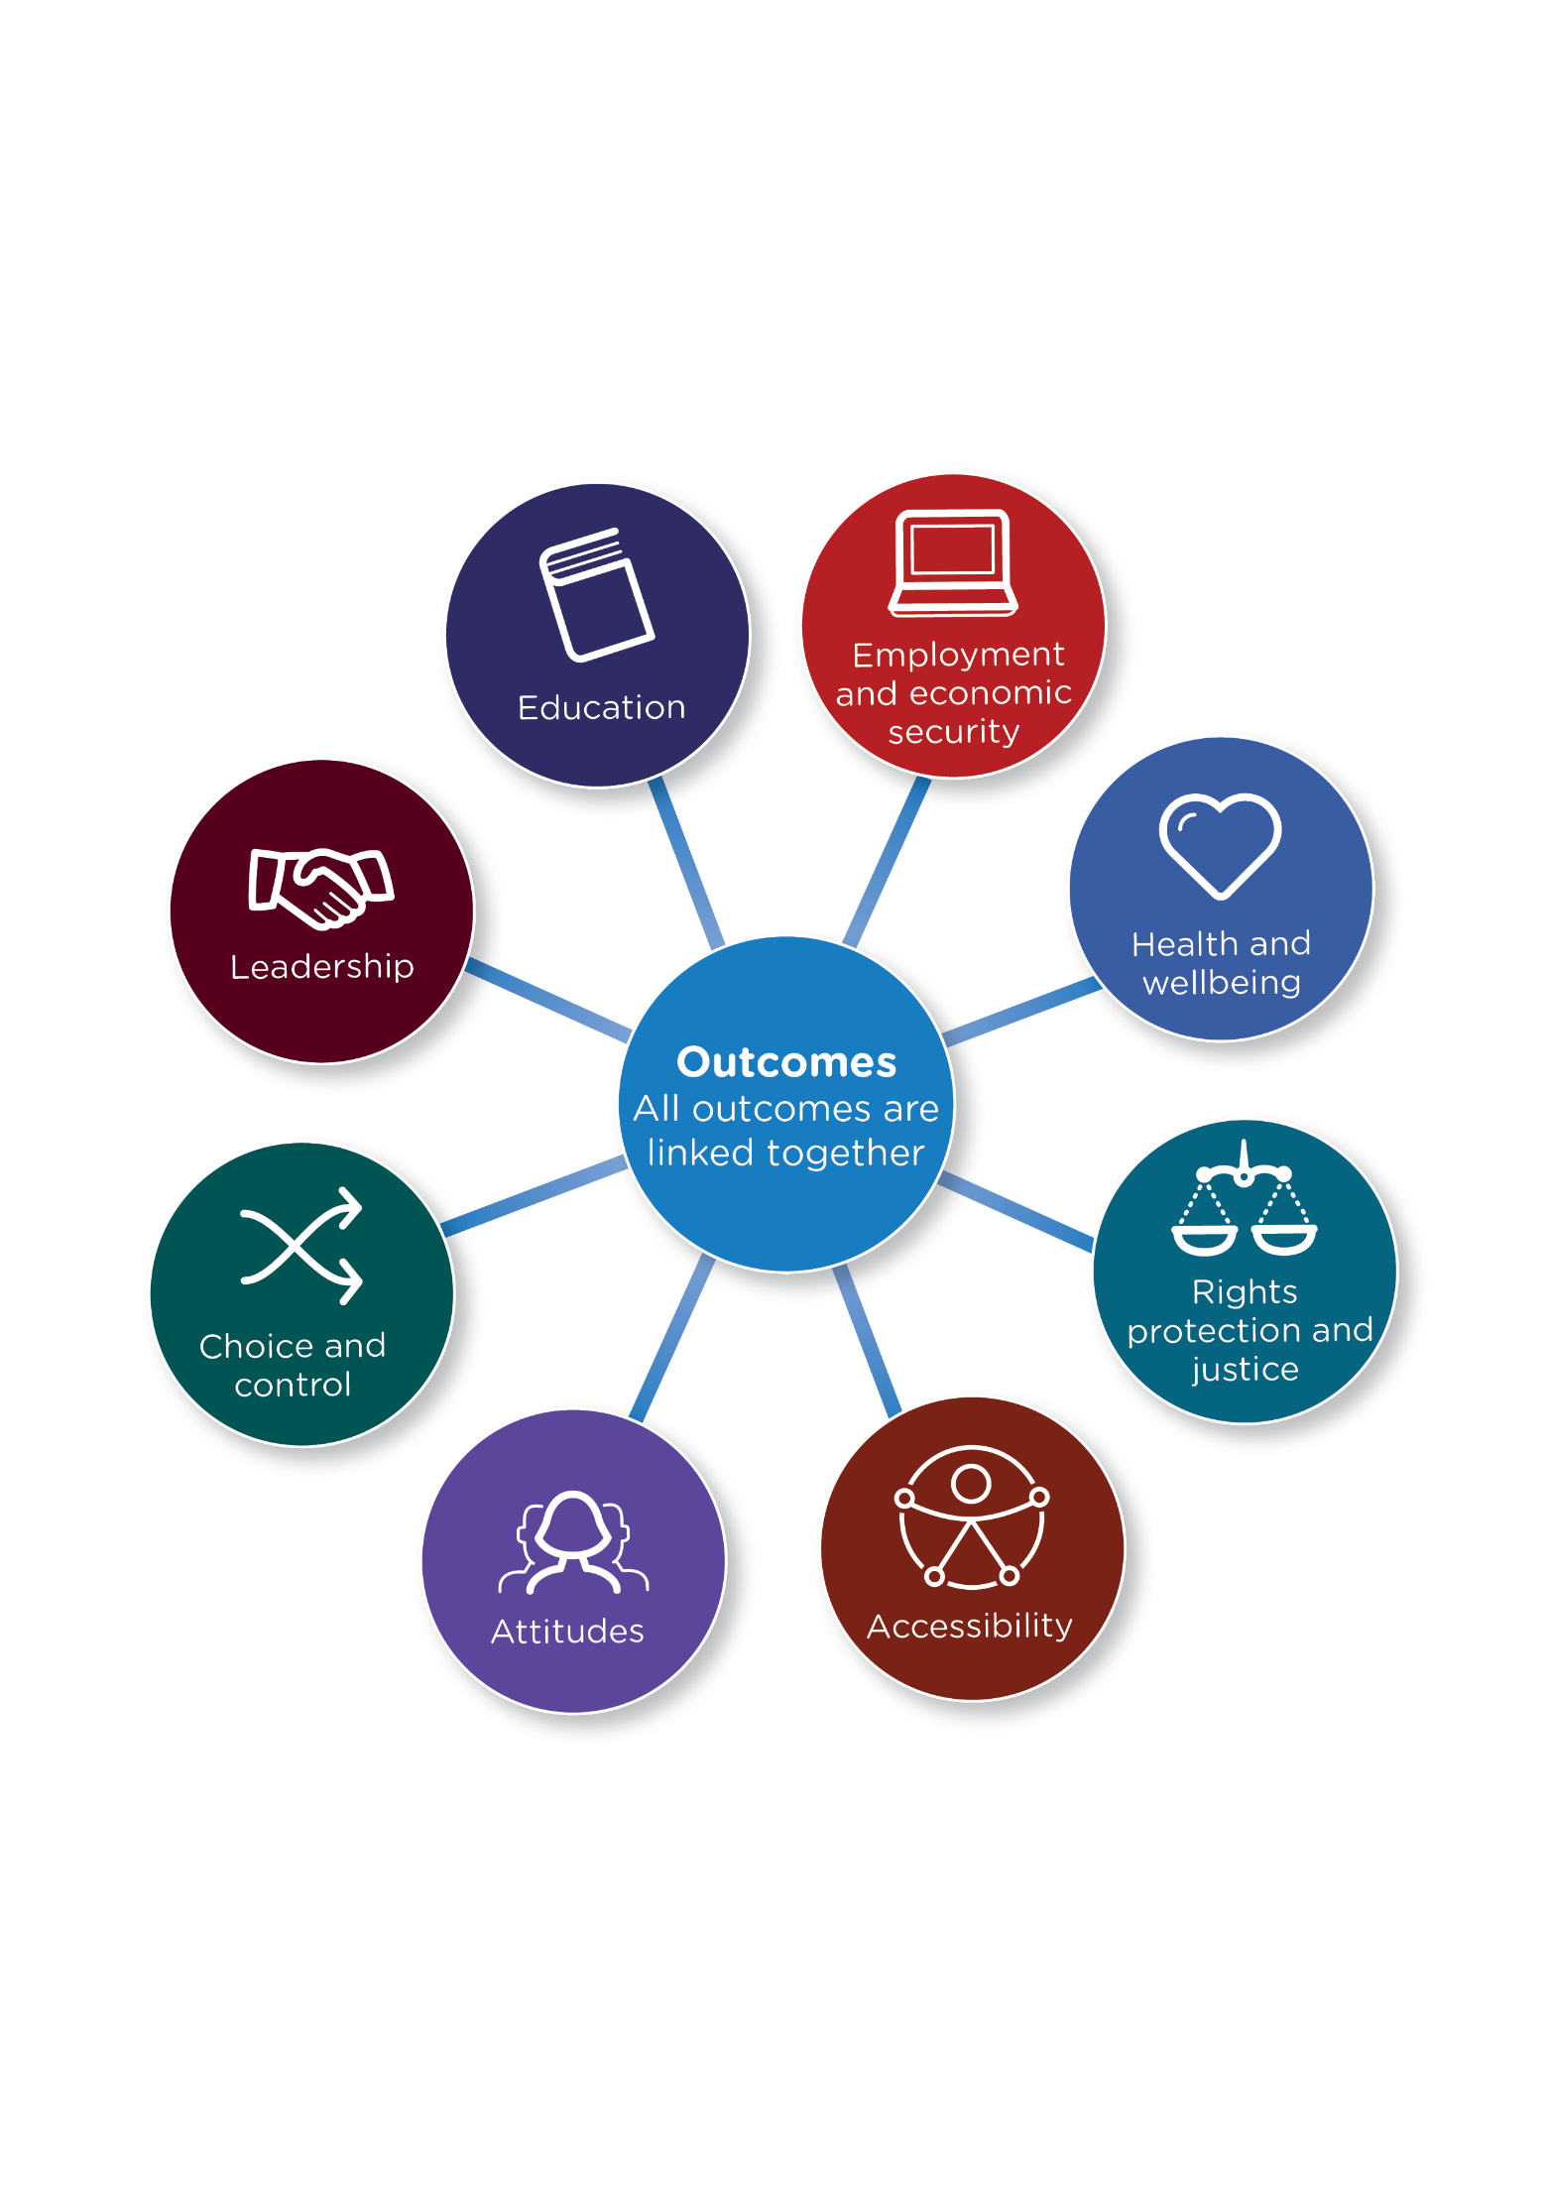

Outcome 1: Education – learning new things

The Disability Strategy is working if disabled people in New Zealand can say these things:

- I can get an excellent education

- I can reach my goals because of my education

- I feel I belong at school
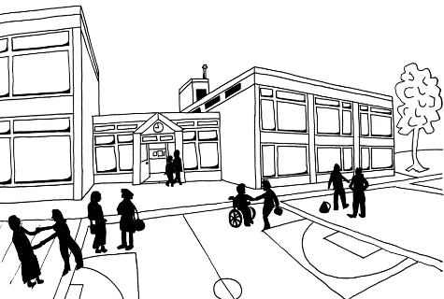
- My teacher supports me and believes I can do well

- I feel valued and important at school

- I can communicate at school in the language I use

- I am treated in a good way by everyone at school

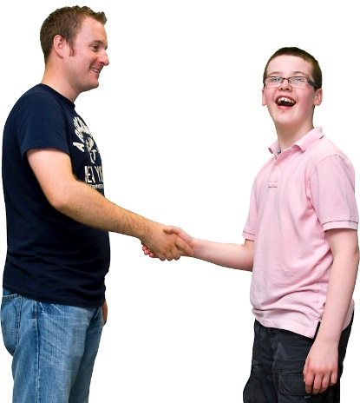
- I can get support that is right for me if I need it

- I can get what I need to help me learn

- I am asked what I think about laws and policies to do with education
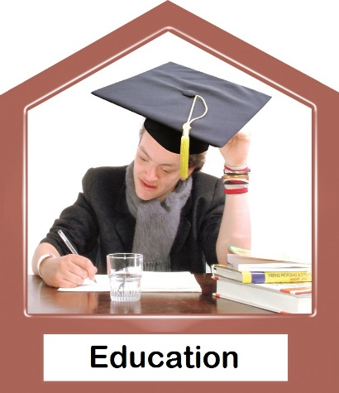
- It is easy for me to get the education that I choose

- Education services for disabled people are good and easy to get to and use

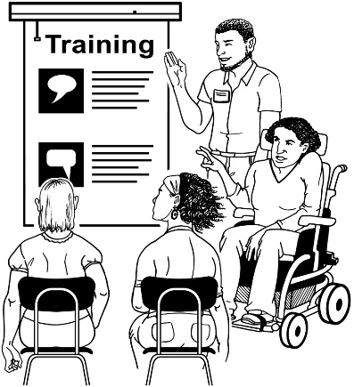
- All teachers know how to include disabled students

- Good decisions are made with good information about education for disabled people.
Outcome 2: Employment – having a job
The Disability Strategy is working if disabled people in New Zealand can say these things:

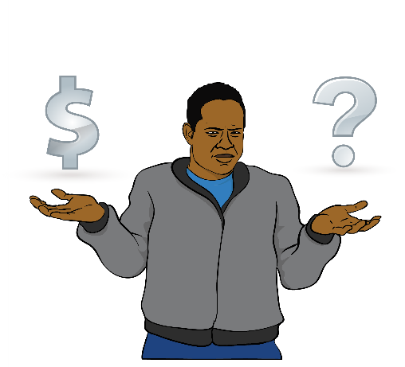
- I get enough money from my job to buy the things I need

- The job I do is important

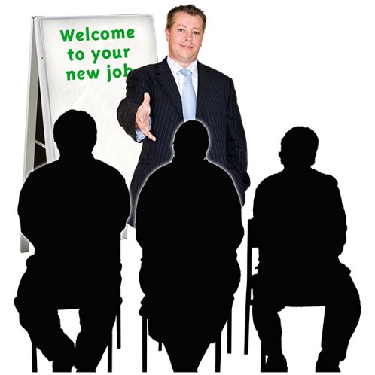
- I am treated in a good way by everyone at work

- I am asked what I think about laws and policies to do with employment and income support

- I can get support that is right for me if I need it

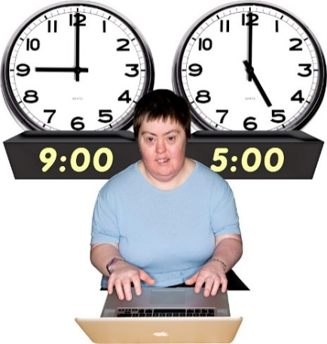
- My boss will make reasonable accommodations for me at work if I need it

- There are no barriers to me getting a job

- All bosses have the support they need to be a fair employer

- Disabled people are managers and bosses

- Lots of disabled people have jobs

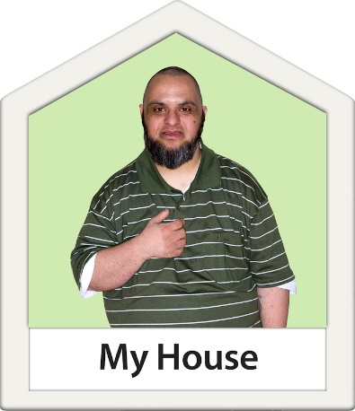
- Disabled people have the same chance to get good jobs as non-disabled people

- All disabled people have enough money to live in a good place
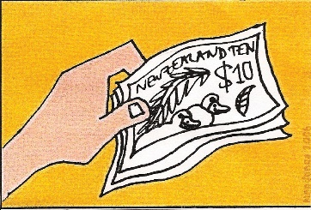
- All disabled people have enough money to join in with things in the community

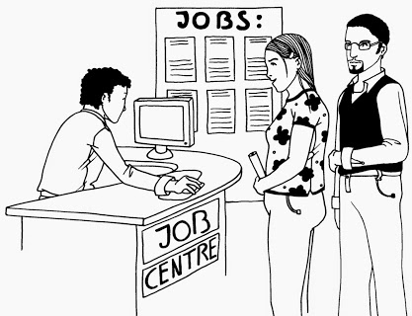
- Employment services for disabled people are good and easy to get and use

- All frontline workers treat disabled people with respect – this means people like bosses and staff at government agencies

- Good decisions are made with good information about employment for disabled people.

Outcome 3: Health – being healthy and well
The Disability Strategy is working if disabled people in New Zealand can say these things:

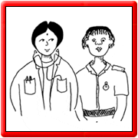
- I get the best health care that is right for me

- I am treated in a good way by all health workers

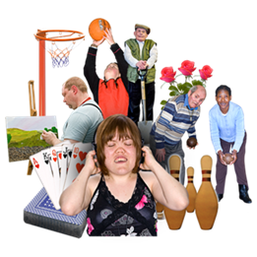
- It is easy for me to get to and use health services

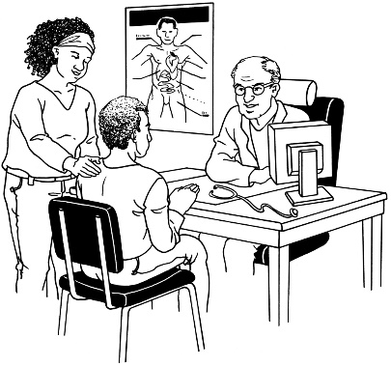
- I can choose and have control over what health supports and services I get

- I can get the health information that services have about me

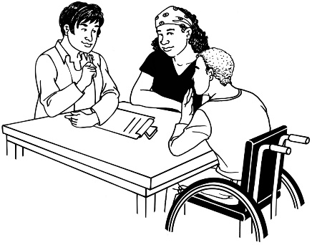
- It is easy for me to get support to communicate

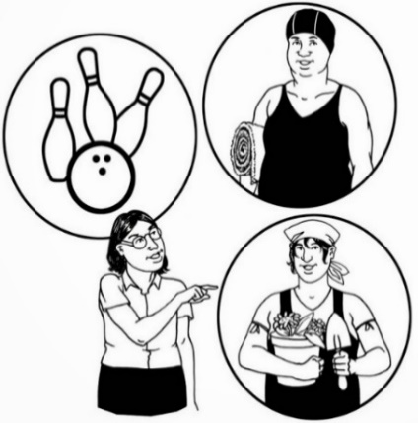
- It is easy for me to make decisions when I need it

- I am valued in the community

- There are no barriers to stop me from joining in community activities
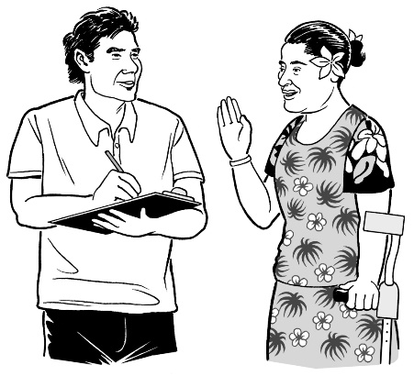
- I am asked what I think about laws and policies to do with health and being well

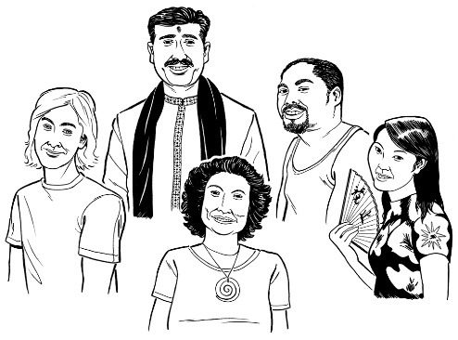
- I feel valued and important in the community

- My culture is respected by health care workers

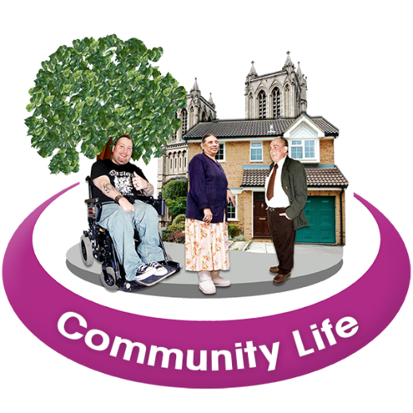
- It is easy for me to join in sport and community activities

- There are no barriers to me getting health services

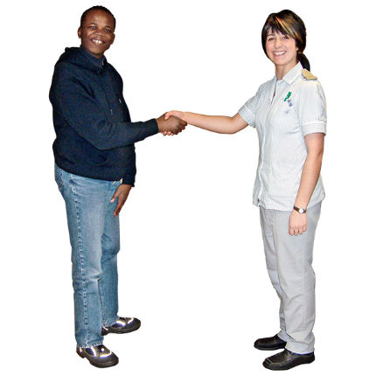
- Health services for disabled people are good and easy to get to and use

- All health workers treat disabled people with respect

- Good decisions are made with good information about health and being well for disabled people.

Outcome 4: Rights and justice – getting my legal rights
The Disability Strategy is working if disabled people in New Zealand can say these things:

- I am listened to
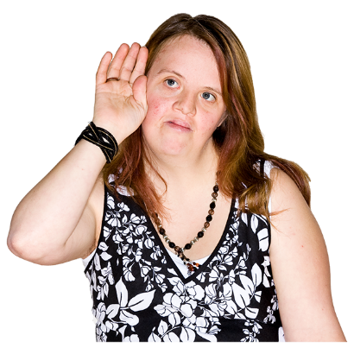
- I feel safe and understood

- I am treated fairly by the justice system – like Police and the courts

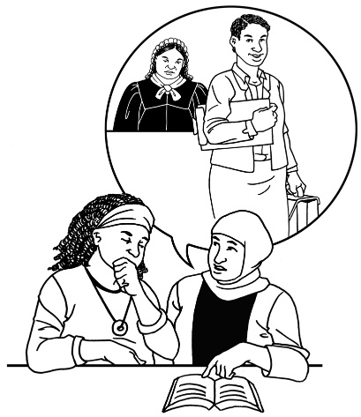
- I can get the support and services I need in the justice system

- I am asked what I think about laws and policies to do with justice and human rights

- I am asked what I think about violence and abuse prevention laws and policy

- My needs are respected

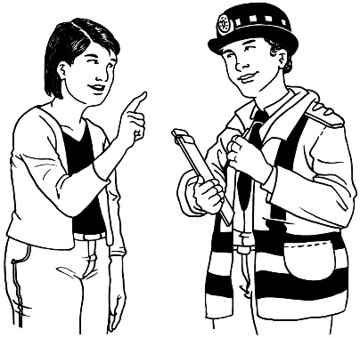
- My rights are protected by laws

- All workers in the justice system understand my disability

- All workers in the justice system treat disabled people with respect

- There are no barriers to getting justice services and supports

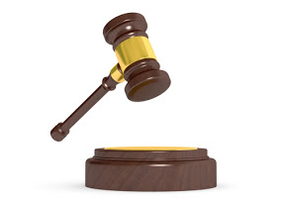
- Good decisions are made with good information about justice, human rights, violence and stopping abuse.

Outcome 5: Access – getting in and around my community
The Disability Strategy is working if disabled people in New Zealand can say these things:

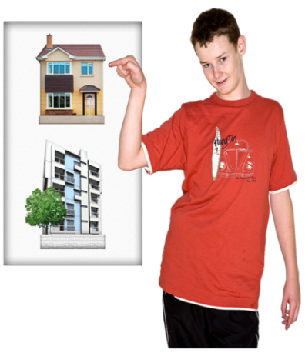
- I can get housing that is right for me

- I feel safe taking public transport

- I am treated in a good way by public transport workers
- I can get information in the language that is right for me

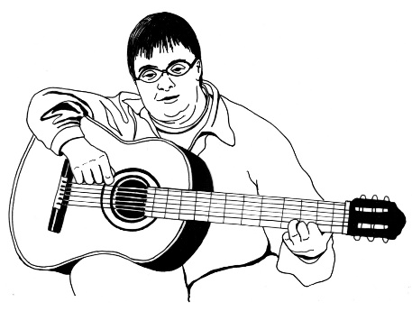
- I can get technology to support me reach my goals

- I can join events to watch or to perform

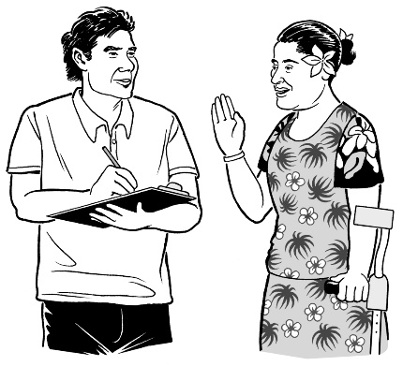
- I am asked what I think about laws and policies for:
  - housing
  - transport
  - buildings
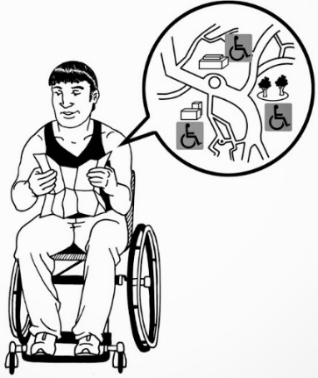
  - public spaces
  - information
  - communication
  - technology.

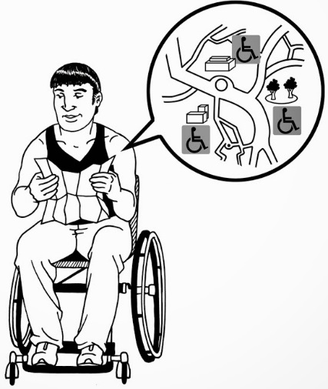
- It is easy for me to get in and around all places

- It is easy for me to understand all information

- Transport does not cost too much

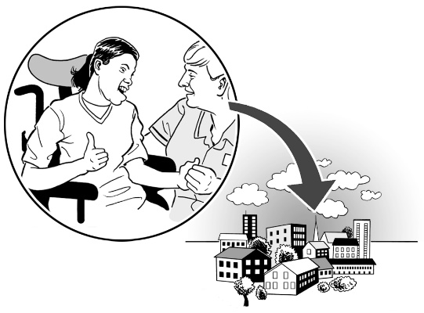
- There are no barriers that make it hard for me to get to places in the community

- Universal design is well known and used
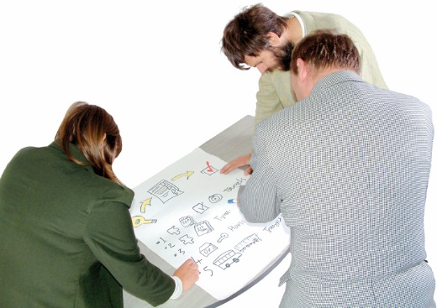
- All people who plan buildings and spaces understand universal design and make things so disabled people can use them

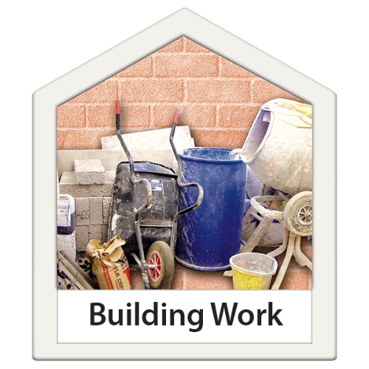
- Good decisions are made with good information about:
  - housing
  - transport
  - buildings
  - public spaces
  - information
  - communication
  - technology.
Outcome 6: Attitude – how disabled people are treated by others
The Disability Strategy is working if disabled people in New Zealand can say these things:

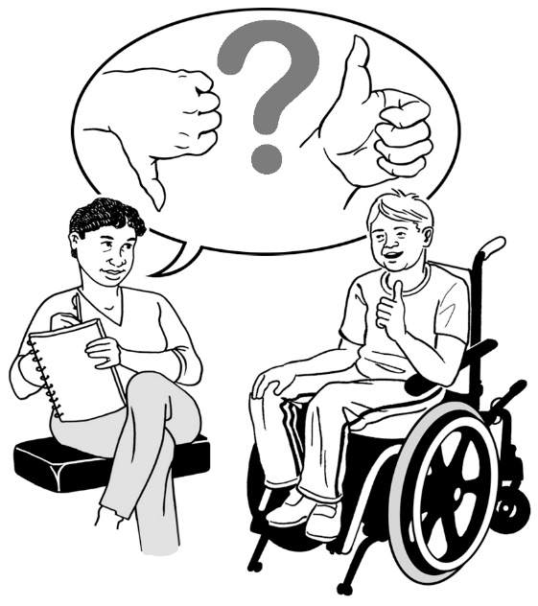
- I am treated with respect

- I am treated in good way by everyone

- I can communicate using the language that is best for me

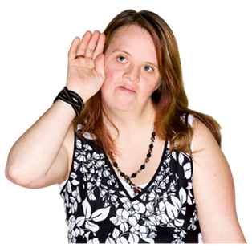
- I am listened to

- I am asked what I think about laws and policies to do with changing attitudes

- My needs are respected

- Disabled people can join any community group

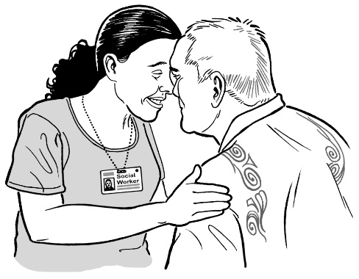
- Work is being done to make people have good attitudes about disabled people

- How disabled people feel about their identity is listened to and respected

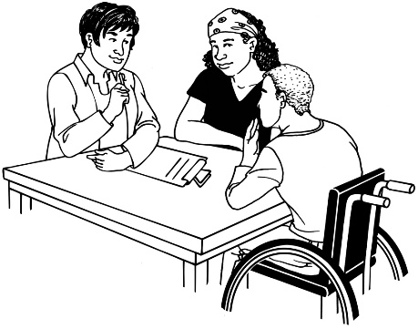
- All frontline workers treat disabled people with respect – this means people like staff of service providers

- Good decisions are made with good information about how disability should be thought about.
Outcome 7: Choice and control – making my own choices and being in control of my own life
The Disability Strategy is working if disabled people in New Zealand can say these things:
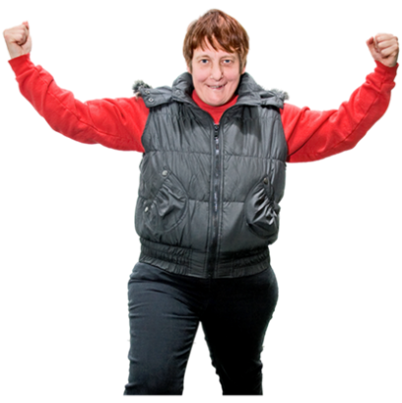
- I am in control of my life

- I make decisions about my life

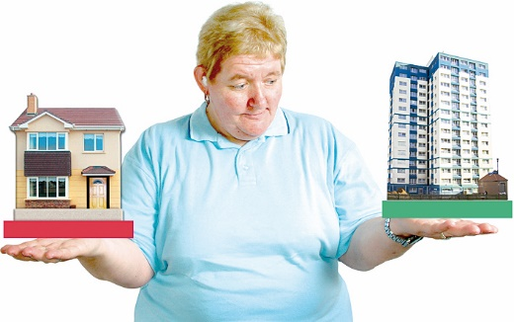
- I am listened to when I say what supports and services I want

- I can choose where I live

- I can get information that is easy for me to understand to support me to make decisions

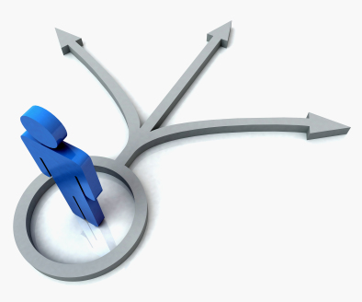
- I can change my decisions if I want to

- I have a right to take risks and learn from my mistakes

- I am asked what I think about laws and policies to do with supports and services

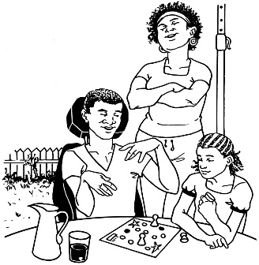
- It is easy for me to get support to talk or make decisions if I need it

- All people that support disabled people to make decisions have access to information to support them

- Good decisions are made with good information about choice and control over supports and services.

Outcome 8: Leadership – being a leader
The Disability Strategy is working if disabled people in New Zealand can say these things:

- I have good chances to be a leader if I want to
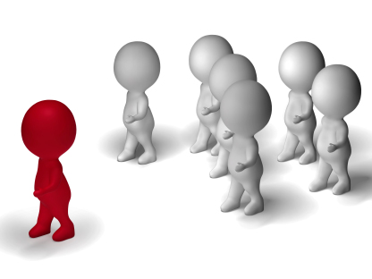
- I have good support to become a leader if I want to

- I am asked what I think about laws and policies to do with leadership

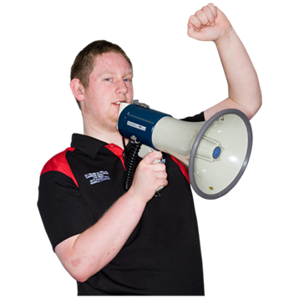
- There are lots of strong leaders in the disability community

- People know that disabled people are experts of their own lives

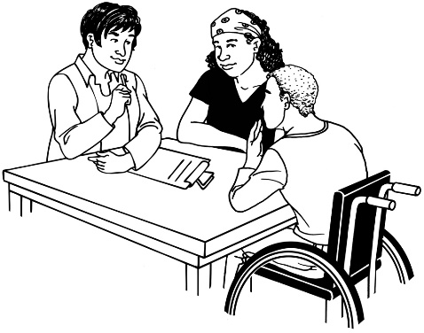
- People value the knowledge that disabled people have about disability

- Non-disabled people in leadership jobs work with disabled people to support the disability community
- Good decisions are made with good information about leadership and disabled people.

Making the strategy work
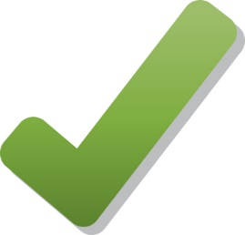
It is important that we can make sure the new disability strategy works.

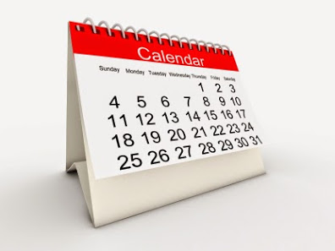
In 2017 a Disability Outcomes Framework for the New Zealand Disability Strategy will be made.

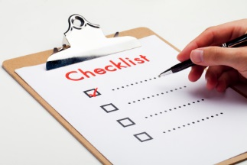
A Disability Outcomes Framework:
- is a way to check that New Zealand is doing the right things to make sure disabled people have good lives
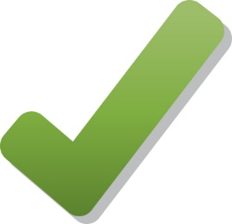
- will show what information needs to be collected to check the Disability Strategy is being done in the right way.

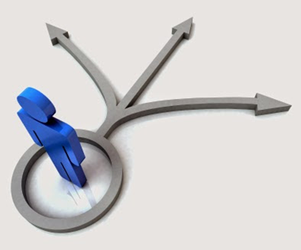
The Disability Outcomes Framework will make sure:
- good decisions are made with good information about things that are important to disabled people and their families
- things are good for disabled people

- there is good information about disabled people

- we know what information we still need

- we know what things we need to work on.
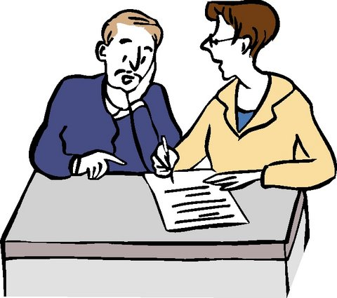
It is important the Government has good information about disabled people so good decisions can be made.

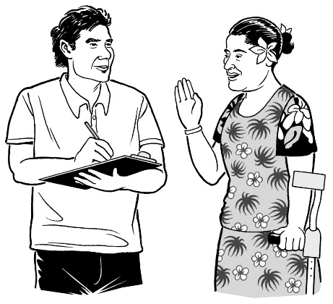
Getting good information about disabled people can make sure the Government:
- knows what disabled people need to have a good life
- can make good decisions.
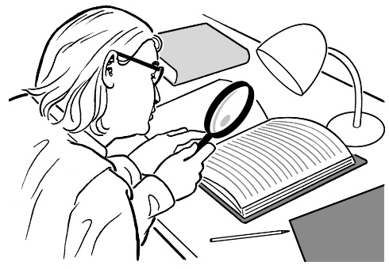
Good information can help everyone to:
- find out what problems there are
- think how to fix the problems
- find out how well we are doing.
Good information means having both:
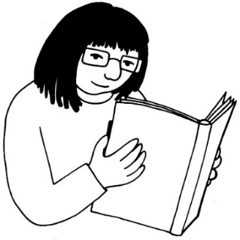
- numbers of disabled people in New Zealand
- stories about disabled people in New Zealand.

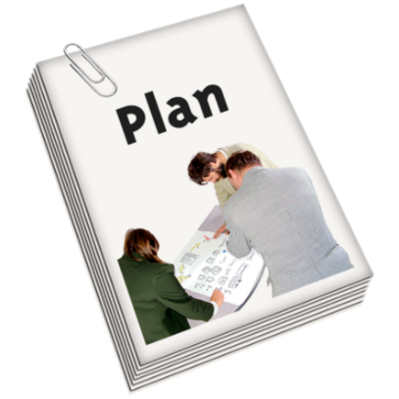
New Zealand has a document called the Disability Action Plan.

The Disability Action Plan says what the Government is doing to make sure disabled people have good lives.
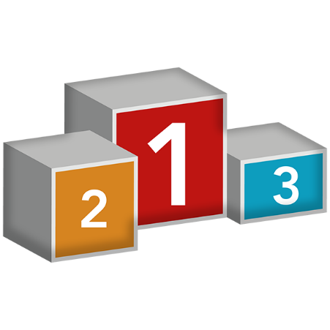

The Disability Action Plan has in it the most important things Government agencies can do to help disabled people have a good life.

The Disability Action Plan can be used to make sure things in the New Zealand Disability Strategy are done.

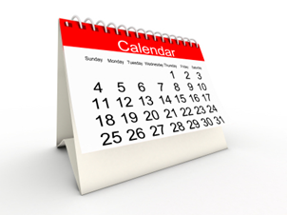
Every 2 years:
- the Disability Action Plan is looked at to make sure it is still ok
- everyone can say what they think should be in the Disability Action Plan.
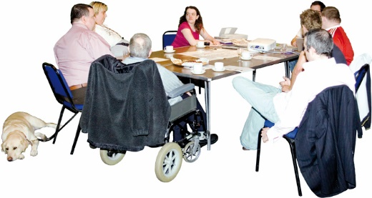
It is important that disabled people say what needs to be in the Disability Action Plan.

There are also other plans that help disabled people lead good lives.

You can find these on the Office for Disability Issues website:
http://www.odi.govt.nz/

Keeping track of what has been done
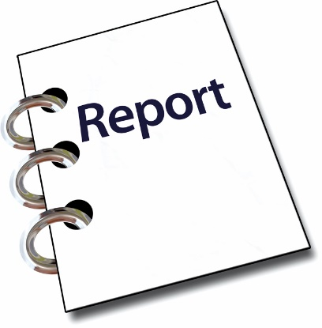
Every year the Minister for Disability Issues reports to Parliament on the:
- New Zealand Disability Strategy
- Disability Action Plan
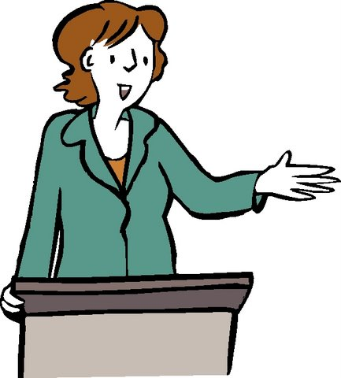
- outcomes that are in the Disability Outcomes Framework.

The Minister’s reports can let everyone know what needs to be changed in the Disability Action Plan.
Every 4 years the New Zealand Government gives a report to the United Nations Committee on the Rights of Persons with Disabilities.

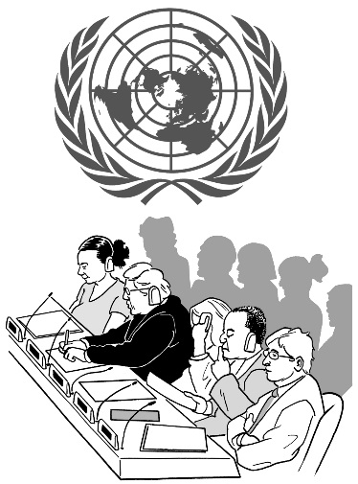
Every 4 years the United Nations Committee on the Rights of Persons with Disabilities gives a report back.

This report is called the Concluding Observations.
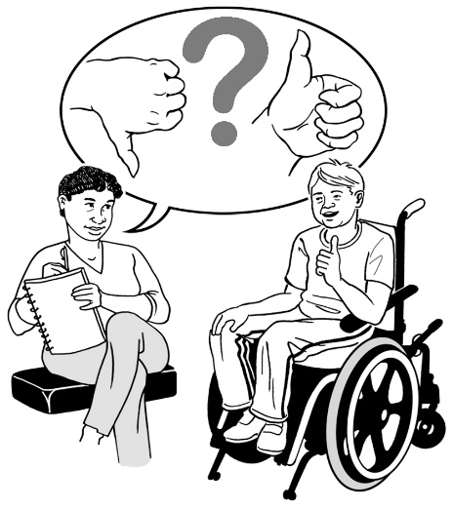
The Concluding Observations tell us things the New Zealand Government:
- is doing well
- needs to do.
The Government will get more Concluding Observations in 2018, 2022 and 2026.
The Concluding Observations will help the Government to know what things in the Disability Action Plan need to change.

Who makes sure the strategy gets done
The New Zealand Disability Strategy is a New Zealand Government Strategy.

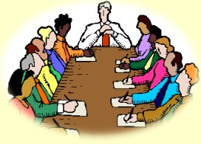
The people in Government that make decisions about the Strategy are called the Cabinet.

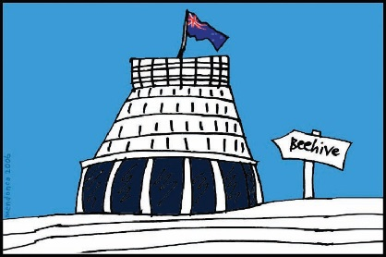
The New Zealand Prime Minister and lots of Ministers are in the Cabinet.

The Cabinet:
- is part of the New Zealand Government

- gets reports on the New Zealand Disability Strategy and Disability Action Plan
- decides what to do to make sure the New Zealand Disability Strategy and Disability Action Plan are used.

The Government knows it is important that disabled people are part of the decisions that it makes.

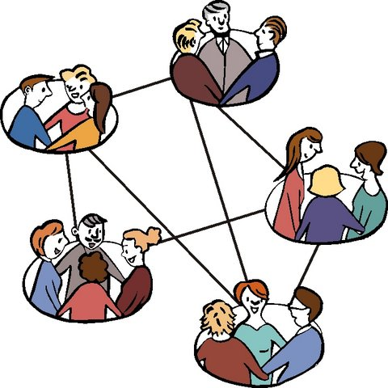
Here are some of the groups that make sure things in the New Zealand Disability Strategy and Disability Action Plan happen.
They are:
- Chief Executives Group on Disability
- Senior Officials Group on Disability
- Disabled People’s Organisations.

The Government has also made another way of checking things.

This is called the Independent Monitoring Mechanism.
There are 3 groups in the Independent Monitoring Mechanism:
- The Office of the Ombudsman
- The Human Rights Commission
- The Convention Coalition Monitoring Group.

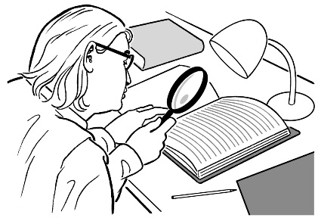
The job of the Independent Monitoring Mechanism is to check if disabled people are getting the rights in the Disability Convention.

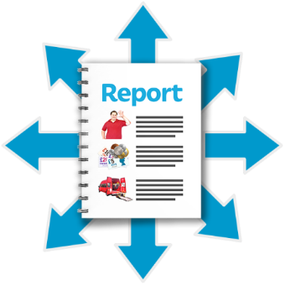
The Independent Monitoring Mechanism gives reports to the Government so they know what needs to be done.
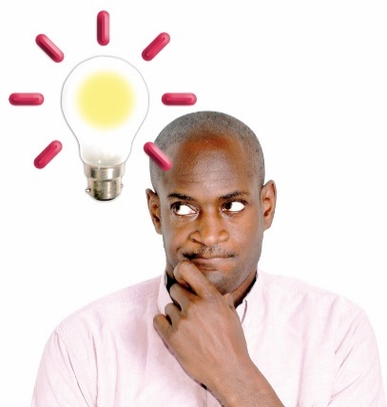
Reports from the Independent Monitoring Mechanism help the Government know what to put in the Disability Action Plan.

What is going to happen over the next 10 years
This New Zealand Disability Strategy will be used for the next 10 years.

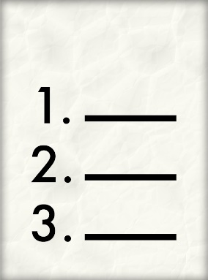
Here is what will happen to make sure the New Zealand Disability Strategy:
- is used by everyone
- works well.
In 2016:
- Agree to the New Zealand Disability Strategy.

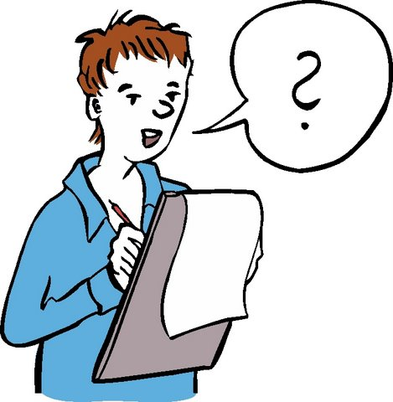
In 2017:
- Ask people in the disability community about the Disability Outcomes Framework.
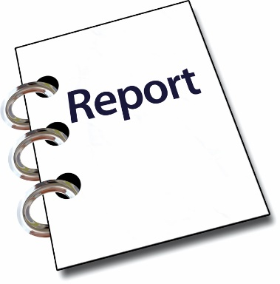
- Agree to the Disability Outcomes Framework.
- Update the Disability Action Plan
- Get annual report from Minister for Disability Issues.

In 2018:
- Give report to the United Nations Committee.
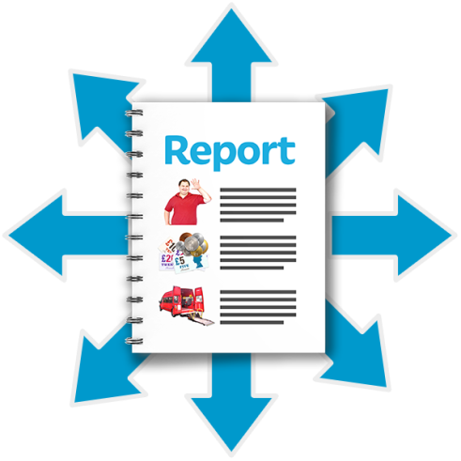
- Get report from the United Nations Committee.
- Get report from the Independent Monitoring Mechanism.
- Get Disability Outcomes report from the Minister for Disability Issues.

In 2019:
          - Ask people in the disability community about the Disability Action Plan.
          - Agree to the Disability Action Plan.
          - Get Disability Outcomes report from the Minister for Disability Issues.
In 2020:
          - Get Disability Outcomes report from the Minister for Disability Issues.
In 2021:
- Ask people in the disability community about the Disability Action Plan.
- Agree to the Disability Action Plan.
- Get Disability Outcomes report from the Minister for Disability Issues.

In 2022:
- Give report to the United Nations Committee.
- Get report from the United Nations Committee.
- Get report from the Independent Monitoring Mechanism.
- Get Disability Outcomes report from the Minister for Disability Issues.

In 2023:
- Ask people in the disability community about the Disability Action Plan.
- Agree to the Disability Action Plan.
- Get Disability Outcomes report from the Minister for Disability Issues.

In 2024:
- Get Disability Outcomes report from the Minister for Disability Issues.

In 2025:
- Ask people in the disability community about the Disability Action Plan.
- Get Disability Outcomes report from the Minister for Disability Issues.

In 2026:
- Give report to the United Nations Committee.
- Get report from the United Nations Committee.
- Get report from the Independent Monitoring Mechanism.
- Evaluate Disability Strategy.
- Evaluate Disability Action Plans.
- Get Disability Outcomes report from the Minister for Disability Issues.
- End of this Disability Strategy.
- Decide what to do next.

Who is involved
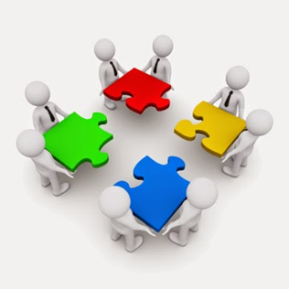
To get the New Zealand Disability Strategy used by everyone in New Zealand lots of people need to work together.
Here are some groups that need to help make sure the New Zealand Disability Strategy is used by everyone in New Zealand:
- Cabinet
- This is part of the New Zealand Government.
- The New Zealand Prime Minister and lots of Ministers are in the Cabinet.
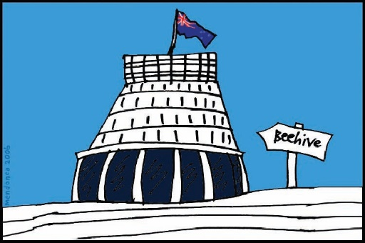
- The Cabinet looks at reports and decides how to get the New Zealand Disability Strategy used by everyone in New Zealand.

- Ministerial Committee on Disability
- This is part of the New Zealand Government.
- Some New Zealand Ministers are in the Ministerial Committee on Disability.

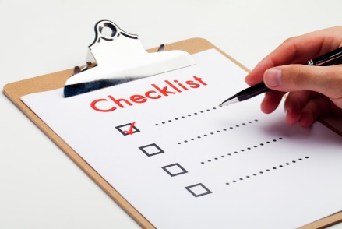
- Independent Monitoring Mechanism
- This group checks to make sure the New Zealand Disability Strategy is used.

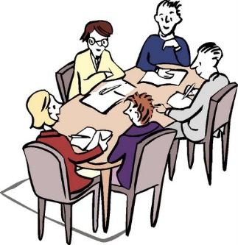
- Chief Executives Group on Disability
- This group makes sure the Disability Action Plan happens.

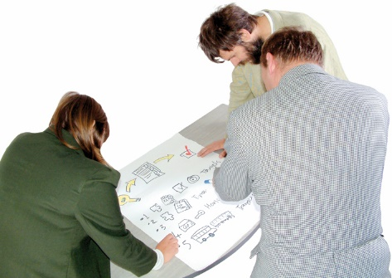
- Senior Officials Group on Disability
- This group makes sure the Disability Action Plan happens.

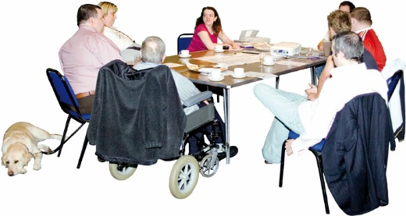
- Disabled People’s Organisations
- Disabled People’s Organisations make sure the Disability Action Plan happens.

- Government agencies
- Government agencies use the New Zealand Disability Strategy and the Disability Action Plan.

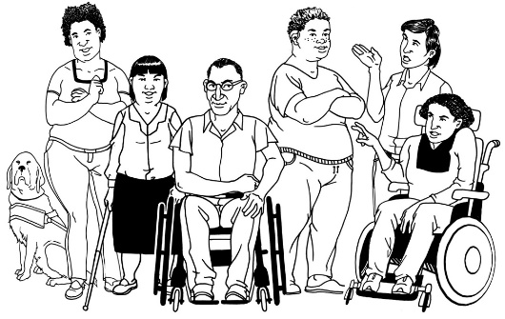
- Disability community
- The people in the disability community can give their ideas on what should go in the Disability Action Plan.

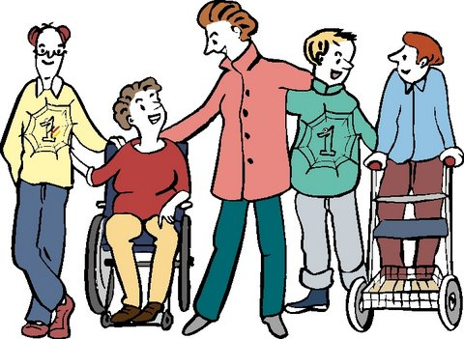
- All New Zealand people
- All New Zealand people can do things to make it easier for disabled people to take part and have good lives.
- All New Zealand people can support the New Zealand Disability Strategy.

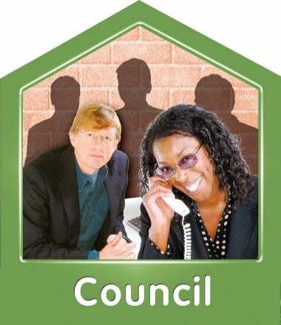
- Councils and Local Groups
- All Councils and Local Groups can do things to support the New Zealand Disability Strategy.
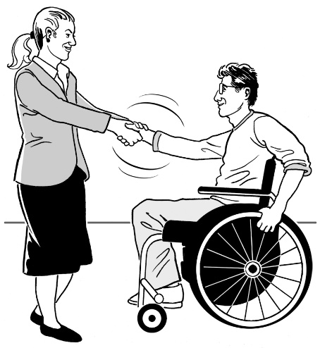
- Private businesses
- All private businesses can do things to make sure disabled people are:
  - able to take part
  - treated fairly
  - treated in a good way.

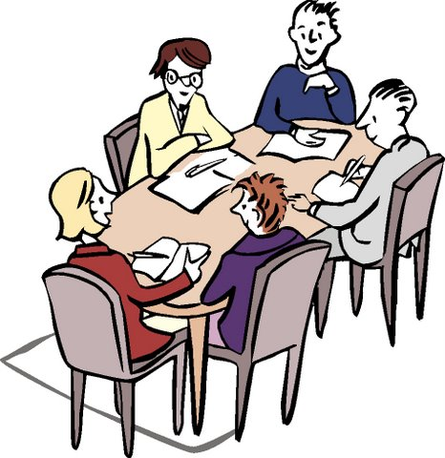
- Other Organisations
- Other organisations that are not part of the Government can do things to make sure disabled people are:
  - able to take part
  - treated fairly
  - treated in a good way.

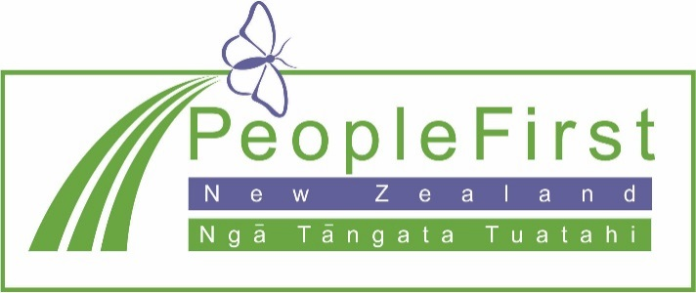

This information has been translated into Easy Read
by People First New Zealand Inc. Ngā Tāngata Tuatahi
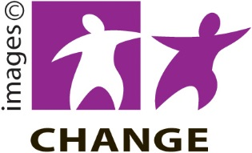

You can find out more about the New Zealand Disability Strategy on the Office for Disability Issues website: www.odi.govt.nz

