Make it Clear

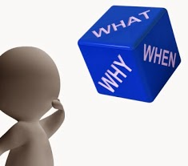

A guide to making
Easy Read information

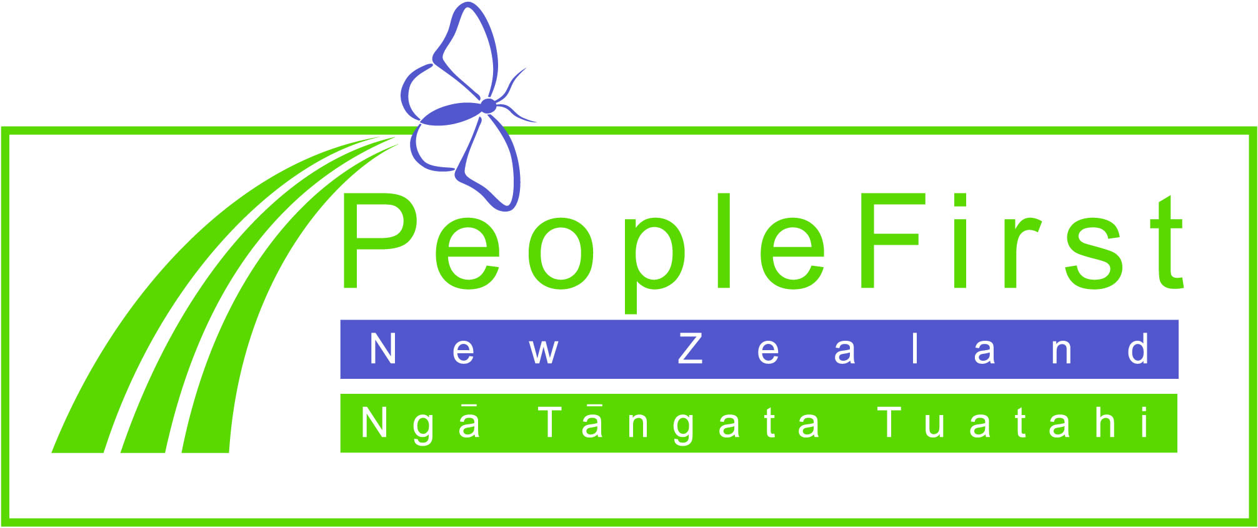

Everyone has the right to get information in a way you understand

How to use words and pictures to make information easier to understand

This guide will help you write information that is easy to understand.

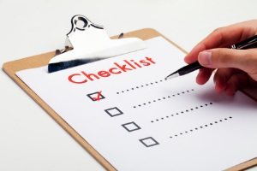
There is a tick list in this document that you can tick off to help you.

About this guide

This guide has been made to help you:
- write your information in a way that is clear and easy to understand

- use easy words and pictures to make your information accessible
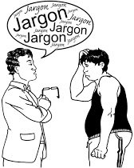
- prepare documents for people who have difficulty reading and understanding written information.

This guide is for:

- organisations
- services
- work place
- businesses
- family/ whanau
- friends
- communities.

What is Easy Read information?

Easy Read information is:
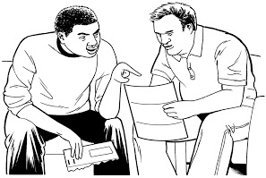
- information that is clear and easy to read and understand

- developed to support people with learning (intellectual) disability better understand written information
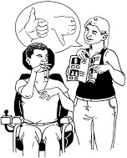
- different from plain English and plain language but uses the same principles and builds on them
http://www.plainenglishawards.org.nz/what-is-plain-english/

http://www.plainenglish.co.uk/

- written information, supported by pictures

- uses everyday words and has no jargon or acronyms.

Who is Easy Read information for?

Easy Read information is for people who have difficulty reading and understanding written information.
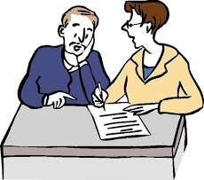
Easy Read information is for some people who:

- have a learning disability

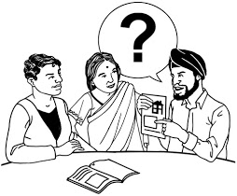
- have low literacy levels

- use English as a second language
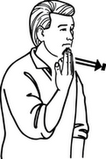
- are elderly

- are Deaf.

Some people will be able to read Easy Read information independently. For others they will require someone to facilitate the information.

Some things to think about before you start writing
- Think about the audience – who are you writing this Easy Read information for?

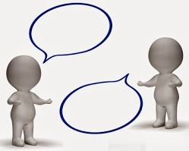
- Understand the content of the document. Ask more questions from the source if you need to clarify information such as does the information have a short life or long life?

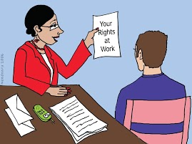
- Think about what the final product needs to look like. Is it a pamphlet, a conference flyer, report, or a research summary?

- Is it part of a set of other accessible documents of the same information? If yes then the Easy Read version needs to look like it belongs to the set – same quality, similar cover design and style.
- Set an appropriate timeframe for making sure you can achieve each step of the process and involve people with learning disability.
Getting started – some of the rules for writing Easy Read information

How to set your page up
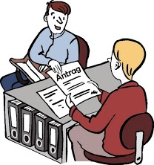
- Use wide margins.

- Justify all of your writing to the left.

- Keep the pictures to the left of the writing.

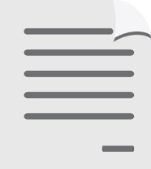
- Use at least 1.5 spacing between lines.

- Number the pages at the bottom right hand side.

- Use large font: at least size 16.

- Use a clear font like Arial.

- Usually 4-5 pictures to a page is the maximum.

- Use wide spaces so the information is clear.

- Use numbers not the words for numbers: 8 not eight.

- Do not use text boxes as they are hard to adjust formatting.

How to organise a document
- Have one idea per page.

- You may need to reorganise the information from the original document. It is best to group all the same topic of information together in the Easy Read translation to make it easier for the reader.

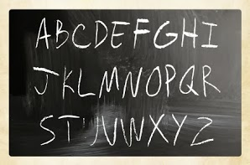
- Use headings and subheadings. Use colour, bold and large font to highlight information. Check colours used will photocopy well in black and white if the document will need to be photocopied for use in the future. Always use the same font across all the headings.

- Always finish a word on the line.

- Always finish a sentence on the same page.

- Always finish a paragraph on the same page.
What images to use
Images support and add meaning to words.
- Use symbols, pictures, photos or drawings.

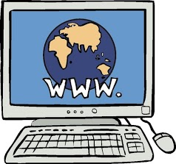
- You can find pictures on the Clipart function of Word.

- You can purchase “picture kits” from specialised organisations.

- Make sure the pictures are relevant and age appropriate.

- You don’t have to have a picture for each bullet point you can have one just for the main point.

- Don’t put pictures over the words.

- When using photos make sure they are up to date and clear with not too much in the photo. Be aware photos date quickly.

- Make sure you use freely available images or make sure you have the right to use them.

Publishing the document
Getting the document ready to publish can take some extra time.

It is important that you check back with the writer to see that:
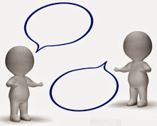
- you have correctly interpreted the information

- the message is still the same and clear

- the images match the words.

Be prepared to make any requested changes.

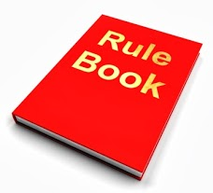
Designers are often unfamiliar with Easy Read principles and they can try and make changes to the document to make it look more appealing.
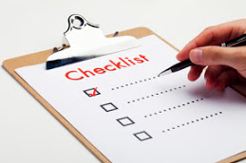
It is important that you make it clear that designers are not to make changes to the format, font size, colour or the images as this will take the document out of Easy Read principles.

How will the document be available?
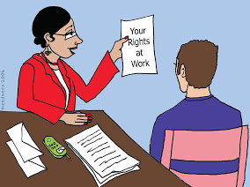
If the document is going to be in hard copy print then there should not be any issues.

If the people or organisation requesting the document are putting it online in Word format then you could encounter problems with formatting.

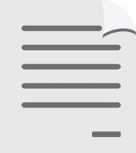
You may want to suggest that the document is put into a PDF file before loading onto the internet although this can reduce some accessibility for people who use screen readers.

What can People First offer?

- People First New Zealand has full Easy Read translation service. You provide the information and People First will estimate cost and translate the information.

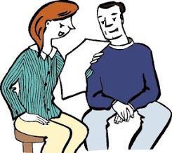
- People First can act as an advisor on documents that you produce. This means that you have a go at producing an Easy Read document and People First will work with you to make sure the information is in line with all Easy Read guidelines.

- People First NZ has groups across the country and they can provide quick feedback to make sure your information and images are easily understood.

Write in short sentences of 15-20 words.

Write as if you are speaking.

Use active verbs as much as possible.

Keep the language personal e.g. you, we, I.

Use Arial font – at least size 16.

Don’t underline, use bold to emphasise a word.

Each sentence has one idea.

Use drop down bullet points to list.

Don’t use jargon or acronyms or italics.

Don’t write in upper case.

Don’t use don’t – use do not.

Always use numbers – don’t write numbers.

Use full names e.g. road, not Rd or Ministry of Heath not MoH.

Reduce punctuation as much as you can.

Use boxes to help information stand out.

Make sure the layout is the same throughout the document.
Check list

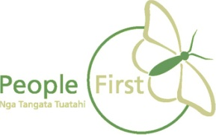
This information has been translated into Easy Read
by People First New Zealand Inc.
